Methodist Health Services Corporation & UnityPoint Health Methodist  Laboratory  CYTOLOGY |  | Page 1 of 2 | Section: UPM CYTO |  |  | Policy #: 11
 |  | Approved by: |  | See signature block at end of policy |  | Date: 04/11/16
 |  | Date Revised: |  |  | Supersedes 2/11/00, 9/12/97, 9/12/96, 9/11/95, 10/11/94
 |  | Date Reviewed: |  |  | 4/11/16, 5/8/14
 |  | Revision Submitted by: |  |  | Shea N Cox, CT (ASCP)
 |  | JCAHO Standard: |  |  | NA
POLICY GUIDELINE ON: | Criteria for Categorizing Unsatisfactory Specimens

- POLICY:
To outline criteria for categorizing unsatisfactory specimens.

- PURPOSE:
To provide guidelines on criteria for unsatisfactory cytology specimens.

- POLICY SCOPE:
This policy applies to all staff reading cytology specimens

- GENERAL INFORMATION:
Unsatisfactory specimens are unsuitable for diagnostic interpretations.

- PROCEDURE:
A. The specimens under following circumstances will be considered unsatisfactory for interpretation:
- Unlabeled or improperly identified as to the patient.
- The submitting physician will be notified to resolve the problem.
- The specimen will be preserved during this attempt to resolve the problem.
- All body fluids kept at room temperature without any fixative for six hours or longer may be considered unsatisfactory and discarded after consultation with a pathologist.
- Clotted specimens may not be suitable for smear preparation.
- The specimen can be processed for cell block.
- The body fluid submitted in leaking container with gross contamination on the container will not be accepted.
- The submitting physician will be contacted in case of every unsatisfactory specimen for processing.
- A rejection letter will be sent to the physician for unsatisfactory specimens, and a copy of the letter will be kept on file.
- The specimens will be accepted only from physicians licensed to practice in the states of Illinois and Iowa.

- MAINTENANCE AND STORAGE
  - All policies and procedures are reviewed every two years, (except for Safety procedures which are yearly) by Laboratory Administration and or the Medical Director of the Laboratory or designee.
  - The Laboratory Administration and Medical Director review policies and procedures when there are changes in practice standards, or requirements.
  - All policies and procedures are reviewed every two years (except for Safety procedures which are yearly) by staff or at the time new or revised ones are put in effect.
  - All policies are retained 8 years after being discontinued or revised.
  - All procedures are retained 2 years after being discontinued or revised

POLICY CREATION :
Author: Devendra Trivedi, MD | October 11, 1994
Medical Director: Devendra Trivedi, MD | October 11, 1994

MEDICAL DIRECTOR
DATE | NAME | SIGNATURE
February 11, 2017 | Elizabeth A. Bauer-Marsh, M.D.
SECTION MEDICAL DIRECTOR
October 11, 1994 | Devendra Trivedi, MD
October 7, 2017 | Katherine Kasper, MD

REVISION HISTORY (began tracking 2011)
Rev | Description of Change | Author | Effective Date
1 | Updated system name, added policy scope | T. Lanan | 5/8/14

Reviewed by
Lead | Date | Coordinator/Manager | Date | Medical Director | Date
 | 8/3/12 | 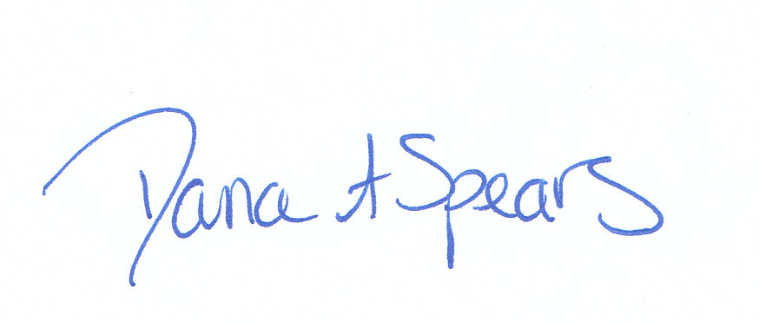 | 8/3/12 |  | 8/3/12
 | 4/30/14 |  | 5/8/14 |  | 5/8/14
 | 4/1/16 |  | 4/1/16 |  | 4/11/16

