Methodist Health Services Corporation & UnityPoint Health Methodist  Laboratory  CYTOLOGY |  | Page # 1 of |  | 2 |  | Section: UPM CYTO | Policy #: 13
 |  | Approved by: |  | See signature block at end of policy |  |  | Date: 5/28/16
 |  | Date Revised: |  | 2/11/00, 9/12/97, 9/12/96, 9/11/95, 10/11/94
 |  | Date Reviewed: | 4/11/16, 5/8/14
 |  | Policy/Revision Submitted by: | Shea N Cox, CT (ASCP)
 |  | JCAHO Standard: |  |  | NA
POLICY GUIDELINE ON: | Workload Surveillance Policy

- POLICY:
This policy establishes cytotechnologist's daily workload monitoring.

- PURPOSE:
To maintain guidelines for cytotechnologists in monitoring screening workload.

- POLICY SCOPE:
This policy applies to all cytotechnologists.

- GENERAL INFORMATION:
The daily screening workload limits are not set as goals or required quotas for the cytotechnologists. They are just maximum limits.

- PROCEDURE:
- The number of slides examined by each cytotechnologist engaged in the evaluation of cytology preparations by non-automated microscopic technique will not be more than 100 slides in a 24-hour period.
- The 100 slide limit includes slides examined at sites or laboratories other than Methodist Medical Center.
- This limit represents an absolute maximum number of slides.
- UnityPoint Methodist Laboratory will NOT set a daily quota of 100 slides per individual.
- The 100 slide limit also applies to pathologists who examined previously unexamined cytology slides.
- Previously examined cytology preparations and tissue pathology slides examined by a pathologist are NOT included in the 100 slide limit.
- For purposes of workload calculation, each slide preparation that covers less than half of the total available slide area and which is examined by non-automated microscopic technique, counts as one-half slide.
- Each individual is responsible for keeping records of the total number of slides examined during each 24-hour period.
- The maximum number of 100 slides examined in no less than an 8 hour work day.
- Workload limits will be set for individuals examining slides on other than an 8-hour work day basis (part-time employees).
- The number of slides that may be examined will be prorated by allowing no more than an average of 12.5 slides per available slide examination hour.

- As part of the laboratory's ongoing quality assurance program, the Cytology Laboratory Director will set individual limits for each cytotechnologist based on his or her performance.
- This performance review will occur at least every six months as outlined in the Cytotechnologist Workload Assessment Policy.

- MAINTENANCE AND STORAGE
  - All policies and procedures are reviewed every two years, (except for Safety procedures which are yearly) by Laboratory Administration and or the Medical Director of the Laboratory or designee.
  - The Laboratory Administration and Medical Director review policies and procedures when there are changes in practice standards, or requirements.
  - All policies are retained 8 years after being discontinued or revised.
  - All procedures are retained 2 years after being discontinued or revised

POLICY CREATION :
Author: Devendra Trivedi, MD | October 11, 1994
Medical Director: Devendra Trivedi, MD | October 11, 1994

MEDICAL DIRECTOR
DATE | NAME | SIGNATURE
February 11, 2017 | Elizabeth A. Bauer-Marsh, M.D.
SECTION MEDICAL DIRECTOR
October 11, 1994 | Devendra Trivedi, MD
October 7, 2017 | Katherine Kasper, MD

REVISION HISTORY (began tracking 2011)
Rev | Description of Change | Author | Effective Date
1 | Updated system name | T. Lanan | 5/8/14

Reviewed by
Lead | Date | Coordinator/Manager | Date | Medical Director | Date
 | 8/8/12 | 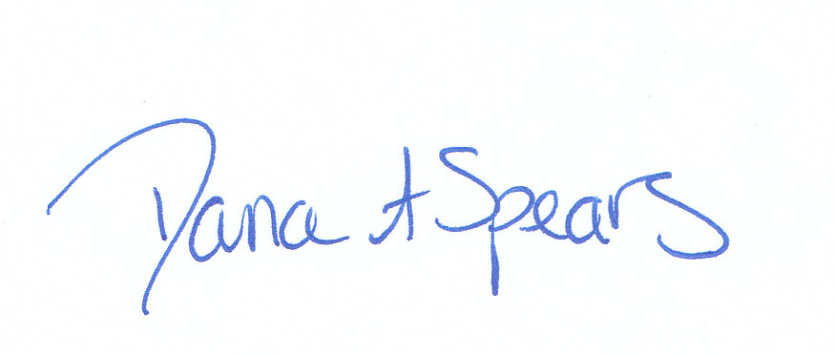 | 8/8/12 |  | 8/8/12
 | 4/30/14 |  | 5/8/14 |  | 5/8/14
 | 4/1/16 |  | 4/1/16 |  | 5/28/16

