Methodist Health Services Corporation  & UnityPoint Health Methodist  Laboratory  CYTOLOGY |  | Page 1 of 3 | Section: | UPM CYTO | Policy #: 16
 |  | Approved by: | See signature block at end of policy |  | Date: 4/11/16
 |  | Date Revised: | 4/11/16, 1/8/03, 9/12/96, 9/11/95, 10/11/94, 9/12/97
 |  | Date Reviewed: | 5/8/14
 |  | Policy/Revision Submitted by: | Shea Cox, CT (ASCP)
 |  | CAP Standard: | NA
POLICY GUIDELINE ON: | Annual Statistical Evaluation Policy

- POLICY:
A standardized policy for annual evaluation of cytology statistics.

- PURPOSE:
To ensure all cytology statistics are evaluated anually.

- POLICY SCOPE
The scope of this policy is to ensure the annual review of statistical evaluations of cytology cases.

- PROCEDURE:
- Annual summary of the following statistical data will be prepared during the months of January and February for the preceding calendar year.
- Total gynecological cases
- Total non-gynecological cases
- Total number of gynecological cases by the following diagnoses:
  - REACTIVE
  - ASC-US: including ASC-H
  - LGSIL
  - HGSIL
  - Squamous cell carcinoma
  - Other carcinomas
  - Unsatisfactory
- Total number of non-gynecological cases by the following diagnoses;
- Unsatisfactory
- Negative
- Atypical
- Suspicious
- Malignant
- Total FNA Cases
- Turnaround time for GYN, Non-GYN, and FNA Cases
- Major discrepancy rates for GYN, Non-GYN, and FNA cases
- These statistical data will be reviewed by the cytology coordinator and pathologist in charge of cytology
laboratory.
- Appropriate actions will be taken when needed upon the review.

- MAINTENANCE AND STORAGE
  - All policies and procedures are reviewed every two years, (except for Safety procedures which are yearly) by Laboratory Administration and or the Medical Director of the Laboratory or designee.
  - The Laboratory Administration and Medical Director review policies and procedures when there are changes in practice standards, or requirements.
  - All policies and procedures are reviewed every two years (except for Safety procedures which are yearly) by staff or at the time new or revised ones are put in effect.
  - All policies are retained 8 years after being discontinued or revised.
  - All procedures are retained 2 years after being discontinued or revised

POLICY CREATION :
Author: Devendra Trivedi, MD | October 11, 1994
Medical Director: Devendra Trivedi, MD | October 11, 1994

MEDICAL DIRECTOR
DATE | NAME | SIGNATURE
February 11, 2017 | Elizabeth A. Bauer-Marsh, M.D.
SECTION MEDICAL DIRECTOR
October 11, 1994 | Devendra Trivedi, MD
October 7, 2017 | Katherine Kasper, MD

REVISION HISTORY (began tracking 2011)
Rev | Description of Change | Author | Effective Date
1 | Updated system name, added policy scope | T. Lanan | 5/8/14
2 | Add catergories for non gyn cases, add FNA cases, turnaround time, major discrepancy rates | S. Cox | 4/1/16

Reviewed by
Lead | Date | Coordinator/Manager | Date | Medical Director | Date
 | 8/3/12 | 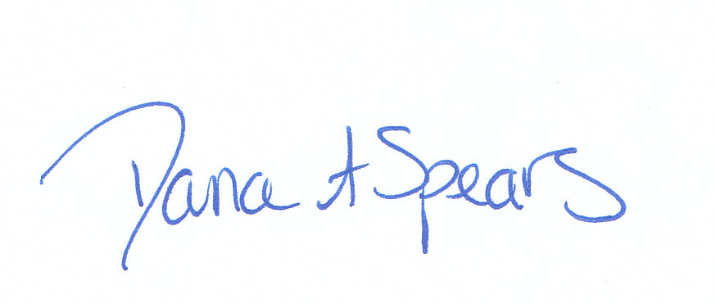 | 8/3/12 |  | 8/3/12
 | 4/30/14 |  | 5/8/14 |  | 5/8/14
 | 4/1/16 |  | 4/1/16 |  | 4/11/16

