AutoCyte PREP System

Preparation of Buffered Water

- MATERIALS NEEDED
- One (1) liter of volumetric flask
- Deionized water
- TRIS Buffered Saline, pH 8.0 (Packet – Sigma, Catalog #T-6664, 10 packs/box)
- Measuring device, 200 ml
- One (1) gallon container

PRECAUTIONS
- Read this procedure carefully. The stock buffer solution must be prepared before the working solution can be made.

PROCEDURE TO MAKE STOCK BUFFER
- Fill the 1 liter flask approximately half full with Deionized water.
- Empty 1 pack of 50 mM TRIS buffered Saline, pH 8.0 into flask and swirl until dissolved.
- Fill flask to the 1 liter mark and seal the flask with parafilm.
- Invert the flask several times to insure complete mixing.
- Label flask with:
- Stock TRIS Buffered Saline, pH 8.0, 50 mM, and
- The date prepared
- Store in refrigerator (2-10°C), this stock solution is stable for one month. Discard after one month.

- PROCEDURE TO MAKE WORKING SOLUTION OF BUFFERED WATER
- Measure 200 ml of Stock buffer and pour into a gallon container.
- Fill the gallon container with Deionized water.
- Cap and invert to mix well.
- Label gallon container
- Buffered PREP water
- Date prepared
- The Working solution of the Buffered PREP Water is stable for two (2) weeks at room temperature (15-30°) and is to be capped when not in use. Discard after two (2) weeks and make fresh solution.
- REFERENCE:
1. AutoCyte PREP System™ Training Manual, 61CR000015, Issue #3.

POLICY CREATION :
Author: James Savoie, CT (ASCP) | June 6, 2001
Medical Director: Devendra Trivedi, MD | June 6, 2001

MEDICAL DIRECTOR
DATE | NAME | SIGNATURE
February 11, 2017 | Elizabeth A. Bauer-Marsh, M.D.
SECTION MEDICAL DIRECTOR
June 6, 2001 | Devendra Trivedi, MD
October 6, 2017 | Katherine Kasper, MD

REVISION HISTORY (began tracking 2011)
Rev | Description of Change | Author | Effective Date
1 | Spelling corrections | S. Cox | 4/1/16

Reviewed by
Lead | Date | Coordinator/Manager | Date | Medical Director | Date
 | 8/3/12 | 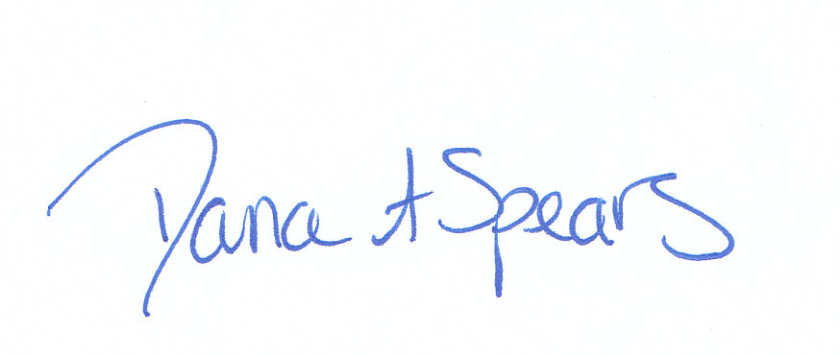 | 8/3/12 |  | 8/3/12
 | 4/30/14 |  | 5/8/14 |  | 5/8/14
 | 4/1/16 |  | 4/1/16 |  | 4/11/16

