Methodist Health Services Corporation & UnityPoint Health Methodist |  | Page # 1 of 2 | Section: UPM CYTO | Policy #: 05
 | Laboratory  CYTOLOGY | Approved by: see signature block and end of policy |  | Date: 4/11/16
 | Laboratory  CYTOLOGY | Date Revised: 8/3/12, 8/18/11, 8/17/10, 9/10/09, 2/10/00, 9/12/97, 1/16/97, 9/11/96, 9/12/95  Date Reviewed: 4/11/16, 5/8/14
 | Laboratory  CYTOLOGY | Policy/Revision Submitted by: Shea N Cox, CT (ASCP)
 | Laboratory  CYTOLOGY | CAP Standard: NA
POLICY GUIDELINE ON: Corrective Actions for Screening Errors in Gynecological Cervico-Vaginal Smears

- POLICY:
This policy covers the corrective actions for screening errors in gynecological cervico-vaginal smears.

- PURPOSE:
- To ensure the highest quality detection rate of gynecological cytology abnormalities possible during routine screening.
- To detect any significant deficiency in screening and interpretation.

- POLICY SCOPE:
The scope of this applies to all staff who review gynecological cervico-vaginal smears.

- PROCEDURE:
- When performing re-screening of negative cervico-vaginal smears, if the pathologist or cytotechnologist detects an abnormality (LGSIL or above), a cytotechnologist qualified for re-screening or a pathologist will re-screen 25% of the batch of that day’s cervico-vaginal smears screened by the cytotechnologist who initially called the case negative. 12.5% of the cases on each side of the originally misdiagnosed smear will be reviewed.
- The misdiagnosed smear, along with the 25% reviewed smears, will be documented.
- The same procedure will apply when re-screening the coordinator’s daily work.
- Any case with an interpretive error by the screening cytologist will be reviewed by pathologist with the cytologist.
- This is an important quality improvement and continuing education step in improving overall patient care at this institution.
- Error rate will be calculated for each cytotechnologist.
- This information will be used in deciding cuytotechnologist’s work load assessment. (See cytotechnologist Workload Assessment Policy.)

V. MAINTENANCE AND STORAGE
  - All policies and procedures are reviewed every two years, (except for Safety procedures which are yearly) by Laboratory Administration and or the Medical Director of the Laboratory or designee.
  - The Laboratory Administration and Medical Director review policies and procedures when there are changes in practice standards, or requirements.
  - All policies and procedures are reviewed every two years (except for Safety procedures which are yearly) by staff or at the time new or revised ones are put in effect.
  - All policies are retained 8 years after being discontinued or revised.
  - All procedures are retained 2 years after being discontinued or revised

POLICY CREATION :
Author: Devendra Trivedi, MD | September 12, 1995
Medical Director: Devendra Trivedi, MD | September 12, 1995

MEDICAL DIRECTOR
DATE | NAME | SIGNATURE
February 11, 2017 | Elizabeth A. Bauer-Marsh, M.D.
SECTION MEDICAL DIRECTOR
September 12, 1995 | Devendra Trivedi, MD
October 7, 2017 | Katherine Kasper, MD

REVISION HISTORY (began tracking 2011)
Rev | Description of Change | Author | Effective Date

Reviewed by
Lead | Date | Coordinator/Manager | Date | Medical Director | Date
 | 8/3/12 | 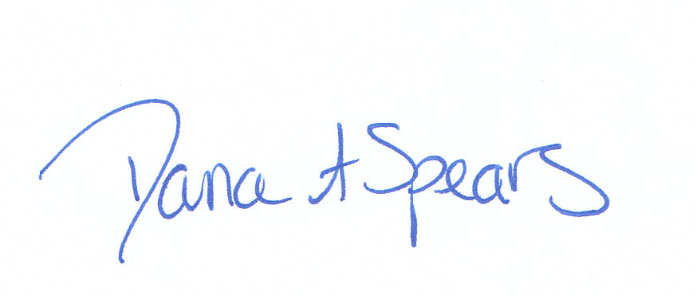 | 8/3/12 |  | 8/3/12
 | 4/30/14 |  | 5/8/14 |  | 5/8/14
 | 4/1/16 |  | 4/1/16 |  | 4/11/16

