  METHODIST |  |  | Page 1 of 3 | Section: UPM CYTO | Policy #: 29
 | CYTOLOGY |  | Approved by: see signature block at end of document |  | Date: 3/1/18  Review by: 3/1/20
 | LABORATORY |  | Policy Created: 10/3/2005  Supersedes:8/3/12, 5/8/14, 3/18/16, 3/1/18
Primary Responsible Parties: Shea Moore
Secondary Responsible Parties: Deb Deeb
 |  |  | CAP Standard: NA
SUBJECT: |  | EVALUATING PAPANICOLAOU STAIN QUALITY

Principle
Optimum staining of cytological samples is critical in arriving at correct cytological diagnosis.

Clinical Significance
Not applicable.

Specimen
Cytological smears stained by Papanicolaou staining procedure.

POLICY SCOPE:
The scope of this applies to any staff associated with the cytology section.

Reagents
Not applicable.

Instrumentation/Equipment
Microscope

Calibration
Not applicable.

Quality Control
This is a quality control procedure.

Procedure
- Observe overall staining quality during screening.
  - For gyn, select a well-fixed smear with both squamous and glandular cells and a few neutrophils present.
- For non-gyn, select a cellular non-gynecologic smear or cytocentrifuged slide.Evaluate the cytoplasmic stain by the following microscopic standards:
  - STANDARDS FOR EA-65
  - Pinks and greens in superficial and intermediate squamous cells are pure and brilliant.
  - Glandular cells stain a pale green or blue-green hue that contrasts well with the nucleus.
  - The cytoplasm of each cell type is transparent including the dense cytoplasm of parabasal and metaplastic squamous cells. Nuclei and the edges of overlapping cells are distinctly visible through the cytoplasm.
  - STANDARDS FOR ORANGE-G STAIN
  - The orange stain is not noticeable in normal smears beyond a slight orange/yellow tint in the cytoplasm of some superficial squames.
  - Fully keratinized squamous cells, when present, stain a pure, brilliant orange.
3. Evaluate the nuclear stain:
a. STANDARDS FOR HEMATOXYLIN STAIN
    - Nuclei stain blue to deep purple.
    - Nuclei have sharp, crisp contour, and contrast well with the cytoplasm.
    - X-chromatin bodies are clearly visible with sharp contours.
    - Parachromatin is lightly tinted in normal, vesicular nuclei.
    - Threads between nuclear segments in a flattened neutrophil are visible.
4. The cytology coordinator will record findings on the "QC Techinal Review" sheets for both Non-GYN and GYN Specimens each day for each staining set up and make sure to document problems and solutions for future reference.
a. Refer to Pap Stain Trouble-Shooting Chart for help when problems occur.

Calculations
Not applicable.

Reporting Results
Not applicable.

References
- Keebler, C.M., et al, Compendium on Cytopreparatory Techniques, 6th Edition, Chicago: Tutorials of Cytology, 1990.
- Keebler, C.M., et al, Manual of Cytotechnology, 1993

POLICY CREATION :
Author: Terry Weisenberger, CT (ASCP) | January 15, 1997
Medical Director: Devendra Trivedi, MD | January 15, 1997

MEDICAL DIRECTOR
DATE | NAME | SIGNATURE
February 11, 2017 | Elizabeth A. Bauer-Marsh, M.D.
SECTION MEDICAL DIRECTOR
January 15, 1997 | Devendra Trivedi, MD
October 6, 2017 | Katherine Kasper, MD

REVISION HISTORY (began tracking 2011)
Rev | Description of Change | Author | Effective Date
1 | Change name of review sheets | S. Cox | 8/14/12
2 | Add QC technical review sheets, change non-gyn review of slides procedure | S. Moore | 2/27/18

Reviewed by
Lead | Date | Coordinator/Manager | Date | Medical Director | Date
 | 8/3/12 | 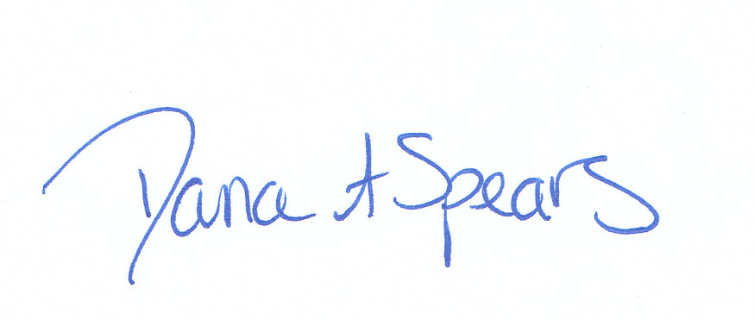 | 8/3/12 |  | 8/3/12
 | 4/30/14 |  | 5/8/14 |  | 5/8/14
 | 3/10/16 |  | 3/11/16 |  | 3/18/16
Shea Moore, CT (ASCP) | 2/27/18 |  | 3/13/18 |  | 3/1/18

