  METHODIST |  |  | Page 1 of 3 | Section: UPM CYTO | Policy #: 29
 | CYTOLOGY |  | Approved by: see signature block at end of document |  | Date: 3/1/18  Review by: 3/1/20
 | LABORATORY |  | Policy Created: 10/3/2005  Supersedes:8/3/12, 5/8/14, 3/18/16, 3/1/18
Primary Responsible Parties: Shea Moore
Secondary Responsible Parties: Deb Deeb
 |  |  | CAP Standard: NA
SUBJECT: |  | CYTOLOGY REPORTS IN POWER PATH BY PATHOLOGIST

PRINCIPLE
Pathologists responsible for signout of the cytology case must review and approve the completed cytology report before it is released by placing an electronic signature in the Laboratory Information System – Power Path.

PURPOSE
To ensure accuracy of cytology reports, including required elements.

POLICY SCOPE:
The scope of this applies to any staff associated with the cytology section.

GENERAL INFORMATION
This procedure ensures that a responsible pathologist has reviewed and approved the completed cytology report before its release to the submitting clinician.

PROCEDURE
- Cytologic cases including the slides and corresponding requisition forms are delivered to pathologists for examination and generating of a cytopathology report. These cases are brought to the pathologists by Cytology staff.
- The specimen accession number and patient’s information is confirmed by the pathologist prior to examination of the specimen to prevent errors in patient identification.
- The case in question is brought up on the computer screen of the Laboratory Information System – Power Path by entering appropriate information (i.e. specimen accession number). The patient identification/demographic information and specimen information on the computer screen must match the case under examination.
- The specimen is examined by the pathologist and appropriate diagnostic report elements are selected and entered. The selected fields for completion of cytology reports include information on interpretation/diagnosis and specimen adequacy. Other fields may require comments on: inflammation, recommendation, or additional comments.
- Now the case is ready for final verification and electronic signature. At this point it is encouraged that all pertinent information is visually verified and the report is electronically verified by the pathologist.

COMMENTS
The cytology slides of the cases are separated by a blank space on the slide folders to prevent verification of wrong cases.

POLICY CREATION :
Author: Terry Weisenberger, CT (ASCP) | October 3, 2005
Medical Director: Devendra Trivedi, MD | October 3, 2005

MEDICAL DIRECTOR
DATE | NAME | SIGNATURE
February 11, 2017 | Elizabeth A. Bauer-Marsh, M.D.
SECTION MEDICAL DIRECTOR
October 3, 2005 | Devendra Trivedi, MD
October 6, 2017 | Katherine Kasper, MD

REVISION HISTORY (began tracking 2011)
Rev | Description of Change | Author | Effective Date
1 | Grammatical errors fixed, deleted comment about pathologists initializing slides to reflect current practice | S. Moore | 2/26/18

Reviewed by
Lead | Date | Coordinator/Manager | Date | Medical Director | Date
 | 8/3/12 | 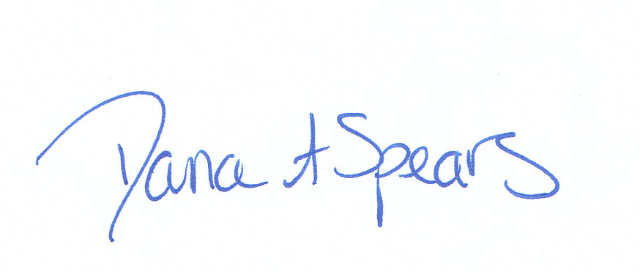 | 8/3/12 |  | 8/3/12
 | 4/30/14 |  | 5/8/14 |  | 5/8/14
 | 3/10/16 |  | 3/11/16 |  | 3/18/16
Shea Moore, CT (ASCP) | 2/26/18 |  | 3/13/18 |  | 3/1/18

