  METHODIST |  |  | Page # 1 of 2 | Section: UPM CP | Policy #: 07.010
 | CELL PROCESSING |  | Approved by: see signature block at end of document |  | Date: 3/22/18  Review by: 3/22/20
 | LABORATORY |  | Policy Created: 6/11/99  Supersedes 6/19/12, 6/26/12, 4/11/14, 7/11/16, 3/22/15
Primary Responsible Parties: Deb Rinne, CLS
Secondary Responsible Parties: June Bembenek
 |  |  | CAP Standard: NA
SUBJECT: |  | HEMATOPOIETIC PROGENITOR CELL MICROBIAL CULTURES

- POLICY:

A post processing specimen is sent to Microbiology by cell processing laboratory personnel for a microbial culture. Positive results are monitored by Microbiology and reported immediately to Cell Processing Laboratory personnel.

- PURPOSE:

To help assure a safe product for infusion by identifying any process that needs a more sterile procedure.

- POLICY SCOPE

The scope of this policy applies to all Laboratory staff that prepares or performs testing on laboratory specimens at UnityPoint Methodist.

- GENERAL INFORMATION:
Hematopoietic progenitor cell products are automatically placed into quarantine storage until infectious disease tests are resulted as nonreactive and microbial cultures are resulted as no growth. “Release date”/”approved by” are indicated on the patient freezer summary sheet at the front of the patient file.

- PROCEDURE:

- In the event of a post processing microbial culture showing positive results, a second microbial culture is repeated on the frozen aliquot stored in unit IV for the corresponding day.
- Order in computer as “REPEAT HPC # _______ POST PROCESSING”.
- Initiate a “Results of Microbial Cultures on HPC Product and Release Form for Positives” form (CP:042) for hematopoietic progenitor cell products.
- Any subsequent positives for the same patient will be recorded on the same form.

- If the second culture is positive, Microbiology informs Cell Processing Lab personnel that same day.
The Clinical Transplant coordinator is notified by Cell Processing, who in turn notifies the transplant physician. Documentation takes place on the “Results of Microbial Cultures” form (CP: 042) form.
- Microbiology will perform susceptibility testing.
- Product will remain in quarantine status as noted on the patient freezer summary sheet in the patient file.
- Await instructions on what to do with the product and note on CP: 042 form and on summary sheet in patients file the culture results and physician decision. The clinical transplant coordinator or the transplant physician will notify the recipient prior to infusion, follow-up with the recipient, and perform an outcome analysis if the product is infused.
- The cell processing lab director will instruct whether or not to file a Biological Product Deviation (BPD) with the Food and Drug Administration if product is to be infused.
- If the second aliquot culture is negative, the physician need not be phoned because the product is not contaminated

Post Repeat on
Processing Frozen Aliquot Probable Explanation Conclusion Follow-up
POS | NEG | LAB OR MICRO  CONTAMINATED 1st  ALIQUOT | PRODUCT UNCONTAMINATED-  NO SUSCEPTIBILITY  PERFORMED | Question those involved with processing and culturing
POS | POS | PATIENT LINE INFECTED?  OR LAB CONTAMINATED PRODUCT OR MICRO CONTAMINATED ALIQUOTS | PRODUCT QUESTIONABLE- SUSCEPTIBILITY PERFORMED | Question those involved with collection, processing and culturing
NEG | N/A | N/A | PRODUCT UNCONTAMINATED | N/A

- If both cultures are positive ( whether or not the patient’s peripheral / line draw blood cultures are positive), product labeling stating this cannot be accomplished due to the frozen nature of the product. Instead, the Patient Summary sheet (CP:033) at the front of the patient’s file details which product(s) have positive microbial cultures and the Results of Microbial Cultures on HPC Product and Release Form for Positives (CP:042) is attached to the positive product(s) upon distribution if product is infused.

- REFERENCES:
FACT-JACIE International Standards for Cellular Therapy Product Collection, Processing and Administration, Fourth Edition, October 2008

POLICY CREATION :
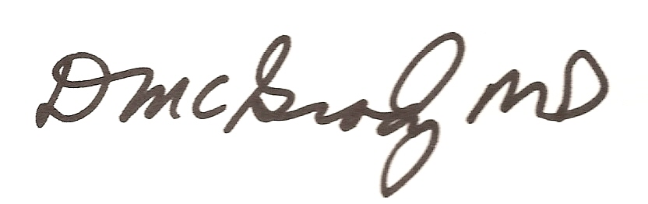  Author: Deb Rinne, CLS | June 9, 1999
Medical Director: Douglas McGrady, MD | June 9, 1999

MEDICAL DIRECTOR
DATE | NAME | SIGNATURE
March 4, 2017 | Elizabeth A. Bauer-Marsh, M.D.
SECTION MEDICAL DIRECTOR
May 10, 2016 | Julia Adams, M.D.

REVISION HISTORY
Rev | Description of Change | Author | Effective Date
0.09 | Title of form CP:042 changed | DRinne | 6/19/12
0.10 | Addition of General Information and product quarantine status outlined in step IV.2.b. | D. Rinne | 09/5/12
0.20 | Clarified when to file BPD. Added new medical director. | Deb Rinne | 3/3/16
0.3 | Added form # and updated title of CP:042. | Deb Rinne | 3/13/18

REVIEWED BY
Lead | Date | Coordinator/Manager | Date | Medical Director | Date
D. Rinne | 9/24/12 |  | 9/24/12 |  | 10/1/12
D. Rinne | 4/11/14 |  | 4/11/14 |  | 4/11/14
D. Rinne | 4/11/14 |  | 6/1/16 |  | 7/11/16
Deb Rinne | 3/13/18 |  | 3/21/18 |  | 3/22/18

