  METHODIST |  |  | Page 1 of 3 | Section: UPM CP | Policy #: 016:05
 | CELL PROCESSING |  | Approved by: see signature block at end of document |  | Date: 3/22/18  Review by: 3/22/20
 | LABORATORY |  | Policy Created: 6/9/99  Supersedes 4/10, 6/12, 3/14, 7/11/16, 3/22/18
Primary Responsible Parties: Deb Rinne, CLS
Secondary Responsible Parties: June Bembenek
 |  |  | CAP Standard: NA
SUBJECT: |  | RECORDS

- POLICY:
Careful records are kept concerning all aspects of hematopoietic progenitor cell processing and related matters.

- PURPOSE:
To define record requirements for the Cell Processing Laboratory.

- POLICY SCOPE
The scope of this policy applies to all Laboratory staff that prepares or performs testing on laboratory specimens at UnityPoint Methodist.

- GENERAL INFORMATION:
- All records and communications among the collection, processing, and transplant areas and their patients shall be regarded as privileged and confidential. General Administration Policy D-2.4 “Use and Disclosure of Protected Health Information” and General Laboratory Policy #4 “Release of Laboratory Information to the Patient” incorporate applicable governmental laws and regulations which are to be followed.

- Patient files containing all information pertaining to harvesting, processing, testing, cryopreservation, storage and infusion or disposal of each product are in locked file cabinets kept in the Cell Processing Laboratory.

- Patient file information, which shall be legible and indelible, includes each step of the processing, testing, cryopreservation, storage, and infusion or disposal of each product so as to be accurately traced.

- Patient file checklist, daily checklist, processing report, and freezer summary sheet / infusion form require initials of the person performing each step. Collection area’s nursing notes contain collector’s signature. Dates (and times where appropriate) are recorded on all these sheets.

- Blank forms are kept in the bottom drawer of the file cabinet along with all other paper work not contained inpatient files.

- Any error correction on completed forms should have a single line drawn through the incorrect information, the initials of person correcting, and the date next to the incorrect information, and the correction written as close by as possible.

- If forms are modified, any changes will be read by all personnel, signed on a cover sheet, and filed in the new Policy/Procedure file.
- The person responsible for any changes made will distribute the material, make sure all personnel have read it and signed the cover sheet, and if appropriate, given their own copy.
- Any training deemed necessary will be documented on the signed cover sheet.

- Passwords to the laboratory computer system are confidential, so laboratory results can be viewed by laboratory employees only.

- It is a breach of hospital confidentiality to access any patient records unless required by the job.

- PROCEDURE: Not Applicable

- REFERENCES:
- FACT-JACIE International Standards for Cellular Therapy Product Collection, Processing and Administration, Fourth Edition, October 2008

MEDICAL DIRECTOR
DATE | NAME | SIGNATURE
March 4, 2017 | Elizabeth A. Bauer-Marsh, M.D.
SECTION MEDICAL DIRECTOR
May 13, 2016 | Julia Adams, M.D.

REVISION HISTORY (began tracking 2011)
Rev | Description of Change | Author | Effective Date
1 | Changed frequency of backup records | Deb Rinne | 3/19/14
2 | Added subject line and new medical director | Deb Rinne | 2/23/16
3 | Removed document control update and record backup. | Deb Rinne | 3/8/18

Reviewed by
Lead | Date | Coordinator/Manager | Date | Medical Director | Date
 |  |  |  | 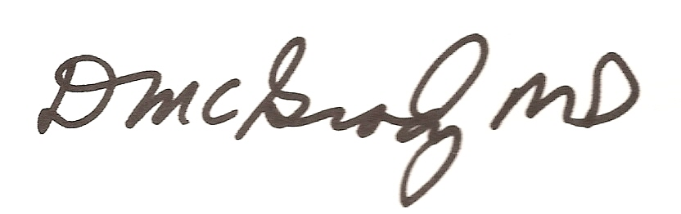 | 6/1/12
 |  |  | 3/19/14 |  | 3/19/14
D. Rinne | 2/23/16 |  | 6/3/16 |  | 7/11/16
Deb Rinne | 3/8/18 |  | 3/21/18 |  | 3/22/18

