  METHODIST |  |  | Page 1 of 7 | Section: UPM MICRO | Policy #: 03.024
 | MICROBIOLOGY |  | Approved by: see signature block at end of document |  | Date: 3/30/18  Review by: 3/30/20
 | LABORATORY |  | Supersedes: 9/9/1996  Date Revised: 6/9/11, 5/5/12, 6/13/12, 4/22/14, 2/2/16, 5/13/16, 6/21/17
Primary Responsible Parties: Marsha Bishoff
Secondary Responsible Parties: Audrey Davis
 |  |  | CAP Standard:
SUBJECT: |  | SURFACE WOUND AND NON-STERILE ABCESS CULTURE

PRINCIPLE
Wound infections and abscesses occur due to an interruption in a mucosal or skin surface. The nature of the infecting microorganisms will depend on the underlying problem and the location of the process. The knowledge of the indigenous microbiota of an area or the way in which this microbiota may be modified by disease or antimicrobial agents, and of the environmental flora permits one to make an educated guess as to the likely etiologic agents.

The clinician also uses this information along with the direct Gram stain information to choose the empirical therapy prior to availability of microbiologic data.

Organisms commonly infecting surface wounds include: S. aureus, S. pyogenes, E. coli, Proteus, Morganella, Providencia, other Enterobacteriaceae, Pseudomonas sp, and Enterococci.

Vascular and neurologic infections which occur commonly on the extremities of diabetics result in the formation of ulcers. The infections often involve S. aureus, S. pyogenes, and S. agalactiae. Those with open ulcers may become colonized with members of the Enterobacteriaceae and Pseudomonas aeruginosa. The poor blood supply which occurs in these infections also encourages the growth of anaerobes. Decubiti are ulcers that occur in bedridden patients and are also referred to as pressure sores. Because most of these are located in proximity to the anus, the ulcers are generally contaminated with fecal microbiota, which leads to chronic infections.

With all of these infections, the collection is very critical since these specimens can be easily contaminated with normal skin and mucosal microbiota or colonizing organisms making interpretation of the culture more difficult. The Gram stain is critical with these specimens since it can guide the physician in using appropriate empirical therapy as well as the technologist in the work up of the wound culture. White blood cells seen on the Gram-stain indicate infection and should signify working up pathogenic bacteria cultured. Epithelial cells seen on Gram-stain can indicate contamination of the culture with skin and mucosal microbiota.

CLINICAL SIGNIFICANCE
Wound cultures aid in the diagnosis of infection of the skin and deeper tissues.

POLICY SCOPE:
The scope of this policy applies to all Laboratory staff that prepares or performs testing on laboratory specimens at UnityPoint Methodist

SPECIMEN
Bio-Safety Level 2 – Specimens are processed within a biological safety cabinet.
- Refer to procedure Specimen Collection and Transport and Initial Processing, Inoculation, and Incubation of Bacteriology Specimens

REAGENTS
- Refer to procedure Initial Processing, Inoculation, and Incubation of Bacteriology Specimens
- Refer to the reagent section of specific tests being performed on positive cultures or suspected isolates.

INSTRUMENTATION/EQUIPMENT
CO₂ Incubator 35°C

QUALITY CONTROL
All media and reagents are quality controlled by the manufacturer and by lot # or shipment when received in our laboratory. (exception: exempt media)
See QC procedure for additional detail

PROCEDURE
- Plates are incubated for 18-24 hours prior to observing for growth.
- Surface wounds are held aerobically for 2 days.
- Gram stain results (bacterial morphotypes and cells -inflammatory and squamous epithelial) should be used to guide the work up of the specimens
- Isolates of cultures which are polymicrobic are not completely identified or tested for susceptibility to antimicrobials. (see reporting section)
- Positive cultures are reported as found.
- Pure or predominant isolates are identified and tested for susceptibility to antimicrobials.

REPORTING RESULTS
- Utilize the direct Gram-stain
  - If there are WBCs and the specimen collection looks like good quality (few or no epithelial cells) work up to three pathogenic bacteria (refer to table) isolated, including susceptibility testing.
  - If anything is in pure culture and WBCs are seen on Gram-stain, please ID and set up for suscept if CLSI guidelines are present
- If more than three pathogenic organisms are present, use the phrase Polymicrobic culture (PMC), but still identify:
  - Staph aureus/MRSA
  - Beta-hemolytic strep A, B, C, F, or G
  - VRE
  - Pseudomonas
  - Anything that grows on chocolate but not blood (eg Francisella in a wound). If any of these are identified in a PMC, please isolate out and hold for susceptibility requests
  - If any pathogen is predominant in a polymicrobic culture, work it up.
- Polymicrobic culture should be used when there are multiple bacteria that makes the collection look like a contaminated specimen or potentially a colonized wound. Do not dig for skin flora to make a culture PMC so you do not work up the potential true pathogens
- Ex/ if you have a moderate growth Gram-negative and light growth CoNS, PYR negative alpha-strep, and diptheroids, you should still work up the GNR. You can report: mixed skin microbiota with GNR identification and suscept.
- Ex/ If you have two GNR, a Staph aureus, Enterococcus, and skin microbiota – you can report out PMC, make sure MRSA/VRE/Pseudo are ruled out and report those appropriately as mentioned above
- Approach to other organisms:

Organism | Report | Exception
Coagulase Negative Staph | If mixed with PMC, report as PMC, do not call out CoNS  If only skin flora is present, can also say “mixed bacteria suggestive of normal skin microbiota”  If identified with other pathogenic bacteria but not PMC or skin microbiota can report: CoNS, suggestive of normal skin microbiota | If isolated from multiple cultures from same patient, present in pure culture, or seen on Gram-stain with WBCS ID and suscept
Viridans Strep | Rule out enterococcus with PYR, if PYR is negative can call alpha strep; if PMC report out PMC, do not call out alpha strep  If only skin flora is present, can also say “mixed bacteria suggestive of normal skin microbiota” | If isolated from multiple cultures from same patient, present in pure culture, or seen on Gram-stain with WBCS ID and susceptibility; if unable to grow for susceptibility, can use phrase “fastidious organism, unable to grow for susceptibility testing”
Gram-Positive Rods (diptheroids, Actinomycete, Arcanobacterium, anything other than Bacillus) | If PMC, do not work up the GPR, report PMC, do not call out GPR  If only skin flora is present, and the GPR is a diptheroids, can also say “mixed bacteria suggestive of normal skin microbiota” | If isolated from multiple cultures from same patient, present in pure culture, or seen on Gram stain with WBCs perform a catalase, if positive, report out diptheroids and hold for full ID and suscept if requested  If catalase negative, full ID (OSF MALDI). If a suscept is requested consult with pathologist on CLSI guidelines prior to sending
Gram-Positive Rods, Bacillus species | If mixed with PMC, report out PMC  If only skin flora is present, can also say “mixed bacteria suggestive of normal skin microbiota” | If isolated from multiple cultures from same patient, present in pure culture, please rule out B. anthracis (non-hemolytic, non-motile); if it is hemolytic no further work up needed, report Bacillus species  If it is non-hemolytic, perform a motility test – if that is negative, send to state to r/o B. anthracis; if motility test is positive, report Bacillus species
Yeast | Germ tube for quick ID, make sure no large round yeast (Cryptococcus) If a candida species and mixed in PMC, report as PMC including Candida species (can say albicans or non-albicans based on germ-tube)  If only skin flora is present, can also say “mixed bacteria suggestive of normal skin microbiota, including Candida species (albicans or non-albicans based on germ-tube)” | If isolated from multiple cultures from same patient, present in pure culture, and/or seen on Gram-stain, ID non-albicans with API20C and hold for suscept if requested.
Gram-negative rods including Pseudomonas, Alcaligenes, and Enterobacter. | ID and report up to three | If more than three GNR, with no predominant organism, report as PMC; if more than three GNR in a PMC and one predominant GNR with no other pathogenic bacteria (eg S. aureus, strep, pseudo), ID and suscept on the predominant GNR
Other GNR  (Aeromonas, Pasteurella, Francisella, Acinetobacter, etc) | Some clues to “other” GNR: oxidase positive, no or weak growth on MacConkey | Always ID and suscept for any “other” GNR

- Preliminary culture reports are turned out at 24 hours. No growth cultures reports are finalized at 48 hours.
- Reports of positive cultures are issued as information is updated.
- Susceptibilities are reported as completed.

The following table is a guideline for normal skin microbiota and potential pathogens. Even though we consider normal skin microbiota less likely to be pathogenic, there is always a chance it can become pathogenic depending on the patient’s immune status and wound history.

Normal Skin Microbiota | Common Surface Wound Pathogens
Alpha-hemolytic Streptococci (mucosa) | Staphylococcus aureus
Bacillus species | Beta-hemolytic Streptococci
Coagulase Negative Staphylococci | VRE
Corynebacterium | Oxidase Positive Gram-negative bacilli (Pseudomonas, Aeromonas, Pasteurella)
Micrococcus | Enteric Gram-negative rods (can also colonize chronic wounds, not infectious at that point)
Propionibacterium
Yeast

REFERENCES

- Leber AL. Clinical Microbiology Procedures Handbook, Fourth Edition. AMS 2016
- Stevens DL, et al. Practice Guidelines for Diagnosis and Management of Skin and Soft Tissue Infections 2014 Update by IDSA. Clin Infect Dis. 2014
- Versalovic J, Editor. Manual of Clinical Microbiology. 10th Edition. ASM Press. 2011.

POLICY CREATION :
Author: Terry A. Smith - Lab Manager | September 9, 1996
Medical Director: Douglas McGrady, M.D. | September 9, 1996

MEDICAL DIRECTOR
DATE | NAME | SIGNATURE
February 12, 2017 | Elizabeth A. Bauer-Marsh, M.D.
SECTION MEDICAL DIRECTOR
August 24, 2015 | Lori Racsa, DO

REVISION HISTORY (began tracking 2011)
Rev | Description of Change | Author | Effective Date
1 | Updated reference minor changes | T Smith | 6/2/11
2 | Changes related to CAP 2012 guidelines | T Smith | 6/13/12
3 | Removed HLAB order number | T Nuese | 2/2/16
4 | Updated PMC procedure and length of time culture should be held | T Nuese | 5/9/16
5 | Changed Title to Surface Wound Culture from Wound Culture | T Nuese | 6/21/17
6 | Updated reporting results. Added hemolytic strep groups to pathogens. Updated tables. Added “Non-sterile Abcess” to title. | A. Davis | 3/27/18

Reviewed by
Lead | Date | Coordinator/Manager | Date | Medical Director | Date
 |  | 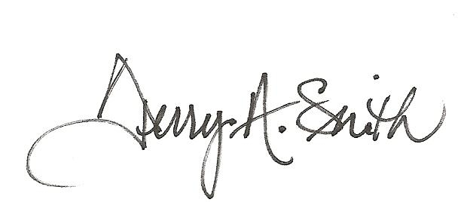 | 6/2/11 | 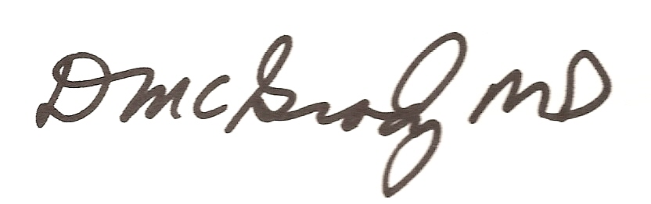 | 6/9/11
 |  |  | 4/23/12 |  | 5/5/12
 |  |  | 6/13/12 |  | 6/13/12
E Penning | 4/9/14 | 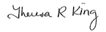 | 4/16/14 |  | 4/22/14
 |  |  | 2/1/16 |  | 2/2/16
 |  |  | 5/9/16 |  | 5/13/16
 |  |  | 6/21/17 |  | 6/21/17
Marsha Bishoff | 4/5/18 |  | 4/1/18 |  | 3/30/18

