Methodist Health Service Corporation & UnityPoint Health Methodist |  | Page # 1 of |  | 2 | Section: | UPM MIC | Policy #: | 007.3
 | Laboratory | Approved by: |  | see signature block at end of document |  |  | Last Reviewed: | 3/8/2018
 | 7000 | Date Revised: |  | 2/1/14, 8/6/04; 6/9/06; 6/17/08; 3/8/2018
 |  | Date Reviewed
 |  | JCAHO Standard:
POLICY GUIDELINE ON:

  METHODIST |  |  | Page 1 of 4 | Section: UPM MICRO | Policy #: 07.003
 | MICROBIOLOGY |  | Approved by: see signature block at end of document |  | Date: 03/21/18  Review by: 03/21/20
 | LABORATORY |  | Supersedes: 6/23/16  Date Revised: 5/23/11, 5/5/12, 4/22/14, 9/5/14, 2/4/16, 6/23/16, 2/14/18
Primary Responsible Parties: Marsha Bishoff
Secondary Responsible Parties: Audrey Davis
 |  |  | CAP Standard: NA
SUBJECT: |  | INTERNAL/EXTERNAL PROFICIENCY TESTING IN THE MICROBIOLOGY LABORATORY

- POLICY
All Microbiology personnel should follow this policy when performing proficiency testing

- PURPOSE:
The purpose of this policy is to give the technologist in Microbiology a guideline to follow when performing proficiency surveys.

- POLICY SCOPE:
The scope of this policy applies to all Laboratory staff that prepares or performs testing on laboratory specimens at UnityPoint Methodist.

- GENERAL INFORMATION:
- The Microbiology laboratory participates in proficiency testing as outlined in the CLIA standards, these proficiencies must be treated the same as patient specimens. Testing that is not performed on patient samples should not be performed on the proficiency samples.
- Interlaboratory communication about proficiency testing samples is prohibited until after the deadline for submission of data to the proficiency provider.
- Referral of proficiency testing to another laboratory for testing is prohibited.

- PROCEDURE:
- Original survey paperwork and survey materials are delivered to the Microbiology laboratory.
- The Point of Care Coordinator will complete the appropriate documentation of receipt , make copies of the survey paperwork, file the original paperwork and distribute the survey samples to testing personnel.
- If the Point of Care Coordinator is not present, a designee will deliver the survey and complete the appropriate paper work for receipt, place the paperwork in the Microbiology Technical Coordinator’s mailbox and give the survey materials to the lead technologist or staff technologist in Microbiology for appropriate storage. The Point of Care Coordinator will take care of paperwork when they return.
- The number of days or weeks given to complete the survey is contained in the paperwork with each individual survey. The actual date it is due is written on the top of the survey copy as a reminder to the technologist working on the survey.
- The surveys are rotated amongst the technologist fairly and evenly. Each technologist should be given the chance to maintain their competency in each area they work.
- Specimens are reconstituted and plated or examined as outlined in the instructions contained in the survey. Survey samples can be ordered in SunQuest and work performed and recorded as with patients specimens.
- All samples are treated as patients. Only testing that is performed on equivalent patient samples should be performed on the survey specimen. Specimen identifications are to the same extent as patient samples. Each technologist should work independently.
- As technologists complete their identifications, they should record their results on the copies posted in the section.
- Prior to the due date, at least one day, the results posted by the technologist are transferred to the original copy by the performing technologist. All personnel who worked on the survey must sign the original copy.
- Prior to submitting the original copy of the survey, the Coordinator and lead technologist review the results for clerical errors. The Section Medical Director signs the form once completed.
- The original completed paperwork is submitted on or before the due date. (Results are submitted online, copies of the submitted work are kept for records.)
- Original specimens or isolates should be kept viable until results of the survey are received. If unacceptable results are received, these samples are used to re-evaluate the survey specimen missed. This re-evaluation is fully documented.
- Once the final critique is received, these are routed to the section Lead, Coordinator and Medical Director. .
- Once the original completed survey is routed and signed, it is filed.

- MAINTENANCE AND STORAGE
  - All policies and procedures are reviewed every two years, (except for Safety procedures which are yearly) by Laboratory Administration and or the Medical Director of the Laboratory or designee. There are changes in practice standards, or requirements.
  - All policies and procedures are reviewed every two years (except for Safety procedures which are yearly) by staff or at the time new or revised ones are put in effect.
  - All policies are retained 8 years after being discontinued or revised.
  - All procedures are retained 2 years after being discontinued or revised

96

POLICY CREATION :
Author: Terry Smith, Laboratory Manager | September 11, 1996
Medical Director: Douglas McGrady | September 11, 1996

MEDICAL DIRECTOR
DATE | NAME | SIGNATURE
February 12, 2017 | Elizabeth A. Bauer-Marsh, M.D.
SECTION MEDICAL DIRECTOR
March 10, 2015 | Lori Racsa, DO

REVISION HISTORY
Rev | Description of Change | Author | Effective Date
1 | Changes to survey suggestions | T. Smith | 5/4/11
2 | Title change to include Internal | T. Smith | 2/17/12
3 | Formally indexed: Microbiology 18 | L. Rasca | 9/30/15
4 | Updated employee titles. Removed HLAB, added Sunquest. Updated to current processes. | A. Davis | 3/8/18

REVIEWED BY
Lead | Date | Coordinator/Manager | Date | Medical Director | Date
 |  | 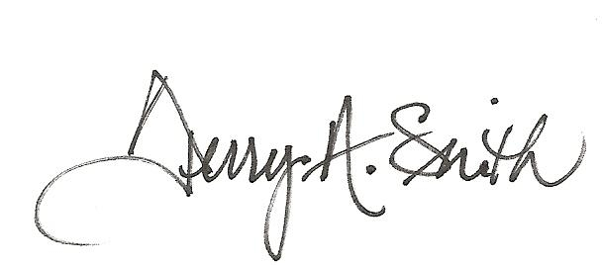 | 5/23/11 | 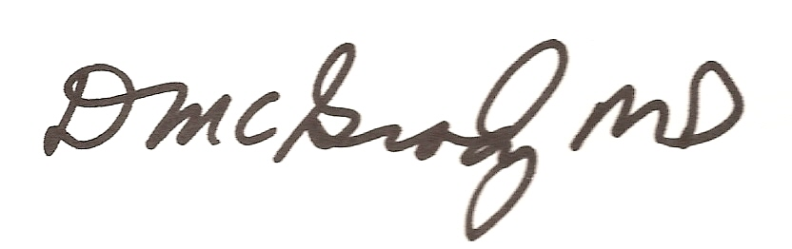 | 5/23/11
 |  |  | 4/23/12 |  | 5/5/12
 |  | 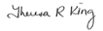 | 4/16/14 |  | 4/22/14
 |  |  | 9/5/14 |  | 9/5/14
 |  |  | 2/3/16 |  | 2/4/16
Amy Mayes | 2/12/16 |  | 6/23/16 |  | 6/23/16
Amy Mayes | 1/26/18 |  | 2/10/18 |  | 2/14/18
Marsha Bishoff | 2/8/18 |  | 3/21/18 |  | 3/23/18

