**Blood Bank Reminders Effective immediately:**

* **ONLY 1 PATIENT SPECIMEN PER RACK**
* Reprint patient LIS labels x 2
* 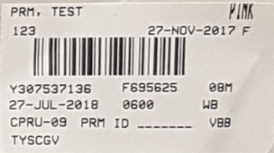Label primary pink top tube and cell

suspension with patient’s large

barcoded label

* Label typing tubes, at a minimum, with the patient’s initials in addition to the reagent name abbreviation – A, B, D

(name and DOB/ labels can also be used)

* 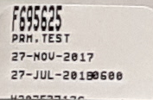Label gel card with patient name and date

of birth – small detail label can be used

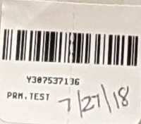If this label is used, date of birth

must be written on the label