  METHODIST |  |  | Page 1 of 5 | Section: UPM BBPRO | Policy #: 02.030
 | BLOOD BANK PROCEDURES |  | Approved by: see signature block at end of document |  | Date: 7/27/18  Review by: 7/27/20
 | LABORATORY |  | Policy Created: 7/6/03  Supersedes 12/29/11, 6/10/14, 7/21/16, 7/27/18
Primary Responsible Parties: Leah Miller
Secondary Responsible Parties: June Bembenek
 |  |  | CAP Standard: NA
SUBJECT: |  | PREWARM ANTIBODY DETECTION, GEL METHOD

PRINCIPLE
The antibody detection or screening test is an indirect antiglobulin test used to detect unexpected blood group antibodies. In the anti-IgG gel card method for this test, reagent red blood cells in a hypotonic buffered saline solution are combined with the serum or plasma sample to be tested. Incubation of these reactants at 37ºC in the upper chamber of the gel card microtube promotes antigen-antibody interaction. Detection of antibody occurs when sensitized red blood cells react with the anti-IgG gel in the microtube during centrifugation. A modification of this technique, referred to as prewarming, can be employed to diminish or eliminate the reactivity of unwanted cold-reactive antibodies, while maintaining sensitivity for clinically significant, warm-reactive antibodies.

SCOPE:
This policy applies to all blood bank technologists.

SPECIMEN
Patient Preparation:
No special preparation of the patient is required prior to specimen collection. Blood should be collected by approved techniques.

Note for Antibody Screens and/or Compatibility Testing:
If patient has been transfused with blood or blood component(s) containing red cells, or has been pregnant within the preceding three months, or if transfusion history is unknown or uncertain, the specimen must be drawn within three days of transfusion. Otherwise, the specimen can be drawn within seven days of transfusion.

Requirements:
K₂ EDTA pink or lavender top tube is preferred.

Minimum Volume:
- Adult: 3.0 mL whole blood
- Pediatric: 2 - K₂ EDTA microtainers (each with 300-500 uL) or cord blood

Specimen Stability:
If stored at room temperature 15-30°C, stable for testing 24 hours.
If stored 2-8°C, stable for testing for 72 hours.

Storage:
2-8°C for a minimum of 7 days after transfusion, or 10 days post crossmatch.

BEFORE ACCEPTING A TYPE AND SCREEN SPECIMEN, the technologist should visually verify that enough plasma would be left in the tube, after performing the T&S, to crossmatch approximately 12 units of blood. This will avoid another sample having to be drawn and repeating testing during an emergency.

Rejection Criteria:
Hemolysis: **In rare occasions where a specimen cannot be redrawn, hemolyzed specimens may be used for testing as long as the testing personnel can accurately interpret the reactions.

REAGENTS
Reagent | Storage | Stability
Selectogen I and II Reagent Red Blood Cells, OrthoClinical, 0.8% ready to use | 2-8°C | Exp date
Biotestcell 1&2, Reagent Red Blood Cells, BIO-RAD to be converted if needed. | 2-8°C | Exp date
MTS Anti-IgG Gel Card | 2-25°C | Exp. date
MTS Diluent 2 | 2-8°C | Exp. date
- Bring reagents to room temperature (18 to 25°C) prior to use.

QUALITY CONTROL
To recognize reagent deterioration, the reagents must be tested daily with appropriate controls:

MTS Diluent 2™: Visually check to verify that the liquid is not discolored, turbid or showing any signs of bacterial contamination.

Procedure for Quality Control for Diluent (perform once each day of testing)
- Pipette 50uL of one of the cell suspensions being used for crossmatch into the diluent QC wells, both positive and negative.
- To the positive well add 25 uL of Immucor QC antisera.
- To the negative well add 25 uL of saline.
- Test as per Crossmatch procedure, document results in LIS QC program.
- MTS Anti-IgG Card: To confirm the specificity and reactivity of the gel card, it is recommended that each lot be tested on each day of use with known positive and negative antibody samples with the appropriate red cells. Reactivity must be present with the positive sample only. Visually check gel cards: do not use if the liquid level in the microtube is at or below the top of the gel matrix, or if drying, bubbles, crystals, and/or artifacts are seen.

PROCEDURE
- Label the MTS Anti-IgG Card with the patient’s last name, first initial, date of birth and test information.
- Remove the foil from the microtubes to be used.
- Place the following in the MTS incubator for 5-10 minutes:
- Small aliquot of screening cells in a test tube
- Small aliquot of patient plasma in a test tube
- Anti-IgG Card
- Add 50uL of the 0.8% prewarmed antibody screen cell suspension(s) to the labeled microtube(s). Do not touch pipette to gel card.
- While keeping the card in the incubator add 25uL of prewarmed serum or plasma to the labeled microtubes.
- Incubate at 37±2°C for minimum of 15 minutes (not longer than 40 minutes).
- Centrifuge the gel card at 895±25 RPMs for 10 minutes.
- Read the front and the back of each microtube and record reactions as described in the interpretation section.

INTERPRETATION
Negative | No agglutination or hemolysis of the screening cells in the gel card is a negative test result and indicates the absence of an antigen/antibody reaction.
Positive | Hemolysis in the absence of a hemolyzed sample or agglutination of any of the red cells in the gel card indicates the presence of an antibody directed against the corresponding antigen, which is present on the screening cells.

Reaction Grading Guide (Use in conjunction with Diagram 1)
REACTION | DESCRIPTION
0 Negative | Unagglutinated red blood cells form a well-defined button at the bottom of the microtube.
1+ Reaction | Red blood cell agglutinates are observed predominantly in the lower half of the gel microtube. Unagglutinated red blood cells form a button in the bottom of the microtube.
2+ Reaction | Red blood cell agglutinates are dispersed throughout the length of the gel microtube. Few unagglutinated red blood cells may be observed in the bottom of the microtube.
3+ Reaction | The majority of red blood cell agglutinates are trapped in the upper half of the gel microtube.
4+ Reaction | Solid band of red blood cell agglutinates on top of the gel. A few agglutinates may filter into the gel but remain near the predominant band.
Mixed Field | Red blood cell agglutinates at the top of the gel or dispersed throughout the gel microtube accompanied by a button of negative red blood cells in the bottom of the microtube. ***See Comments
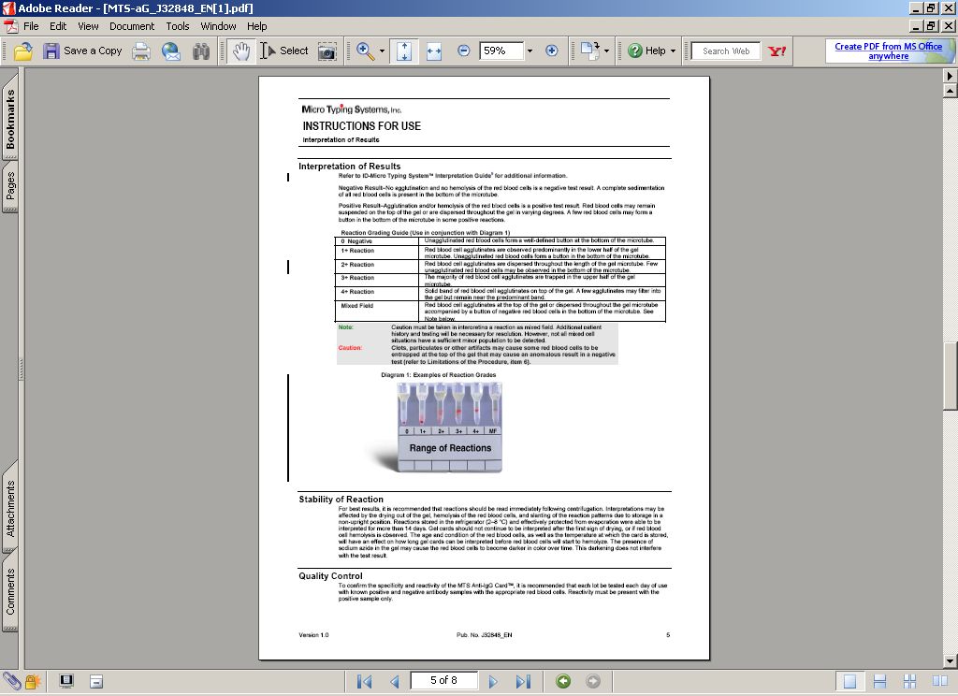

COMMENTS
Interpretation of mixed-field reactions must be done with caution. The presence of fibrin, clots or particulates may result in some cells layering at the top of the gel. Mixed-field reactions are generally only observed in tests containing a dual population of red cells, such as a transfused patient, bone marrow recipient or when a pooled cell sample is used for testing. However, not all mixed cell situations have a sufficient minor population to be detected.

LIMITATIONS:
- Some antibodies of clinical importance may be eliminated by prewarming.
- Antibodies below the threshold level may not be detected with this test.
- Antibodies specific for low-incidence antigens not represented on the test cells will not be detected.
- False-positive results may occur if antibodies to components of the preservative solution are present in the serum tested.
- Significant variations in red blood cell suspensions (<0.6 or >1.0%) may result in false-positive or false-negative reactions.
- Anomalous results may be caused by fresh serum, fibrin or particulate matter in serum or plasma, or red cells that stick to the sides of the microtube. Anomalous results with fresh serum (i.e., a line of red cells on top of the gel) may be minimized by the use of EDTA plasma.
- Adherence to the manufacturer’s package insert is critical to test performance.

REFERENCES
Technical manual. 16th ed. Bethesda, MD: American Association of Blood Banks, 2008: 902.
Current package insert: Anti-Human Globulin Anti-IgG (Rabbit) MTS Anti-IgG Card. Pompano Beach, FL: Micro Typing Systems, Inc.

Current package insert: Reagent Red Blood Cells SELECTOGEN® . Raritan, N.J. Ortho-Clinical Diagnostics Inc.
Current package insert: MTS Diluent 2 Red Blood Cell Diluent. Pompano Beach, FL: Micro Typing Systems, Inc.
Malyska H, Weiland D. The gel test. Laboratory Medicine, 1994;25:81-5.
Standards for blood bank and transfusion services. 18th ed. Bethesda, MD: American Association of Blood Banks, 1997.

UnityPoint Methodist Laboratory is a CAP accredited facility. As of July 1, 2011, the responsibility of new and/or substantially revised policies and procedures will be restricted the Laboratory Director whose name appears on the CLIA certificate, and the signature appears below. The biennial review will be completed by the appointed Section Medical Director.

POLICY CREATION :
Author: Mary McCallister | July 9, 2003
Medical Director: Elizabeth Bauer-Marsh, MD | July 9, 2003

REVISION HISTORY
Rev | Description of Change | Author | Effective Date
1 | Revised pretransfusion sample to be acceptable for 30 days, minor formatting, document ID added to header. | S.Schaffer | 12/06/11
2 | Added BIO-RAD Reagent and changed acceptable specimen from 30 days to 7 days. | Kathy Turpin | 05/02/14
3 | Clarified MTS diluent QC | Vincent Strow | 02/10/16
4 | Replaced labeling gel card with MRN with date of birth. | Leah Miller | 7/16/18
REVIEWED BY
Lead | Date | Coordinator/  Manager | Date | Medical Director | Date
K. Maher | 12/30/11 | 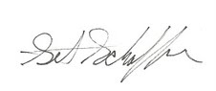 | 12/29/11 |  | 12/29/11
D. Allen | 5/4/14 |  | 5/2/14 |  | 6/10/14
V. Strow | 4/15/16 |  | 7/8/16 |  | 7/21/16
L. Miller | 7/26/18 |  | 7/26/18 |  | 7/27/18

