  METHODIST PROCTOR PEKIN |  |  | Page 1 of 3 | Section: UPPIA LA: | Policy #: 06.011
 | EXPOSURE CONTROL |  | Medical Director Initial Approval:  (delegated to Administrative Director after initial- see signature block at end of document) |  | Date: 5/23/18  Review by: 5/23/20
 |  |  | Methodist Medical Director: Date:  5/31/18 |  | Date: 5/23/18  Review by: 5/23/20
 |  |  | Proctor Medical Director: Date:  5/24/18 |  | Date: 5/23/18  Review by: 5/23/20
 |  |  | Pekin Medical Director: Date: |  | Date: 5/23/18  Review by: 5/23/20
 | LABORATORY ADMINISTRATION |  | Policy Created: 9/17/1992  Date Revised: 2/10/10, 2/1611, 2/16/12, 12/4/13, 1/30/15, 1/20/16, 11/30/16, 5/23/16
Primary Responsible Parties: DANA SPEARS
Secondary Responsible Parties: TINA PORTER-LANAN
 |  |  | CAP Standard: GEN. 74400
SUBJECT: |  | EATING, DRINKING, AND SMOKING IN THE LABORATORY

- POLICY:
No eating or drinking will be allowed in the work areas where potential for exposure exists. Smoking is not permitted on the UnityPoint Campuses.

- PURPOSE:
To outline procedures to follow for eating, drinking and smoking in the laboratory.

- POLICY SCOPE:
The scope of this policy applies to all Laboratory staff of UnityPoint Regional Laboratories of Central Illinois.

- GENERAL INFORMATION:
Laboratory accidents and the transmission of diseases are often a result of carelessness, haste, lack of knowledge negligence and unsafe practices.

- PROCEDURE:
- Smoking is prohibited inside the Medical Centers of Methodist, Proctor and Pekin Campuses on its grounds, in and around all affiliated buildings.
- Eating (to include mints and gum), drinking, applying cosmetics or lip balm and handling contact lenses are prohibited in work areas where there is potential for occupational exposure.
- Food and drink shall not be stored in refrigerators, freezers, bench tops, or cabinets where blood or potentially infectious materials are stored or in other areas of possible contamination.
- Food in "FOOD ONLY" refrigerator shall be covered, initialed, and dated in order to facilitate a clean out schedule. Expiration dates will be observed.

- MAINTENANCE AND STORAGE:
- All policies and procedures are reviewed every two years, (except for Safety procedures which are yearly) by Laboratory Administration and or the Medical Director of the Laboratory or designee when there are changes in practice standards, or requirements.
- All policies and procedures are reviewed every two years (except for Safety procedures which are yearly) by staff or at the time new or revised ones are put in effect.
- All policies are retained 8 years after being discontinued or revised.
- All procedures are retained 2 years after being discontinued or revised

POLICY CREATION :
Author: Rich Borge | September 7. 1992

MEDICAL DIRECTOR
DATE | NAME | SIGNATURE
February 11, 2017 | Elizabeth A. Bauer-Marsh, M.D.
REGIONAL ADMINISTRATIVE DIRECTOR
September 17, 2017 | Dana A. Spears | 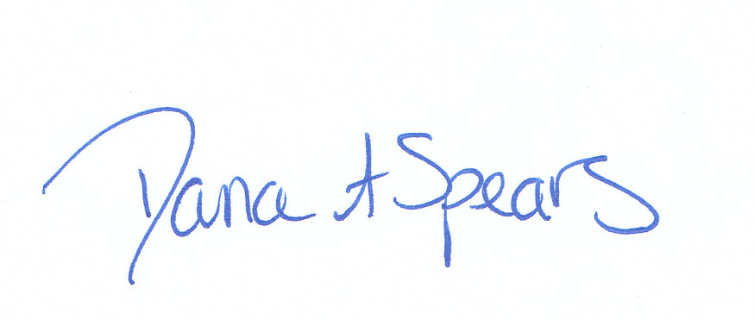

REVISION HISTORY
Rev | Description of Change | Author | Effective Date
1 | Added policy scope, changed system logo and formatting changes | T. Lanan | 3/7/14
2 | Reviewed and combined for both campuses | R. Borge | 1/20/16
3 | Added additional information for food items | D. Spears | 5/23/18

Reviewed by
Designee | Date | Laboratory Director | Date
 |  | 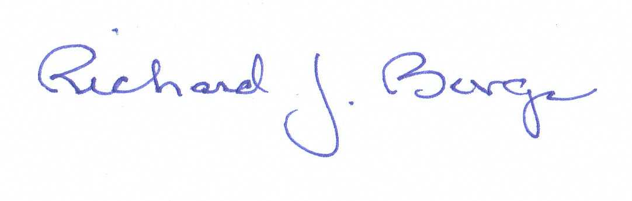 | 10/5/15
Managers | 5/23/18 |  | 5/23/18

