 |  |  | Page # 1 of 2 | Section: | Policy #: 26
 | REFERENCE |  | Approved by: see signature block at end of document |  | Date: 11/8/18  Review by:
 | LABORATORY |  | Policy Created: 11/8/18  Supersedes:
Primary Responsible Parties: Deb Deeb, MT
Secondary Responsible Parties: Peggy Bennett
 |  |  | CAP Standard: 77500
SUBJECT: |  | DRY ICE (CO2, SOLID) SAFE HANDLING PRACTICES
METHODIST

- POLICY:
To ensure safe handling and use of dry ice. (CO2, solid)

- PURPOSE:
The safe handling of Dry Ice involves knowing the potential hazards involved and using common sense procedures based on that knowledge.

- POLICY SCOPE
The scope of this policy applies to all Laboratory staff that utilizes dry ice to transport or ship laboratory specimens at UnityPoint Methodist.

- GENERAL INFORMATION:

- Contact of dry ice with the skin or eyes may cause serious freezing (frostbite) injury.
- Handle Dry Ice carefully. Dry ice handled without proper protection can freeze human flesh very rapidly. Delicate tissue, such as that of the eyes, can also be damaged by exposure.
- Never allow any unprotected part of your body to touch dry ice.
- Wear protective clothing. Wear goggles and insulated gloves when handling.

- Carbon dioxide (dry ice) can cause suffocation without warning.
- Store and use dry ice only in a well-ventilated place. Keep the storage container tightly closed. Do not lean into the container. In closed areas, excessive amounts of dry ice can reduce the concentration of oxygen and can result in asphyxiation. Because the gas is colorless, odorless and tasteless, it cannot be detected by the human senses and will be breathed as if it were air.
- Transporting Dry Ice. When transporting dry ice keep windows cracked to allow any CO2 to escape through the windows. Assure that the container is tightly closed.
- Refer to MSDS sheet for additional information.

- PROCEDURE:

- Prompt medical attention is mandatory in all cases of overexposure to CO2
- Inhalation: Conscious persons should be assisted to an uncontaminated area and inhale fresh air. Quick removal from the contaminated area is most important. Unconscious persons should be moved to an uncontaminated area, given mouth-to-mouth resuscitation and supplemental oxygen. Call 911 or Rapid Response Team if within the hospital. Further treatment should be symptomatic and supportive.
- Dermal Contact or Frostbite: Flush affected areas with lukewarm water. DO NOT USE HOT WATER. A physician should see the patient promptly if the cryogenic “burn” has resulted in blistering of the dermal surface or deep tissue freezing.

- REFERENCES:
CONTINENTAL CARBONICS, SDS SHEET REVISION 1.14, 9/19/2017.

POLICY CREATION :
Author: Deb Deeb | November 2, 2018
Medical Director: Elizabeth A. Bauer-Marsh, MD | November 8, 2018

UnityPoint Methodist Laboratory is a CAP accredited facility. As of July 1, 2011, the responsibility of new and/or
substantially revised policies and procedures will be restricted the Laboratory Director whose name appears on the
CLIA certificate, and the signature appear below. The biennial review will be completed by the appointed Section
Medical Director.

MEDICAL DIRECTOR
DATE | NAME | SIGNATURE
November 8, 2018 | Elizabeth A. Bauer-Marsh, M.D.
SECTION MEDICAL DIRECTOR
November 8, 2018 | Dana A. Spears | 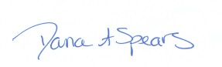
REVISION HISTORY
Rev | Description of Change | Author | Effective Date
1 | New Release | Deb. Deeb | 12/8/18
R
Coordinator | Date | Manager | Date | Administrative Director | Date
 |  |  | 11/2/18 | 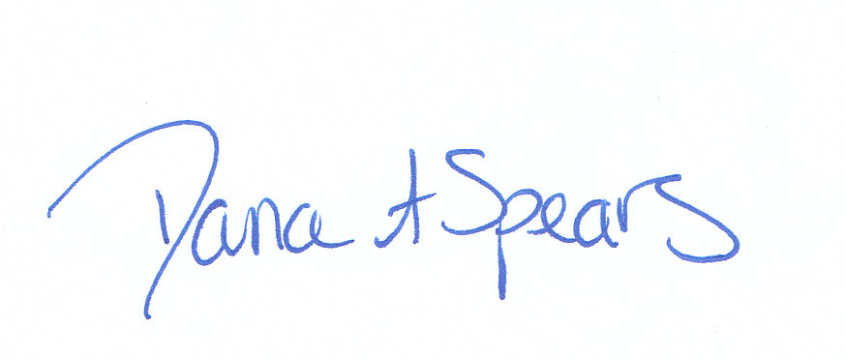 | 11/4/18

