|  |  |  |  |  |  |
| --- | --- | --- | --- | --- | --- |
| /Volumes/dsm/UPH/Creative Services/Graphic Design/Logos/UnityPoint Health/UnityPoint Health/png/1 UP Health 2c H.png  METHODIST | | | Page 1 of 29 | Section: UPM CHEMI | Policy #: 04.047 |
|  | CHEMISTRY, IMMUNO | | Approved by: see signature block at end of document | | Date: 11/28/18  Review by:11/18/20 |
|  | LABORATORY | | Policy Created: 11/28/18  Supersedes: | | |
|  | |  | Primary Responsible Parties: Michelle Greer  Secondary Responsible Parties: Amy Gibbs | | |
|  | |  | CAP Standard: | | |
| SUBJECT: | | TORC IGM | | | |

**MultiPlex Flow Immunoassay**

**BioPlex 2200**

**ToRC-M panel includes :**

**TOXOABM (Toxo IgM)**

**TOXO (Toxo IgG/IgM)**

**CMIGM**

**RUBM**

1. **PRINCIPLE**

The BioPlex 2200 ToRC IgM assay employs a panel of three antigen-coated fluoromagnetic beads with unique fluorescent signatures to identify the presence of IgM class antibodies to Toxoplasma gondii ,Rubella and CMV antigens in a two- step assay format. In the first step, the system combines an aliquot of patient sample with sample diluent and bead reagent then agitates the mixture at 37°C. In the second step, immobilized IgM is identified indirectly using a fluorescent anti-human IgM reporter conjugate in a manner similar to antibody detection using an enzyme-linked reporter in an EIA. The assay is calibrated using a set of two distinct calibrator vials, supplied separately by Bio-Rad Laboratories. One vial containing negative sample, one multi-analyte vial containing. gondii IgM, Rubella IgM and CMV IgM, are used for qualitative calibration of the assays.

Two control beads are used to normalize assay output for fluctuations in detector function (internal standard bead, ISB), and the other control bead is used to verify the sample is serum or plasma (serum verification bead, SVB) and does not bind non-specifically to the antigen-coated beads (reagent blank bead, RBB). Refer to the BioPlex 2200 System Operation Manual for more information about control beads. The fluorescent properties of the beads allow multi-analyte data to be acquired simultaneously from a single sample and segregated based upon the fluorescent codes embedded in the antigen-coated and control beads. The magnetic properties of the beads allow rapid washing to remove unbound molecules in between assay steps. Bead classification and reporter data are acquired in flow using a dual laser detector employing the same principles utilized by fluorescence activated cell sorters. Raw data are reported as relative fluorescent intensity (RFI).

1. **CLINICAL SIGNIFICANCE**

**Toxoplasmosis**

Toxoplasma gondii (T. gondii) is a protozoan that causes toxoplasmosis in numerous mammalian and avian species. Toxoplasmosis during pregnancy has been implicated in serious congenital abnormalities including impaired brain function and stillbirth. Identification of T. gondii antibodies in women prior to conception provides assurance of fetal protection from possible infection during pregnancy.

**Rubella**

Rubella (German measles) is a viral infection with clinical manifestations including low-grade fever, headache, sore throat, and generalized skin rash. A serological test showing a positive Rubella IgM titer is indicative of recent exposure even when symptoms are not present.2

A Rubella infection during first trimester pregnancy is serious and may present multiple congenital complications including deafness, cataracts and/or mental retardation or fetal death.3

Cytomegalovirus

Cytomegalovirus (CMV) is a member of the Herpesviridae family. Transmission of CMV is associated with close interpersonal contact or the introduction of cells or body fluids.4 Primary CMV infection can present like infectious mononucleosis in adults with symptoms including fever, lethargy and atypical lymphocytosis.5 Major clinical manifestations include CMV retinitis and bowel disease.

Congenital CMV infection may result in a severe generalized cytomegalic inclusion disease (CID) in the neonate, characterized by hepatosplenomegaly, jaundice, microcephaly, intracerebral calcification, psychomotor retardation, deafness, chorioretinitis, thrombocytopenia and hemolytic anemia.6 Although transplacental infection occurs in about 1% of deliveries, about 1 in 2000 infants are born expressing classical CID. The fetus is only at risk of acquiring CID if the mother is acutely infected with CMV. The fetus can be damaged by infection in any trimester of pregnancy.7

The detection of CMV IgM antibodies in the blood is a valuable tool for determining current or recent infection.1

Congenital CMV infection may result in a severe generalized cytomegalic inclusion disease (CID) in the neonate, characterized by hepatosplenomegaly, jaundice, microcephaly, intracerebral calcification, psychomotor retardation, deafness, chorioretinitis, thrombocytopenia and hemolytic anemia.6 Although transplacental infection occurs in about 1% of deliveries, about 1 in 2000 infants are born expressing classical CID. The fetus is only at risk of acquiring CID if the mother is acutely infected with CMV. The fetus can be damaged by infection in any trimester of pregnancy.7

The detection of CMV IgM antibodies in the blood is a valuable tool for determining current or recent infection.1

1. **POLICY SCOPE**

The scope of this policy applies to all Laboratory staff that prepares or performs testing on laboratory specimens at UnityPoint Methodist.

1. **SPECIMEN**

**Specimen volume:** 5 uL ( plus dead space, approx. 400 uL)

Specimen Collection Precaution

Consider any materials of human origin as infectious and handle them using typical biosafety procedures.

**Patient preparation**: none

Specimen Type

Serum and plasma (K3 EDTA, lithium heparin or sodium Heparin) are the recommended samples. Avoid hemolysis.

Specimen Storage

Serum or plasma may be stored at room temperature for up to 3 days and under refrigeration (2-8°C) for up to 7 days. For longer storage of samples, keep at -20°C or colder.

Specimen Preparation

Thoroughly mix thawed specimens; it is also recommended to centrifuge thawed specimens to remove gross particulate matter. Avoid multiple freeze/thaw cycles (up to 3 cycles is acceptable).

**Interfering Substances**

Testing for interfering substances was conducted according to CLSI Protocol EP7-A2 (Vol. 25, No. 27). Samples were prepared by blending a pool of negative human serum with samples positive for T. gondii, Rubella and CMV IgM to achieve values of 0.4 to 0.7 AI (high negative) 1.5 to 2.4 AI (low positive) and 2.5 to 4.0 AI (positive). Interferent or solvent was added exogenously at levels indicated in Table R below. No significant interference was observed in any of the substances tested. The following substances, listed in Table R, were tested (N=13) at maximum levels on one reagent lot.

1. **REAGENTS**

|  |  |
| --- | --- |
|  | Description |
| Bead Set | One (1) 10 mL vial, containing dyed beads coated with lysates of Rubella and CMV plus an Internal Standard bead (ISB), a Serum Verification bead (SVB), and a Reagent Blank bead (RBB) in buffer with Glycerol and protein stabilizers (bovine). ProClin 300 (≤ 0.3%), sodium benzoate (≤ 0.1%) and sodium azide (< 0.1%) as preservatives. |
| Conjugate | One (1) 5 mL vial, containing phycoerythrin-conjugated donkey polyclonal anti‑human IgM antibody and phycoerythrin-conjugated murine monoclonal anti‑human FXIII antibody, in buffer with protein stabilizers (bovine and equine). ProClin 300 (≤ 0.3%), sodium benzoate (≤ 0.1%) and sodium azide (< 0.1%) as preservatives. |
| Sample Diluent | One (1) 10 mL vial, containing goat anti-human IgG antibody and protein stabilizers (bovine and equine) in buffer. ProClin 300 (≤ 0.3%), sodium benzoate (≤ 0.1%) and sodium azide (< 0.1%) as preservatives. |
| 12000677 | BioPlex 2200 ToRC-M Calibrator Set: Two (2) 0.5 mL vials. The calibrators are provided in a human serum matrix made from defibrinated plasma with added known analyte concentration consisting of HuCAL recombinant IgM antibodies for rubella and human disease state plasma derived antibodies for T gondii and CMV. All calibrators contain ProClin 300 (≤ 0.3%), sodium benzoate (≤ 0.1%) and sodium azide (< 0.1%) as preservatives. |
| 12000678 | BioPlex 2200 ToRC IgM Control Set: Two (2) 1.5 mL Positive Control serum vials, containing human disease state IgM antibodies T. gondii and CMV, and HuCAL recombinant IgM antibodies to Rubella in a human serum matrix made from defibrinated plasma; and two (2) 1.5 mL Negative Control serum vials, in a human serum matrix made from defibrinated plasma. All controls contain Amikacin (0.003%), Cycloheximide (C15H23NO4) (0.009%), Amphotericin B (0.002%), Cefotaxime Sodium (0.002%), Ciprofloxacin (0.005%), ProClin 300 (≤ 0.3%), sodium benzoate (≤ 0.1%) and sodium azide (< 0.1%). |
| 660-0817 | BioPlex 2200 Sheath Fluid: Two (2) 4 L bottles containing Phosphate Buffered Saline (PBS). ProClin 300 (0.03%) and sodium azide (< 0.1%) as preservatives. |
| 660-0818 | BioPlex 2200 Wash Solution: One (1) 10 L bottle containing Phosphate Buffered Saline (PBS) and Tween 20. ProClin 300 (0.03%) and sodium azide (< 0.1%) as preservatives. |
| 660-0000 | BioPlex 2200 Instrument and Software System. |

1. PREPARATION AND STORAGE OF REAGENTS
   1. **Do not freeze the ToRC IgM Reagent Pack.**
   2. Reagents in the ToRC IgM kit are ready to use. After initial use, the reagents are stable for 60 days or until the date of expiration when stored unopened on the instrument or refrigerated at 2-8ºC.
   3. Do not use reagents beyond expiration dates.
2. INDICATIONS OF INSTABILITY OR DETERIORATION OF REAGENTS
   1. Store all reagents at the labeled temperature and do not use past their expiration dates.
   2. Do not use any reagents which have any indications of discoloration, cloudiness or excessive precipitation.
   3. Do not use any reagents that show any signs of leakage.
3. Precautions /Warnings

May cause an allergic skin reaction.

If on skin: Wash with plenty of soap and water.

If skin irritation or rash occurs: Get medical advice/attention.

1. **INSTRUMENTATION/EQUIPMENT**

BioPlex 2200, manufactured by Bio-Rad Laboratories.

1. **CALIBRATION**

ToRC IgM Calibrator Set should be loaded and assayed at minimum in duplicate every 30 days or with each new Reagent Pack lot. For all assays, a two-point curve is used to calculate qualitative results. Refer to the BioPlex 2200 System Operation Manual for more information.

1. **QUALITY CONTROL**

For each reagent pack and once per day testing is performed, load and process the BioPlex 2200 ToRC IgM Control Set as indicated in the BioPlex 2200 System Operation Manual.

The ToRC IgM Control Set includes a negative control as well as multi analyte positive control in a human serum matrix made from defibrinated plasma, containing antibodies to ToRC antigens within the BioPlex 2200 ToRC IgM kit. The positive controls are manufactured to give positive results, with values above the cut-off for each specific bead. The negative control is manufactured to give negative results, with values below the cut-off for each specific bead. The negative control must have a negative result, and the positive control must have a positive result.

**Note**: The Negative and Positive Controls of the ToRC IgM Control Set are intended to monitor for substantial reagent failure. The Positive Control will not ensure precision at the assay cutoff.

Lot specific values for the positive controls are loaded into the BioPlex 2200 System database via the provided media or by manual input. After identifying the control via the barcoded vial, the BioPlex 2200 System compares the control results to the expected lot specific control values stored in the BioPlex 2200 System database.

Failure to obtain the appropriate values for controls will invalidate the assay and indicates procedural error, improper sample handling or deterioration of reagents. Additional controls may be tested in accordance with local, state and/or federal regulations or accreditation requirements and your laboratory’s quality control policy.

IMPORTANT QC TROUBLESHOOTING: At low frequency, reagent packs may exhibit falsely low signals for any one of the two analytes and generate QC errors. The following troubleshooting steps should be followed when observing the noted QC behavior:

1. QC Warning - LOW for only some analytes:

Repeat QC testing. If the QC Warning repeats, remove the pack with the flagged QC results and do not use. Please call Bio-Rad Technical Support to report the suspected low signal pack. Run QC with a new reagent pack. If QC results are within the acceptable range on the new reagent pack, discard the affected reagent pack with the QC Warning - Low results and do not report patient test results from that reagent pack. If the QC Warning repeats on the new reagent pack, please call Bio-Rad Technical Support for assistance with troubleshooting. Re-test any samples that were tested using the affected reagent pack. If multiple packs for a particularBioPlex2200assayare on-board the instrument, the reagent pack (kit) serial number associated with the QC Warning - low results can be determined by viewing the Control Result dialog for the corresponding QC Event.

2. QC Warning - HIGH for only some analytes:

Re-calibrate the reagent pack with the QC Warning - high and re-run QC. Verify that QC results are within the acceptable range for all analytes before reporting out-patient results. Any samples tested using the pack with the QC Warning - high must be re-tested. Patient samples run on the affected pack are valid due to the fact that a calibration occurred with that pack.

If a control result is out of its specified range, any test results generated since the last acceptable control results must be evaluated to determine if test results may have been adversely affected. Adversely affected results are invalid, and these samples must be re-tested.

1. **PROCEDURE**

Steps for the routine operation of the instrument include the following:

1. Maintenance
2. Assay calibration
3. Assay quality control
4. Sample loading
5. Sample removal
6. Result review
7. End of shift procedure
8. **MAINTENANCE**
9. Daily maintenance
10. Address messages
11. Load Reagent Packs
12. Replenish supplies and empty waste
13. Visual inspection
14. Weekly Maintenance
15. Inspect the sheath filter
16. Inspect the syringes
17. Clean the sample handler
18. Database maintenance
19. Inspect and wipe the system probes
20. Clean the system probes
21. Detector calibration
22. Monthly Maintenance
23. Clean the liquid waste containers
24. Sanitize the deionized water container
25. On Demand Maintenance

a. Other maintenance activities done on a periodic basis are described in section 11.8 of the BioPlex 2200 System Operation Manual.

b. All maintenance activities are described in detail in section 11.1 – 11.84 of the BioPlex 2200 System Operation Manual.

1. **ASSAY CALIBRATION**

Perform required calibrations, as described in section VI.

* Refer to the BioPlex 2200 System Operation Manual, section 6.1-6.4 for more information concerning calibration.

1. **ASSAY QUALITY CONTROL**

Quality control material should be run, as described in section VII. Patient samples should not be run until requirements for quality control results are met.

Failure to obtain the appropriate values for controls will invalidate the assay and indicates procedural error, improper sample handling or deterioration of reagents.

1. **SAMPLE LOADING**

1. **Prepare Specimens for Processing**
2. Determine if the tubes provided fulfill the requirements of the system.
3. Determine if the volume of specimen is adequate for testing.
4. If tubes and volumes are suitable, load specimens into sample racks, with caps removed, and bar-codes clearly visible through the rack opening.
5. Remove any debris, film, or bubbles present in the sample.

*Detailed description of sample preparation may be found in section 9.3 of the BioPlex 2200 System Operation Manual.

1. **Loading and Processing Samples**
2. Calibration curves must be available and current (having passed performance standards) for any analyte to be tested.
3. At least two levels of quality control material must be tested and pass performance standards before samples may be run.
4. Sample racks may be individually loaded or sample trays may be loaded onto the Sample Input Area. Alternatively, individual racks may be loaded into the STAT Input Platform.

*Detailed description of loading and processing samples may be found in section 9.4 of the BioPlex 2200 System Operation Manual.

1. **SAMPLE REMOVAL**

Remove processed sample racks individually after they arrive at the Sample Output Area or wait until all processed racks arrive and then remove the filled sample tray.

Processed sample racks will not be moved to the sample Output Area if the sample tray is filled or if there is no tray present. In either case, new samples will not be processed until racks are cleared or the sample tray is replaced.

*Detailed description of removing processed samples may be found in section 9.5 of the BioPlex 2200 System Operation Manual.

1. **RESULT REVIEW**
2. Review patient and control results under RESULTS > Review
3. Review error list under RESULTS > Review> Error List
4. Release results under RESULTS > Release
5. Print results under RESULTS > Review> Print

*Detailed description of review of results may be found in section 10.1- 10.37 of the BioPlex 2200 Sustem Operation Manual.

1. **END OF SHIFT PROCEDURE**
   * + 1. Log Out

On the Global Menu, touch “USER.” The Log Out dialog box appears. Touch “Log Out.” The Log In dialog box appears for the next user to log in.

* + - 1. Shut Down

1. If the instrument will not be in use for over 3 days, remove all reagent packs and keep refrigerated.
2. Ensure that the instrument is not processing samples or performing maintenance.
3. Touch the “SHUTDOWN” button on the Maintenance Calendar workspace to open the shutdown dialog box.
4. Touch “CONTINUE” to begin the instrument shut down procedures, which take approximately three minutes to complete.
5. Once the computer has shut down and powered itself off, turn off the BioPlex 2200 using the main power switch on the right outside panel of the instrument.

*Detailed description of the end of shift procedure may be found in section 9.6 of the BioPlex 2200 System Operation Manual.

1. **REPORTING RESULTS**
2. **Calculation**

All calculations necessary to interpret the results are performed automatically by the BioPlex 2200 System Software.

Test results are reported numerically:

**Linear Range: 0.2 – 4.0 AI**

**CRR Range: 0.2 – 4.0 AI**

1. **Data Analysis**

The results for ToRC IgM antibodies shown in Table A are expressed in antibody index (AI).

The cut-off values and assignment of the calibrators are determined by performing concordance and Receiver Operator Characteristic (ROC) analysis using predicate results as the standard.

Table A:

|  |  |  |
| --- | --- | --- |
| T.gondi, Rubella and CMV IgM Interpretation | | |
|  |  |  |
| Result | Status | Interpretation |
| ≤ 0.8 AI | Negative | ToRC IgM antibodies were not detected |
| 0.9, 1.0 AI | Equivocal | Equivicol results ToRC M status not determined. |
|  |  | Obtain an additional sample within an appropriate |
|  |  | timeframe (collected in 2-3 weeks) for re-testing. |
| ≥ 1.1 AI | Positive | ToRC IgM antibody(ies) were detected which may |
|  |  | indicate a current or recent infection. |

## The following table is a guide to general interpretation of Toxoplasma Serology Results (IgG & IgM). It can be used to provide additional information for interpretation of *T. gondii* IgM results if available.

Table B: Toxoplasmosis Interpretation

|  |  |  |
| --- | --- | --- |
| **T.gondii IgG Result** | **T.gondii IgM Result** | **Result Interpretation** |
| Negative (-) | Negative (-) | No serological evidence of infection with T. gondii |
| Negative (-) | Equivocal | Possible early acute infection or false-positive IgM reaction. Obtain a new specimen for IgG and IgM testing. If the new specimen result remains the same, the patient is probably not infected with T. gondii |
| Negative (-) | Positive (+) | Possible acute infection or false-positive IgM result. Obtain a new specimen for IgG and IgM testing. IF results from the second specimen remain the same, the IgM reaction is probably a false-positive. |
| Equivocal | Negative (-) | Equivocal: obtain a new specimen for testing or retest this specimen for IgG using a different assay. |
| Equivocal | Equivocal | Equivocal: obtain a new specimen for both IgG and IgM testing. |
| Equivocal | Positive (+) | Possible acute infection with T.gondii. Obtain a new specimen for IgG and IgM testing. If results with the new specimen remain the same or the IgG becomes positive, both specimens should be sent to a reference laboratory with experience in the diagnosis of toxoplasmosis. |
| Positive (+) | Negative (-) | Infected with T.gondii for more than one year |
| Positive (+) | Equivocal | Infected with T.gondii for probably more than 1 year or false-positive IgM reaction. Obtain a new specimen for IgG and IgM testing. If results from the second specimen remain the same, both specimens should be sent to a reference laboratory with experience in the diagnosis of toxoplasmosis. |
| Positive (+) | Positive (+) | Possible recent infection within the last 12 months. Send the specimen to a reference laboratory with experience in the diagnosis of toxoplasmosis. |

Adapted from FDA Publication: :Limitations of Toxoplasma IgM Commercial Test Kits” July 25, 1997.

1. **Selection** **of Result Presentation**

The laboratory may elect to run any of the antibodies requested individually, or any group of antibodies may be requested for a specific sample. The laboratory may pre-define the test groupings by using the software screen entitled “Test Group Setup,” allowing the operator to request the “customized” groupings. For example, *T. gondii*, Rubella and CMV may be analyzed together.

“Add-On” test(s) for immediate reporting of results for additional individual antibodies, or a user-defined test grouping containing antibodies, not previously requested, can also be performed. If the selected antibody has been previously requested, the sample will be treated as a repeated request. Refer to the BioPlex 2200 System Operation Manual for more information.

**Note:** An Over-Range (OR) result may be generated when results for selected antibodies are requested. Dilution of Over-Range results for qualitative assays is not recommended.

1. Expected Values

## Prevalence

The observed prevalence for the ToRC IgM assays was determined in samples collected from pregnant women in the U.S. as well as in clinical samples submitted for *T. gondii*, Rubella, or CMV IgM testing. Results are shown in Tables C – D.

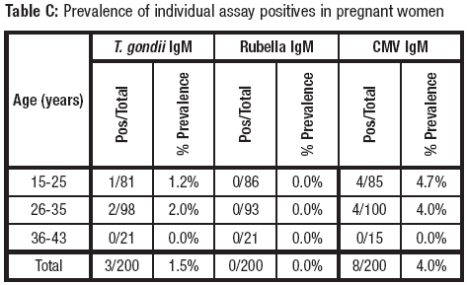

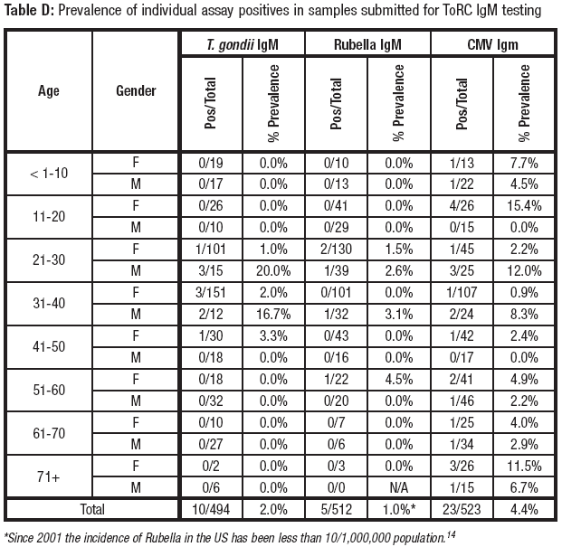

1. Performance Characteristics

## Comparative Testing: Prospective

Performance of the ToRC IgM kit was evaluated against corresponding commercially available *T. gondii*, Rubella, and CMV IgM immunoassays. Three clinical sites tested a combined total of 2129 prospective samples (694-723 samples per analyte) submitted for *T. gondii*, Rubella, or CMV testing. 200 of the samples per analyte were from pregnant women. Results are shown in Table E.

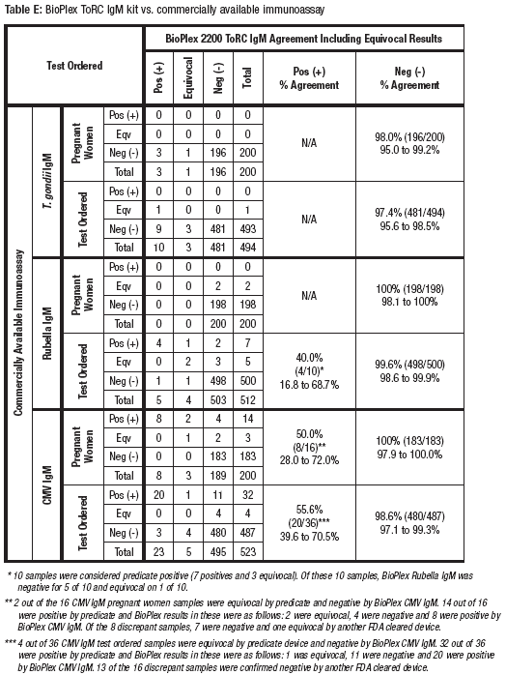

## Comparative Testing: Retrospective

Performance of the ToRC IgM kit was evaluated against corresponding commercially available *T. gondii*, Rubella, and CMV IgM immunoassays. Three clinical sites tested 210 *T. gondii* (134 female, 76 male), 101 Rubella (44 female, 57 male) and 213 CMV (119 female, 94 male) IgM presumptive positive samples. Presumed positive banked samples for ToRC IgM were further selected by the respective predicate device used for the comparative analysis. Results are shown in Table F.

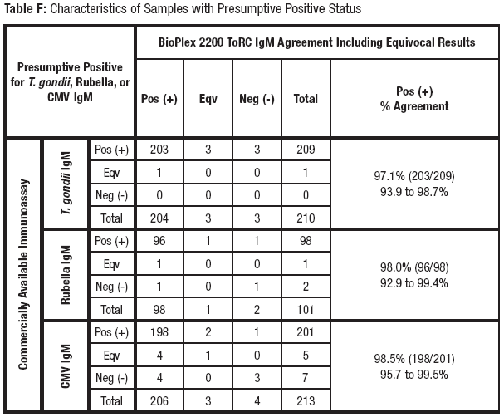

## *Correlation with CDC Evaluation Serum Panel*

The Centers for Disease Control (CDC) provided an evaluation serum panel for testing of *T. gondii* IgM. This panel was tested to evaluate characteristics of the ToRC IgM kit. The results are presented as a means to convey further information on the performance of assays in the ToRC IgM kit with masked, characterized serum panels. This does not imply an endorsement of the BioPlex 2200 ToRC IgM kit by the CDC. Results are shown in Table G.

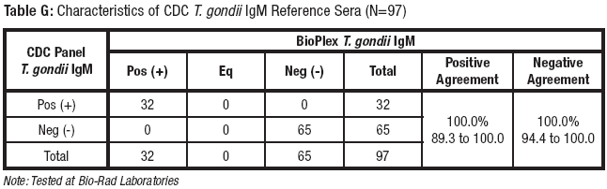

## Reproducibility Studies

To assess reproducibility of each of the assays in the BioPlex 2200 ToRC IgM kit, a reproducibility panel was prepared at Bio-Rad Laboratories. The panel contained members with varying levels of antibodies to the analytes in the BioPlex 2200 ToRC IgM kit, and a positive control (antibody positive for all analytes). Reproducibility testing was performed at 3 clinical trial sites. One lot of BioPlex 2200 ToRC IgM Reagent Packs, BioPlex 2200 ToRC IgM Calibrator Sets and BioPlex 2200 ToRC IgM Control Sets was used to evaluate reproducibility. Each of the panel members and a positive and negative control was tested in quadruplicate on 2 runs per day over 5 days at each of 3 sites (4 replicates x 2 runs x 5 days = 40 replicates per panel member per site = 120 total replicates for 3 sites). The data were analyzed for intra-assay and inter-assay reproducibility according to the Clinical and Laboratory Standards Institute (CLSI) guidance EP5-A3. The mean Antibody Index (AI), Standard Deviation (SD), and percent Coefficient of Variation (%CV) for each panel member were calculated. Results are shown in Tables H – J.

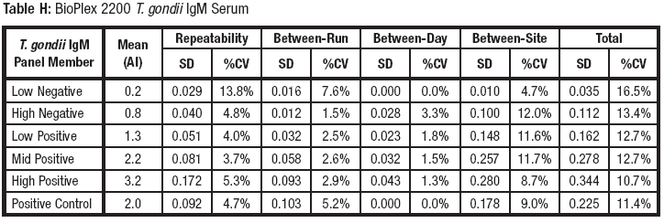

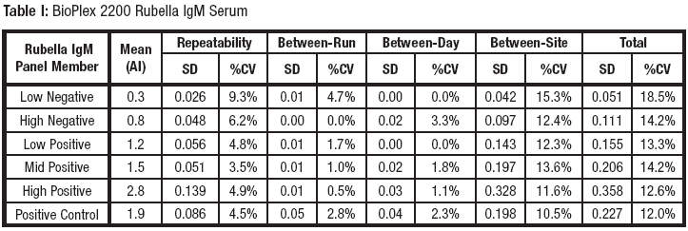

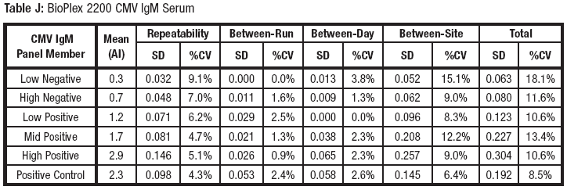

## Matrix Comparison

Matched serum and plasma samples drawn from > 40 individual donors were acquired from commercial sources. All samples were evaluated in replicates of 2. Mean plasma values were compared to matched mean serum AI values. Scatter plots comparing the performance of plasma samples against serum samples along with the corresponding slopes of regression and correlation coefficient are shown in Figures 1 – 9.

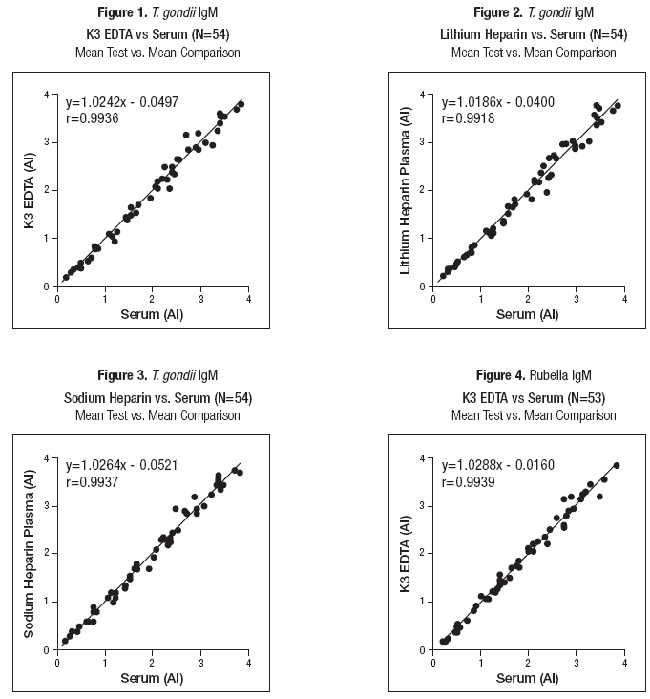

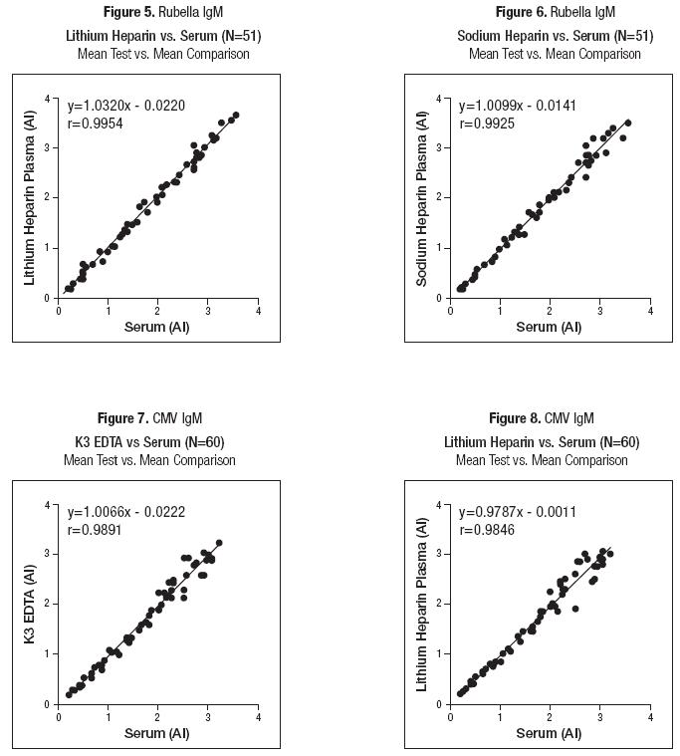

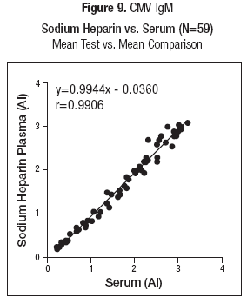

## IgM Specificity

*T. gondii*, Rubella and CMV IgM positive samples were selected and supplemented with matched, specific IgG. The sample pools were split and further supplemented with dithiothreitol (DTT) which inactivates IgM activity. The samples were assayed neat and diluted into assay range in replicates of two. IgM was measured using the BioPlex 2200 ToRC IgM kit. The results are shown in Tables K – M.

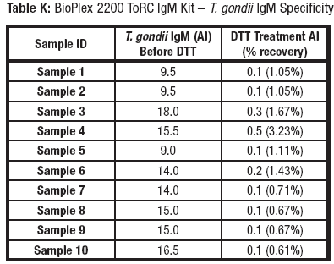

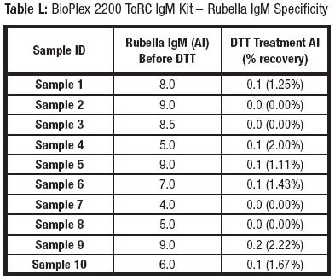

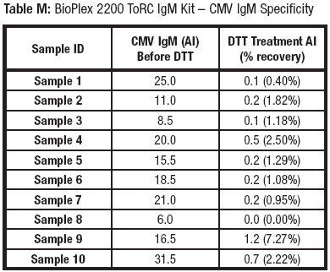

## *Seroconversion Testing*

*T. gondii* IgM seroconversion panels were tested with the BioPlex 2200 ToRC IgM kit. The results shown in Table N were compared to the predicate device.

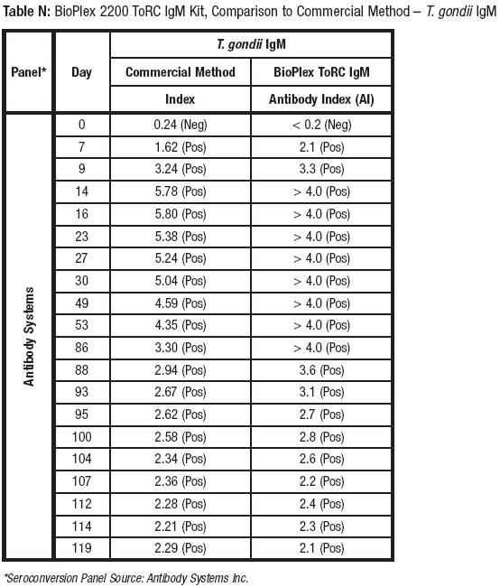

## *Rubella IgM*

Rubella IgM seroconversion panels were tested with the BioPlex 2200 ToRC IgM kit. The results shown in Table O were compared to the predicate device.

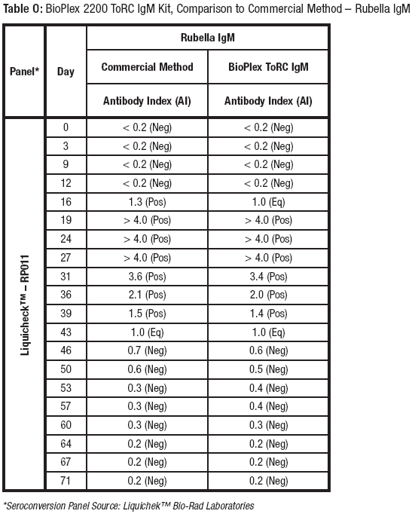

## *CMV IgM*

CMV IgM seroconversion panels were tested with the BioPlex 2200 ToRC IgM kit. The results shown in Table P were compared to the predicate device.

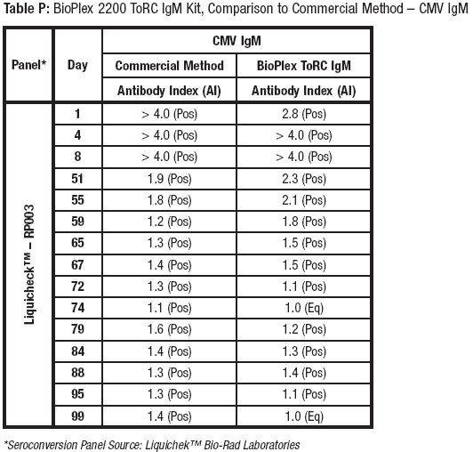

## Cross-Reactivity

A cross-reactivity study was performed to determine if samples from various disease states and other potentially cross-reacting agents interfere with test results when tested with the BioPlex 2200 ToRC IgM kit. Samples known to be positive for one of the potential cross-reactants listed in the table below were evaluated with the BioPlex 2200 ToRC IgM assays. All samples were pre-tested by commercially available *T. gondii*, Rubella and CMV IgM assays and only those that tested negative by the commercially available assay were further tested by the BioPlex 2200 ToRC IgM kit. Table Q summarizes negative agreement between the BioPlex 2200 ToRC IgM assays and the corresponding commercially available *T. gondii*, Rubella and CMV IgM assays within each of the cross-reactant panels.

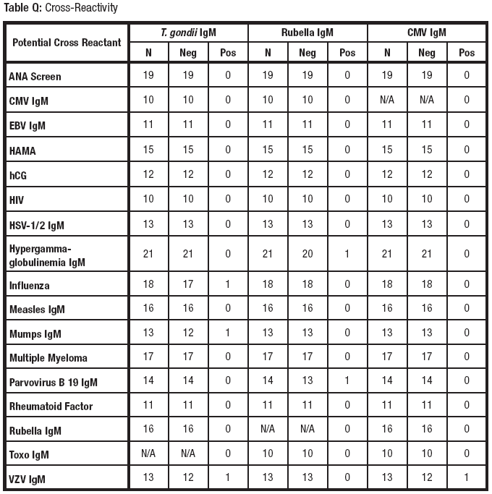

## Interfering Substances

Testing for interfering substances was conducted according to CLSI Protocol EP7-A2 (Vol. 25, No. 27). Samples were prepared by blending a pool of negative human serum with samples positive for *T. gondii*, Rubella and CMV IgM to achieve values of 0.4 to 0.7 AI (high negative), 1.5 to 2.4 AI (low positive) and 2.5 to 4.0 AI (positive). Interferent or solvent was added exogenously at levels indicated in Table R. No significant interference was observed in any of the substances tested. The following substances, listed in Table R, were tested (N=13) at maximum levels on one reagent lot.

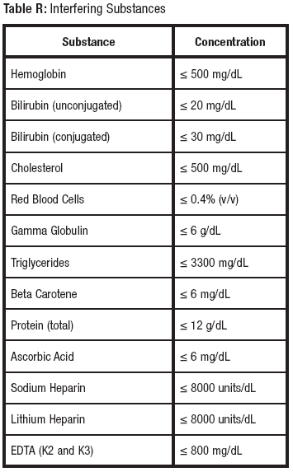

1. **PROCEDURAL NOTES/PROBLEM-SOLVING TIPS**
2. The ToRC IgM kit is not, in and of itself, diagnostic for each infectious disease and should be considered in conjunction with the patient’s clinical presentation/history and other laboratory test results.
3. Samples collected early in the course of the infection may not have detectable levels of specific IgM. A nonreactive IgM result may be due to delayed seroconversion and does not rule out current infection.
4. In immunocompromised patients, the ability to produce an IgM response may be impaired and specific IgM may be falsely negative during an active infection.
5. False positive results may occur. The results of the test must be taken within the context of the patient's clinical history, symptomology and other laboratory findings.
6. The IgM results are not intended to replace virus isolation.
7. The predictive value of positive or negative results depends on the population’s prevalence and the pretest likelihood of T. gondii, Rubella and CMV IgM.
8. This kit is not intended for use in screening blood or plasma donors.
9. The performance characteristics have not been established for cord blood testing and neonates.
10. Contaminated, icteric, lipemic, hemolyzed or heat inactivated sera may cause erroneous results and should be avoided.
11. The performance characteristics have not been established for any matrices other than serum and plasma (potassium EDTA or sodium heparin).
12. Immune complexes or other immunoglobulin aggregates present in patient samples may cause increased non-specific binding and produce false positive results. Antibodies to Infuenza virus, VZV or Parvovirus B19 and Hypergamma-globulinemia IgM may interfere with the assay. Results from these patients should be evaluated with care.
13. Potential cross-reactivity for Myeloma IgM samples tested with the Rubella & CMV IgM assays, and EBV VCA IgM, Parvovirus B19 IgM and dsDNA samples tested with the CMV IgM assay cannot be ruled out.
14. In the event that the BioPlex is inoperable for an extended period of time, specimens will be sent to ARUP for testing.
15. SDS are available at Bio-Rad.com.
16. **REFERENCES**

1. Tietz NW, editor. *Clinical Guide to Laboratory Tests*. 3rd ed. Philadelphia: WB Saunders; 1995:958.

2. Centers for Disease Control and Prevention. Toxoplasmosis Frequently asked Questions (FAQs)

<http://www.cdc.gov/parasites/toxoplasmosis/gen_info/faqs.h>tml#what

(accessed December 2015).

3. Centers for Disease Control and Prevention. Rubella (German Measles, Three-Day Measles) <http://www.cdc.gov/rubella/about/index.html> (accessed December 2015)

4. Centers for Disease Control and Prevention. Control and prevention of Rubella: Evaluation and management of sus­pected outbreaks, rubella in pregnant women, and surveillance for congenital rubella syndrome. *MMWR*. 2001;50(RR- 12):1–23.

5. Centers for Disease Control and Prevention. Cytomegalovirus (CMV) and Congenital

CMV Infection <http://www.cdc.gov/cmv/clinical/features.html> (accessed December 2015)

6. Drew WL. Herpesviridae: cytomegalovirus. In: Lennette EH, Halonen P, Murphy FA, editors. *Laboratory Diagnosis of Infectious Diseases: Principles and Practice, Volume II, Viral, Rickettsial and Chlamydial Diseases*. New York: Springer-Verlag; 1988:247-260.

7. Yow M, White N, Taber L, Frank A, Gruber W, May R, et al. Acquisition of Cytomegalovirus Infection From Birth to 10 Years: A Longitudinal Serologic Study. *J Pediatr*. 1987;110:37-42.

8. Ho M. Characteristics of Cytomegalovirus. In: *Cytomegalovirus Biology and Infection: Current Topics in Infectious Disease*. New York: Plenum; 1982:9-32.

9. Stagno S, Pass R, Cloud G, Britt W, Henderson R, Walton P, *et al*. Primary Cytomegalovirus Infection in Pregnancy: Incidence, Transmission to the Fetus, and Clinical Outcome. *JAMA*. 1986;256:1904-1908.

10. US Department of Health and Human Services. *Biosafety in Microbiological and Biomedical Laboratories*. 5th ed. Washington, DC: US Government Printing Office; January 2007.

11. World Health Organization. *Laboratory Biosafety Manu*al. 3rd ed. Geneva: World Health Organization; 2004.

12. Clinical and Laboratory Standards Institute. *Protection of Laboratory Workers from Occupationally Acquired Infections: Approved Guideline* -Third Edition. CLSI Document M29-A3. Wayne, PA: Clinical and Laboratory Standards Institute, 2005.

13. US Department of Labor, Occupational Safety and Health Administration, 29 CFR Part 1910.1030, Occupational safety and health standards, *Bloodborne Path*ogens.

14. Reef SE, Redd S, Abernathy E, Zimmerman L, Icenolge JP. The epidemiological profile of rubella and congenital rubella syndrome in the United States, 1998-2004: the evidence for absence of endemic transmission. Clin Infect Dis., 2006;43 (Suppl)3

:S126-132.

|  |  |
| --- | --- |
| ***POLICY CREATION :*** |  |
| ***Author: Michelle Greer*** | ***11/13/18*** |
| ***Medical Director: Elizabeth A. Bauer-Marsh, M.D.*** | ***11/27/18*** |

|  |  |  |
| --- | --- | --- |
| ***MEDICAL DIRECTOR*** | | |
| DATE | NAME | SIGNATURE |
| November 27, 2018 | Elizabeth A. Bauer-Marsh, M.D. |  |
| ***SECTION MEDICAL DIRECTOR*** | | |
| November 28, 2018 | Lori Racsa, DO |  |
|  |  |  |

|  |  |  |  |
| --- | --- | --- | --- |
| **REVISION HISTORY** | | | |
| **Rev** | **Description of Change** | **Author** | **Effective Date** |
| 1 | Initial Release | M. Greer | 11/13/18 |

**REVIEWED BY**

|  |  |  |  |  |  |
| --- | --- | --- | --- | --- | --- |
| **Lead** | **Date** | **Coordinator/**  **Manager** | **Date** | **Medical Director** | **Date** |
| Michelle Greer | 11/13/18 |  | 11/13/18 |  | 11/28/18 |
|  |  |  |  |  |  |
|  |  |  |  |  |  |