  METHODIST |  |  | Page 1 of 4 | Section: UPM MICRO | Policy #: 03.008
 | MICROBIOLOGY |  | Approved by: see signature block at end of document |  | Date: 8/10/18  Review by: 8/10/20
 | LABORATORY |  | Policy Created: 9/3/96  Date Reviewed: 5/17/11, 5/5/12, 4/24/14, 4/8/16, 5/15/18, 8/10/18
Primary Responsible Parties: Marsha Bishoff
Secondary Responsible Parties: Scarlett Haley
 |  |  | CAP Standard: NA
SUBJECT: |  | EPIDEMIOLOGY ENVIROMENTAL CULTURES

PRINCIPLE

Epidemiology cultures are performed at the request of departments within the hospital or out patient clients to determine whether an acceptable level of microbial growth is present.

CLINICAL SIGNIFICANCE

Clinical significance is determined by the client requesting the cultures. The interpretation of these results is the sole responsibility of the client.

POLICY SCOPE
The scope of this policy applies to all Laboratory staff that prepares or performs testing on laboratory specimens at UnityPoint Methodist.

SPECIMEN

Bio-Safety Level 1

- All cultures are recorded on the Epidemiology/Environmental Culture Form.
- Dialysis cultures: Samples are retrieved from equipment by the personnel involved in the dialysis of patients. Samples must be assayed within 30 minutes of collection or immediately stored at 5°C and assayed within 24 h of collection.
- Pharmacy cultures: Pharmacy performs their own environmental cultures and sends positive culture for the Microbiology laboratory to identify.
- Engineering cultures: Samples are retrieved from the water system by engineering personnel. Handle as with dialysis cultures.
- Transplant cultures of Transplant rooms: Five settling plates of Sabourauds agar are allowed to sit opened for 1 hour in various locations in the room. A control plate which is the same lot is left unopened in the room and is incubated with the other plates to insure sterility of plates. Microbiology staff perform the culturing.

REAGENTS

- Reagents used in the identification of organisms present in positive cultures are variable. Refer to specific procedure being performed.
- See processing section for plating media.

INSTRUMENTATION/EQUIPMENT

Ambient incubator 35°C and 30°C

QUALITY CONTROL

All media and reagents are quality controlled by the manufacturer and by lot # or shipment when received in our laboratory. (Exception: exempt media)

PROCEDURE

A. Dialysis Water and Dialysate Cultures In House (Acute)
- Plates are incubated for 48 hours prior to finalizing.
- Remove plates from incubator and determine colony count by multiplying the number of colonies present by the dilution factor. (see Calculations)
- Determine the bacterial morphology of the organisms present or Genus if possible. (Gram negatives are the largest concern because of the presence of endotoxin.)

B. Pharmacy cultures
- Plates with growth are submitted to the Microbiology for analysis.
- Quantitate growth on plates.
- Isolates of positive cultures need not be fully identified unless requested by Pharmacy. Report bacterial morphology or Genus.
- Engineering cultures - Handle the same as dialysis cultures - In house acute.

E. Transplant cultures
1. Plates are read twice a week with fungus cultures.
- Observe for the presence of molds such as Aspergillus sp. (or other environmental contaminants)
3. Plates are incubated for 10 days prior to finalizing.
4. Any growth is quantitated and fully identified.

F

CALCULATIONS

Dialysis and Dialysate or Engineering water cultures:

RO Water Cultures

Inoculum size: 100 uL (use pipette)
Plates: Report as CFU/ml = 10 x # of colonies on plate

Dialysate (Phoenix)

Inoculum size: 10ul (blue loop)
Plates: Report as CFU/ml = 100 x # of colonies on plate

REPORTING RESULTS

All reports are documented on the Epidemiology/Environmental Culture Form and form is faxed or sent via in-house mail to the ordering department.

A. Dialysis or Dialysate cultures - In house acute
1. Finalize no growth cultures at 48 hrs.
2. Quantify growth and report as CFU/ml.
- Report bacterial morphology or genus.
- Phone all dialysis cultures which have counts >/= 100 CFU/ml and dialysate cultures >100 CFU/ml to the charge nurse in acute dialysis.

B. Dialysis or Dialysate cultures - Midwest Kidney chronic
- Finalize no growth cultures at 48 hrs.
- Quantify growth using colony comparison chart (Table I) and report as CFU/ml or "Too numerous to count".

C. Pharmacy cultures
- Finals for no growth cultures are issued at 48 hrs.
- Report bacterial morphology or genus.
- Reports are issued to Main Pharmacy personnel

D. Engineering cultures
- Refer to Dialysis cultures - In house
- Reports are issued to Clinical engineering.

Transplant cultures

Final reports on no growth cultures are issued at day 10.
- Quantitate growth in report.

REFRERENCES

- American National Standard for Hemodialysis Systems, p. 203.
- Jorgensen, James H, Michael A. Pfaller, and Karen C. Carroll. Manual of Clinical Microbiology. Washington: ASM Press, 2015. Print
- Leber, Amy L. Clinical Microbiology Procedures Handbook. Washington, DC: ASM Press, 2016.
.

POLICY CREATION :
Author: Terry A. Smith | September 3, 1996
Medical Director: Douglas McGrady, MD | September 3, 1996

MEDICAL DIRECTOR
DATE | NAME | SIGNATURE
February 12, 2017 | Elizabeth A. Bauer-Marsh, M.D.
SECTION MEDICAL DIRECTOR
September 9, 2015 | Lori Racsa, D.O.

REVISION HISTORY
Rev | Description of Change | Author | Effective Date
1 | Formally indexed: Micro II – 8E | L. Racsa | 9/9/15
2 | Updated dialysis cultures. Updated references. General reformatting. | A. Davis | 1/4/18

REVIEWED BY
Lead | Date | Coordinator/Manager | Date | Medical Director | Date
 |  | 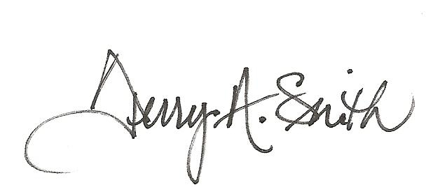 | 5/16/11 | 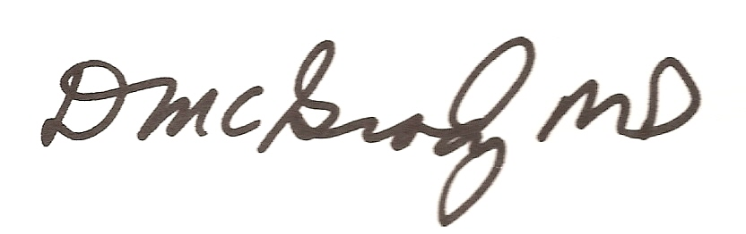 | 5/17/11
 |  |  | 4/23/12 |  | 5/5/12
 |  | 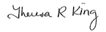 | 4/20/14 |  | 4/24/14
 |  |  | 4/7/16 |  | 4/8/16
Marsha Bishoff | 5/10/18 |  | 5/10/18 |  | 5/15/18
Marsha Bishoff | 8/8/18 |  | 8/1/18 |  | 8/10/18

