  METHODIST |  |  | 1 of 3 | Section: UPM HEMO | Policy #: 07
 | HEMATOLOGY |  | Approved by: see signature block at end of document |  | Date: 2/26/19  Review by: 2/26/21
 | LABORATORY |  | Policy Created: 10/20/97  Supersedes: 1/19/10, 8/2/12, 7/17/14, 7/25/16, 3/20/18, 6/20/18, 7/3/18, 2/26/19
Primary Responsible Parties: Kim Paige
Secondary Responsible Parties: June Bembenek
 |  |  | CAP Standard: NA
SUBJECT: |  | MALARIA TESTING SUBMITTED TO IDPH

I. POLICY
All positive malaria screening tests will be sent to the IDPH for further testing using the RT-PCR assay for malaria.

II. PURPOSE
IDPH will identify malarial infection. If the IDPH is unable to confirm malarial infection, blood and corresponding paperwork will be referred to the Center of Disease Control.

III. POLICY SCOPE
Hematology Technologists and Referral Specialist

VI. GENERAL INFORMATION
- ml EDTA whole blood
Make sure the specimen contains the patient’s full name and date of birth.
Complete a Communicable Diseases Laboratory test requisition form. Include preliminary microscopic observations including semi-quantitation, such as low-level of parasitemia, etc. on pg. 2 in the “Other Pertinent Information” section.
Send all specimens at 4-8° In addition to sending the whole blood to IDPH. The Peoria County Health Department must also be notified.

V. PROCEDURE
- Notify the Peoria County Health Department at (309) 679-6022. For all inpatients, also notify the UnityPoint Health Methodist Infection Control Nurse.
- Notify the State Department of Public Health by calling the Parasitology Laboratory at (312)793-5466.
- Mail blood sample to IDPH:
  - Place the properly labeled specimen in a leak proof bag Make sure specimen and bag are tightly sealed.
  - Place specimen and all forms in a white mailing box. (These are located on the ARUP shelves in the storeroom.) Make sure that the specimen is packaged with packing material to prevent breakage in transport.
  - Fill out IDPH Information Form and the IDPH Communicable Diseases Laboratory Test requisition (Forms may be found in "Malaria Folder" in black filing cabinet in Hematology).
  - Copy form and place the copy in Malaria file for our record.
  - Specimen shipping bags, pre-printed labels, etc can be obtained from the referral specialist. The box that contains the specimens must have a Category B sticker placed on it prior to placing in the shipping bag. Seal bag and deliver to the admin office and place it into the area for UPS pickups.
Ship UPS to:

Illinois Department of Public Health
Division of Laboratories
825 N. Rutledge St
Springfield, IL 62702
(217)782-6562

- When the green report from IDPH comes back with result, order a malaria confirmation test (MISCLB) on the same accession # as original malaria test. Free text "Illinois Department of Public Health reports the malaria to be__________". IDPH performs this testing at no charge.
- Staple the green slip to IDPH Malaria Information Form and re-file in the "Malaria Folder".

VI. MAINTENANCE AND STORAGE
  - All policies and procedures are reviewed every two years, (except for Safety procedures which are yearly) by Laboratory Administration and or the Medical Director of the Laboratory or designee when there are changes in practice standards, or requirements.
  - All policies and procedures are reviewed every two years (except for Safety procedures which are yearly) by staff or at the time new or revised ones are put in effect.
  - All policies are retained 8 years after being discontinued or revised.
  - All procedures are retained 2 years after being discontinued or revised

MEDICAL DIRECTOR
DATE | NAME | SIGNATURE
February 11, 2017 | Elizabeth A. Bauer-Marsh, M.D.
SECTION MEDICAL DIRECTOR
July 17, 2014 | Julia Adams, M.D.

REVISION HISTORY
Rev | Description of Change | Author | Effective Date
 | Initial release | Judy Sutherland | 10/20/97
1 | Added# 1 in front of order number Added revision history table and reviewed by table. | Kathy Turpin | 08/02/12
2 | Added Scope | Kathy Turpin | 7/2/14
3 | Updated verbiage to include UnityPoint Health Methodist; minor wording corrections; updated IDPH information. | June Bembenek | 03/16/18
4. | Changed procedure to reflect proper steps and locations for mailing out malarial smears added another form | Kim Paige | 7/3/18
5 | Updated policy per IDPH Memorandum rec’d on 2-22-19, specimen and testing requirements. Changed title of policy and worksheet. | Kim Paige | 2/22/19

REVIEWED BY
Lead | Date | Coordinator/Manager | Date | Medical Director | Date
 |  |  | 8/2/12 | 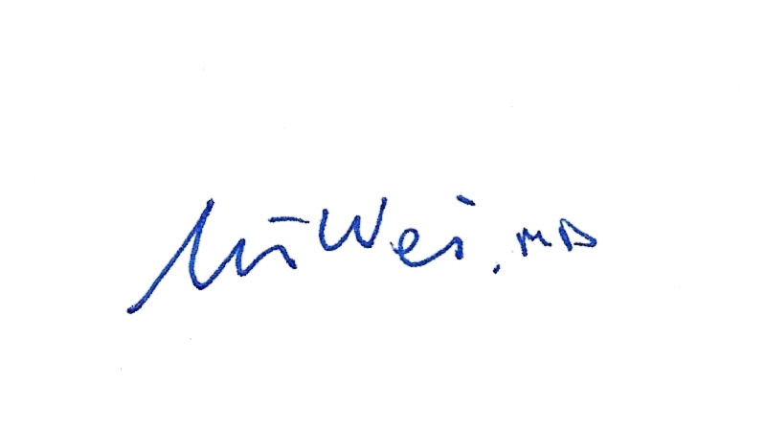 | 8/8/12
R. Fitzgerald | 5/29/14 |  | 7/2/14 |  | 7/17/14
 |  |  | 7/19/16 |  | 7/25/16
Kim Paige | 3/19/18 |  | 3/16/18 |  | 3/20/18
Kim Paige | 6/14/18 |  | 6/14/18 |  | 6/20/18
Kim Paige | 7/3/18 |  | 7/3/18 |  | 7/3/18
Kim Paige | 2/22/19 |  | 2/22/19 |  | 2/26/19


IDPH MALARIA INFORMATION FORM

PATIENT NAME:
ADDRESS:

GENDER:

DATE OF BIRTH:

DATE OF ONSET:

TRAVELED OUT OF COUNTRY? YES When? Where?

ATTENDING PHYSICAN:

STATUS OF PATIENT:

FROM: Department of Pathology & Laboratory Medicine
Hematology Section
Methodist Medical Center of Illinois
221 N.E. Glen Oak
Peoria, Illinois 61636

