|  |  |  |  |  |  |
| --- | --- | --- | --- | --- | --- |
| /Volumes/dsm/UPH/Creative Services/Graphic Design/Logos/UnityPoint Health/UnityPoint Health/png/1 UP Health 2c H.png  METHODIST | | | Page 1 of 6 | Section: UPM BBPRO | Policy #: 02.032 |
|  | BLOOD BANK PROCEDURES | | Approved by: see signature block at end of document | | Date: 2/4/19  Review by: 2/4/20 |
|  | LABORATORY | | Policy Created: 5/28/02  Supersedes 10/19/11, 1/21/14, 7/11/16, 5/9/17 | | |
|  | |  | Primary Responsible Parties:  Secondary Responsible Parties: June Bembenek | | |
|  | |  | CAP Standard: NA | | |
| SUBJECT: | | RESOLVING ABO DISCREPANCIES | | | |

**Principle**

ABO testing may give unexpected reaction patterns, some possible causes are listed below:

* ABO subgroups
* Autoagglutinins/excess plasma proteins
* Hypogammaglobulinemia
* Cold reacting allo/autoantibodies

This procedure shall serve as a guide for techs to recognize and utilize the appropriate management for ABO discrepancies that may present during routine testing.

**Clinical Significance**

Forward and reverse typing need to agree so that the proper blood type is interpreted and thus a safe transfusion is assured.

**SCOPE**

This policy applies to all Blood Bank technologists.

**Specimen**

Patient Preparation: No special preparation of the patient is required prior to specimen collection. Blood should be collected by approved techniques.

Requirements: K2 EDTA pink or lavender top tube is preferred.

Minimum Volume:

* Adult: 3.0 mL whole blood
* Pediatric: 2 - K2 EDTA microtainers (each with 300-500 uL) or cord blood specimen

Specimen Stability:

If stored at room temperature 15-30°C, stable for testing for 24 hours.

If stored 2-8°C, stable for testing for 72 hours.

Storage: 2-8°C for a minimum of 7 days after transfusion, or 10 days post crossmatch.

Rejection Criteria: Hemolysis. **In rare occasions where sample cannot be redrawn, hemolyzed specimen may be used for testing as long as the testing personnel can accurately interpret the reactions.

**Reagents**

|  |  |  |
| --- | --- | --- |
| **Reagent** | **Storage** | **Stability** |
| Isotonic Saline | 15-30°C | Unopened: exp date  Open: 1 month. |
| Biotestcell A1and B reagent cells, BIO-RAD | 2-8°C | Exp date |
| Anti-Human Globulin, Anti-IgG,Rabbit, BIO-RAD. | 2-8°C | Exp date |

**Instrumentation/Equipment**

1. 10 x 75 mm tubes
2. centrifuge
3. pipettes

**Quality Control**

To be performed once per day of testing. Refer to Blood Bank Quality Control Procedure for more information, Daily Reagent Quality Control UPMBBQA 03.003

**Procedure**

Technical or clerical errors are a common source of ABO discrepancies; repeat the ABORh with a new suspension, ensuring all tubes are labeled properly and double checking the reagents in use. Once technical or clerical error has been ruled out, it is necessary to determine the source of the discrepancy so appropriate management can take place.

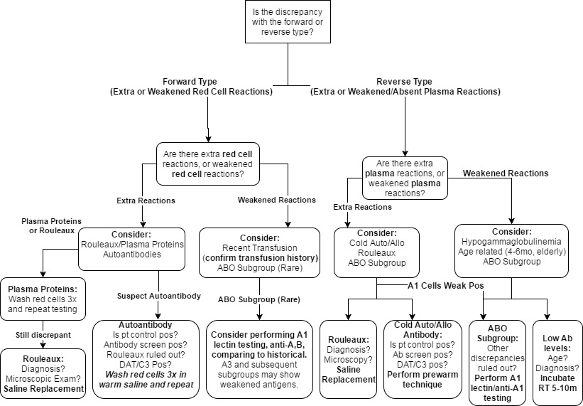

*Chart is for guidance purposes, refer to following procedures for resolution*

**Saline Replacement Procedure for possible discrepancy due to Rouleaux**

Excess plasma proteins can cause pseudo-agglutination, manifesting as additional reactions.  
Microscopic examination of the patient control will show the classic “stack of coins” appearance.   
**This discrepancy may appear in both the forward and the reverse typings.** The patient’s clinical diagnosis may be helpful, as abnormalities with globulin levels are often associated with conditions such as multiple myeloma or lymphoma.

1. Recentrifuge the tubes where rouleaux was observed.
2. Remove the supernatant, leaving the red cell button.
3. Replace the supernatant with equal volume saline (2 drops).
4. Resuspend the cell button gently and read for agglutination. Rouleaux will disperse when suspended in saline. True agglutination is stable in the presence of saline.
5. If agglutination persists, consider other potential causes, such as cold autoantibody or ABO subgroup.

**Suspect discrepancy due to subgroup of A**

Subgroups of A, such as A2, may have Anti-A1 present in their plasma that binds to the A1 red cells (≤2+ reactivity) used for reverse typing. A1 lectin testing and reagent A2 cells should be used for resolution. AB blood groups may also have subgroup of A.  
**If rare subgroup showing weakened red cell reactivity (Ax, Ael) is suspected, notify lead.**

-Refer to UPM BB Procedure 03: Anti-A1 Lectin and Anti-A1 Testing

**Room Temperature Incubation for hypogammaglobulinemia**

Plasma from elderly (or immune-suppressed) patients may have lower levels of antibodies, demonstrating significantly weaker reactivity in the reverse typing at immediate spin. Confirm age and diagnosis.

1. Incubate the A1, B, and patient control tubes at room temperature for 5-30 minutes.
   1. Adding 2 extra drops of plasma may enhance reactivity
   2. Incubating for the full 30 minutes may enhance reactivity
2. After incubation, mix well, centrifuge, and read for agglutination, using a viewer if necessary.
3. If RT incubation fails to resolve discrepancy, consider other potential causes, such as bone marrow transplantation or recent transfusion.

**Warm saline wash for forward discrepancy due to cold autoagglutinin**

With sufficiently high titers of autoagglutinin, patient red cells may spontaneously agglutinate during centrifugation, causing a discrepancy in the forward typing. Washing the patient red cells in warmed saline may help manage interference from strong cold autoantibodies. ABO antisera should **never** be incubated at 37°C.

1. Aliquot a small amount of patient red cells for washing. A 12x75 tube may be used if desired.
2. Prepare a 3-5% cell suspension and incubate at 37°C for 15 minutes.

-If strongly reacting cold autoantibody encountered, incubate for 30-60 minutes

1. Hand wash patient red cells three times with 37°C warmed saline.
2. Decant last wash fully and prepare a 3-5% cell suspension with warmed saline for testing.
3. Perform the forward typing immediately, and read for agglutination.
4. If warm saline wash fails to resolve discrepancy, consider other potential causes, such as mixed field reactivity due to recent transfusion.

**Prewarm Procedure for reverse discrepancy due to cold autoagglutinin**

1. Incubate several drops of patient plasma, one drop patient cell suspension, and one drop of reagent A1 cells, and reagent B cells separately in 37°C incubator for 5 to 10 minutes.   
    -If strong antibody, incubate the full ten minutes.
2. Add 2 drops of plasma to A1, B, and patient cells without removing tubes from the incubator.
3. Incubate 30-60 minutes. If strong antibody, incubate for 60 minutes.
4. After incubation, immediately centrifuge and read for reactivity.
5. If prewarm incubation fails to resolve discrepancy, consider other potential causes, such as rouleaux or ABO subgroup.

**Reporting Results**

Determine the individual’s group based on the presence or absence of agglutination as follows:

|  |  |  |  |  |  |
| --- | --- | --- | --- | --- | --- |
| Anti-A | Anti-B | A1 Cells | B Cells | Patient Control | Group Interpretation |
| NEG | NEG | POS | POS | NEG | O |
| POS | NEG | NEG | POS | NEG | A |
| NEG | POS | POS | NEG | NEG | B |
| POS | POS | NEG | NEG | NEG | AB |

1. Enter results and interpretation into the LIS
2. Enter a comment for appropriate technique used to resolve discrepancy.

**References**

1. ARC Reference Laboratory
2. AABB. (2014). Technical Manual (18th ed.). Bethesda, MD: Author.
3. Bio-Rad Reagent Red Blood Cells Biotestcell A1&B insert, rev 18613/09 Aug 2014

|  |  |
| --- | --- |
| ***POLICY CREATION :*** |  |
| ***Author: Kathy Maher*** | ***May 28. 2002*** |
| ***Medical Director: Douglas McGrady, MD*** | ***May 28, 2002*** |

|  |  |  |
| --- | --- | --- |
| ***MEDICAL DIRECTOR*** | | |
| DATE | NAME | SIGNATURE |
|  | Elizabeth A. Bauer-Marsh, M.D. |  |

|  |  |  |  |
| --- | --- | --- | --- |
| **REVISION HISTORY** | | | |
| **Rev** | **Description of Change** | **Author** | **Effective Date** |
| 1 | Minor formatting changes, added Document ID to header. Added new LIS steps. | S. Schaffer | 9/15/11 |
| 2 | Updated reagents to BIO-RAD and changed reagent storage temp. | Kathy Turpin | 12/6/13 |
| 3 | Removed LIS specific reference | Vincent Strow | 2/10/16 |
| 4 (Revision) | Updated Policy to cover more ABO discrepancies and maintenance thereof. Updated reverse discrepancy prewarm procedure in accordance with AABB 18th edition technical manual. Added procedures for discrepancy maintenance in accordance with AABB 18th edition technical manual and manufacturer’s inserts. | Vincent Strow | 5/4/17 |
| 5 | Added Saline Replacement reference to rouleaux discrepancy; Added reference to Daily Reagent QC UPMBBQA 3.003 | June Bembenek | 3/7/19 |

**Reviewed by**

|  |  |  |  |  |  |
| --- | --- | --- | --- | --- | --- |
| **Lead** | **Date** | **Coordinator/**  **Manager** | **Date** | Medical Director | **Date** |
| K. Maher | 12/30/11 | schafer | 12/19/11 |  | 10/19/11 |
| D. Allen | 1/20/14 |  | 1/20/14 |  | 1/21/14 |
| V. Strow | 2/10/16 |  | 7/8/16 |  | 7/11/16 |
| V. Strow | 5/8/17 |  | 5/8/17 |  | 5/9/17 |
|  |  |  | 3/7/19 |  | 3/11/19 |
|  |  |  |  |  |  |