  METHODIST |  |  | Page 1 of 24 | Section: UPMCHEMI | Policy #: 04.048
 | IMMUNO CHEMISTRY |  | Approved by: see signature block at end of document |  | Date:  Review by:
 | LABORATORY |  | Policy Created: Date policy first signed off by medical director  Date Reviewed: Oldest first
Primary Responsible Parties: section lead
Secondary Responsible Parties: section coordinator
 |  |  | CAP Standard:
SUBJECT: |  | SYPHILIS TOTAL IGG/IGM AND RPR

- PROCEDURE STATEMENT:
The BioPlex 2200 Syphilis Total & RPR kit employs Treponema pallidum fusion protein (rTP47/rTP17) and cardiolipin antigen-coated fluoromagnetic beads with unique fluorescent signatures to identify the presence of IgG and IgM antibodies to Treponema pallidum and nontreponemal reagin antibodies in a two-step assay format.
Dyed beads are coated with recombinant T. pallidum rTP47/rTP17 fusion protein or cardiolipin antigen. The BioPlex 2200 System combines an aliquot of patient sample, sample diluent, and bead reagent into a reaction vessel. The mixture is incubated at 37°C. After a wash cycle, a mixture of murine monoclonal anti-human IgG and murine monoclonal anti-human IgM antibody conjugated to phycoerythrin (PE) is added to the dyed beads, and this mixture is incubated at 37°C. The excess conjugate is removed in another wash cycle and the beads are re-suspended in wash buffer. The bead mixture then passes through the detector. The identity of the dyed beads is determined by the fluorescence of the dyes, and the amount of antibody captured by the antigen is determined by the fluorescence of the attached PE. Raw data is calculated in relative fluorescence intensity (RFI).
Two additional dyed beads, an Internal Standard Bead (ISB) and a Serum Verification Bead (SVB) are present in each reaction mixture to verify detector response and the presence of serum or plasma in the reaction vessel. Refer to the BioPlex 2200 System Operation Manual for more information.
The system is calibrated using a set of five (5) distinct calibrator vials, supplied separately by Bio-Rad Laboratories. One vial containing negative sample and four vials containing human Treponema pallidum and human reagin antibodies, are used for qualitative calibration of the assays. The results are expressed in antibody index (AI). The Syphilis Total assay results are reported as nonreactive (≤ 0.8 AI), equivocal (0.9, 1.0 AI) or reactive (≥ 1.1 AI); while the RPR assay results are reported as nonreactive (< 1.0 AI) or reactive (≥ 1.0 AI).

- PURPOSE:
Syphilis is a global sexually transmitted disease caused by infection from the spirochete bacterium Treponema pallidum. Infection by T. pallidum, if untreated, can progress through many complex systemic disease stages over many years: primary, secondary, early latent, late latent, and tertiary. The disease stages are identified by clinical diagnosis [i.e., chancre, swollen glands and fever (primary), rash on extremities and swollen glands (secondary), asymptomatic (early and late latent) to neurological damage, massive cell destruction, and possible death (tertiary)] and diagnostic testing. Disease progression can be characterized by extended latency periods in excess of 20 years. Syphilis is also known to play a role in the spread of the HIV virus.¹

- SCOPE OF PROCEDURE:
The scope of this policy applies to all Laboratory staff that prepares or performs testing on laboratory specimens at UnityPoint Methodist.

- SPECIMEN:

Serum and plasma (EDTA and heparin) are the recommended sample types. Avoid hemolysis.

Serum or plasma may be stored under refrigeration (2-8°C) for up to 7 days. For longer storage of samples, keep at -20°C or colder.

Thoroughly mix thawed specimens; it is also recommended to centrifuge thawed specimens to remove gross particulate matter. Avoid multiple freeze/thaw cycles (up to 3 cycles is acceptable).

- TEST CODE:
- Sunquest: SYPHYGM

- REAGENT: Syphilis Total & RPR (  12000650). The reagent pack contains supplies sufficient for 100 tests.

Vial |  | Description
Bead Set   |  | One (1) 10 mL vial, containing dyed beads coated with recombinant Syphilis rTP47/rTP17 fusion protein, a cardiolipin antigen, an Internal Standard bead (ISB) and a Serum Verification bead (SVB) in MOPS (3-[N-Morpholino] propanesulfonic acid) buffer containing bovine proteins with protein stabilizers. ProClin 300 (≤ 0.3%), sodium benzoate (≤ 0.1%) and sodium azide (< 0.1%) are added as preservatives.
Conjugate   |  | One (1) 5 mL vial, containing phycoerythrin conjugated murine monoclonal anti-human IgG and murine monoclonal anti-human IgM, and phycoerythrin conjugated murine monoclonal anti-human FXIII antibody in phosphate buffer supplemented with murine and bovine protein stabilizers. ProClin 300 (≤ 0.3%), sodium benzoate (≤ 0.1%) and sodium azide (< 0.1%) are added as preservatives.
Sample Diluent   |  | One (1) 10 mL vial, containing bovine and murine protein stabilizers in MOPS (3-[N-Morpholino] propanesulfonic acid) buffer. ProClin 300 (≤ 0.3%), sodium benzoate (≤ 0.1%) and sodium azide (< 0.1%) are added as preservatives.
 | Description
12000651 | BioPlex 2200 Syphilis Total & RPR Calibrator Set: Four (4) 0.5 mL vials, each containing T. pallidum and reagin antibodies in a human serum matrix made from defibrinated plasma, and one (1) 0.5 mL vial containing human serum matrix made from defibrinated plasma for a total of five (5) calibrator vials. All calibrators contain ProClin 300 (≤ 0.3%), sodium benzoate (≤ 0.1%) and sodium azide (< 0.1%) as preservatives
12000653 | BioPlex 2200 Syphilis Total & RPR Control Set: Two sets of three (3) control vials. Each set contains two (2) 1.5 mL Positive Control vials with antibodies to T. pallidum and reagin in a human serum matrix made from defibrinated plasma and one (1) 1.5 mL vial of Negative Control in a human serum matrix made from defibrinated plasma. ProClin 300 (≤ 0.3%), sodium benzoate (≤ 0.1%) and sodium azide (< 0.1%) are added as preservatives for all controls.
660-0817 | BioPlex 2200 Sheath Fluid: Two (2) 4 L bottles containing Phosphate Buffered Saline (PBS). ProClin 300 (0.03%) and sodium azide (< 0.1%) are added as preservatives.
660-0818 | BioPlex 2200 Wash Solution: One (1) 10 L bottle containing Phosphate Buffered Saline (PBS) and Tween 20. ProClin 300 (0.03%) and sodium azide (< 0.1%) are added as preservatives.
660-0000 | BioPlex 2200 System and software
12006863 | BioPlex 2200 Sample Dilution Buffer: One (1) 120 mL bottle containing Phosphate Buffered Saline (PBS) and Tween 20. ProClin 300 (0.03%) and sodium azide (< 0.1%) are added as preservatives.

Contains ≤ 0.3% ProClin 300
May cause an allergic skin reaction.
IF ON SKIN: Wash with plenty of soap and water.
If skin irritation or rash occurs: Get medical advice/attention.

Preparation and Storage of Reagents
1. Do not freeze the Syphilis Total & RPR kit.
2. Reagents in the Syphilis Total & RPR kit are ready to use. After initial use, the reagents are stable for 60 days or until the date of expiration when stored unopened and on the instrument or refrigerated at 2-8ºC.
3. Do not use reagents beyond expiration dates.

Indications of Instability or Deterioration of Reagents
Store all reagents at the labeled temperature and do not use past their expiration dates. Do not use any reagents which have any indications of discoloration, cloudiness or precipitation. Do not use any reagents that show any signs of leakage. Do not exceed the storage time and temperature limitations listed above.

- INSTRUMENT/EQUIPMENT:
BioPlex 2200, manufactured by Bio-Rad Laboratories.

- CALIBRATION:
The Syphilis Total & RPR Calibrator Set should be loaded and assayed, at minimum, in duplicate every 30 days or with each new Reagent Pack lot. A two or four point curve is used to calculate results corresponding to the cutoff concentration. Refer to the BioPlex 2200 System Operation Manual for more information.

- QUALITY CONTROL
At the beginning of each day that the Syphilis Total & RPR kit is to be used, load and process the Syphilis Total & RPR Control Set as indicated in the BioPlex 2200 System Operation Manual. The Syphilis Total & RPR Control Set should be run at least once per day, and with each new Reagent Pack lot.
The Syphilis Total & RPR Control Set includes a negative control and a positive control each for Syphilis Total and RPR in a human serum matrix made from defibrinated plasma. Each positive control contains antibodies for analytes within the Syphilis Total & RPR kit. The positive control is manufactured to give reactive results, with values above the cut-off for each specific bead. The negative control is manufactured to give nonreactive results with values below the cut-off for each specific bead. The negative control must have a nonreactive result, and the positive control must have a reactive result.
Note: The Negative and Positive Controls of the Syphilis Total & RPR Control Set are intended to monitor for substantial reagent failure. The Positive Control will not ensure precision at the assay cutoff.
Lot specific values for the positive control are loaded into the BioPlex 2200 System database via the provided media or by manual input. After identifying the control via the barcoded vial, the BioPlex 2200 System compares the control results to the expected lot specific control values stored in the BioPlex 2200 System database.
Failure to obtain the appropriate values for controls will invalidate the assay and indicates procedural error, improper sample handling or deterioration of reagents. Additional controls may be tested in accordance with local, state and/or federal regulations or accreditation requirements and your laboratory’s quality control policy
IMPORTANT QC TROUBLESHOOTING:
At low frequency, reagent packs may exhibit falsely low signals for certain analytes and generate QC errors. The following troubleshooting steps should be followed when observing the noted QC behavior:
1. QC Warning - low for only some analytes:
Repeat QC testing. If the QC Warning repeats, remove the pack with the flagged QC results and do not use. Please call Bio-Rad Technical Support to report the suspected low signal pack. Run QC with a new reagent pack. If QC results are within the acceptable range on the new reagent pack, discard the affected reagent pack with the QC Warning - Low results and do not report patient test results from that reagent pack. If the QC Warning repeats on the new reagent pack, please call Bio-Rad Technical Support for assistance with troubleshooting. Re-test any samples that were tested using the affected reagent pack. If multiple packs for a particular BioPlex 2200 assay are on-board the instrument, the reagent pack (kit) serial number associated with the QC Warning - low results can be determined by viewing the Control Result dialog for the corresponding QC Event.
2. QC Warning - high for only some analytes:
Recalibrate the reagent pack with the QC Warning - high and re-run QC. Verify that QC results are within the acceptable range for all analytes before reporting patient results. Any samples tested using the pack with the QC Warning - high must be retested. Patient samples run on the affected pack are valid due to the fact that a calibration occurred with that pack.
If a control result is out of its specified range, any test results generated since the last acceptable control results must be evaluated to determine if test results may have been adversely affected. Adversely affected results are invalid, and these samples must be retested.

- PROCEDURE:
A. Steps for the routine operation of the instrument include the following:
- Maintenance
- Assay calibration
- Assay quality control
- Sample loading
- Sample removal
- Result review
- End of shift procedure

B. MAINTENANCE

1. Daily maintenance
- Address messages
- Load Reagent Packs
- Replenish supplies and empty waste
- Visual inspection

2. Weekly Maintenance
- Inspect the sheath filter
- Inspect the syringes
- Clean the sample handler
- Database maintenance
- Inspect and wipe the system probes
- Clean the system probes
- Detector calibration
3. Monthly Maintenance
- Clean the liquid waste containers
- Sanitize the deionized water container
4. On Demand Maintenance
a. Other maintenance activities done on a periodic basis are described in section 11.8 of the BioPlex 2200 System Operation Manual.
b. All maintenance activities are described in detail in section 11.1 – 11.84 of the BioPlex 2200 System Operation Manual.

- REPORTING RESULTS
Report out as Nonreactive, Equivocal or Reactive.

As of January 1, 2019, we are not reporting out the RPR. If a RPR is needed, the RPR will be sent to a reference laboratory for further testing.

1. Measuring Range

AMR: 0.2 – 8.0 AI
CRR: 0.2 – 8.0 AI

2. Guidelines for Interpretation of Results
All calculations necessary to interpret the results are performed automatically by the BioPlex 2200 System Software. Results are calculated for each analyte and are compared against its respective cutoff.

Syphilis Total assay results are expressed as an antibody index (AI). Results of ≤ 0.8 AI are nonreactive, 0.9 and 1.0 AI are equivocal, and ≥ 1.1 AI are reported as reactive.
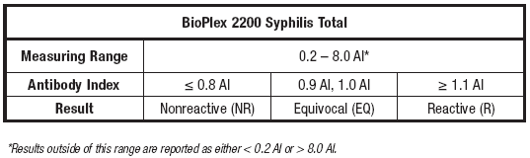
For specimens that are equivocal, the patient sample will be treated as a postitive result. Run patient in duplicate. Follow with confirmation testing if needed of RPR. If the repeated testing is still equivocal, report out equivocal. . In conjunction with these results, the immune status of patients should be evaluated based on their clinical status, related risk factors, and other diagnostic test results. Initially reactive results should be supplemented with a non-treponemal test to distinguish between present and past infection. An additional sample should be obtained (one drawn at a later date) if the results of non-treponemal and treponemal tests do not establish a diagnosis.
Diagnostic considerations should be based on treponemal and nontreponemal testing as described in the Centers for Disease Control and Prevention (CDC) Sexually Transmitted Diseases Treatment Guidelines, 2015.³

3. Titer for RPR Reactive Samples
Samples that are REACTIVE for the qualitative RPR may be titered (optional). To titer reactive samples, the following titers may be requested in the user interface: 1:4, 1:8, 1:16,1:32, and 1:64. Test each dilution as described in the section above. Note: RPR titers are recommended to be run in batch mode.
For titers < 1:4 or > 1:64, manual dilutions may be performed using BioPlex 2200 Sample Dilution Buffer (P/N 12006863).
For titers < 1:4, a 1:2 manual dilution (150 μl neat sample + 150 μl BioPlex 2200 Sample Dilution Buffer) is required. The diluted sample should then be run neat (no onboard dilution required).
For titers > 1:64, a 1:32 manual dilution (25 μl neat sample + 775 μl BioPlex 2200 Sample Dilution Buffer) is required. Once the 1:32 dilution is made, the five on- board dilutions may be requested in the user interface (1:4, 1:8, 1:16, 1:32 and 1:64) to obtain extended titers for 1:128, 1:256, 1:512, 1:1024 and 1:2048 respectively.

4. The following table can be used for additional interpretation of results:
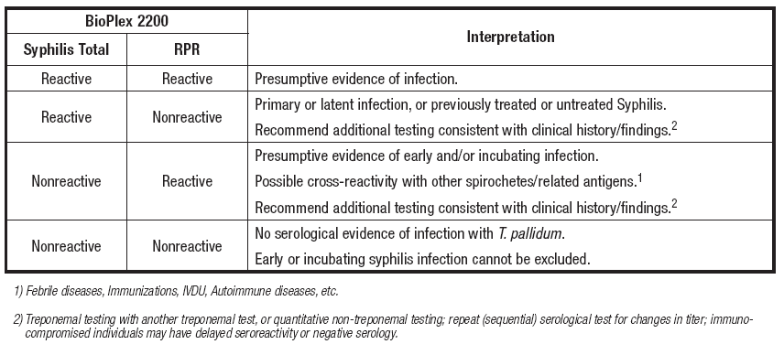

5. RPR Titer Data Analysis
RPR titer results on RPR reactive samples should be reported as shown below. Samples nonreactive at 1:4 dilution should be interpreted as titer: < 1:4. Samples reactive at 1:64 dilution should be interpreted as titer: > 1:64.
The RPR titer corresponds to the highest reactive dilution. For example:
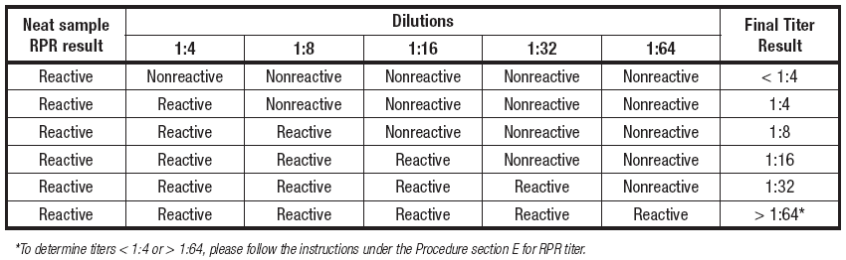

Prevalence
Expected values for the Syphilis Total & RPR kit are presented by age and gender for patients included in the study. The following tables (Tables A – C), show BioPlex 2200 test results for serum samples from the intended use population, which includes patients who had a syphilis test ordered (N=401), pregnant women (N=295), and HIV positive patients (N=305).
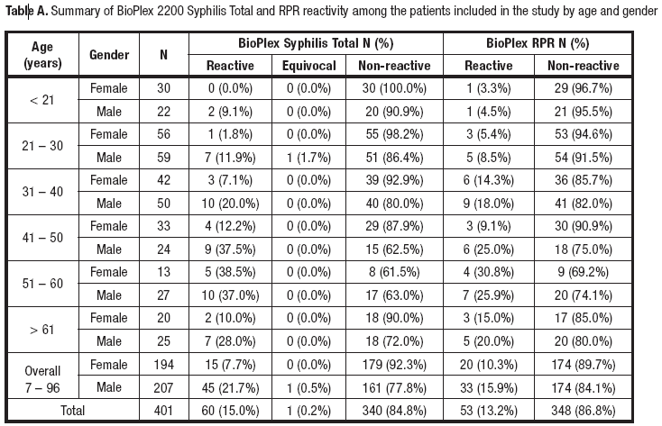
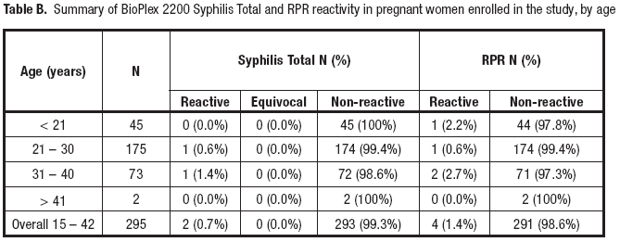
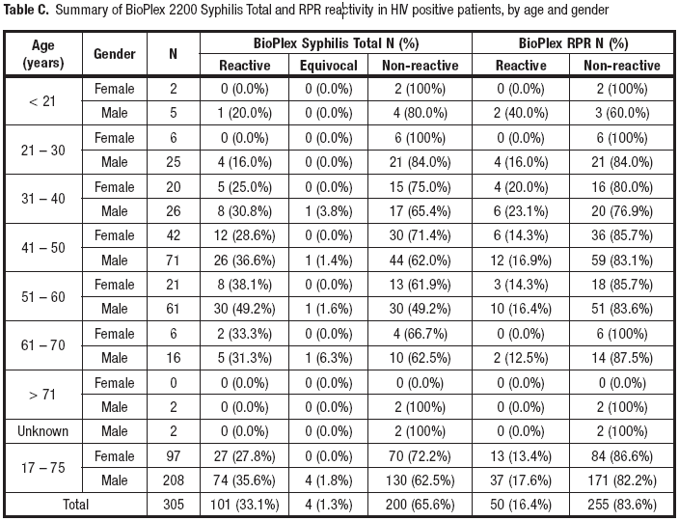

Performance Characteristics
The performance of the BioPlex 2200 Syphilis Total assay was evaluated against three commercially available reference assays (Treponemal, non-treponemal and 2nd Treponemal). The final, interpreted comparator results are shown below in Table D.
The performance of the BioPlex 2200 RPR assay was evaluated against commercially available RPR assay.
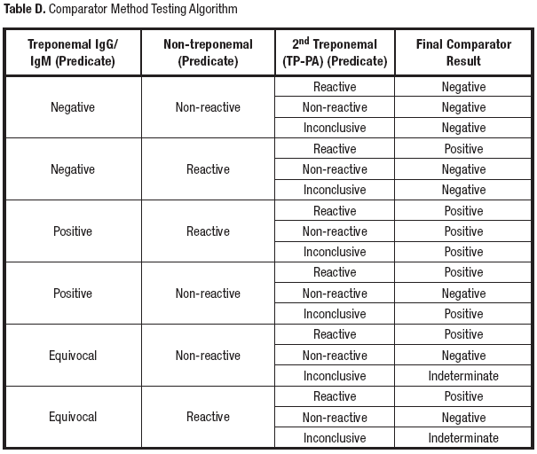

Method Comparison

Prospective Study
A total of 1001 serum samples were evaluated at three (3) U.S. clinical testing sites. Performance of the BioPlex 2200 Syphilis Total & RPR kit was evaluated using serum samples from patients who had a syphilis test ordered (N=401), HIV positive patients (N=305), and pregnant women who had a syphilis test ordered (N=295). Results are shown in Tables E – F.
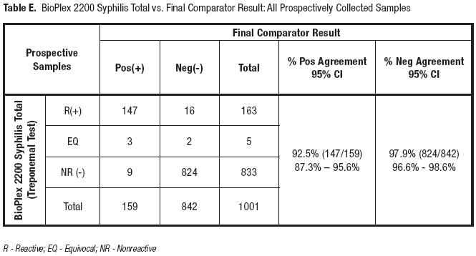
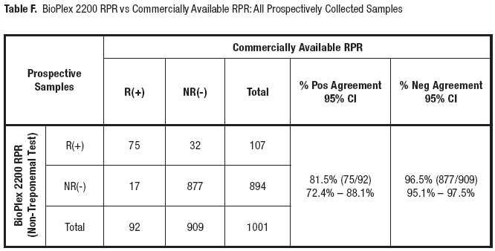

Apparently Healthy Subjects
An additional study was conducted to evaluate the performance of the BioPlex 2200 Syphilis Total & RPR kit using a total of 301 samples collected prospectively from apparently healthy subjects.
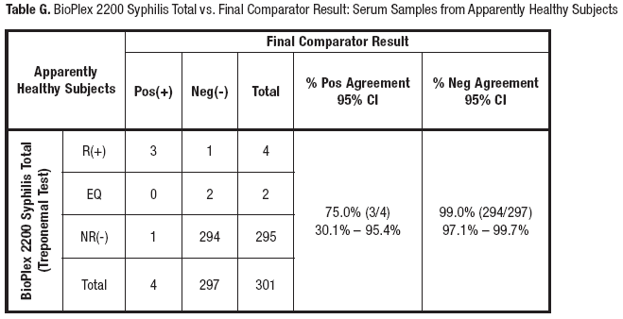

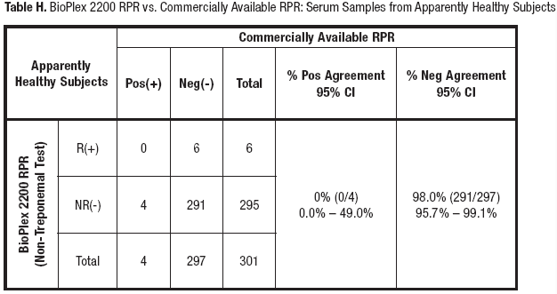

Clinical Performance in Samples from Pregnant Women
Performance of the BioPlex 2200 Syphilis Total & RPR kit was evaluated using a total of 372 samples from pregnant women who had a syphilis test ordered (N=295), including pregnant women with a history of STD (N=45), and pregnant women with presumptive positive syphilis test results (N=32).
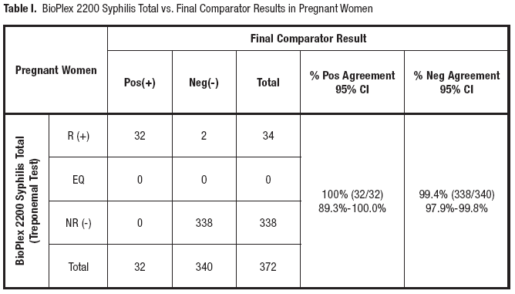
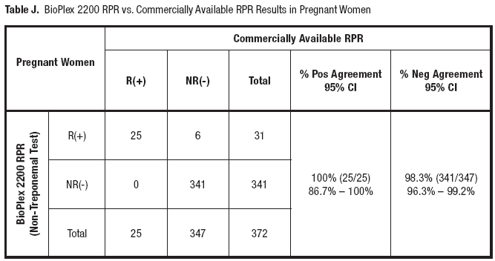

Retrospective Study
Performance of the BioPlex 2200 Syphilis Total & RPR kit was evaluated using a total of 544 retrospective samples, including RPR/VDRL positive samples (N=410), samples from pregnant women with a history of STD (N=45), samples from pregnant women with presumptive syphilis positive test results (N=32), and samples from HIV/Syphilis dual positive patients (N=57).
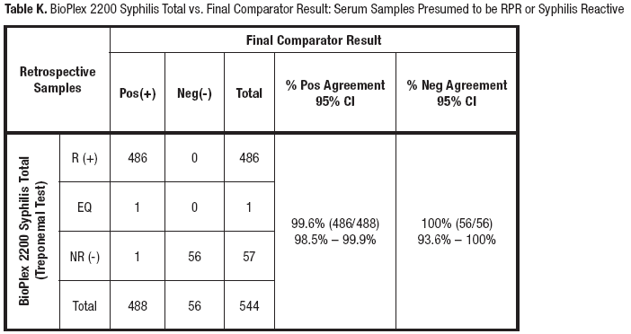
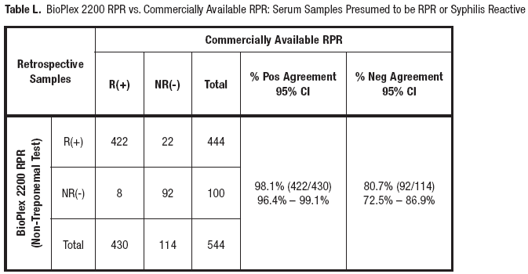

BIOPLEX 2200 SYPHILIS REACTIVITY IN HIV-1 POSITIVE SAMPLES
Performance of the BioPlex 2200 Syphilis Total & RPR kit was evaluated using samples from HIV positive individuals (N=362) including 57 HIV/Syphilis dual positive.

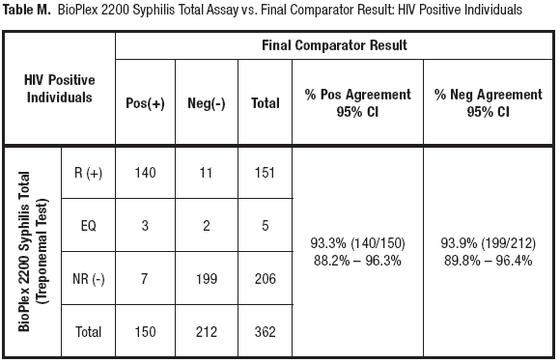
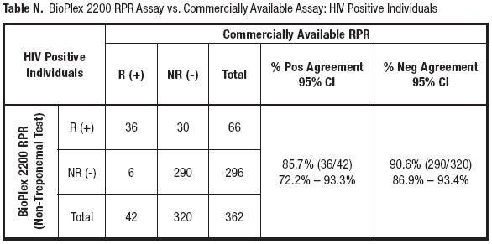

BIOPLEX 2200 SYPHILIS RESULTS IN PATIENTS MEDICALLY DIAGNOSED WITH SYPHILIS
The performance of the Syphilis Total & RPR kit was evaluated using banked frozen characterized sera (N=156), with known disease stage and treatment status. Samples were from treated and untreated patients with primary, secondary or latent infections. Performance of the Syphilis Total assay was compared to final comparator results as described above. The BioPlex 2200 RPR assay was compared to commercially available RPR assays. Results are shown below in Tables O – P.

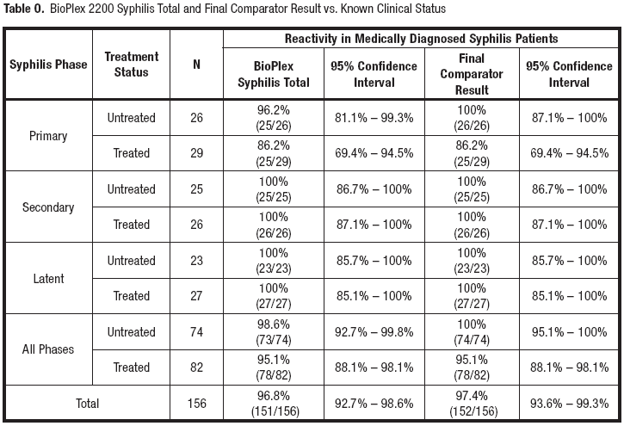
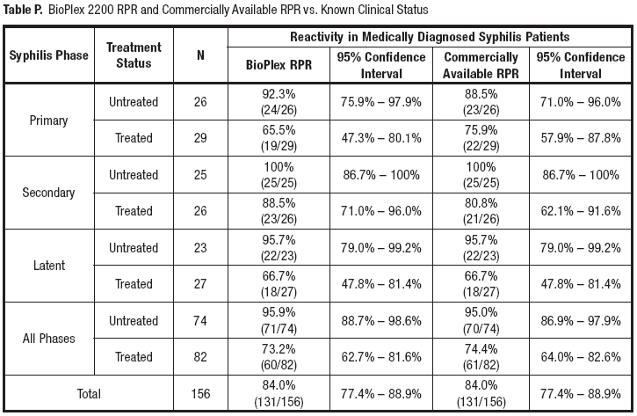

Diagnostic Test Results
Results from testing with the BioPlex 2200 Syphilis Total & RPR are presented below to demonstrate its utility as a diagnostic test. The BioPlex Syphilis Total & RPR assay also confirms reactive results from other commercially available treponemal and non-treponemal screening assays.

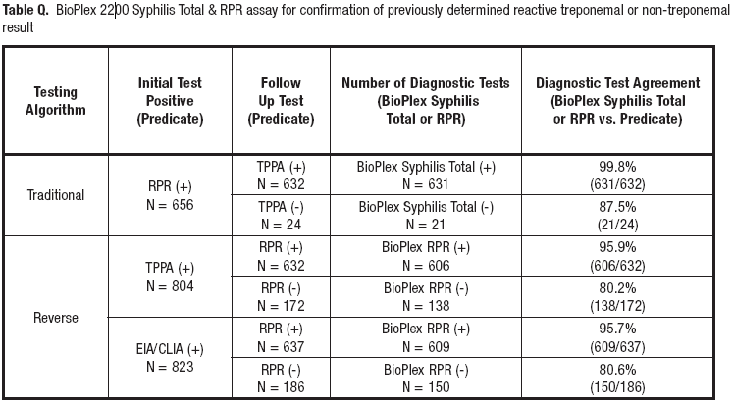
The following Serological Profile Tables for the Prospective and Retrospective Data further support the data above.
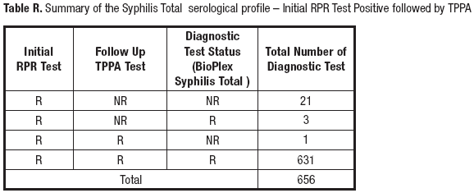

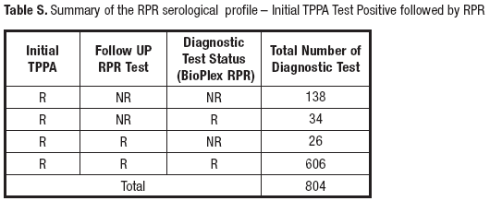
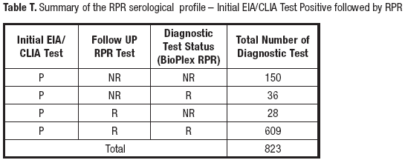

REPRODUCIBILITY STUDIES
Reproducibility testing was performed at three (3) US testing sites using one (1) lot of the Syphilis Total & RPR kit, one (1) lot of the Syphilis Total & RPR Calibrator Set, and one (1) lot of the Syphilis Total & RPR Control Set.
The reproducibility panel and positive and negative controls were tested on three (3) sites in quadruplicate (x4) in two (2) runs per day for five (5) days to generate 120 data points per panel member and controls (3 sites x 4 replicates x 2 runs x 5 days = 120).
The data were analyzed for intra-assay and inter-assay reproducibility according to the principles described in the Clinical Laboratory Standards Institute guidance EP15-A3. The standard deviation (SD) and percent coefficient of variation (%CV) were calculated. Results are shown below.
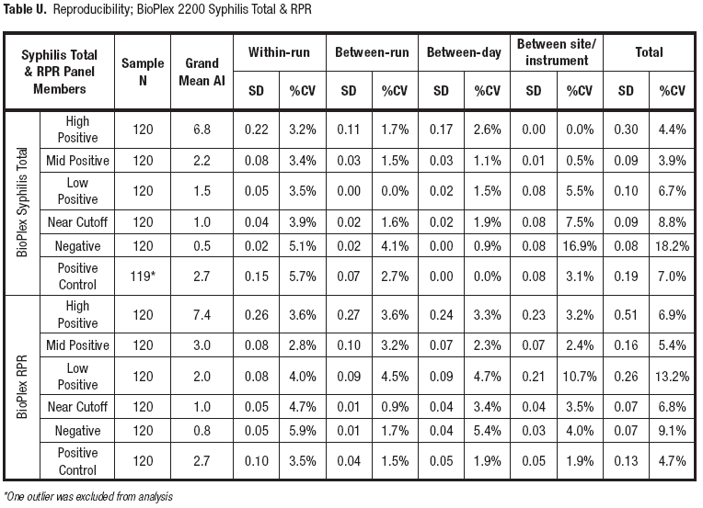

PRECISION STUDIES
Precision testing was performed at Bio-Rad Laboratories with one lot of the BioPlex 2200 Syphilis Total & RPR kit, one lot of the BioPlex 2200 Syphilis Total & RPR Calibrator Set and one lot of the BioPlex 2200 Syphilis Total & RPR Control Set. Precision panel members and positive and negative controls were tested in duplicate (2x) on two (2) runs per day for twenty (20) days to obtain 80 data points per member and control (2 replicates x 2 runs x 20 days = 80). The data were analyzed for intra-assay and inter-assay precision according to the principles described in the Clinical Laboratory Standards Institute guidance EP5-A3. The standard deviation (SD) and percent coefficient of variation (%CV) were calculated.
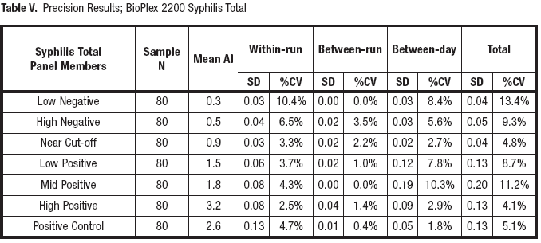
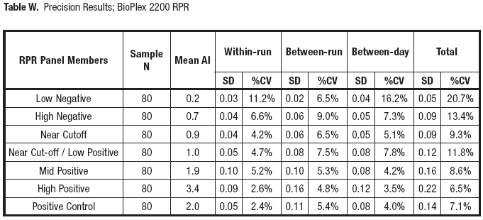

CROSS-REACTIVITY
A cross-reactivity study was performed to determine if samples from various disease states and other potentially present antibodies cross-react with test results when tested with the BioPlex 2200 Syphilis Total & RPR kit. A panel of minimum ten (10) specimens positive for each cross reactant was evaluated for possible cross reactivity with the BioPlex 2200 Syphilis Total & RPR kit. All cross-reactant samples were pretested by commercially available Syphilis Total or RPR assays and only those that tested negative were further evaluated by the BioPlex 2200 Syphilis Total and RPR kit. Percent negative agreement is calculated by dividing the numbers of negative results of the BioPlex 2200 Syphilis Total and RPR assays by the total number of negative samples tested. The results demonstrated no significant cross-reactivity for the various disease state samples and the BioPlex 2200 Syphilis Total & RPR assays.
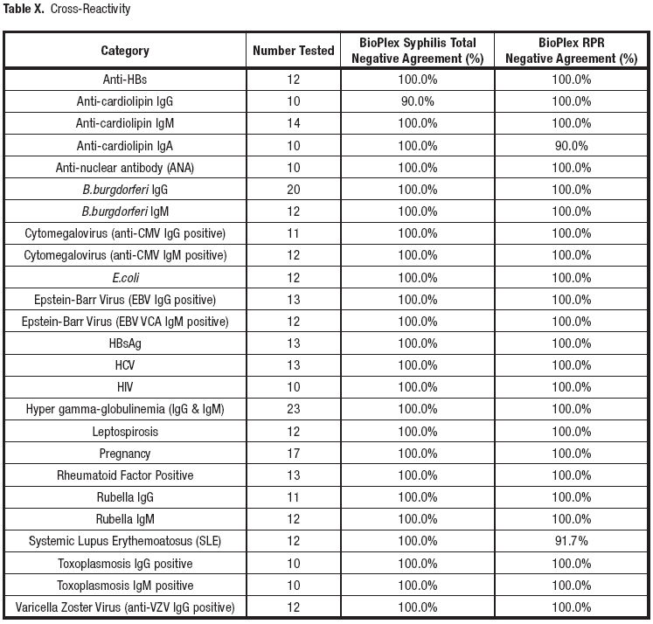
INTERFERING SUBSTANCES
Testing for interfering substances was conducted according to CLSI Protocol EP07-A2. No significant interference was observed with any of the substances tested (N=10) at concentration levels shown below.
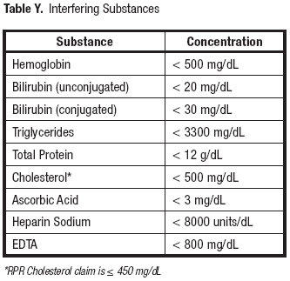

- PROCEDURAL NOTES/PROBLEM-SOLVING TIPS
1. The Syphilis Total & RPR test results should be considered with other laboratory results as well as the clinical presentation of the patient. Results should be interpreted by a physician.
2. A nonreactive result does not exclude the possibility of exposure to or infection with T. pallidum. Antibodies may be at low or undetectable levels in incubating or early primary disease and in some clinical conditions. Therefore results need to be interpreted with caution.
3. Detection of treponemal antibodies may indicate recent, past or successfully treated syphilis infections and therefore cannot be used to differentiate between active and cured cases.
4. Assay interference due to circulating antibodies against yaws, pinta, and bejel has not been evaluated. Cross-reactivity with these treponemal disease conditions is to be expected with treponemal antibody tests.
5. RPR Assay interference resulting in false positive results may occur due to cross reacting antibodies from patients diagnosed with Systemic Lupus Erythemoatosus, pregnancy, malaria, autoimmune disease, viral pneumonia, intravenous drug use, and in people who have been recently immunized (e.g., smallpox vaccination).
6. Results obtained from immunocompromised individuals should be interpreted with caution.¹⁸
7. A patient with a Syphilis Total reactive result will usually remain reactive for life, and therefore antibody indices cannot be used to determine responses to therapy.
8. Contaminated, icteric, lipemic, hemolyzed or heat inactivated sera may cause erroneous results and should be avoided.

- REFERENCES (Recommend to include lab manual entries)

- Singh AE and Romanowski B. Syphilis: Review with Emphasis on Clinical, Epidemiologic, and Some Biologic Features. Clin Microbiol Rev 1999; 12: 187-209.
- Larsen SA, Steiner BM and Rudolph AH. Laboratory Diagnosis and Interpretation of Tests for Syphilis. Clin Microbiol Rev 1995; 8: 1-21.
- Wicher K, Horwitz HW and Wicher V. Laboratory Methods of Diagnosis of Syphilis for the Beginning of the Third Millennium. Microbes Infect 1999; 1: 1035-49.
- Augenbraun M, Rolfs R, Johnson R, Joesoef R and Pope V. Treponemal Specific Tests for the Serodiagnosis of Syphilis. Sex Transm Dis 1998; 25(10): 549-52.
- Halling VW, Jones MF, Bestrom JE, Wold AD, Rosenblatt JE, Smith TD and Cockerill III FR. Clinical Comparison of the Treponema pallidum CAPTIA Syphilis-G Enzyme Immunoassay with the Fluorescent Treponemal Antibody Absorption Immunoglobulin G Assay for Syphilis Testing. J Clin Microbiol 1999: 37(10): 3233-4.
- Gutierrez J, Vergara MJ, Soto MJ, Piedrola G and Maroto MC. Clinical Utility of a Competitive ELISA to Detect Antibodies against Treponema pallidum. J Clin Lab Anal 2000; 14: 83-6.
- Castro R, Prietro ES, Santo I, Azevedo J, and Exposto FL. Evaluation of an Enzyme Immunoassay Technique for Detection of Antibodies against Treponema pallidum. J Clin Microbiol 2003; 41(1): 250-3.
- Byrne RE, Laska S, Bell M, Larson D, Phillips J and Todd J. Evaluation of a Treponema pallidum Western Immunoblot Assay as a Confirmatory Test for Syphilis. J Clin Microbiol 1992; 30(1); 115-22.
- George R, Pope V, Fears M, Morrill B and Larsen S. An Analysis of the Value of Some Antigen-Antibody Interactions used as Diagnostic Indicators in a Treponemal Western Blot (TWB) Test for Syphilis. J Clin Lab Immunol 1998: 50: 27-44.
- Marangoni A, Sambri V, Olmo A, D’Antuono A, Negosanti M and Cevenini R. IgG Western Blot as a Confirmatory Test in Early Syphilis. Zent bl Bakteriol 1999; 289: 125-33.
- Backhouse JL and Nesteroff SI. Treponema pallidum Western Blot; Comparison with the FTA-ABS Test as a Confirmatory Test for Syphilis. Diagn Microbiol Infect Dis 2001; 39: 9-14.
- Sambri V, Marangoni A, Eyer C, Reichhuber C, Soutschek E, Negosanti M, D’Antuono A and Cevenin R. Western Immunoblotting with Five Treponema pallidum Recombinant Antigens for Serologic Diagnosis of Syphilis. Clin Diagn Lab Immunol 2001; 8(3): 534-9.
- US Department of Health and Human Services. Biosafety in Microbiological and Biomedical Laboratories. 5th ed. Washington, DC: US Government Printing Office; January 2007.
- World Health Organization. Laboratory Biosafety Manual. 3rd ed. Geneva: World Health Organization; 2004.
- Clinical and Laboratory Standards Institute. Protection of Laboratory Workers from Occupationally Acquired Infections: Approved Guideline—Third Edition. CLSI Document M29-A3. Wayne, PA: Clinical and Laboratory Standards Institute, 2005.
- US Department of Labor, Occupational Safety and Health Administration, 29 CFR Part 1910.1030, Occupational safety and health standards, bloodborne pathogens.
- 1976. Current Intelligence Bulletin 13: Explosive Azide Hazard. In: NIOSH Current Intelligence Reprints - Bulletins 1-18 (1975-1977). DHEW(NIOSH) Publication 78-127, NTIS PB83-105-080.
- Young H, Moyes A and Ross JD. Markers of Past Syphilis in HIV Infection Comparing CAPTIA Syphilis-G Anti- Treponemal IgG Enzyme Immunoassay with Other Treponemal Antigen Tests. Int J STD & AIDS 1995; 6: 101-4.

UnityPoint Health Methodist Laboratory is a CAP accredited facility. As of 7/1/11, the responsibility of new and/or substantially revised policies and procedures will be restricted the Laboratory Director whose name appears on the CLIA certificate, whose signature appears below. The biennial review will be completed by the Administrative Director.

POLICY CREATION :
Author: Amy Gibbs | DATE: 10/25/18
Medical Director: Dr. Elizabeth Bauer-Marsh, M.D. | DATE: 11/27/18

MEDICAL DIRECTOR
DATE | NAME | SIGNATURE
November 27, 2018 | Elizabeth A. Bauer-Marsh, M.D.
SECTION MEDICAL DIRECTOR
November 28, 2018 | Lori Racsa, DO

REVISION HISTORY
Rev | Description of Change | Author | Effective Date
1 | Initial Release | A. Gibbs | 4/4/19

REVIEWED BY
Lead | Date | Coordinator/Manager | Date | Medical Director | Date
Michelle Greer | 11/13/18 |  | 11/13/18 |  | 11/28/18

