  METHODIST |  |  | Page 1 of 7 | Section: UPM BBPRO | Policy #: 02.025
 | BLOOD BANK PROCEDURES |  | Approved by: see signature block at end of document |  | Date: 5/30/19  Review by: 5/30/21
 | LABORATORY |  | Policy Created: 7/9/03  Supersedes 12/30/11, 11/20/12, 1/30/15, 7/21/16, 5/22/17, 2/4/19, 5/30/19
Primary Responsible Parties: April Cannon
Secondary Responsible Parties: June Bembenek
 |  |  | CAP Standard: NA
SUBJECT: |  | INDIRECT ANTIGLOBULIN TEST, GEL CARD METHOD

PRINCIPLE
The Indirect Antiglobulin Test is used to detect unexpected blood group antibodies. In this test, the reagent red blood cells in a hypotonic buffered saline solution are combined with patient serum/plasma to allow antigen/antibody interaction in the upper chamber of the microtube. This results in promoting antibody uptake. The detection of an antibody occurs when the sensitized red blood cells react with the Anti-IgG gel in the microtube during centrifugation.

CLINICAL SIGNIFICANCE
The information gained from the IAT test is useful in planning the best procedures for definitive antibody identification and may offer some clues as to probable specificity.

SCOPE
This policy applies to all Blood Bank technologists.

SPECIMEN
Patient Preparation: No special preparation of the patient is required prior to specimen collection. Blood should be collected by approved techniques.
Note for Antibody Screens and/or Compatibility Testing: If patient has been transfused with blood or blood component(s) containing red cells, or has been pregnant within the preceding three months, or if transfusion history is unknown or uncertain, sample must be drawn within three days of transfusion. Otherwise, sample can be drawn within 7 days of transfusion.
Requirements: K₂ EDTA pink or lavender top tube is preferred.
Minimum Volume:
- Adult: 3.0 mL whole blood
- Pediatric: 2 - K₂ EDTA microtainers (each with 300-500 uL) or cord blood specimen
Specimen Stability:
If stored at room temperature 15-30°C, stable for testing 24 hours.
If stored 2-8°C, stable for testing for 72 hours.
Storage: 2-8°C for a minimum of 7 days after transfusion, or 10 days post crossmatch.

BEFORE ACCEPTING A TYPE AND SCREEN SPECIMEN, the technologist should visually verify that enough plasma would be left in the tube after performing the T&S to crossmatch approximately 12 units of blood. This will avoid another sample having to be drawn and repeating testing during an emergency.

Rejection Criteria: Hemolysis. **In rare occasions where sample cannot be redrawn, hemolyzed specimens may be used for testing as long as the testing personnel can accurately interpret the reactions.

REAGENTS
Antibody screen cells comprised of two vials of human red blood cells as:
- 0.8%, ready for use in MTS Anti-IgG Gel testing, OR
- 3%, to be prepared in-house for use in MTS Anti-IgG testing

Reagent | Storage | Stability
Selectogen I and II Reagent Red Blood Cells, OrthoClinical, 0.8% ready to use | 2-8°C | Exp date
MTS Anti-IgG Gel Card | 2-25°C | Exp. date
- Do not use beyond expiration date. Bring reagents to room temperature (18 to 25°C) prior to use.

INSTRUMENTS/EQUIPMENT
- Pipettes for 25uL and 50uL dispensing
- Pipette tips
- MTS Centrifuge
- MTS Incubator

QUALITY CONTROL
MTS Anti-IgG Card:
- To confirm the specificity and reactivity of the gel card, it is recommended that each lot be tested on each day of use with known positive and negative antibody samples with the appropriate red cells. Reactivity must be present with the positive sample only.
- Visually check gel cards: do not use if the liquid level in the microtube is at or below the top of the gel matrix, or if drying, bubbles, crystals, and/or artifacts are seen.

PROCEDURE
- Label the MTS Anti-IgG Card appropriately,
Ex: Write patient’s last name, first initial, date of birth and test information.
- Remove the foil seal from the microtubes to be used.
- Add 50uL of each 0.8% antibody screen cell suspensions to its labeled microtube. Do not touch pipette to gel card.
- Add 25uL of serum or plasma to the labeled microtubes. There should not be more than a 15 minute delay before adding plasma/serum to the testing cells in the microtube.
- Incubate at 37±2°C for 15 minutes (not longer than 40 minutes).
- Centrifuge the gel card at 895±25 RPMs for 10 minutes.
- Read the front and the back of each microtube macroscopically and record reactions as described below.

INTERPRETATION OF RESULTS
Negative Result | No agglutination and no hemolysis of the red blood cells is a negative test result. A complete sedimentation of all red blood cells is present in the bottom of the microtube.
Positive Result | Agglutination and/or hemolysis of the red blood cells is a positive test result. Red blood cells may remain suspended on the top of the gel or are dispersed throughout the gel in varying degrees. A few red blood cells may form a button in the bottom of the microtube in some positive reactions.

Reaction Grading Guide (Use in conjunction with Diagram 1 below)
REACTION | DESCRIPTION
0 Negative | Unagglutinated red blood cells form a well-defined button at the bottom of the microtube.
1+ Reaction | Red blood cell agglutinates are observed predominantly in the lower half of the gel microtube. Unagglutinated red blood cells form a button in the bottom of the microtube.
2+ Reaction | Red blood cell agglutinates are dispersed throughout the length of the gel microtube. Few unagglutinated red blood cells may be observed in the bottom of the microtube.
3+ Reaction | The majority of red blood cell agglutinates are trapped in the upper half of the gel microtube.
4+ Reaction | Solid band of red blood cell agglutinates on top of the gel. A few agglutinates may filter into the gel but remain near the predominant band.
Mixed Field | Red blood cell agglutinates at the top of the gel or dispersed throughout the gel microtube accompanied by a button of negative red blood cells in the bottom of the microtube. ***See Comments

Diagram 1 (ID-MTS Reaction Grading Chart, Ortho-Clinical Diagnostics, Inc. 1998 BB1011)
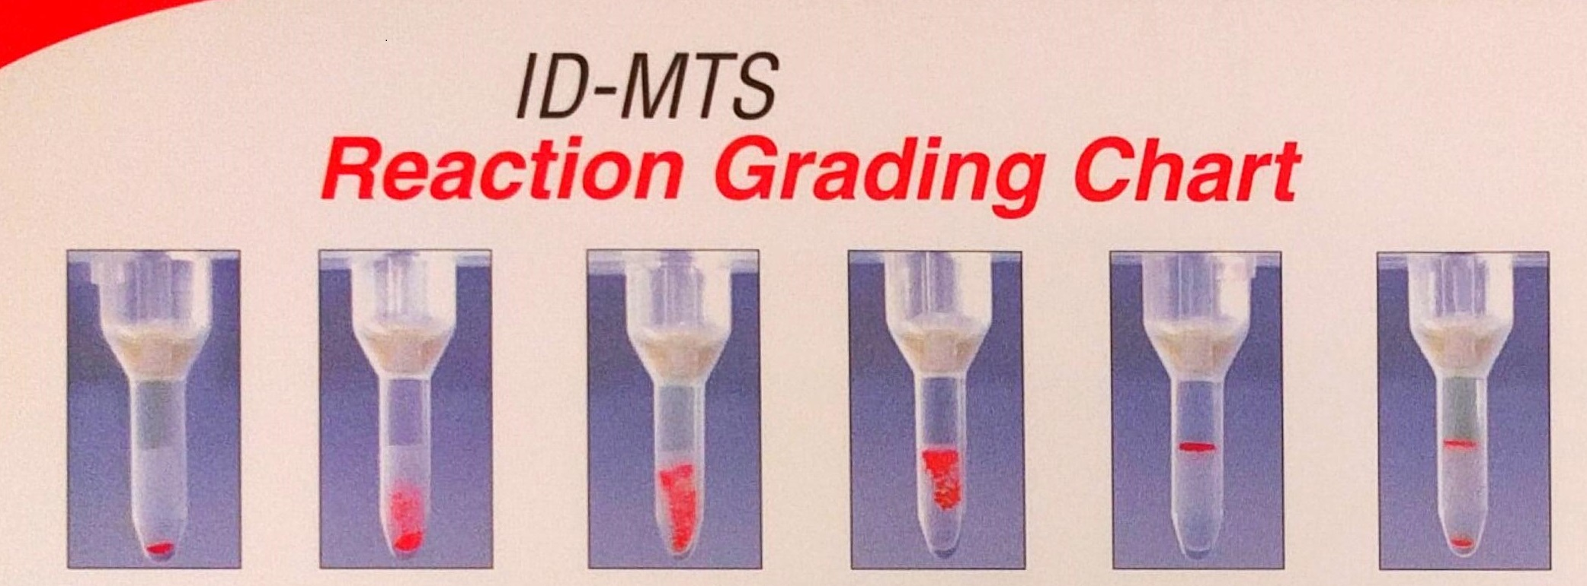
Negative | 1+ Reaction | 2+ Reaction | 3+ Reaction | 4+ Reaction | Mixed Field

RESULTS
*Check Epic Care Everywhere for additional patient history.

Absence of hemolysis or agglutination indicates a negative reaction and should be resulted as such.
Agglutination or hemolysis (from a non-hemolyzed specimen) indicates a positive reaction and should be resulted as such. Positive reactions warrant further investigation, including antibody identification if indicated.
Mixed field reactions must be interpreted with caution. Possible causes are coagulopathy, cold or warm autoantibodies, and medications. Antibodies to the preservative solution present in Ortho reagent cells can also cause a mixed field reaction.

Troubleshooting Tips:
- Investigating possible false positive reactivity due to degraded reagent cells
- Repeat testing with another set of reagent screening cells from the same lot
- Repeat testing with another set of reagent screening cells from a different lot

*Note: This is typically investigated when a positive screen is followed by a negative antibody panel. Antibody panel should always be performed following a positive antibody screen, even if results are questionable.

If a type and screen is ordered and the antibody screen is positive, perform an antibody identification (if indicated), and prepare two units pRBCs (antigen negative if indicated) to be Coombs crossmatched and allocated to the patient during the admission.

RESULT ENTRY
- Enter results in LIS appropriately

LIMITATIONS
- Antibodies specific for low-incidence antigens not represented on the test cells will not be detected.
- Antibodies below the threshold level may not be detected with this test.
- False-positive or mixed field results may occur if antibodies to components of the preservative solution are present in the plasma/serum tested.
- These are typically characterized by panreactive mixed field patterns on the gel panel with a negative patient auto control and negative gel crossmatches.
- Significant variations in red blood cell suspensions (<0.6 or >1.0%) may result in false-positive or false-negative reactions.
- Anomalous results may be caused by fresh serum, fibrin or particulate matter in serum or plasma, or red cells that stick to the sides of the microtube. Anomalous results with fresh serum (i.e. a line of red cells on top of the gel) may be minimized by the use of EDTA plasma.
- Adherence to the manufacturer’s package insert is critical to test performance.
- It may help to spin the sample for 10 minutes and repeat testing if a mixed field reaction is observed.

REFERENCES
Technical manual. 16th ed. Bethesda, MD: American Association of Blood Banks, 2008:437-460.
Current package insert: Reagent Red Blood Cells SELECTOGEN®. Raritan, NJ: Ortho-Clinical Diagnostics Inc.
Current package insert: Anti-Human Globulin Anti-IgG (Rabbit) MTS Anti-IgG Card. Pompano Beach, FL: Micro Typing Systems, Inc.
Current package insert: MTS Diluent 2 Red Blood Cell Diluent. Pompano Beach, FL: Micro Typing Systems, Inc.
Malyska H, Weiland D. The gel test. Laboratory Medicine, 1994;25:81-5.
Standards for blood bank and transfusion services. 26th ed. Bethesda, MD: American Association of Blood Banks, 2009.

POLICY CREATION :
Author: Mary McCallister | July 9, 2003
Medical Director: Devendra Trivedi, M.D. | July 9, 2003

MEDICAL DIRECTOR
DATE | NAME | SIGNATURE
 | Elizabeth A. Bauer-Marsh, M.D.
SECTION MEDICAL DIRECTOR

REVISION HISTORY (began tracking 2011)
Rev | Description of Change | Author | Effective Date
1 | Minor formatting, added document ID to header, updated pretransfusion sample to 30 day acceptability. Added the Resulting for HBB | S.Schaffer | 12/6/11
2 | Clarification under results for setting up units if antibody screen is positive. | Kathy Turpin | 11/19/12
3 | Added BioRad reagents. Changed specimen acceptability from 30 days to 7. Added number 7 to limitations section. | Kathy Turpin | 12/22/14
4 | Clarified MTS diluent QC. Removed LIS specific references | Vincent Strow | 2/10/16
5 | Removed redundancies, inserted better diagram 1 for reaction results, added information on mixed field reactions and resolution. Clarified antibody ID reflex when screen positive. | Vincent Strow | 5/11/17
6 | Procedure updated; Added troubleshooting tips, check Epic Care Everywhere and Scope and Clinical Significance. | Leah Miller/June Bembenek | 1/24/19
7 | Removed convert to 0.8% suspension | June Bembenek | 5/10/19

Reviewed by
Lead | Date | Coordinator/Manager | Date | Medical Director | Date
K. Maher | 12/30/11 | 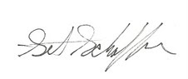 | 12/27/11 |  | 12/30/11
 |  |  | 11/19/12 |  | 11/20/12
D. Allen | 11/4/14 |  | 12/22/14 |  | 1/30/15
V. Strow | 2/10/16 |  | 7/8/16 |  | 7/21/16
V. Strow | 5/11/17 |  | 5/18/17 |  | 5/22/17
 |  |  | 1/24/19 |  | 2/4/19
 |  |  | 5/30/19 |  | 5/30/19

