  METHODIST |  |  | Page 1 of 6 | Section: UPM HEMO | Policy #: 23
 | HEMATOLOGY |  | Approved by: see signature block at end of document |  | Date: 7/29/19  Review by: 7/29/21
 | LABORATORY |  | Date Created: 8/31/10  Date Revised: 8/8/12, 2/4/14, 1/28/15, 9/8/16, 4/5/17, 4/16/19, 6/17/19, 7/29/19
Primary Responsible Parties: Kim Paige
Secondary Responsible Parties: June Bembenek
 |  |  | CAP Standard: NA
SUBJECT: |  | BRONCHIAL LAVAGE

- PRINCIPLE
A bronchial lavage is performed to obtain fluid from the lining of the epithelial surface of the lower respiratory tract. The cells present on the epithelial surface of the alveoli are believed to represent the inflammatory and immune system of the entire lower respiratory tract.

CLINICAL SIGNIFICANCE
Patients with interstitial pulmonary fibrosis have an increased number of neutrophils. Patients with idiopathic pulmonary fibrosis demonstrate lymphocyte percentages in the same range (10%) as normal controls and decreased percentages of alveolar macrophages.

SPECIMEN
Washing from bronchial lavage. Stable at 2-8°C for 24 hours.
Stored 2-8°C for 7 days in urinalysis/body fluid refrigerator.

- REAGENTS
Wright's Stain
Protocol Stain Pack
Nerl saline

INSTRUMENTATION/EQUIPMENT
- Cytocentrifuge
- Cytocentrifuge Cups & Paper
- Plastic Pipettes
- Glass Slide
- Hematek Slide Stainer
- Sysmex SP-10
- Warmed Box

- QUALITY CONTROL
- Level 2 Quantimetric Microscopic Urinalysis Controls, once per 8 hours of patient testing.
- Count WBCs and RBCs in 4 corner squares on both sides of hemacytometer.
- Calculate and record results on Body Fluid Control Form UPM-HEMO 24.01
- Verify counts are within acceptable range, as established, prior to patient testing.
- Correlate number of cells seen on slide to cell count.
  - The proportion of RBCs and WBC as well as the # of cells seen are QC checks.
  - If there is any discrepancy, repeat both the cell count and the preparation of the smear.
- If performing a dilution, background checks must be performed on the Nerl saline at the time of the counts at least once per day of testing or with a change in the lot number of the saline. Plate the Nerl saline on the hemocytometer and observe for contamination. Document on Body Fluid Control Form UPM-HEMO 24.01.

PROCEDURE
SPECIMEN PREPARATION: All Body Fluid specimens must go to microbiology first for proper routing and paper work. Microbiology will place the volume and description for each tube submitted on the Body Fluid worksheet. If this has not been done, check with microbiology before beginning processing to insure proper information on worksheet.

- Cell Counts

- Mix specimen well.
- Observe the clarity of the specimen to aid you in determining dilution to use.
    - If clear, charge both sides of the hemacytometer with undiluted fluid using the microhematocrit tubes or a 10ul pipette
  - If cloudy, perform a dilution using Nerl Saline.
- Charge both sides of the hemacytometer.
- Perform both a WBC and RBC:
  - Count the number of cells, differentiating RBC and WBC, on both sides of the counting chamber (18 sqmm). Document the cell counts on Hematology cell count form UPM-HEMO 23.01. Counts should agree to within 15%; if not recharge the hemacytometer chamber and recount. To calculate the % difference: (side 1) – (side 2 ) / (side 2) x 100 = %CV
  - If count is extremely high, count only the cells in the 4 corner squares on both sides (8 sqmm) or the central square millimeter on both sides (2 sqmm).
- Calculate the RBC and WBC using the following formula:
Count = # cells X depth (10) X dilution
#sqmm counted

- Differentials

- Prepare 2 cytospin slides from a well-mixed specimen according to the cytospin procedure.
- Allow cytospin slides to dry thoroughly.
- Stain both slides with Wright's stain.
- Perform a 200 cell differential count if possible including histiocyte/macrophages in the count.
- Please make note of the presence or absence of Bronchial and Squamous Epithelial cells in the manual result entry field. You do not have to enumerate these cells.

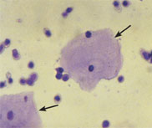
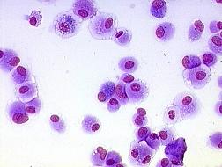
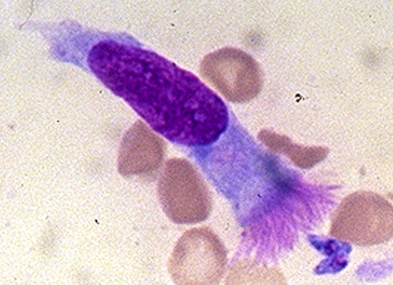
Bronchial Epithelial Cells¹ Macrophages/ Histiocyte² Squamous Epithelial³

- Report the differential.
- If requested, Report "Inflammatory Cell Ratio" (% lymphs versus % neutrophils). The LIS will calculate the ICR for you. If LIS is down, please use the formula below to calculate the ICR.

CALCULATIONS
EXAMPLE: 200 Cell Differential: Neutrophils- 30
Lymphocytes- 90
Histocyte- 80

90 + 30 = 120
90/120 = 75% Lymphocyte
30/120 = 25% Neutrophils
ICR = Neutrophils 25%; Lymphocytes 75%

REPORTING RESULTS
- In LIS Report Results according to:
WBC and RBC counts | Report as/cu mm
Differential | Report as percentages. See example below.
Inflammatory Cell Ratio | Report as percent

EXAMPLE:
Differential: Neutrophils- 25% Inflammatory Cell Ratio:
Lymphocyte - 50% Neutrophils - 33%
Eosinophil - 2% Lymphocyte - 67%
Basophil- 1%
Histiocyte - 22%

Reference Intervals
Normal Adult Values
Alveolar macrophages | 90-96%
Lymphocytes | 6-8%
Neutrophils | 1%
Eosinophils | 1%
Basophils | 1%

- PROCEDURAL NOTES/PROBLEM-SOLVING TIPS
- Footnote any body fluid that has a clot, clumped cells, or other debris present and indicate that counts may be inaccurate.
- Place cell counts on worksheet.
- Order Path Review only if requested.
- If cytology is also ordered on the specimen inform the clinical pathologist that a body fluid count was also ordered and performed.
- A reference interval has not been established for RBC and WBC cell counts on this specimen type.
- Hematology Cell Count Worksheet for calculations is attached.

- REFERENCE
"IDIOPATHIC PULMONARY FIBROSIS", G.B. Toews, Medical Grand Rounds, Parkland Hospital, Dallas, Texas, 12/18/80
Image references:
- “Basic Principles and Techniques of Bronchoalveolar Lavage”, Talmadge E, King Jr, MD. wwwuptodate.com. “Bronchoalveorlar Lavage”, Baughman RP (Ed), Year Book Medical Publishers, Philadelphia 1991. p.31 www.pathology.washington.edu/about/education/gallery/infections/38%20ppt.jpg

- http://upload.wikimedia.org/wikipedia/commons/0/0e/Macrophage.png
- www.aafp.org/afp/2005/0315/afp20050315p1153-f1.jpg
POLICY CREATION :
Author: Hematology/SDWT | December 15, 1992
Medical Director: Horea Baila, MD 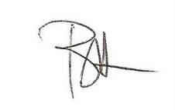 | August 31, 2010

MEDICAL DIRECTOR
DATE | NAME | SIGNATURE
February 11, 2017 | Elizabeth A. Bauer-Marsh, M.D.
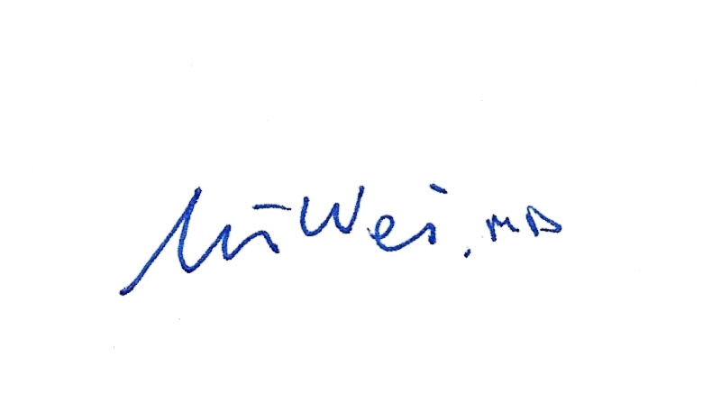
SECTION MEDICAL DIRECTOR
August 8, 2012 | Wei Liu, MD, PhD
January 28, 2015 | Julia Adams, M.D.

REVISION HISTORY
Rev | Description of Change | Author | Effective Date
1 | Formatting, added images |  | 8/31/10
2 | deleted CSF in procedure. ICR y request only was deleted in step 6 and reporting results. | K. Turpin | 8/2/12
3 | Added to procedural notes/problem solving tip: notify the pathologist that other testing was performed if cytology is ordered. Also added to document cell count on body fluid worksheet. System logo and name updated. | K. Turpin | 1/6/14
4 | Removed the Bronchial and Squamous epithelial cells from the differential count. Added #5 footnote the presence or absence of Bronchial and Squamous Epithelial cells. Corrected differential example. Added References. Changed stainer to SP-10. | K. Turpin | 1/26/15
5 | Added background checks when performing dilutions and changed to reflect the ICR is calculated by the LIS. Added A reference interval has not been established for this test on the supplied specimen type. Please integrate test results into the context of the patient’s clinical condition for interpretation. | Kim Paige | 9/5/16
6 | Added testing will include differential cell counts, but, not WBC and RBC cell counts unless specifically ordered by the physician. Please note absent or present when reporting out the presence of bronch lavage cells. | J. Bembenek | 3/24/17
7 | Added references to the Body Fluid Control Form and Hematology Cell Count Worksheet. Minor spelling corrections and punctuation changes. | Kim Paige | 4-16-19
8 | Removed WBC and RBC counts are only done when specifically ordered by a physician. WBC and RBC counts will be performed on all BAL specimens. | J Bembenek | 7/24/19

Reviewed by
Lead | Date | Coordinator/  Manager | Date | Medical Director | Date
 |  | 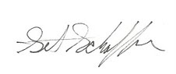 | 8/31/10 |  | 8/31/10
 |  |  | 8/2/12 |  | 8/8/12
 |  |  | 1/17/14 |  | 2/4/14
 |  |  | 1/26/15 |  | 1/28/15
K. Paige | 9/5/16 |  | 9/7/16 |  | 9/8/16
K. Paige | 3/29/17 |  | 3/30/17 |  | 4/5/17  4/3/17
 |  |  | 4/15/19 |  | 4/16/19
Kim Paige | 4/16/19 |  | 6/17/19 |  | 6/17/19
 |  |  | 7/29/19 |  | 7/29/19

