  METHODIST |  |  | Page 1 of 6 | Section: UPM BBPRO | Policy #: 02.004
 | BLOOD BANK PROCEDURES |  | Approved by: see signature block at end of document |  | Date: 9/24/19  Review by: 9/24/21
 | LABORATORY |  | Policy Created: 7/9/03  Supersedes 12/29/11, 12/12, 8/30/13, 12/30/15, 7/7/16, 12/21/16, 3/11/19, 5/30/19, 9/24/19
Primary Responsible Parties: April Cannon
Secondary Responsible Parties: June Bembenek
 |  |  | CAP Standard: NA
SUBJECT: |  | ANTIBODY IDENTIFICATION, GEL METHOD

PRINCIPLE
The antibody identification test is used to identify unexpected blood group antibodies. In this test, the reagent red blood cells in a hypotonic buffered saline solution are combined with patient serum/plasma to allow antigen/antibody interaction in the upper chamber of the microtube. This results in promoting antibody uptake. The detection of an antibody occurs when the sensitized red blood cells react with the Anti-IgG gel in the microtube during centrifugation.

SPECIMEN
Patient Preparation: No special preparation of the patient is required prior to specimen collection. Blood should be collected by approved techniques.
Note for Antibody Screens and/or Compatibility Testing: If patient has been transfused with blood or blood component(s) containing red cells, or has been pregnant within the preceding three months, or if transfusion history is unknown or uncertain, sample must be drawn within three days of transfusion. Otherwise, sample can be drawn within 7 days of transfusion.
Requirements: K₂ EDTA pink or lavender top tube is preferred.
Minimum Volume:
- Adult: 3.0 mL whole blood
- Pediatric: 2 - K₂ EDTA microtainers (each with 300-500 uL) or cord blood
Specimen Stability:
If stored at room temperature 15-30°C, stable for testing 24 hours.
If stored 2-8°C, stable for 72 hours.
Storage: 2-8°C for a minimum of 7 days after transfusion, or 10 days post crossmatch.

BEFORE ACCEPTING A TYPE AND SCREEN SPECIMEN, the technologist should visually verify that enough plasma would be left in the tube after performing the T&S to crossmatch approximately 12 units of blood. This will avoid another sample having to be drawn and repeating testing during an emergency.

Rejection Criteria: Hemolysis. **In rare occasions where sample cannot be redrawn, hemolyzed specimen may be used for testing as long as the testing personnel can interpret the reactions.

SCOPE
This policy applies to all Blood Bank Technologists.

REAGENTS
Reagent | Storage | Stability
0.8% Resolve Panel A, Ortho Clinical Diagnostics | 2-8°C | Exp. date
0.8% Resolve Panel B, Ortho Clinical Diagnostics | 2-8°C | Exp. date
MTS Anti-IgG Gel Card | 2-25°C | Exp. date
MTS Diluent 2 | 2-8°C | Exp. date
- Bring reagents to room temperature (18 to 25°C) prior to use.

INSTRUMENTS/EQUIPMENT
- Pipettes for 25uL and 50uL dispensing
- Pipette tips
- MTS Centrifuge
- MTS Incubator

QUALITY CONTROL
To recognize reagent deterioration, the reagents must be tested each day of use with appropriate controls:
- MTS Diluent 2: visually check to verify that the liquid is not discolored, turbid or showing any signs of bacterial contamination. Perform Quality Control for MTS Diluent once each day of testing.

Procedure for Quality Control for Diluent (perform once each day of testing)
- Pipette 50 uL of one of the cell suspensions being used for crossmatch into the diluent QC wells, both positive and negative.
- To the positive well add 25 uL of Immucor QC antisera.
- To the negative well add 25 uL of saline.
- Test according to procedure, document QC results in the computer.
- MTS Anti-IgG Card: To confirm the specificity and reactivity of the gel card, it is recommended that each lot be tested on each day of use with known positive and negative antibody samples with the appropriate red cells. Reactivity must be present with the positive sample only. Visually check gel cards: do not use if the liquid level in the microtube is at or below the top of the gel matrix, if drying, bubbles, crystals, and/or artifacts are seen.

PROCEDURE
Preparation of Patient Auto-Control:
- Dispense 1 ml of MTS diluent into a 12x75 tube
- Pipette 10 uL of packed red blood cells from patient tube. Mix into MTS diluent.

Antibody Identification Test Procedure:
- All antibody identification testing must be performed at UnityPoint Health Methodist. You cannot use results from testing that was performed from any UnityPoint Health affiliates or outside entities.
- If an antibody identification must be performed, be sure to check patient history for prior antibodies identified as well as transfusion history. Sources to be checked include UnityPoint history in the LIS/Sunquest and Care Everywhere in the HIS/EPIC. If any historical antibodies are found, document the antibodies on the patient’s card in Sunquest as a PB comment with the antibody code.
- Label two MTS Anti-IgG Cards™ with the appropriate identification and test information. Label 1-11 for panel cells, and AC for auto control.
- Remove the foil seal from the microtubes to be used.
- Add 50uL of each 0.8% antibody panel A cell suspension to the correct microtubes 1-11. Do not touch pipette to gel card.
- Add 50uL of 0.8% Patient Cell Suspension to microtube labeled AC for autocontrol.
- Add 25uL of patient serum or plasma to the correct microtubes, 1-11 and AC. The maximum amount of time that can elapse between the addition of cells and the plasma is 15 minutes.
- Incubate at 37±2°C for 15 minutes. (maximum 40 min.)
- Centrifuge the gel cards at 895±25 RPMs for 10 minutes.
- Read the front and the back of each microtube macroscopically and record reactions as described in the interpretation section on panel worksheet.

INTERPRETATION OF RESULTS

Negative Result–No agglutination and no hemolysis of the red blood cells is a negative test result. A complete sedimentation of all red blood cells is present in the bottom of the microtube.

Positive Result–Agglutination and/or hemolysis of the red blood cells is a positive test result. Red blood cells may remain suspended on the top of the gel or are dispersed throughout the gel in varying degrees. A few red blood cells may form a button in the bottom of the microtube in some positive reactions.

Reaction Grading Guide (Use in conjunction with Diagram 1)
REACTION | DESCRIPTION
0 Negative | Unagglutinated red blood cells form a well-defined button at the bottom of the microtube.
1+ Reaction | Red blood cell agglutinates are observed predominantly in the lower half of the gel microtube. Unagglutinated red blood cells form a button in the bottom of the microtube.
2+ Reaction | Red blood cell agglutinates are dispersed throughout the length of the gel microtube. Few unagglutinated red blood cells may be observed in the bottom of the microtube.
3+ Reaction | The majority of red blood cell agglutinates are trapped in the upper half of the gel microtube.
4+ Reaction | Solid band of red blood cell agglutinates on top of the gel. A few agglutinates may filter into the gel but remain near the predominant band.
Mixed Field | Red blood cell agglutinates at the top of the gel or dispersed throughout the gel microtube accompanied by a button of negative red blood cells in the bottom of the microtube. ***See Comments
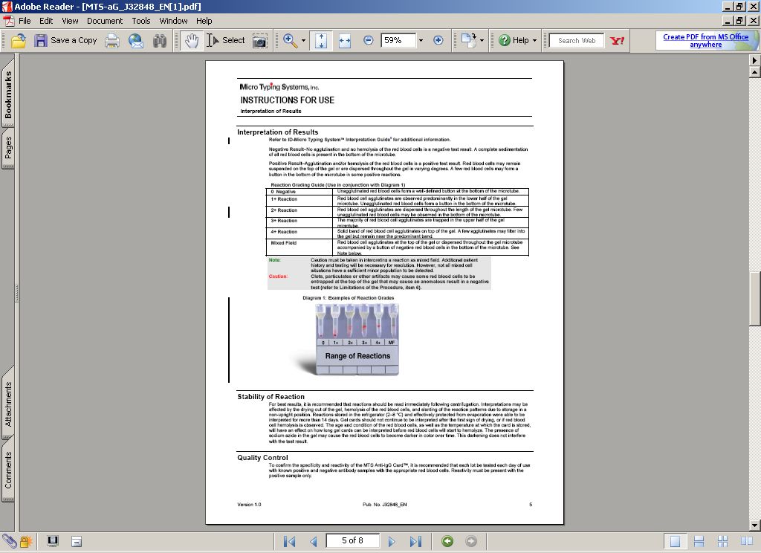

Guideline to Identify an Unknown Antibody:

- Review reactions. Cross off antigens present on the nonreactive red cells at each phase of testing.
- To rule out an antibody – a negative reaction on at least one cell for the antigen being tested.
- To confirm an antibody – a positive reaction on a minimum of two cells for the antigen being tested.
- Select additional cells from current in-date panels, Ortho Panel B or select cells from out-dated panels that are less than four months old.
- Perform positive and negative QC on each additional outdated cell used for testing. Use the antisera of the antigen you are trying to confirm or exclude. You cannot use the cell to rule in or out if the QC does not give the expected reaction.

- Compare the pattern/strengths of agglutination with the antigen profiles not crossed-off.
- If one antigen remains: the antibody is preliminarily identified.
- If more than one antigen remains, further identification steps need to be performed.
- Check for dosage on the Rh, Duffy, Kidd, and MNS groups. The antibody may be reacting more strongly with cells that are homozygous for the antigenic determinant than with the heterozygous cells.
- Variation in reaction strength may be seen in P1, SdA, LeA, LeB, and I. Sometimes, diminished strength can be related to disease or to the length of time the suspension has been stored.
- If positive and negative reactions do not fit any pattern, it may be suggestive of multiple antibodies or antibodies to unspecified antigens.
- Test the patient red blood cells with antisera corresponding to suspected antibody. The patient should be negative for an antigen for a corresponding antibody they exhibit.

- If patient control is positive, an auto-antibody or allo-antibody coated transfused cells could be the cause of reactivity. Perform DAT. See UPMBBPRO 02.016 Direct Antiglobulin Testing. (If negative, it is an alloantibody)

Reporting Results
When an antibody is discovered, the following steps should be followed:
- In the LIS add on an antibody ID test.
- Result out the Antibody ID
- If only a type and screen is ordered on an inpatient or Pre-admit patient: 2 packed cells must be set up (Coombs crossmatches) and antigen testing must be done on the units. Order 2 packed cells in the LIS. Refer to Compatibility Testing and Antigen Typing for Other Blood Group Systems procedures.
- Perform a DAT on any positive Patient Control reactions.
- Place a comment in the computer for any significant information pertaining to the antibody Identification.
- An antibody identification is only necessary once a month, unless the reaction of the screening cells has changed, or the antigen negative units are incompatible.
- Record all tests appropriately. Fill out the panel sheet completely, including patient's name, ABORH, date tested, your initials, existing antibodies, interpretation, panel results, screening cell results, direct Coombs, elution, and antigen typing results.
- Leave the panel sheet in the review folder for the lead tech to review.

If all cells are mixed field and the patient auto control is negative:
- There may be interference with the gel cell preservative.
- Perform tube antibody screen. If tube screen is positive, perform tube panel.

If Anti-D is found:
- If anti D is identified on an Rh positive patient, inquire whether or not the patient has received WinRho. If yes, see UPM BBPOL 01.018, PATIENTS RECEIVING ANTI-D FOR TREATMENT OF ITP; RELEASING ANTI-D TO PHARMACY FOR TREATMENT OF ITP, AND TRANSFUSION REQUIREMENTS regarding transfusion information for patients who have received WinRho.
- A pathologist and patient’s physician should discuss if patient should receive Rh positive or Rh negative blood.
- If anti-D is found due to Rh immune globulin report the antibody screen interpretation as “Anti D due to Rh immune globulin given on date”. See UPM BBPOL 01.017, ANTI D DUE TO RHIG.

For warm autoantibody. Send out to ARC for adsorption and request crossmatched units as needed.

*If an antibody is still unidentifiable after following the Guideline to Identify an Unknown Antibody, send specimen to ARC for antibody identification.

COMMENTS
Interpretation of mixed-field reactions must be done with caution. The presence of fibrin, clots or particulates may result in some cells layering at the top of the gel. Mixed-field reactions should only be observed in tests containing a dual population of red cells, such as a transfused patient, bone marrow recipient or when a pooled cell sample is used for testing. However, not all mixed cell situations have a sufficient minor population to be detected.

LIMITATIONS
- All allo-antibody nonspecific reactivity that cannot be identified should be sent to the American Red Cross for identification. Order a consultation in the ARC Blood Hub.
- Antibodies below the threshold level may not be detected by this test.
- False-positive results may occur if antibodies to components of the preservative solution are present in the serum tested.
- Significant variations in red blood cell suspensions (<0.6 or >1.0%) may result in false-positive or false-negative reactions.
- Anomalous results may be caused by fresh serum, fibrin or particulate matter in serum or plasma, or red cells that stick to the sides of the microtube. Anomalous results with fresh serum (i.e., a line of red cells on top of the gel) may be minimized by the use of EDTA plasma.
- Adherence to the manufacturer’s package insert is critical to test performance.
- Anti-IgG may occasionally fail to detect antibodies which are demonstrable by the use of antiglobulin reagents that contain anti-C3.
- For anti-D on Rh positive patients, see procedural notes under Antibody Identification in black procedure Manual.

REFERENCES
Technical manual. 18th ed. Bethesda, MD: American Association of Blood Banks, 2014: 400-419.

Current package insert: Reagent Red Blood Cells RESOLVE Panel A. Raritan, NJ: Ortho-Clinical Diagnostics Inc.

Current package insert: Anti-Human Globulin Anti-IgG (Rabbit) MTS Anti-IgG Card™. Pompano Beach, FL: Micro Typing Systems, Inc.

Current package insert: MTS Diluent 2™ Red Blood Cell Diluent. Pompano Beach, FL: Micro Typing Systems, Inc.

Malyska H, Weiland D. The gel test. Laboratory Medicine, 1994;25:81-5.

Standards for blood bank and transfusion services. 31th ed. Bethesda, MD: American Association of Blood Banks, 2018: 36-38.

POLICY CREATION :
Author: Mary McCallister | July 9, 2003
Medical Director: Douglas McGrady, MD | July 9, 2003

MEDICAL DIRECTOR
DATE | NAME | SIGNATURE
 | Elizabeth A. Bauer-Marsh, M.D.

REVISION HISTORY
Rev | Description of Change | Author | Effective Date
0 | Initial release. | M. McCallister | 7/2003
1 | Minor formatting changes, added reaction interpretations, updated pretransfusion sample to be acceptable within 30 days. | T. Mikolajczyk | 12/6/2010
2 | Updated for new LIS processes | S. Schaffer | 5/5/2011
3 | Page 4, number 2a. changed rule out by two to rule out by one cell. | K. Turpin | 12/18/2012
4 | Under specimen I changed pretransfusion sample to be acceptable within 7 days. | Kathy Turpin | 08-30-2013
5 | Removed LIS specific references. Updated Warm Autoantibody section. Reorganized MTS Diluent QC for clarity. | Vincent Strow | 02/10/2016
6 | Add all testing testing will be performed at UnityPoint Health Methodist | K. Turpin | 12/21/16
7 | Clarified procedure and Guide to Identify an Unknown Antibody; Send unidentifiable antibodies to ARC; | June Bembenek | 3/7/19
8 | Removed tube panel cell conversion to 0.8%; Updated anti-D information. | June Bembenek | 5/10/19
9 | Added the use of Panel B; Minor wording changes. | April Cannon | 9/18/19

Reviewed by
Lead | Date | Coordinator/  Manager | Date | Medical Director | Date
K. Maher | 12/30/11 |  | 12/29/11 |  | 12/29/11
K. Maher | 12/18/12 |  | 12/18/12 |  | 12/12  8/
K. Maher |  |  | 8/30/13 |  | 8/30/13
V. Strow | 10/19/15 |  | 12/30/15 |  | 12/30/15
V. Strow |  |  | 7/6/16 |  | 7/7/16
 |  |  | 12/21/16 |  | 12/21/16
 |  |  | 3/7/19 |  | 3/11/19
 |  |  | 5/30/19 |  | 5/30/19
April Cannon | 9/24/19 |  | 9/24/19 |  | 9/24/19

