  METHODIST PROCTOR PEKIN |  |  | Page 1 of 4 | Section: UPPIA LA: | Policy #: 03.010
 | PATIENT SERVICES |  | Medical Director Initial Approval:  (delegated to Administrative Director after initial- see signature block at end of document) |  | Date:  06/18/18  Review by:  06/18/20
 |  |  | Methodist Medical Director:  Date: 2/11/17 |  | Date:  06/18/18  Review by:  06/18/20
 |  |  | Proctor Medical Director:  Date: 5/31/18 |  | Date:  06/18/18  Review by:  06/18/20
 |  |  | Pekin Medical Director: |  | Date:  06/18/18  Review by:  06/18/20
 | LABORATORY ADMINISTRATION |  | Date Created: 12/1/95  Date Revised: 1/31/10, 2/25/11, 2/16/12, 2/8/14, 10/5/15, 6/18/18
Primary Responsible Parties: Dana Spears
Secondary Responsible Parties: Lab Managers
 |  |  | CAP Standard: 20208, 41307, 41310, 40492
SUBJECT: |  | ERROR EVENT REPORTING

- POLICY:
All laboratory personnel will be able to respond to any event errors that occur during the pre-analytic, analytic and post analytic processor.

- PURPOSE:
- It is the goal of this laboratory to order tests, collect specimens, perform assays, and generate results in an event free manner; however, errors do occur.
- This policy defines the necessary steps to be taken in the event of an error.

- POLICY SCOPE:
The scope applies to all laboratory staff at all UnityPoint Health Peoria campuses.

- GENERAL INFORMATION:
- Errors can be detected in the ordering, collection, testing, review, or reporting process.
- Legally Acceptable Documentation Guidelines:
- Utilize indelible black ink for written documentation.
- Write legibly utilizing correct grammar and spelling.
- Document clear, concise, objective, accurate and pertinent information.
- Correct errors on a written record by marking a single line through the written error, Initial, and date above the entry
- Document late entries by writing “Late Entry” and the actual date and time and the Date and time the record should have been recorded.
- For electronic documentation each employee must be logged in using their password.

- The following documentation practices are not acceptable:
- Erasing, obliteration or use of liquid paper correction fluid.
- Scribbling out or writing over entries.
- Arrows down and “Ditto” marks on logs indicating entry is the same as the above.
- Using a terminal when someone else is logged in.

- The person making the error, the person detecting it, and the team leader/coordinator/manager notified of it are equally responsible for seeing that the necessary steps are taken to correct it. This may include leaving documentation for the lead to review.

- PROCEDURE:
In the event of an error, follow the procedure below:

- Any error detected during the procurement or testing, but before results are reported, should be corrected by the person detecting it.

- When an error is detected after the result has been verified and it can be corrected without obtaining a new specimen, take the following corrective measures immediately.
- The person detecting the error must determine whether the difference between the incorrect and correct results is clinically significant.
- To make this decision, consultation with a colleague, lead tech, coordinator, Manager or Pathologist may be necessary.
- The person detecting the error must correct it or direct this responsibility to the person who made it.
- All clinically significant errors require notification of the physician, nursing unit, and physician’s office and client hospital laboratory.
- If the change in results could affect treatment, IMMEDIATE notification is necessary.
- A comment for each analyte changed is appended. Document who was notified, the time and date.
- All error corrections involving client hospitals are phoned to that laboratory.
- Correct the report in LIS Results Entry. Remember to search for finalized results.
- Add a reportable comment to the corrected result indicating the name of the clinician notified, if applicable, the date and time of notification, and initials of the person making the correction.
- Any comments made during the original verification must be retained.
- Enter the event into RL Solutions by the end of the shift during which the problem was detected.
- When a specimen is determined to be of questionable integrity (i.e. hemolysis, IV contamination) after the results have been verified and a valid specimen cannot be obtained, take the following corrective measures immediately.
- The CLS/CLT discovering the problem must notify the physician/nursing unit/physician’s office and determine whether the patient was treated based on the erroneous result. Follow the steps for specimen rejection on Policy C-11 Laboratory Specimen Rejection.
- Using Result Entry substitute.
- a Reportable Comment stating the nature of the problem, the name of the clinician, the time he/she was notified, and your initials.
- Any footnotes made during the original verification must be retained in.
- Print a patient report, and leave it for Laboratory Billing to credit the patient account if warranted.
- It is the CLS/CLT’s responsibility to let the patient’s nurse or physician’s office know that they need to re-order the test if it is still needed.
- The redraw testing will be performed using a new accession number.
- Enter the event into RL Solutions.
- In the Microbiology section, the incorrect results should be replaced in results entry.
- Add a reportable result comment stating the nature of the problem, the name of the clinician, the time he/she was notified, and your initials.

- Enter into RL Solutions by the end of the shift during which the problem was detected.

- For those results, which are reported on a separate report and not in the LIS, locate the original incorrect report, but do not remove it from the chart.
- Mark the incorrect result so it is clearly recognized as invalid and make reference to the corrected report (i.e. write in large block letters in black ink ERROR – SEE CORRECTED REPORT, and mark through the result with a single line without obliterating it).
- Record date, time, and initials of person correcting the report.
- A personal explanation to the nursing unit may be indicated.
- If the patient’s chart is not accessible (OP or Reference Lab), phone the physician’s office, request that they disregard the original report and inform them that a corrected report will follow.
- A corrected report will be issued that reflects corrected values.
- Attach our copy of the corrected report to our filed incorrect report. (chart will show _____corrected from______on 0/00/00)
- UNDER NO CIRCUMSTANCES, SHOULD ANY HUMAN RESULT BE COMPLETELY DELETED FROM THE INFORMATION SYSTEM.

- MAINTENANCE AND STORAGE
  - All policies and procedures are reviewed every two years, (except for Safety procedures which are yearly) by Laboratory Administration and/or the Medical Director of the Laboratory or designee when there are changes in practice standards, or requirements.
  - All policies and procedures are reviewed every two years (except for Safety procedures which are yearly) by staff or at the time new or revised ones are put in effect.
  - All policies are retained 8 years after being discontinued or revised.
  - All procedures are retained 2 years after being discontinued or revised

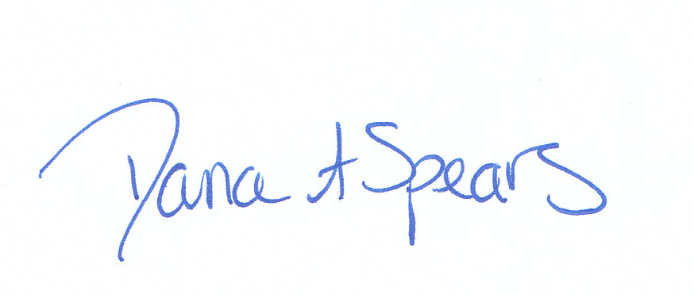
ADMINISTRATIVE DIRECTOR
September 17, 2017 | Dana A. Spears, BS, HTL (ASCP)

REVISION HISTORY
Rev | Description of Change | Author | Effective Date
0 | Initial Release | N. Krakowiecki | 12/15/14
0.1 | Updated peminic to RL solutions under microbiology section | S Burton | 05/30/18

Reviewed by
Designee | Date | Laboratory Director | Date
NA |  | 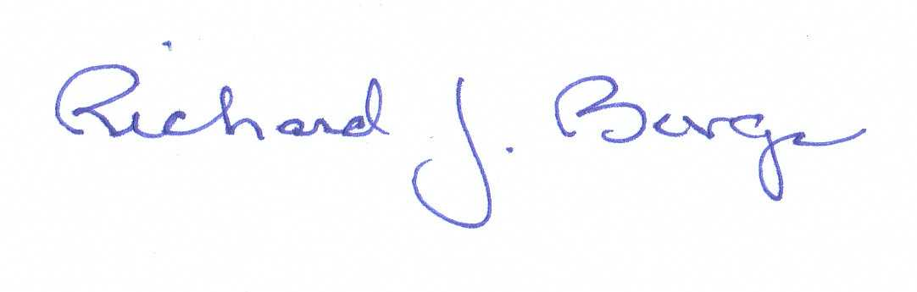 | 1/30/10
NA |  |  | 2/25/11
NA |  |  | 2/16/12
NA |  |  | 2/8/14
NA |  |  | 10/5/15
NA |  |  | 6/18/18

