Blood Bank Staff Meeting
October 21, 2014

Present: Kay Schanuel, Chris Zalocusky, Jennifer Harris, Glenda Martiszus, Melissa Huschle
- Old Business
  - For those who are blood bank days, Jennifer will be performing evaluations this year.
    - They will be conducted between 11/7-11/24. Look for invite in email coming soon.

- People
  - Full-time tech position
    - Jim B is moving to full time eve/nights. Starts BB training on 10/27.
    - Jan G is working on the weekend schedule for next year.
      - Jennifer is open to covering the extra weekend.
  - Micro supervisor
    - Kathy Brown will start 10/27. She is coming from Barnes/SSM
  - Histo Lead tech
    - Still interviewing (No update)
  - PT Histo tech
    - Newly open (No update)
  - 2 Phlebotomy positions
    - 2 positions still open. Will hire for off-sites (No update)

- Financial
  - (No update)

- New Business
  - Blood refrigerator is not being repaired. Days consensus was to move the current blood refrigerator by the reagent refrigerator and move the freezer next to the thawer.
  - Meeting minutes will be posted on MTS going forward. An email will be sent out when they are available.
  - MTS will be used, going forward, for all memos and competencies as it permits. Jennifer is still playing with the software, so more information will follow.
  - Reminder to check all extended typings on the back and the sides of all anagrams before dismissing extra reactions on NEO or ECHO.
  - Labels on thawed plasma were discussed. The new expiration date label should be applied OVER the old expiration date label. See below where the old exp. Date/time were crossed out and the new one written. We should not being writing the new expiration, but we should be covering the old one.

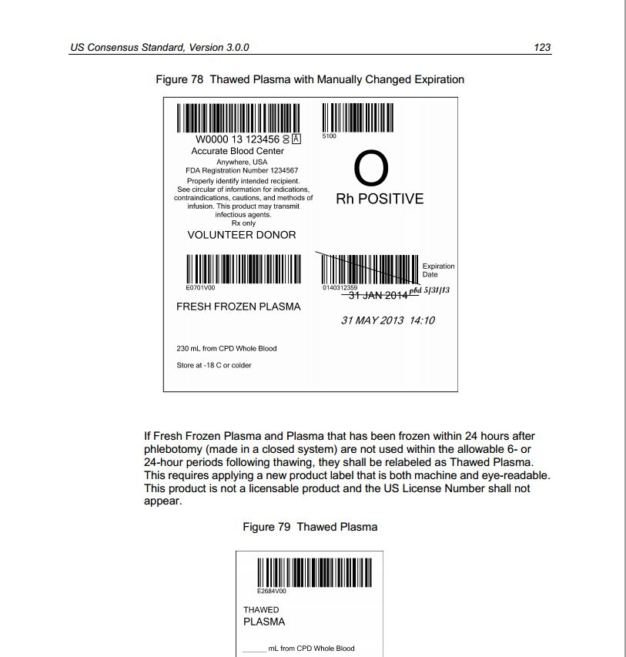

- There is a memo for antibody ID and crossmatching of low frequency antibodies. It is on MTS. Please read and indicate you have read it on there ASAP.
- Kay requested that surveys be completed in Meditech like they are in Chem and Heme. Jennifer will not require that, but doesn't care whether it is in the system or not. Either way is fine unless directed to do something specific.

Respectfully submitted,
Jennifer L. Harris, MT(ASCP)SBB^{CM}
Blood Bank Supervisor

