Blood Bank Staff Meeting
October 21, 2014

Present: Linda Althardt, Jennifer Harris, Brenna Cardin, Jan Henry, Lindsay Powell, Alyssa Weygandt
- Old Business
  - Evaluations will be completed and conducted by Kathy. She will be providing further information on that.

- People
  - Full-time tech position (this is actually a PT position, not FT. Look for more on this in the near future as this is a developing and changing role)
    - Jim B is moving to full time eve/nights. Starts BB training on 11/3.
    - Jan G is working on the weekend schedule for next year.
      - Jennifer is open to covering the extra weekend.
  - Micro supervisor
    - Kathy Brown will start 10/27. She is coming from Barnes/SSM
  - Histo Lead tech
    - Still interviewing (No update)
  - PT Histo tech
    - Newly open (No update)
  - 1 Phlebotomy position
    - 1 positions still open.

- Financial
  - (No update)

- New Business
  - Blood refrigerator is not being repaired. Days consensus was to move the current blood refrigerator by the reagent refrigerator and move the freezer next to the thawer.
  - Meeting minutes will be posted on MTS going forward. An email will be sent out when they are available.
  - MTS will be used, going forward, for all memos and competencies as it permits. Jennifer is still playing with the software, so more information will follow.
  - Reminder to check all extended typings on the back and the sides of all anagrams before dismissing extra reactions on NEO or ECHO.
  - Labels on thawed plasma were discussed. The new expiration date label should be applied OVER the old expiration date label. See below where the old exp. Date/time were crossed out and the new one written. We should not being writing the new expiration, but we should be covering the old one.

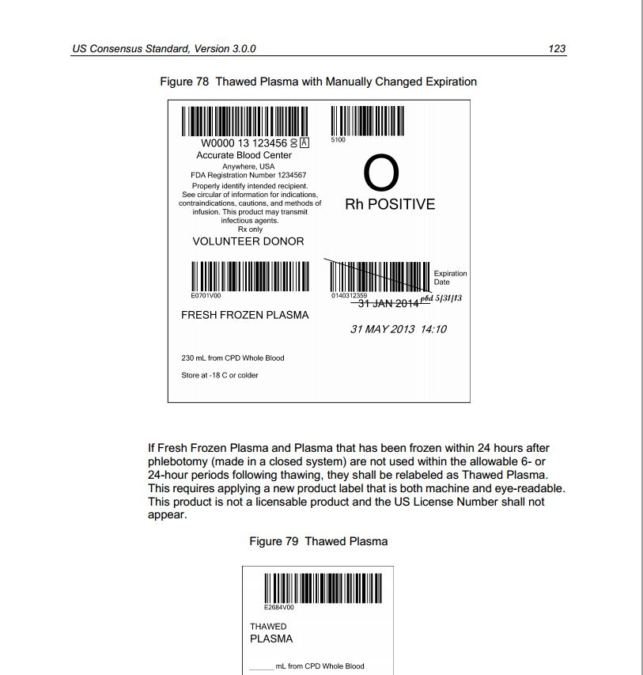

- There is a memo for antibody ID and crossmatching of low frequency antibodies. It is on MTS. Please read and indicate you have read it on there ASAP.
- Kay requested that surveys be completed in Meditech like they are in Chem and Heme. Jennifer will not require that, but doesn't care whether it is in the system or not. Either way is fine unless directed to do something specific.
- Lindsay asked why weekly maintenance for Chem on Sun wasn't completed all at once and the machine was shut down and brought back up. Spoke with Evan, who would like specifics when this occurs again. This should not be happening, but needs to know more. Please direct specifics to Evan so he can investigate.
- AMS still calling over the weekend and demanding results be faxed to nursing homes. Forwarded to Kathy.
- Charge tech duties- evenings would like a flowchart to be made. Please submit instances that occur that need to be part of the flow chart sot that it can be created.
- Weekend coverage of Micro and other departments. Suggested that Micro come in later and night shift come in earlier. Management believes that this will be eased when Chem/Heme goes to autoverification, but in the meantime, staff time changes might help. Need feedback from evening shift to verify.
- Survey monkey survey sent out 10/27 to help collect data from evening shift for these items.

Respectfully submitted,
Jennifer L. Harris, MT(ASCP)SBB^{CM}
Blood Bank Supervisor

