Blood Bank Memo

To: All Blood Bank

11/3/14

Re: Use of Panel cells

I know this may be a change in what everyone is used to, but I would like to make a few changes effective **11/7/14.**

For units:

* antigen typing QC should have **in date** panel cells used.

For patients:

* **In date** panel cells should be used for antigen typings.
* **In date** panel cells should be used for manual screens and selected cell panels.
* For selected cells, please add the expiration date of all expired cells to the panel as shown below.

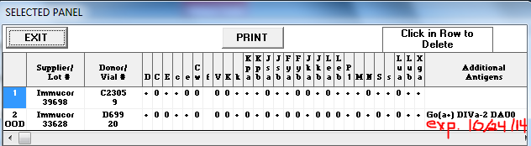

Exceptions:

* Antigen typings or antibody workups involving low frequency antigens/antibodies.
  + Ytb, Cob, Goa, He, Doa, Dob, Kpa, Jsa, etc.
* Antigen typings or antibody workups involving high frequency antigens/antibodies.
  + Yta, Coa, HTLAs, U, k, Jsb, Kpb, etc.

This is a best practice guideline. The best way to practice this is to ask if you could find this in an in date panel, then you should use an in date panel. If you can’t, then use an out of date panel.