Blood Bank Staff Meeting
October 30, 2014

Present: Kathy Stanley, Jennifer Harris, Brandon Mason, Douglas Auffarth, John Matthews

- People
  - Full-time tech position
    - Jim B is moving to full time eve/nights. Starts BB training on 11/3.
  - Micro supervisor
    - Kathy Brown will started 10/27.
  - Histo Lead tech
    - Still interviewing
  - PT Histo tech
    - Newly open (No update)
  - 1 Phlebotomy positions

- New Business
  - Blood refrigerator is not being repaired. Days consensus was to move the current blood refrigerator by the reagent refrigerator and move the freezer next to the thawer. Nights agreed
  - Meeting minutes will be posted on MTS going forward. An email will be sent out when they are available.
  - MTS will be used, going forward, for all memos and competencies as it permits. Jennifer is still playing with the software, so more information will follow.
  - Reminder to check all extended typings on the back and the sides of all anagrams before dismissing extra reactions on NEO or ECHO.
  - Labels on thawed plasma were discussed. The new expiration date label should be applied OVER the old expiration date label. See below where the old exp. Date/time were crossed out and the new one written. We should not being writing the new expiration, but we should be covering the old one.

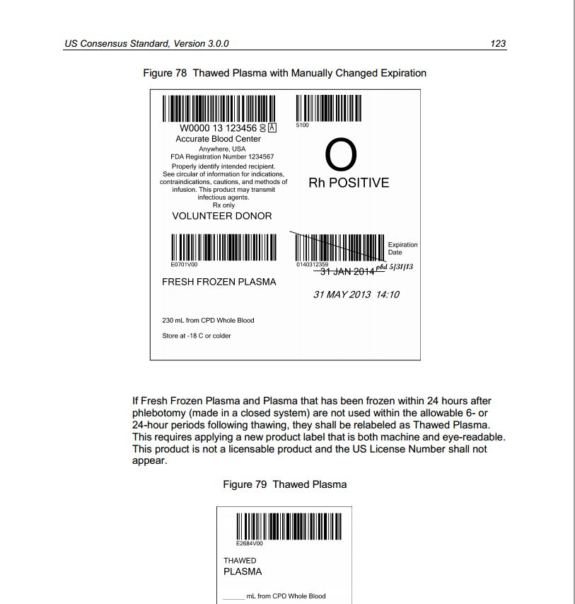

- There is a memo for antibody ID and crossmatching of low frequency antibodies. It is on MTS. Please read and indicate you have read it on MTS ASAP.
- Kay requested that surveys be completed in Meditech like they are in Chem and Heme. Jennifer will not require that, but doesn't care whether it is in the system or not. Either way is fine unless directed to do something specific.
- Maintenance in the Core lab will be moved to nights to accommodate reducing staff on the day shift.
  - Linearity and precision studies will stay on the day shift.
  - Blood bank will remain the same as it is now.
  - It was discussed whether bringing night shift in early would assist in getting this completed. Nothing was decided.
  - Carmella will come in to train on maintenance. More information will be communicated through Evan and Carmella on specifics.
  - Evan requested that John and Doug be on opposite weekend to assist in making sure the maintenance gets completed.
    - Kathy will talk more with Evan to get clarification on this.
- IL Department of Labor and Memorial Hospital require that all personnel take their lunch break within the first 5 hours of their shift if they are working 7+ hours. Night techs indicated that they take their lunches at the end of their shift due to not being able to get away. Kathy and Jennifer reiterated that all night techs need to cover for each other so that they can get at least a 20 minute break in the first 5 hours of work and that “no lunches” should not be taken unless the work volume can justify it.
  - John requested that nights be deemed a "no lunch" shift.
  - Kathy to speak to HR regarding this.
- John requested that the schedule be released to nights like it is for evenings before it is official in order to check for even scheduling in departments. Feels he has worked more in one dept. over another.
- John requested that staff be re-reminded about the ext.6500 to call and not call ext. 6605. He has been told that the operator is transferring calls to 6605 when they are asking for phlebotomy.
- Nights requested an update on self-scheduling. Follow-up at next meeting.

Respectfully submitted,
Jennifer L. Harris, MT(ASCP)SBB^{CM}
Blood Bank Supervisor

