Technical Memo to Blood Bank staff

11/11/14

To: All BMH BB staff

Re: Antigen typing

It has recently come to my attention that there is no procedure on antigen typing of red cell products. This is an essential function of our antibody workup capabilities.

A few major things have come to my attention recently that we need to correct in order to meet CAP, AABB and FDA standards of quality.

**Effective immediately, we are no longer freezing in-date antisera. This is directly against package inserts and it cannot be used for antigen typing of units if it has been frozen and freezing is prohibited by the manufacturer’s insert.**

1. The only antisera that we will be using for antigen typing of units are anti-D, anti-C, anti-E, anti-c, anti-e, anti-K and anti-Jka. For all other antigens, you must order fully antigen typed units from MVBC.
   1. Only use never frozen, **in-date** anti-sera for the following antibodies: Exception: screening for antigen negative units may be performed with outdated and/or frozen antisera, however, it MUST be repeated with antisera that is in-date and has never been frozen.
      1. D
      2. C
      3. E
      4. c
      5. e
      6. K
      7. Fya
      8. Fyb
      9. Jka
      10. Jkb
      11. Lea
      12. Leb
      13. M
      14. N
      15. S
      16. S
      17. P1
      18. Cw
   2. If the antigen you are looking to type for does not fall on this list, then frozen, outdated antisera may be used.
2. Only in date reagent cells should be used for QC for antigen typing.
   1. Make sure that positive control is heterozygous for antigen. (Exception: Lewis. There are very, very few cells that are Le(a+b+) so it is acceptable to use Le(a+b-) cell for positive control.
      1. E.g. anti-Jka would require cell that is Jk(a+b+)
   2. Make sure that negative control is negative for antigen.
3. QC of any reagent antisera needs to only be performed once per day.
   1. This must be recorded in MCare using the QC template attached in a comment to the antigen typing on one of the units typed. See picture below:

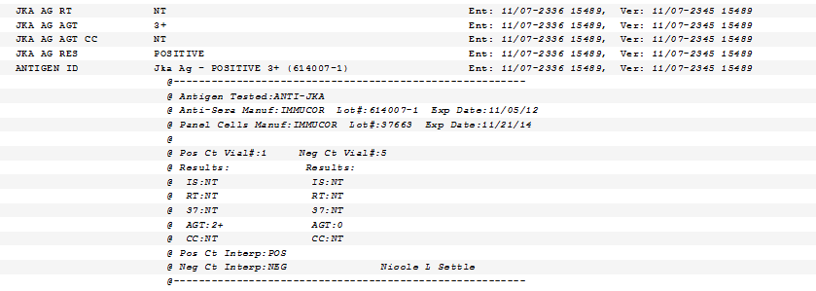

* 1. Subsequent typings or concurrent typings only need the “QC not performed” template attached in a comment to the antigen typing to EACH additional unit in a 24 hour period. See below.

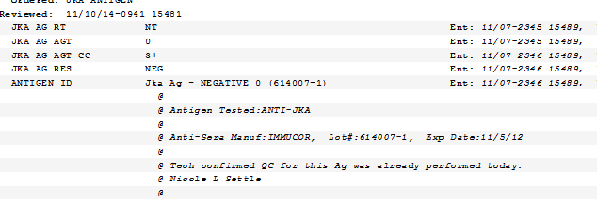

* 1. QC needs to be verified before testing is performed or it needs to be repeated.

1. Use/phase of testing of any antisera MUST follow package insert.
   1. E.g. Anti-C requires testing at IS and then a 15 minute incubation at RT and then to read it again. Both phases must be completed and recorded as acceptable for valid QC.
2. Here is the CAP standard and its note about antisera.
   1. **TRM.31250**

**Are all reagents used within their indicated expiration date?**

*NOTE: Rare reagents may be used beyond their expiration date if appropriate positive and negative*

*controls are run each day of use and react as expected. This exception is permitted by the FDA. This*

*does NOT apply to reagents that are readily available. The laboratory should establish criteria*

*defining which reagents are considered “rare.”*

1. Please see attached page for useful things to know before screening for antigen negative units.

|  |  |  |  |  |  |  |
| --- | --- | --- | --- | --- | --- | --- |
| **Useful Things to know** | | |  |  |  |  |
|  |  |  |  |  |  |  |
| **Antigen** | **Prevalence (approximate negative)** | **Should I screen?** | **What should I screen?** | **Do I need antigen neg units?** | **Can I do XM compatible without antigen negative?** | **Comments** |
| C | 30% | Yes | Rh pos units | Yes |  | Higher % neg in Rh neg and AA* donors |
| E | 70% | Yes | Rh pos units (unless patient is Rh neg) | Yes |  | Higher % neg in Rh neg and AA* donors |
| c | 20% | No |  | Yes |  |  |
| e | 2% | No |  | Yes |  |  |
| Cw | 98% | Yes | Rh pos units (unless patient is Rh neg) | If reacting <1+ | Yes | Low incidence antigen, make sure antibody is reacting 1+ or greater. |
| V | 99% | Yes | Any | If reacting <1+ | Yes | Low incidence antigen, make sure antibody is reacting 1+ or greater. |
| K | 91% | Yes | Rh pos units (unless patient is Rh neg) | Yes |  |  |
| Fya | 35% | Yes** | AA* donor, Rh pos | Yes |  | AA* donors are mostly Fy(a-b-) |
| Fyb | 15% | No |  | Yes |  | AA* donors are mostly Fy(a-b-) |
| Jka | 20% | Yes** | Cauc donor/Rh any | Yes |  |  |
| Jkb | 25% | No |  | Yes |  | AA* donors are mostly Jk(a+b-) |
| Lea |  | Yes*** | AA* donor, Rh any |  | Yes | Higher incidence of Le(a-b-) in AA* donors |
| Leb |  | Yes*** | AA* donor, Rh any |  | Yes | Higher incidence of Le(a-b-) in AA* donors |
| M | 35% | Yes*** | Rh pos units (unless patient is Rh neg) |  | Yes |  |
| N | 30% | No |  | Yes |  |  |
| S | 45% | Yes*** | Rh pos units (unless patient is Rh neg) | Yes |  | AA* donors are mostly S-s+ |
| s | 20% | No |  | Yes |  | AA* donors are mostly S-s+ |
| Lua | 98% | Yes | Any |  | Yes | Never get antigen negative units regardless of strength |
|  |  |  |  |  |  |  |
| *AA-African American | |  |  |  |  |  |
| **Only as long as we have in-date antisera | | | |  |  |  |
| ***Only if we have in-date antisera | | | |  |  |  |