BBMAN 13.0-Antigen Typing

- Principle
Red Blood cell units selected for transfusion to a patient with potentially clinically significant antibodies should be tested and found negative for the corresponding antigen(s). Even if the antibody is no longer detectable, all subsequent red blood cell transfusions to that patient should lack the antigen in order to prevent a secondary immune response. Additionally, when an alloantibody has been tentatively identified in the serum, the corresponding antigen is expected to be absent from the autologous red cells. Corresponding antigen results that are positive on a patient may indicate the presence of an autoantibody.

General Policies

Phenotyping of patient red cells is generally performed:

before assigning a specificity to a newly detected antibody,

on patients with a positive DAT due to autoantibody, and

on patients requiring long-term transfusion support.
Note: A phenotype performed on a patient transfused within the previous 3 months may not be valid due to the presence of transfused donor cells. Attempting a phenotype in some circumstances may be useful and the results should be interpreted with caution.
  - Phenotyping on patients that have been transfused in the last 3 months should not be entered into blood bank laboratory information system (LIS).
  - Donor cell antigen typing should be performed for units that will be transfused to patients with previous or newly identified antibodies.
  - Only use never frozen, in-date anti-sera for the following antibodies: Exception: screening for antigen negative units may be performed with outdated and/or frozen antisera, however, it MUST be repeated with antisera that is in-date and has never been frozen.
    - D, C, E, c, e, K, k, Fyª, Fy^{b}, Jkª, Jk^{b}, Leª, Le^{b}, M, N, S, s, P1, Cw, A₁
  - If the antigen you are looking to type for does not fall on this list, then frozen, outdated antisera may be used.
  - Only in date reagent cells can be used for QC for antigen typing. Exception: If the control cell cannot be found on an in-date reagent panel/cell, expired cells may be used. This usually only occurs when trying to type for low or high frequency antigens.
  - Donor units will not be typed for A₁ antigen.
    - Type O units will be given for patients with anti-A₁ antibody.

Specimen Collection and Preparation
Preferred specimen: Anticoagulated specimen, less than 7 days old.
Alternate specimen: none
Storage: 1-10C when not in use. Specimen should be tested with 48 hours of collection.
Criteria for rejection: Gross hemolysis or bacterial contamination
See specific antisera package insert for additional specimen requirements and dating limitations.

Equipment
  - Calibrated centrifuge
  - Agglutination lamp
  - Timer
  - Monitored heat block

Supplies
  - Test tubes
  - Dispopipettes
  - Segment cutters or scissors

Reagents
  - Anti-IgG
    - Preparation: Use as supplied
    - Storage: 1-10C when not is use
    - Expiration: Use until indicated by manufacturer
  - Antisera (example: Anti-C)
    - Preparation: Use as supplied
    - Storage: 1-10C when not is use
    - Expiration: Use until indicated by manufacturer
  - Coombs Control Cells
    - Preparation: Use as supplied
    - Storage: 1-10C when not is use
    - Expiration: Use until indicated by manufacturer
  - 0.9% buffered physiologic saline
    - Preparation: Use as supplied
    - Storage: 20-24C
    - Expiration: Daily use squeeze bottle – One week from preparation. Original container – One month from opening not to exceed original expiration date.

Quality Control
  - Performed each day of use and must be acceptable.
    - Unacceptable results must be resolved prior to patient or donor testing.
    - Choose positive and negative control cells from any in date panel/screen cells.
Positive Control | Negative Control
2% to 4% reagent red cells possessing a single dose of antigen against which the antiserum is directed. | 2% to 4% reagent red cells that do not possess the antigen against which the antiserum is directed.
Example: Choose a Fy(a+b+) cell when using anti-Fyª or anti-Fy^{b} antisera, or E+e+ cell when using anti-E or anti-e antisera. | Example: Choose a Fy(a–b+) cell when using anti-Fyª antisera. The negative control must be nonreactive for testing to be valid.
      - (Exception: Lewis. There are very, very few cells that are Le(a+b+) so it is acceptable to use Le(a+b-) cell for positive control.

Safety
Refer to Chemical Hygiene and Blood Borne Pathogen Plan for Memorial Hospital Laboratory.

Procedure

 | Action |  |  | Related Documents Title
 |  |  |  | Appendix C: Flowchart for Antigen Typing of Patient and Donor Cells.
 | Determine if antigen testing is needed and if you can perform testing by using flowchart at the end of procedure. Obtain Antigen Typing QC Worksheet for current date and determine if QC will need to be run with patient/donor sample(s).
1 | Select the antiserum(sera) that correspond(s) to the antigen(s) being tested:  Note: Consult the current manufacturer procedure insert before testing. Different manufacturers and lot numbers may have different testing requirements.
2 | Consider each type of antiserum being used. |  |  | Specific antisera manufacturer’s package insert
2 | If | Then |  | Specific antisera manufacturer’s package insert
2 | the antiserum  requires testing by an IAT method | check that the patient DAT is negative |  | Specific antisera manufacturer’s package insert
2 | the antiserum  requires testing by an IAT method | If the DAT is | Then phenotype the red cells | Specific antisera manufacturer’s package insert
2 | the antiserum  requires testing by an IAT method | Positive with anti-IgG reagent | is not able to be performed. | Specific antisera manufacturer’s package insert
2 | the antiserum  requires testing by an IAT method | positive using anti-C3 only | using an anti-IgG AHG reagent. | Specific antisera manufacturer’s package insert
2 | monoclonal antisera are used | consult manufacturer’s procedure insert for limitations. |  | Specific antisera manufacturer’s package insert
3 | For each antiserum to be tested:  - Record lot number and expiration of each antiserum used on the phenotyping worksheet. See Appendix A.  - Label tubes with:  - the patient’s identifier and the name of the antigen (eg, Fyª),  - Identifier could be MRN, last name, first three letters of last name, etc. as long as it is unique to the patient for that testing run.  - positive control for each antigen to be typed, and  - negative control for each antigen to be typed.  - Record methods, incubation times, and temperatures on worksheet. |  |  | Appendix A: Example of Antigen Typing QC Worksheet

4 | Select a positive and negative control cell for each antigen to be typed as described in the QC section above.  Note: Controls must be performed once every 24 hours. Consult QC Worksheet binder for day’s QC. If not performed in last 24 hours, then QC must be performed with current testing run. | Quality Control Section of this Procedure
5 | Record the panel cell lot number used for the positive and negative controls on the phenotyping worksheet. See Appendix A. | Appendix A: Example of Antigen Typing QC Worksheet
6 | Prepare red cell suspension of patient or donor cells. Consult antisera package insert for any special instructions regarding extra washing or modified suspension requirements for specific antisera. | 2% to 4% Red Cell Suspension Preparation Procedure
7 | Add the appropriate amount of antiserum (consult manufacturer’s package insert) into the corresponding labeled tubes. | Specific antisera manufacturer’s package insert
8 | Add the appropriate amount of the red cell suspension (consult manufacturer’s package insert) into each labeled tube for:  - patient red cells,  - positive control cells, and  - negative control cells. | Specific antisera manufacturer’s package insert
9 | Follow the manufacturer’s package insert directions for testing using tube method. | Specific antisera manufacturer’s package insert
10 | Record all control results on the phenotyping worksheet. See Appendix A.  Note 1:  - For phenotyping to be valid, the control cells must react appropriately.  - Repeat testing if controls are not valid.  Note 2:  - Most antisera produce results of at least grade 2 with the positive control.  If less than grade 2 or mixed field results are obtained after repeat examination, consult supervisor. | Appendix A: Example of Antigen Typing QC Worksheet
11 | DO NOT read control or patient results microscopically unless directed to by manufacturer’s package insert or mixed field reaction is suspected. | Specific antisera manufacturer’s package insert
12 | Interpretation of controls and patient results should follow manufacturer’s package insert. Questionable or mixed field results should NOT be resulted and left for supervisor review. | Specific antisera manufacturer’s package insert
13 | Record patient results on back of Patient Manual Testing Worksheet. Record patient’s name, antigen being tested, lot # of antisera, expiration date of antisera and results in the designated columns that correspond with the proper testing for the antigen being assessed. See Appendix B. | Appendix B: Example of Patient Manual Testing Worksheet
14 | Record patient and/or donor cell testing in blood bank LIS.  - Order antigen test on donor unit or patient sample.  - Receive order into system, if necessary.  - Go to “Enter Results” module and choose correct test to result.  - Enter reaction grades into the appropriate fields of testing for antisera.  - For phases of testing that were not used, enter “NP” in result field.  - Enter interpretation of test in the Ag Interpretation field.  - Save result and verify. | Refer to SOP for Meditech ordering and entry of results.
15 | For donor units, obtain a yellow antigen testing tag and complete.  - Attach unit sticker to yellow tag in appropriate field.  - Complete unit expiration on yellow tag.  - Enter antigen that was testing in appropriate row on yellow tag.  - Mark ☑ or ☒ in the appropriate column to indicate whether antigen tested was positive or negative.  - Enter tech initials in far right column. | Donor antigen testing tag

- Reporting of Results
  - All QC results are to be documented on form BBF 17.0-Antigen Typing QC Worksheet.
  - Patient results are to be documented on Patient Manual Testing Worksheet and in blood bank LIS.
  - Donor cell results are to be documented in blood bank LIS.
  - Donor cell results can be recorded on Patient Manual Testing Worksheet during downtime. See Appendix B for example of recording.
  - Patient who have been transfused in the past 120 days or who have mixed field reactions should not be entered into LIS system. These should be left for supervisor review.
  - Antigen typings performed at a reference lab may be entered into blood bank LIS for patients and donor units. A comment should be added to patient history where and when typings were performed.
  - Antigen typings performed at another hospital will not be honored without confirmation at Belleville Memorial blood bank. A comment may be entered into blood bank LIS about results, date and location of typings, but these should not be added as results to the patient’s record in the blood bank LIS.

References
  - Technical Manual, AABB, 17th Edition, 2008, pp. 499-504, Method 3-6, Bethesda, MD.
  - Judd’s Methods in Immunohematology, 3rd Edition, 2008, Method XI-B, Bethesda, MD.
  - Manufacturer’s procedure inserts for specific antisera.

Appendix:

Appendix A: Example of Antigen Typing QC Worksheet
Appendix B: Example of back of Patient Manual Testing Worksheet
Appendix C: Flowchart for Antigen Typing of Patient and Donor Cells.
Appendix D: Useful things to know

Appendix A: Example of Antigen Typing QC Worksheet
Antigen Typing QC Worksheet
Note: QC on any one reagent antisera needs to be performed once every 24 hours.
DATE TESTED: 11/12/14
Reagent: | Anti-C | Anti-E |  | Anti-c | Anti-e |  | Anti-K | Anti-M |  | Anti-Fyª | Anti-Jkª |  | Anti-Jk^{b}
Time tested: | 0200 |  |  | 1500 |  |  | 2300 |  | 0400 |  | 0600
Manufacturer: | Immucor |  |  | Immucor |  |  | Immucor |  | Immucor |  | Immucor
Lot #: | 964510 |  |  | 458730 |  |  | 23489-2 |  | 34666 |  | 451872
Expiration: | 12/30/14 |  |  | 5/5/15 |  |  | 10/31/16 |  | 5/30/15 |  | 2/15/16
Pos Control:
Panel Manuf | Immucor |  | Immucor |  |  | Immucor |  |  | Immucor |  |  | Immucor
Panel Lot# | 361245 |  | 361245 |  |  | 361245 |  |  | 361245 |  |  | 361245
Panel Exp. | 1/5/15 |  | 1/5/15 |  |  | 1/5/15 |  |  | 1/5/15 |  |  | 1/5/15
Cell # | 5 |  | 5 |  |  | 7 |  |  | 6 |  |  | 3
Cell Pheno | C+c+ | E+e+ | C+c+ |  | E+e+ | K+k+ |  | M+N+ | Fy(a+b+) |  |  | Jk(a+b+) | Jk(a+b+)
Reaction(s): | POSITIVE CONTROLS MUST BE ≥2+ TO BE VALID
IS | 2+ |  | 1+ |  |  | NA |  |  | NA |  |  | NA
2-10 min RT | NA |  | NA |  |  | 3+ |  |  | NA |  |  | 1+
15 min RT | 3+ |  | NA |  |  | NA |  |  | NA |  |  | NA
15 min 37ºC | NA |  | 4+ |  |  | NA |  |  | NA |  |  | NA
IgG | NA |  | NA |  |  | NA |  |  | 3+ |  |  | NA
CC | NA |  | NA |  |  | NA |  |  | NA |  |  | NA
Interpretation: | POS |  | POS |  |  | POS |  |  | POS |  |  | INV
Neg Control:
Panel Manuf | Immucor |  | Immucor |  |  | Immucor |  |  | Immucor |  |  | Immucor
Panel Lot# | 361245 |  | 361245 |  |  | 361245 |  |  | 361245 |  |  | 361245
Panel Exp. | 1/5/15 |  | 1/5/15 |  |  | 1/5/15 |  |  | 1/5/15 |  |  | 1/5/15
Cell # | 4 |  | 1 |  |  | 3 |  |  | 10 |  |  | 8
Cell Pheno | C-c+ | E-e+ | C+c- |  | E+e- | K-k+ |  | M-N+ | Fy(a-b+) |  |  | Jk(a-b+) | Jk(a+b-)
Reaction(s):
IS | 0 |  | 0 |  |  | NA |  |  | NA |  |  | NA
2-10 min RT | NA |  | NA |  |  | 0 |  |  | NA |  |  | 0
15 min RT | 0 |  | NA |  |  | NA |  |  | NA |  |  | NA
15 min 37ºC | NA |  | 0 |  |  | NA |  |  | NA |  |  | NA
IgG | NA |  | NA |  |  | NA |  |  | 0 |  |  | NA
CC | NA |  | NA |  |  | NA |  |  | 3+ |  |  | NA
Interpretation: | NEG |  | NEG |  |  | NEG |  |  | NEG |  |  | NEG
Testing Tech initials: | JLH |  | JLH |  |  | JLH |  |  | JLH |  |  | JLH
QC Acc? Y/N | Y |  | Y |  |  | Y |  |  | Y |  |  | N
Repeated if not acceptable? |  |  |  |  |  |  |  |  |  |  |  | Repeat with longer inc. time

Appendix B: Example of back of Patient Manual Testing Worksheet
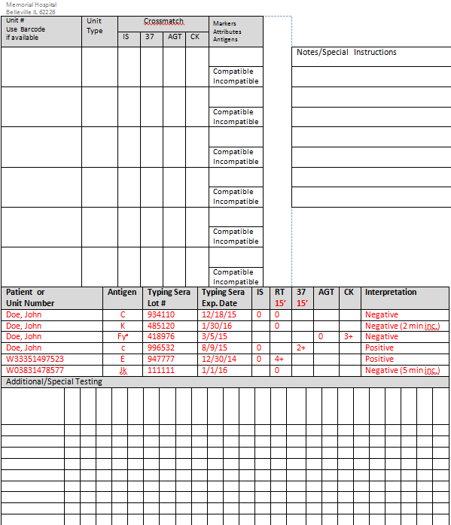
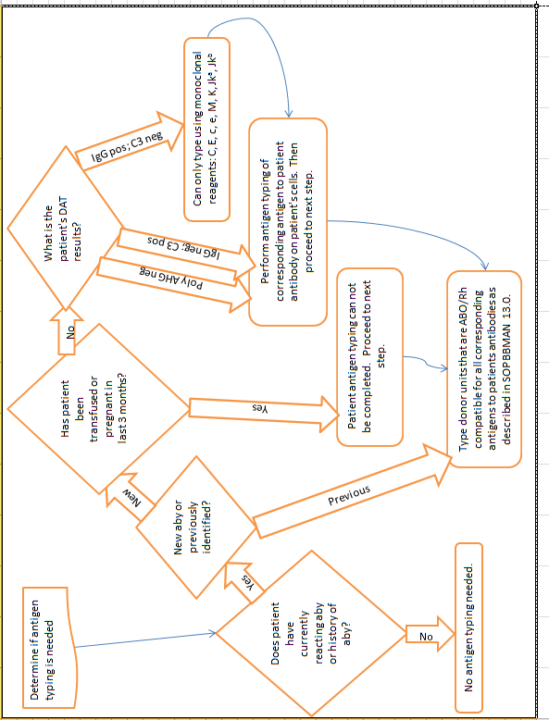
Appendix C: Flowchart for Antigen Typing of Patient and Donor Cells.

Appendix D: Useful Things to know
Antigen | Prevalence (approximate negative) | Should I screen? | What should I screen? | Do I need antigen neg units? | Can I do XM compatible without antigen negative? | Comments
C | 30% | Yes | Rh pos units | Yes |  | Higher % neg in Rh neg and AA* donors
E | 70% | Yes | Rh pos units (unless patient is Rh neg) | Yes |  | Higher % neg in Rh neg and AA* donors
c | 20% | No |  | Yes
e | 2% | No |  | Yes
Cw | 98% | Yes** | Rh pos units (unless patient is Rh neg) | If reacting <1+ | Yes | Low incidence antigen, make sure antibody is reacting 1+ or greater.
V | 99% | Yes** | Any | If reacting <1+ | Yes | Low incidence antigen, make sure antibody is reacting 1+ or greater.
K | 91% | Yes | Rh pos units (unless patient is Rh neg) | Yes
Fyª | 35% | Yes | AA* donor, Rh pos | Yes |  | AA* donors are mostly Fy(a-b-)
Fy^{b} | 15% | No |  | Yes |  | AA* donors are mostly Fy(a-b-)
Jkª | 20% | Yes | Cauc donor/Rh any | Yes
Jk^{b} | 25% | No |  | Yes |  | AA* donors are mostly Jk(a+b-)
Leª |  | Yes** | AA* donor, Rh any | Only if unable to find XM compatible | Yes | Higher incidence of Le(a-b-) in AA* donors
Le^{b} |  | Yes** | AA* donor, Rh any | Only if unable to find XM compatible | Yes | Higher incidence of Le(a-b-) in AA* donors
M | 35% | Yes | Rh pos units (unless patient is Rh neg) | Only if unable to find XM compatible | Yes
N | 30% | No |  | Yes
S | 45% | Yes | Rh pos units (unless patient is Rh neg) | Yes |  | AA* donors are mostly S-s+
s | 20% | No |  | Yes |  | AA* donors are mostly S-s+
Luª | 98% | Yes** | Any | Never | Yes | Never get antigen negative units regardless of strength
*AA-African American
**Use crossmatching to screen for units negative for antigen

PROCEDURE AND FORM CHANGE CONTROL

Title: BBMAN 13.0-Antigen Typing
Written |  | Validated |  | Path Review |  | Review |  | Effective |  | Reason for Revision
Date | By | Date | By | Date | By | Date | By | Date | By | Reason for Revision
11/12/14 | JLH | 1/6/14 | GJM/KMS | 1/7/15 | JAP |  |  | 1/7/15 | JLH
Revised

Location of any copy(s) of the procedure:

Out of use:

Date:_______________By:_______________Reason:___________________________

