Issue and Transport of Blood and Blood Products

Purpose To provide instructions on issuing blood and blood products to patient care areas from the blood bank and guidance on how to transport them.

Background Blood and blood products can be safely transported using the hospital pneumatic tube system. In order to track shipment and prevent loss of the products they will be sent only by badge secure transaction. Each red blood cell product will have a temperature monitoring device affixed prior to shipment. Identification of patient and blood product is a very important step in the issuing and transport process.

Specimen NA

Materials
Reagents | Supplies | Equipment
NA | - Genesis Timestrip® Blood Temp 10 temperature sticker  - Large Biohazard plastic bag | - Pneumatic tube system

Quality
Control NA

Procedure
- Pre-Issue Steps

Step | Action
1 | Ensure the patient care area has ordered a “Request Blood Product Delivery” in MCARE.  NOTE: If the order is for an emergent need or for a transporter, see the appropriate corresponding procedure for how notification of transfusion need occurs.
2 | Ensure that the following have been performed:
  Step | Action
  1 | The product(s) have been ordered in MCARE.
  2 | The patient information on the request for delivery matches the patient information on the order for blood products.
  3 | An ABORh has been completed on the patient’s encounter, indicated by the H# at the top of the request for delivery, in the last 72 hours.
  4 | An antibody screen has been completed on the patient’s encounter, indicated by the H# at the top of the request for delivery, in the last 72 hours.
3 | Retrieve the assigned or crossmatched unit from storage.
4 | Retrieve the “Request Blood Product Delivery” order sheet from printer.
5 | Record the on the “Request for Delivery of Blood Products” the following information from the patient’s history screen in MCARE:  - Patient’s antibodies, if applicable.  - Patient’s special requirements, if applicable (CMV neg, IRR, HgbS neg, etc.)
6 | Verify that the blood product order matches the blood product retrieved.
7 | If blood product is a red blood cell product, activate and attach a Genesis Timestrip® Blood Temp 10 temperature sticker as described in Use of Genesis Timestrip® Blood Temp 10 SOP.
8 | All other blood products should be issued without temperature sticker attached.

- Issuing Units

Step | Action
1 | From the main desktop in MCARE, open the BBK Unit desktop.  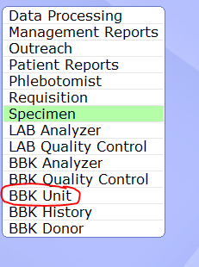
2 | Choose Single from the right menu bar.  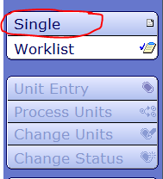
3 | Choose Issue from the right menu bar.  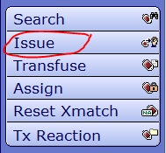
4 | Choose Issue Units by Patient from resulting menu.  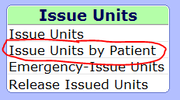
5 | In the Patient Name:, type 1 of the following:  a. The patient’s name in the following format Last Name,First Name  b. The patient’s M number in the following format U#MXXXXXXX.
6 | Select the correct patient by comparing all information available from the resulting list.
7 | Select the correct admission by matching the H number on the “Request for Delivery of Blood Products” to the H number next to the patient’s name in the list.
8 | Press F12 to bypass the most recent laboratory results.
9 | Available units will appear in a message window; compare the unit you selected to the list.
10 | Click F12 or Close to bypass this screen.
11 | Scan the unit number barcode into the Unit field on the screen.  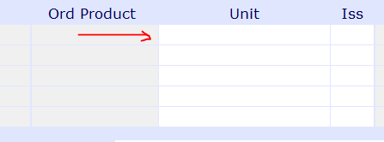
12 | The issuing information will fill in by default based on the log in, indicated by the red arrows below.  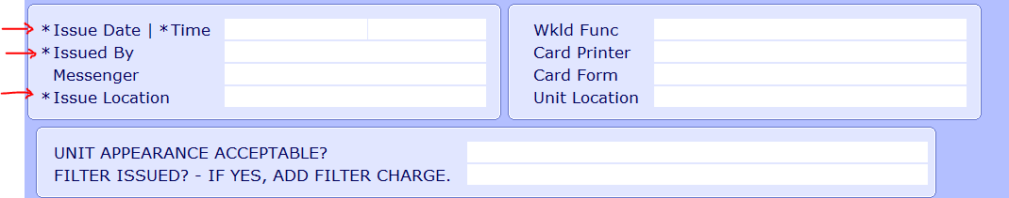
13 | Press the Enter key until the cursor is in the Messenger field.
14 | In this field, enter the location that you are physically sending the unit (ie. 1S, ICU, ER, etc)
15 | Press enter to go down to the Issue Location field.
16 | Check to ensure that information in Issue Location field reflects where unit is actually going.  - If unit is going to OR, type “H.OR”  - If unit is going to PACU, type “H.PACU”  - If unit is going to GI lab, type “H.GILAB”
17 | Press the Enter key until the cursor reaches the UNIT APPEARANCE ACCEPTABLE? Field.
18 | If the appearance of the unit meets the guidelines outlined in the appearance check chart, then type “Y” and then press enter.
19 | If the appearance of the units doesn’t meet the guidelines for issue, then quarantine the unit and repeat the above steps starting from the “Pre-Issuing Steps” #3.
20 | In the FILTER ISSUED? – IF YES, ADD FILTER CHARGE field, type “N”.  NOTE: Filters for transfusion are kept and maintained by nursing. There are no filters to be given out by blood bank.
21 | In the Units Issued Comments field, type any free text comments desired.  - If unit is being sent in a transporter, free text a comment indicating the id number of the transporter the unit was sent in.
22 | Click Save.
23 | Click No in the Enter Transfusion Data dialogue box.
24 | The “Issue/Transfusion” document should print on the printer.

- Issue/Transfusion Sheet

Step | Action
1 | Locate on the “Request Blood Product Delivery” order, the Pre-approved paper documentation field. (Example below)  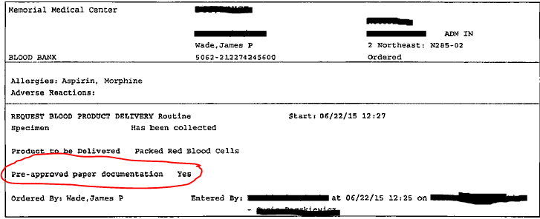
2 | Look at the answer to the above question:
  If…. | Then….
  The answer is “Yes” | - Print off a second Issue/Transfusion sheet.  - See step 3 for directions on how to print.
  The answer is “No” | Proceed to section 4: Second Person Review
3 | To print a second Issue/Transfusion document:
  Step | Action
  1 | Open the BBK Units Desktop as described above
  2 | Click on Single on the right side of the screen.
  3 | Click on Print Cards  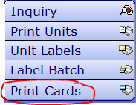
  4 | Click on Issue/Transfuse Card  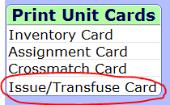
  5 | Enter the patient’s name and then press Enter.  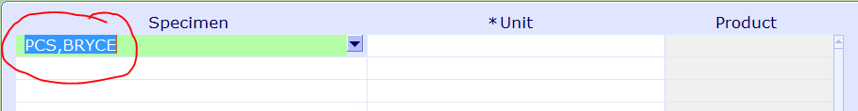
  6 | Choose the correct encounter by matching the H#.  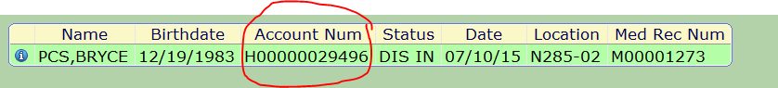
  7 | Choose the order that matches your blood product crossmatch.  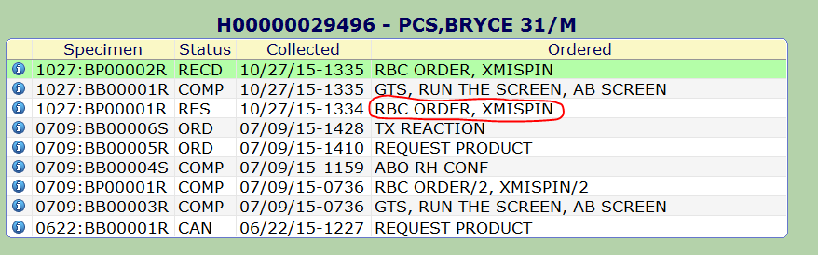
  8 | Scan the unit barcode into the Unit field.
  9 | Press F12 or click “OK”.
  10 | Choose the correct printer if not already in the field.
  11 | Press F12 or click “OK”.
  12 | Click “Close” in the End of report dialogue box.

- Second Person Review

► Non-laboratory personnel or laboratory personnel NOT trained in blood bank

Step | Action
1 | A second staff member must perform a second check or verification BEFORE any blood product is released to the patient care area for transfusion.
2 | Any Memorial Hospital/Memorial East Hospital employee is capable of performing the verification check.
3 | The blood bank tech will retrieve the issued unit, the “Request Blood Product Delivery” and the “Issue/Transfusion” sheet.
4 | The second person will be given the issued unit and Job Aid for second person review. See Appendix B.
5 | The second person will check:  - The unit has a Genesis Timestrip® Blood Temp 10 temperature sticker attached to the unit and that it is activated.  - The unit has a crossmatch tag attached to it.  - The base label has not been defaced in any way.
6 | The second person will read from the front of the unit:  - The donor unit number.  - The donor unit expiration.  - The donor unit ABO and Rh type.  - The type of unit (ex. Red Blood Cells, Irradiated Red Blood cells)  - If the unit is CMV negative or not.  - Any antigen typing results.
7 | As the second person reads from the front of the unit, the blood bank personnel will check the information against the information located on the Issue/Transfusion sheet and the antibody and special requirement information that they recorded on the “Request Blood Product Delivery” sheet.
8 | The second person will then read the following from the transfusion sticker attached to the unit:  - The patient’s full name  - The patient’s date of birth  - The patient’s H number (Account number)  - The interpretation of crossmatch where it  says “Comp?” read “Y” or “L”. If unit is a  plasma product, this will be blank.  - The issue date/time.
9 | As the second person reads from the transfusion sticker, the blood bank personnel will check the information against the information located on the “Request Blood Product Delivery” sheet.
10 | If all information matches, the second person will put their employee ID number next to the issue tech’s ID number on the Issue/Transfusion sheet that the blood bank will keep. Proceed to step 12.
11 | If any of the information does not match, blood bank tech must investigate or have a reason for the discrepancy. See the “Interpretation” section of procedure for further instructions.
12 | Blood bank personnel will then staple or otherwise attach the “Request Blood Product Delivery” sheet and the Issue/Transfusion sheet to each other and place in the review box.

► Blood bank trained personnel

Step | Action
1 | A second staff member must perform a second check or verification BEFORE any blood product is released to the patient care area for transfusion.
2 | If the second checker is blood bank trained, then continue to step 3. If the second checker is not blood bank trained, then return to the previous section for personnel not trained in blood bank.
3 | The issuing tech will retrieve the issued unit, the “Request Blood Product Delivery” and the Issue/Transfusion sheet and give all to the second checker.
4 | The second checker will check:  - The unit has a Genesis Timestrip® Blood Temp 10 temperature sticker attached to the unit and that it is activated.  - The unit has a crossmatch tag attached to it.  - The base label has not been defaced in any way.
5 | The second checker will compare the following to ensure the they match exactly:
  Item checked | 1st Comparison | 2nd Comparison
  - Patient’s full name  - Patient’s H#  - Patient’s DOB  - Patient’s ABO/Rh  - Donor ABO/Rh  - Donor unit #  - Donor unit expiration  - Special requirements  - Patient’s antibodies  - Crossmatch results | - Request for Delivery  - Request for Delivery  - Request for Delivery  - Transfusion Tag  - Transfusion Tag  - Transfusion Tag  - Transfusion Tag  - Request for Delivery  - Request for Delivery  - Transfusion Tag | - Transfusion Tag  - Transfusion Tag  - Transfusion Tag  - (Is it compatible with unit?)  - (Is it compatible with patient?)  - Front of donor unit  - Front of donor unit  - Donor label and/or tags  - Donor label and/or tags  - (If anything other than “Y”, do you have a release signed?)
6 | If all information matches, the second checker will put their employee ID number next to the issue tech’s ID number on the Issue/Transfusion sheet that the blood bank will keep.
7 | If any of the information does not match, blood bank tech must investigate or have a reason for the discrepancy. See the “Interpretation” section of procedure for further instructions.
8 | Blood bank personnel will then staple or otherwise attach the “Request Blood Product Delivery” sheet and the Issue/Transfusion sheet to each other and place in the review box.

5. Transportation of Blood Products
 | Policies
1 | All units must be transported out of the blood bank one at a time.  Note: Exception can be given to FFP orders and orders going out in transporters.
2 | Only a RN, LPN, physician or other personnel as indicated by blood bank supervisor or laboratory management, may transport blood from the blood bank that is not in a transporter.
3 | Any personnel wishing to transport blood from the blood bank must present a typewritten piece of identification of the patient they are wishing to receive products on. Handwritten or verbal confirmation will not be accepted.
4 | The second person check MUST be performed before units can be removed from the blood bank.
5 | Units can be transported in the following ways:  - Pick up by nurse/physician (see section below)  - Pneumatic tube system (see section below)  - Temperature controlled transporters (see Transport of Blood Product in Blood Bank Transporters SOP for procedure on transporters)

► Nurse pickup

Step | Action
1 | Nurse/physician presents blood banker with patient identification.
2 | Blood banker retrieves unit to be given.
3 | If second person check has not been performed, perform with nurse/physician or laboratory personnel.
4 | If Pre-approved paper documentation was “yes”, place extra Issue/Transfusion sheet into the front pocket of large biohazard plastic bag. If “no”, continue to step 5.
5 | Place unit in large biohazard plastic bag and seal.
6 | Hand off to nurse/physician.

► Pneumatic tube transport

Step | Action
1 | If second person check has not been performed, perform with other laboratory personnel.
2 | Retrieve unit to be given.
3 | If Pre-approved paper documentation was “yes”, place extra Issue/Transfusion sheet into the front pocket of large biohazard plastic bag. If “no”, continue to step 5.
4 | Place unit in large biohazard plastic bag and seal.
5 | Scan badge into tube system
6 | Press Send/Enter
7 | Press Menu
8 | Arrow down to User Special Function
9 | Press Send/Enter
10 | Arrow down to Badge Secure Transaction
11 | Press Send/Enter
12 | Enter the numeric code for the location that the unit needs to go to.
13 | Press Send/Enter
14 | If the unit on the other end does not pick up the unit within 5 minutes, the tube will return to the blood bank station and you must scan your badge to retrieve tube.

Interpretation

If any of the checks do not match or there are any discrepancies, they must be resolved before any units are released to a patient care area for transfusion. If discrepancies in computer information arise, contact the LIS team or the help desk to try to resolve. If discrepancies exist between the unit information or the patient testing, contact the blood bank supervisor for help in resolving. If unable to resolve, DO NOT release unit. Put unit in quarantine if it is a unit issue and perform the process again with a different unit. If it is a patient identification problem, return unit to inventory until resolved.

Result
Reporting
NA

References AABB. Standards for Blood Banks and Transfusion Services--29th Edition. Std. 5.22, 5.22.1, 5.23, 5.25, Bethesda, MD: American Association of Blood Banks; 2014
SwissLog Pneumatic Tube Users Manual

Related Appendix A: Job Aid for Non-Blood Bank Personnel Performing Second Check
Documents Appendix B: Flowchart for Issue and Transport of Blood and Blood Products

Appendix A: Job Aid for Non-Blood Bank Personnel Performing Second Check

Please check donor unit for the following:
- Unit has a temperature sticker attached to it
  - The sticker looks like the picture below with a green window above a white window outlined in red.
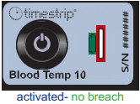
  - If the sticker looks like either of the following pictures, alert blood bank personnel to correct.
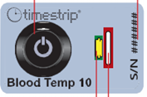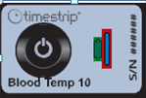
- Unit has the transfusion sticker attached to the unit in some way.
- The unit has no stray markings or defacement to its label.

Read the following to the blood banker from the front of the unit:
- The donor unit number that starts with “W”
- The donor unit expiration
- The donor unit ABO and Rh type.
- The type of unit (ex. Red Blood Cells, Irradiated Red Blood cells)
- Check if the unit has another barcode at the bottom right that indicates it is CMV neg-if so, indicate that to the blood banker.
- If the unit has any tags attached to it that indicate antigens it is negative for, read those to the blood banker.

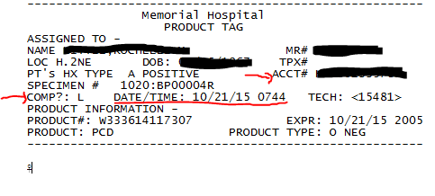
Read the following to the blood banker from the transfusion sticker attached to the unit:
- The patient’s full name
- The patient’s date of birth
- The patient’s H number (Account number)
- The interpretation of crossmatch where it
says “Comp?” read “Y” or “L”. If unit is a
plasma product, this will be blank.
- The issue date/time (underlined in example)

PROCEDURE AND FORM CHANGE CONTROL

Title: Issue and Transport of Blood and Blood Products
Written |  | Validated |  | Path Review |  | Review |  | Effective |  | Reason for Revision
Date | By | Date | By | Date | By | Date | By | Date | By | Reason for Revision
04/19/10 | PAB | 4/27/10 | GJM | 5/3/10 | ESB |  |  | 5/4/10 | PAB
Revised
12/3/10 | PAB | 12/28/10 | MLH | 12/28/10 | ESB |  |  | 1/10/11 | PAB | Updated for new tag format
5/13/11 | PAB | 5/28/11 | MLH | 6/6/11 | ESB |  |  | 6/14/11 | PAB | Updated for new Meditech version
6/17/11 | PAB |  |  | 6/25/11 | ESB |  |  | 7/1/11 | PAB | Removed three ply paper
8/13/12 | PAB | 8/14/12 | GJM | 8/21/12 | ESB |  |  | 8/21/12 | PAB | Revised for pneumatic tube transport and XM on demand
5/8/13 | PAB |  |  | 5/13/13 | ESB |  |  | 5/15/13 | PAB | Revised issue to nursing
11/13/13 | PAB |  |  | 11/15/13 | ESB |  |  | 12/9/13 | PAB | Included HemoTemp on PRBC
 |  |  |  |  |  | 4/1/14 | PAB
1/21/15 | JLH |  |  |  |  |  |  | 1/21/15 | JLH | Added instructions to add issue location to match location.
2/5/15 | JLH |  |  |  |  |  |  | 2/6/15 | JLH | Changed blood temp indicator to Timestrip
10/21/15 | JLH |  |  |  |  |  |  |  |  | New header, more detail, changed second person review, added flowchart, changed flow for TAR implementation

Location of any copy(s) of the procedure:

Out of use:

Date:_______________By:_______________Reason:___________________________

