**Antibody Workup Samples for Memorial East**

**Purpose** To provide instructions on handling antibody workup samples from Memorial East Hospital

**Background** Memorial East Hospital has limited means of performing antibody workups on patients with previous and new antibodies. When Memorial East tests a sample that they get a positive antibody screen result on, it will be forwarded to Memorial Belleville Hospital for workup.

**Specimen** 1-2 anticoagulated specimens in EDTA or can be clotted specimens without gel separator.

|  |  |  |
| --- | --- | --- |
| Reagents | Supplies | Equipment |
| NA | **NA** | NA |

**Materials**

**Quality**

**Control** NA

**Procedure**

|  |  |
| --- | --- |
| **Step** | **Action** |
| 1 | Memorial East will notify Memorial Belleville that a sample will be coming for workup. |
| 2 | If the patient is one that requires sending to the reference lab, then notify Memorial East and the sample will be sent directly to the reference lab for workup. |
|  | The sample will be sent by courier or cab depending on availability. |
|  | Once the specimen has arrived, retrieve specimen(s) received from Memorial East |
|  | Antibody Workup Results Form should accompany specimen(s).   * Contact Memorial East to fax form if not received with specimens and have a completed form faxed over. |
|  | Review form for history if any |
|  | Perform history check and antibody workup according to SOPs |
|  | When complete, record results on Antibody Workup Results Form.   * See Appendix A for example |
|  | Call Memorial East laboratory to inform them that workup is complete and you are faxing results. |
|  | Fax completed form to Memorial East and place in antibody workup folder for review. |
|  | Supervisor or designee will review workup and sign off on results in the final review section of the form and fax to Memorial East when complete. |

**Interpretation**

If workup needs to be sent to reference lab as determined from workup, then it will be sent from Memorial Belleville unless specimen is exhausted and a new one needs to be collected, then specimen will be re-collected and sent to reference lab from Memorial East

If antigen negative units are needed, Memorial East will order from supplier upon receipt of final results.

Memorial East must perform all crossmatches for patient use. Memorial Belleville crossmatches can only be used for workup interpretation purposes.

**Result**

**Reporting**

Memorial East will enter results of antibody workup into system.

**References** NA

**Related**

**Documents**

Appendix A: Example of Antibody Workup Results Form

Appendix B: Antibody Workups from East Flowchart

**Appendix A: Example of Antibody Workup Results Form**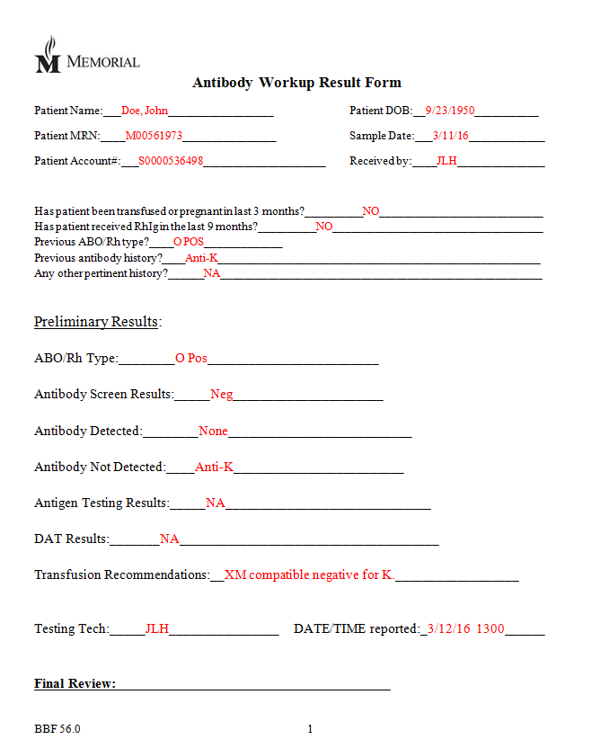



**PROCEDURE AND FORM CHANGE CONTROL**

|  |  |  |  |  |  |  |  |  |  |  |
| --- | --- | --- | --- | --- | --- | --- | --- | --- | --- | --- |
| Title: Antibody Workup Samples for Memorial East | | | | | | | | | | |
| Written | | **Validated** | | **Path Review** | | **Review** | | **Effective** | | **Reason for Revision** |
| Date | **By** | **Date** | **By** | **Date** | **By** | **Date** | **By** | **Date** | **By** |
| 3/14/16 | JLH |  |  | 3/23/16 | ESB |  |  | 4/12/16 | JLH | New procedure |
| **Revised** |  |  |  |  |  |  |  |  |  |  |
|  |  |  |  |  |  |  |  |  |  |  |
|  |  |  |  |  |  |  |  |  |  |  |
|  |  |  |  |  |  |  |  |  |  |  |
|  |  |  |  |  |  |  |  |  |  |  |
|  |  |  |  |  |  |  |  |  |  |  |
|  |  |  |  |  |  |  |  |  |  |  |
|  |  |  |  |  |  |  |  |  |  |  |
|  |  |  |  |  |  |  |  |  |  |  |
|  |  |  |  |  |  |  |  |  |  |  |
|  |  |  |  |  |  |  |  |  |  |  |
|  |  |  |  |  |  |  |  |  |  |  |

Location of any copy(s) of the procedure:

**Out of use:**

**Date:_______________By:_______________Reason:___________________________**