**PRINCIPLE:**

The automated verification process has been built in the Instrument Manager (DI) using the Roche Diagnostics CC/IA Rules Package combined with our laboratory’s parameters set up in Value Lists (Customer-defined tables). The rules package uses these Value Lists as the verification criteria to determine if the patient results can be automatically validated or require tech review in the DI.

Tests results which will be HELD for VERIFICATION in DI include:

CRITICALS

DELTAS

LIN LIMITS (Originals and repeats)

POS DAUS

Results with FLAGS

Results held if QC is not valid.

In MCARE, the Analyzer Type Dictionary has been configured to allow normal and abnormal data without transmission flags to file and verify without tech intervention when received from the DI. The tests which are held for verification in DI, then released, will need to be reviewed in MCARE as well.

Tests which require comments to be added (Criticals, Deltas, and POS DAUS) will be released to MCARE. The comments will then be added in MCARE because the comment format is already set up in MCARE and is easier to use than in DI.

The tech will also need to review the MCARE Analyzer Batch for patient results on 24 hour urines which need additional data (weight and total volume) added in order to file/verify.

MCARE LOGIC will be used for Linearity Limits. Therefore, the tech will need to send from DI to MCARE the **original result** with LIN LIMIT flag **before** the **repeat result**. This will allow the INTERNAL MCARE Reports to include the original and repeat results and CRITICAL and CALLED documentation.

Invalid QC on a test will cause both QC and patient results to be held in the DI. The tests results will continue to be held on any patients run until the tech stops the holding process and releases or reruns the patient results.

The auto-verification process can be STOPPED in the DI by any tech by using the “Start Holding all Tests for Verification” selection under the System: Status menu.

**OVERVIEW of Instrument Manager (DI)**

A. Logon to DI

1. From user desktop, select Instrument Manager (DI) Icon 

2 Select Run.

3. Enter your User ID (your initials) and Password which is case sensitive.

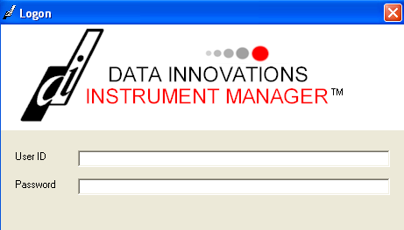

4. Press Logon (bottom of box) or just Enter.

5. You will have access to **System**, **Diagnostics** and **Specimen Management**.

**Help** includes the User’s Guide.



**B. System: Status**

1. Select System, at top left of toolbar.

2. Select **Status**.

3. **License #** is in the Top of the Status Display. Tech may need the License # when calling for service on the instrument manager.

4. Listed under **Connection** and **Status** are the COBAS Live and Test interface connections and their status of ‘On’ or ‘Off’.

5. The following must be ON:

**Purge** allows data to purge on the appropriate day as set in Configuration Editor.

**Qmgr** allows data to flow through the instrument manager.

**Quality Control** processes QC through the instrument manager.

**COBAS1 MT6** and **COBAS2 MT6** are the analyzer interfaces.

**LIS-IN for MT6** is the Download interface. (CDI DOWN in MCARE)

**MT_LIS-OUT C1** and **MT_LIS-OUT C2** are the Upload interfaces.

**(**COBAS1 and COBAS2 analyzer batches in MCARE)

Download Process: MCARE LIS-IN 🡪 DI 🡪COBAS 1 & 2 Analyzers

Upload Process: COBAS 1 & 2 Analyzers 🡪 DI 🡪 MT_LIS-OUT C1 and C2

**Example for B5: System; Status**

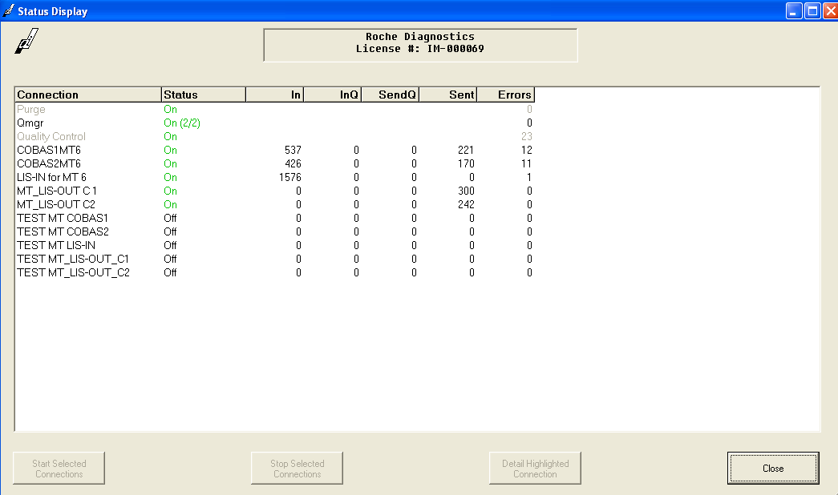

6. At the bottom of Status Display are Start and Stop selected interface connections options.

To Start (or Stop) an interface connection:

* Highlight the connection you wish to Start (or Stop)
* Select the Start (or Stop) Selected Connection box.
* Or right-click to bring up a pop-up box and select Start (or Stop) Selected Connection
* You will also need to Start (or Stop) the interface connections in MCARE analyzer process batch Status menu.

7. **Qmgr** sometimes turns OFF with no warning, then the data is no longer sent from DI to MCARE. If you notice the Qmgr is OFF:

* Highlight Qmgr
* Select Start Selected Connection box (or right-click and select on pop-up box)

**C. How to STOP the AUTO-VERIFICATION process in DI**

1. Select System, at top left toolbar

2. Select **Status**

3**.** Highlight the interface connection for COBAS1 MT6 or COBAS2 MT6.

4. Right-click in the window and select **Start Holding All Tests for Verification.**

5. A dialog box will appear.

* Choose No to exit the window.
* Choose Yes to have all results, from this point forward, for the selected connection put in a **Hold for Verification Status.** All results from this point forward will be held until you remove this setting.

6. To remove this hold and allow tests to be automatically released again:

* Select Specimen Management
* Select SM Workspace
* View Tests Scheduled to be Held pane.
* Right-click in the window and select **Stop Holding Selected Test for Verification.**

**Example for C5: Start Holding All Tests for Verification**

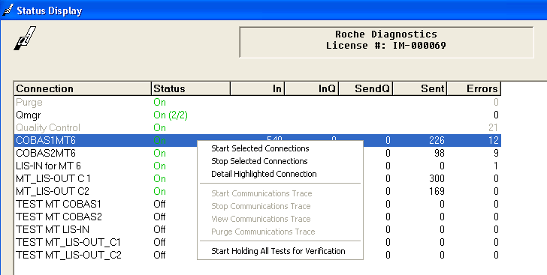

**Example for C6: Stop Holding Selected Tests for Verification**

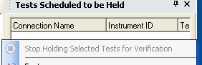

7. Tests would need to be rerun on the alternate COBAS or on the problem COBAS after troubleshooting the problem.

8. Tests which were held will NOT auto release.

**D. Diagnostics: Specimen Event Log**

1. Select Diagnostics.

2. Select Specimen Event Log

3. Enter Specimen ID (Barcode) in top left field to track the progress of a specimen.

4. Select green arrow to right of Enter Specimen ID or press enter on keyboard.

5. From toolbar, select:

* **Specimen Event Log View**
* Displays all events that have occurred to each specimen
* Each message processed for each specimen is assigned a transaction ID
* Displays changes made to **Test Code, Error Code, Fluid Code,** and **Instrument ID** mapping for any message on which mapping is performed
* **Audit Trail View**
* Audit events are created when rules are fired.
* The Audit Trail Report window displays all the data elements that were processed by rules.
* **Specimen Tracking View**
* Displays the tracking events for each specimen
* Displays date and time specimen was logged at each connection

6. Specimen Event Log and Audit Trail are also accessible from Specimen Management

Workspace.

**E. Diagnostics: System Log**

1. Select Diagnostics

2. Select System Log

3. User ID and PC Names are listed with Event date/time.

4. User log ons and log offs are recorded by the System Log.

**F. Specimen Management: SM Workspace**

1. Select Specimen Management

2. Select SM Workspace

3. Specimen Management Workspace has six main menus: **Workspace, Edit, View, Format, Action, and Help.**

4. Menu options from these menus are also accessible by **right-clicking** in the **Workspace** **panes.** Note that the listings will vary depending on the pane where you right-click.

5. Gray selections are not accessible.



6. There are 4 Panes with specimen, test, patient and QC information we will use.

**Right click** in any space in SM Workspace to bring up a menu which will include Panes:

* Patient Information
* Specimen Worksheet
* Test Worksheet
* Tests Scheduled to be Held

**Example of menu options found by right-clicking in Patient Information Pane:**

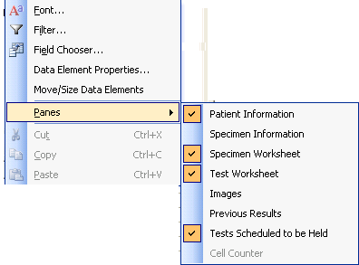

7. Color-coding has been added to aid the reviewing tech.

* They are listed by priority. Critical is highest priority.
* The Specimen Worksheet will have the color of the highest priority per specimen.
* The Test Worksheet may have more than one color per specimen.

NOTE: For colors to match this list, your background color scheme needs to be set to default/blue.

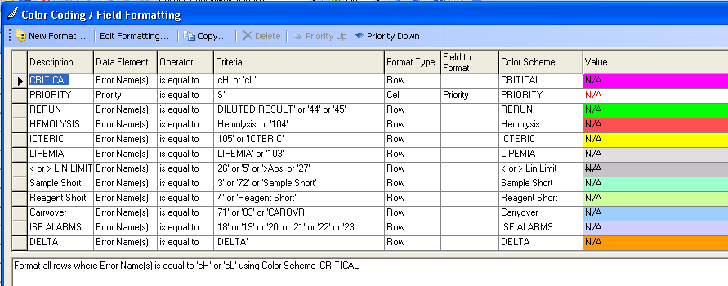

8. Icons on the toolbar may also be found when right-click in worksheet panes.



Most useful are:

*  Filter
*  Field chooser (use this to add / remove fields from Specimen or Test

Worksheets)

*  Release
*  Reject

**G. Set up your SM Workspace**

1. **Specimen Worksheet** includes the Patient Name, Specimen ID (Barcode) and Priority.

**Stats** will have a **Red S** under Priority**.**

2. Select a specimen by placing the arrow at left of line and left-click to Blue highlight the line.

3. The **Patient Information** pane includes that patient’s Hospital ID, DOB, Sex, Location, ordering physician and collection date. Collection time is not available.

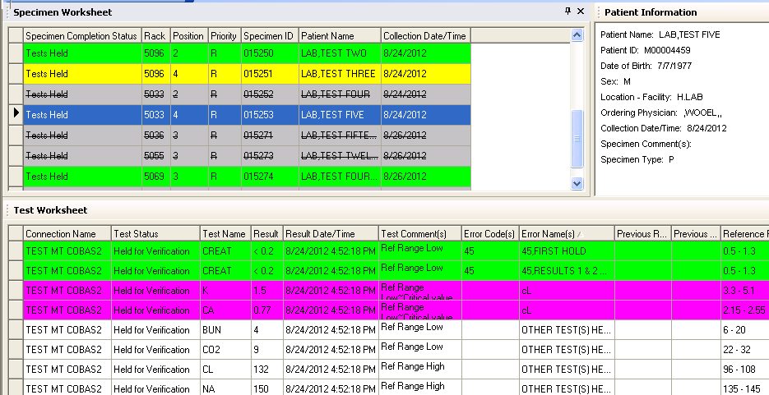

4. The **Test Worksheet** pane lists the test results for the patient highlighted in Specimen Worksheet. Fields in Test Worksheet should include:

* Connection Name
* Test Status (Filtered on ‘Tests held for Verification’, will only show that status)
* Test Name
* Result
* Result Date/Time (time is **not** specimen collection time)
* Test comments (Indices comments will release to MCARE)
* Error Codes ( useful for troubleshooting)
* Error Names ( includes information e.g. ‘Perform Manual Dilution’)
* Previous Result (useful for specimens with Delta Flags)
* Previous Result date/time
* Reference Range

5. Techs may update their SM Workspace by adding or removing fields.

* Click in the Worksheet pane
* Select field chooser icon
* Check mark to add a selection
* Remove check mark to deselect

**AUTO-VERIFICATION PROCEDURE**

**A. Setup one PC to display MCARE**

1. Daily in MCARE, CREATE a new CDI DOWN.

2. Per shift in MCARE, CREATE a new COBAS1 (and COBAS2 until Merge COBAS to one screen)

3. Open Specimen Pending Tracking screens

* COBAS Selection Profile / Received
* CU,BF Dept Prefixes / Ordered
* C1 Selection Profile / Ordered
* C2 Selection Profile / Ordered

**B. Setup second PC to display Instrument Manager (DI)**

1. Log on using your Initials and Password

2. From Toolbar, select Specimen Management

3. Select SM Workspace.

4. Select **Results Review Edit Release**

5. Select **Refresh** Icon drop down arrow.  .

* Choose **30, 60, 120 or 300** seconds to refresh the SM Workspace.
* If you leave it Off, you will need to select Refresh frequently to not miss specimens needing tech attention.

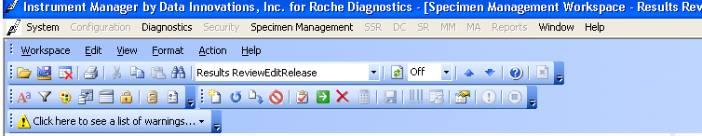

6. Select **Funnel  (Filter)** to bring up pop-up box with the selections for reviewing patient results. The selections remain in your SM Workspace when you log out.

7. Select **Tests held for Verification (Results Review/Edit/Release)**

8. Select the COBAS1 MT6 and / or COBAS2 MT6 and Current day

9. These selections allow for the most efficient way to find the specimens needing review.

**Example of Filter pop-up box:**

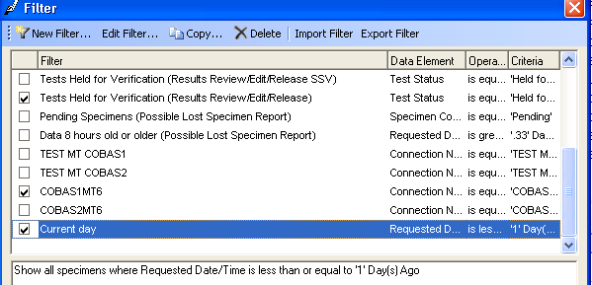

**C. Review** patient results carefully in DI.

1. Test results that are Held for Verification need the attention of you the tech.

* Some are warnings (e.g. Criticals, POS DAUS) that once you release the result, you will need to add a comment or further release a result in MCARE.
* Others (e.g. Lipids with > Lin limit Trig, Chol and /or HDL) (e.g. CRP with manual dilution) will require the tech to release results in the correct order or edit the result before releasing. Follow up will be needed in MCARE also.

2. Understand **Meditech Logic** when releasing results

* Results outside linear limits need to be approved in MCARE before the repeat linear result.
* Calculations will still occur in MCARE, but will ‘File and Verify’ **immediately**. If results are Held for Verification and are part of a calculation, follow the protocol included with this procedure

**D. Release** patient results

1. Select specimen from **Specimen Worksheet**

* Click on box to left of specimen to display an **arrow**
* Specimen line should **highlight** **Blue**
* The list of tests in **Test Worksheet** and the information in **Patient Information** belong to that specimen.

2. Select test from **Test Worksheet**

* Click on box to left of test to display an **arrow**
* Test line should **highlight** **Blue**
* Options for **Release** and **Reject Result**
* Right clickin the Test Worksheet pane. Pop-up box appears with options

**Release** and **Reject Result**

* Use toolbar icons  Release and  Reject

3. In MCARE, results may appear as **\*Filed** (Partially Filed)

* Use the + sign in MCARE to determine what may still need to be file/verified
* Filed is the right column; Y= filed, N= not filed

**Example of 2D: Right click in Test Worksheet to Release or Reject result**

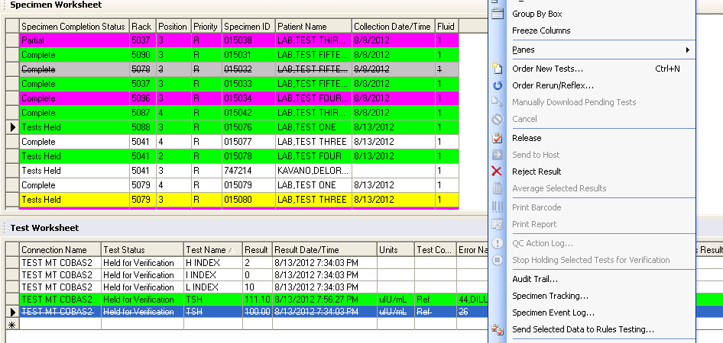

3. Use the following guidelines.

**GUIDELINES for Auto-Verification**

If more than one test has an issue, follow guidelines in order of importance and Release each test from the **Test Worksheet**. Example if Critical Glucose and above Linear Limit BUN on same BMP, deal with Critical Glucose first.

**A. CRITICAL** results (row is Fuchsia color)

1. Critical results will need to be released from the Test Worksheetif the specimen has

other flags (e.g. linear limit) to be addressed

2. If Critical result is the ONLY flag, entire specimen may be released from the Specimen Worksheet

3. If the Critical result is within linear limits:

* + Release the test from DI
  + Call the result and document by adding the CRIT comment in MCARE.
  + Save and verify the result in MCARE.

4. If the Critical result is outside linear limits:

* Release the result that is outside linear limits from DI.
* Save and verify the result in MCARE, which will expect a repeat to follow.
* Release the repeat result if within linear limits from DI.
* Call the repeat result and document by adding the CRIT comment in MCARE.
* Save and verify the result in MCARE.

**B. POS DAU** results

1. Release the entire DAU from **Specimen Worksheet**

2. Call POS results and document by adding the DAU comment in MCARE

3. File and verify the DAU in MCARE

**C. INDICES FLAGS**

1. In DI, the tests will flag for Hemolysis (RED), Icterus (YELLOW), and Lipemia (light gray) according to their package insert.

2. Tech will need to check the Hemolysis, Icterus and Lipemia values in Test Workspace to determine how to handle.

3. HEMOLYSIS

* Chemistry guidelines are to REDRAW specimens if Hemolysis is > 100
* In DI, tests will flag and test line will turn red if test is affected by Hemolysis
* If a BMP has a red flag for Potassium, DI comment states ‘REDRAW: Hemolyzed Specimen’: then the entire specimen should be redrawn.
* **Reject** the entire specimen from Specimen Worksheet
* **Cancel**  and reorder the specimen in MCARE
* If tech decides to use the specimen, highlight and edit the comment in DI.
* MCARE will hold results with Hemolysis Indices flags.
* Tech may also edit the attached comment in MCARE.
* E.g. DBIL Hemolysis comment will state “Hemolyzed: Hemolysis interferes with the above test.” Tech may add the degree of Hemolysis: Slight, Moderate, etc.
* File/Verify the result in MCARE.

4. ICTERUS

* Icterus flag will add Icterus comments to the affected tests.
* Address other flags on the specimen first
* Release the specimen from Specimen Worksheet after all other flags have been addressed.
* MCARE will hold results with Icterus Indices flags. File/Verify in MCARE.

5. LIPEMIA

* Lipemia flag will add comments to the affected tests.
* NOTE: Some tests affected by Lipemia may need to be airfuged then rerun. AST and ALT with Lipemia > 150 may have ABS flags. Airfuge that specimen and rerun for the ALT and AST.
* If specimen needs to be airfuged and rerun for entire specimen, reject the result from Specimen Worksheet
* If specimen needs to be airfuged and rerun for certain tests, reject the test results from Test Worksheet
* MCARE will hold results with Lipemia Indices flags. File/ Verify in MCARE.

**D. DELTAS** (row is orange)

1. Previous test results can be viewed in Test Worksheet.

2. Glucose POC results would need to be viewed in EMR from MCARE.

3. Address other flags first (e.g. Criticals, Linear limits)

4. If Delta result is linear:

* Release the specimen from Specimen Worksheet.
* Document by adding ‘D’ comment for ‘Results Reviewed’ in MCARE
* Save and verify in MCARE

5. If the Delta result is outside linear limits:

* Release the result that is outside linear limits from DI.
* Save and verify the result in MCARE, which will expect a repeat to follow.
* Release the repeat result if within linear limits from DI.
* Document by adding ‘D’ comment for ‘Results Reviewed’ in MCARE
* Save and verify in MCARE

6. NOTE: Glucose results (previous and current) in DI include GTT results whereas in MCARE, GTT has separate mnemonics. If you see a Glucose Delta in DI that is NOT in MCARE, it may be from a previous GTT.

**E. LINEAR LIMIT OUTLIERS: ABOVE** LINEAR LIMIT **(**row is **gray** with line through it)

1. Test results that are above linear limit will flag with error code **26** and be Held for Verification in DI.

2. CHECK the COBAS screen on all patients that are Held for Verification, especially patients needing auto and manual dilutions

**CAUTION: the following directions are NOT for results included in Calculations**

3. Repeat is within linear limits and not included in a calculation:

* Release the first result from DI Test Worksheet
* File and Verify in MCARE
* Release the repeat **if linear** from DI Specimen Worksheet
* File and Verify in MCARE

4. Repeat is still above linear limits, needs manual dilution and is not included in calculation:

* Release the first result from DI Test Worksheet
* File and Verify in MCARE
* Release the repeat which is above linear limit from DI Test Worksheet
* \Z the result in MCARE, file and verify
* Perform manual dilution
* **In DI**, the tech will need to **manually enter the calculation for the dilution**.
* Release the corrected manual dilution result from DI Test Worksheet
* File and Verify in MCARE

**F. ABS, PROZONE, KINETIC**

1. Test results that are above linear limit and have ABS or PROZONE flags will not have a result listed in DI although the specimen will be listed in Test Worksheet. COBAS does not send these results.

2. The repeat result may be held in DI with a flag of 26.

3. Follow guidelines for Linear Limit Outliers: Above Linear Limit

* Tech will need to make a manual dilution and rerun that dilution
* Tech will need to manually enter the calculation for the dilution

4. The repeat result may be held in DI with a flag of 44

* Tech will need to add \R to the result when release to MCARE
* Tech will need to manually enter the previous result for documentation in MCARE

**G. LINEAR LIMIT OUTLIERS: BELOW** LINEAR LIMIT **(**row is **gray** with line through it)

1. Tests results that are below linear limit and require repeat will flag with error code **27** and be Held for Verification.

**CAUTION: the following directions are NOT for results included in Calculations**

* Release the first result from DI Test Worksheet
* File and Verify in MCARE
* Release the repeat from DI Test Worksheet
* File and Verify in MCARE
* Release the entire specimen from Specimen Worksheet

2. Tests that require repeat for error code 27 include IGG, IGA, IGM

* IG tests need the ‘IG’ comment added in MCARE
* Enter the repeat result in the IG comment

**H. EXCEPTIONS to LINEAR LIMITS**

1. Some tests do not require repeats even though they flag with error code 26 or 27.

* Examples are TNI, DBIL, DIG, and BHCG for error code 27 and B12 and TESTO for error code 26.
* These tests will NOT be held for verification in DI and will not be held in MCARE.

2. You may see these tests in DI if they are held with other tests, however, they will not have the error flags, so they may be released as soon as possible.

**I. CREAT** <0.2 (row is green, flag is **45**) or (row is yellow, flag is 105)

1. CREAT will automatically calculate the GFR in MCARE.

2. If CREAT is < 0.2, HOLD that result in DI until the repeat result is available.

* If the repeat is also < 0.2, Release from DI and add the \R in MCARE
* If the repeat is 0.2 are above, use the linear result and add the \R in MCARE
* If the GFR is calculated and you release a second CREAT, a correction will appear on the GFR result.

3. Reject the second result in DI after added as \R in MCARE

4. NOTE: You must **release** the **yellow line with 105 error flag** in order for MCARE to receive the Icterus comment. If you send the green line with error flag 45, add the **ICT** comment in MCARE. This occurs because when results repeat, the indices do not repeat.

**J. CALCULATIONS with test results ABOVE or BELOW linear limit**

1. LIPIDS, MALBRU, IRNPKG and other calculations occasionally have tests results which are above are below the linear limit.

2. If results are sent to MCARE as a group, the calculation will immediately fly in MCARE

3. CAUTION needs to be taken to make sure the correct results are used in the calculations.

* Release the first nonlinear result from Test Worksheet in DI
* Immediately \Z that result in MCARE
* Immediately file and verify in MCARE
* Failure to \Z the result could result in that result being used in calculation
* Release the repeat result if linear from Test Worksheet in DI
* The previous result should fill in
* Immediately File and verify in MCARE
* Failure to file and verify in MCARE before release the rest of the tests in the calculation could result in the incorrect result being used in calculation
* Release the specimen from Specimen Worksheet in DI
* Calculation should occur correctly
* Check in MCARE internal report if in doubt

**K. Anion GAP <2**

1. DI calculates the anion GAP, but does NOT send to MCARE.

2. If GAP is <2, DI will hold the Electrolytes.

3. Tech will need to repeat the Electrolytes.

4. If Repeat Electrolytes have anion GAP > 2, results will automatically be sent to MCARE.

5. If Repeat Electrolytes have anion GAP < 2, Tech will need to Release a set of Electrolytes.

* Hold the Ctrl key and select the NA, K, CL, CO2 results to release
* Hold the Ctrl key and select the second set of results. Reject those results.

**L. REFLEX TESTS**

1. Tests that MCARE has set to Reflex to run additional tests (TRIG >250🡪LDL) (Abnormal TSHREF 🡪 FT4), will automatically be ordered in MCARE

2. Tech may or may not see this action in MCARE depending on if other issues need to be addressed (e.g. another test has a Critical or a linear limit to view in MCARE)

3. Check your Specimen Pending Tracking screen and ‘View’ the specimens that have a long time. They may have had a Reflex test added.

**QUALITY CONTROL**

A. Quality control results that are within the control limits will autoverify.

B. Quality control results that are outside the control limits will appear in SM Workspace

‘Tests Held for Verification’ and in the ‘Tests Scheduled to be Held’ pane

1. Patient results will be held for the tests which are outside the control limits as well.

2. Release the failed QC to MCARE and add comment

3. Repeat QC

4. Release repeated QC. If the values are within control limits, the tech may:

* Go to the ‘Tests Scheduled to be Held’ pane
* Select ‘Stop Holding Selected Tests for Verification’ for each control listed that the repeat control is now within control limits
* Release any patients tests that were held

5. If a test needs to be calibrated

* Release the failed QC to MCARE and add comment ‘See repeat after calibration’
* Do NOT release the patient tests
* Patients will need to be rerun

# PROCEDURE AND FORM CHANGE CONTROL

|  |  |  |  |  |  |  |  |  |  |  |  |  |  |
| --- | --- | --- | --- | --- | --- | --- | --- | --- | --- | --- | --- | --- | --- |
| **Title: COBAS AUTO-VERIFICATON USING INSTRUMENT MANAGER (DI)** | | | | | | | | | | | | | |
| **Written** | | **Validated** | | **Path Review** | | | **Review** | | **Effective** | | |  | |
| **Date** | **By** | **Date** | **By** | **Date** | | **By** | **Date** | **By** | **Date** | **By** | | **Reason for Revision** | |
| 8/22/12 | NAB | 9/7/12 | EWE | 9/10/12 | | ESB | 9/10/12 | KTS | 9/12/12 | | **NAB** | **NEW PROCEDURE** | |
| **Revised**  **Date** |  |  |  |  | |  |  |  |  | |  |  | |
|  |  |  |  |  | |  |  |  |  | |  |  | |
|  |  |  |  |  | |  |  |  |  | |  |  | |
|  |  |  |  |  | |  |  |  |  | |  |  | |
|  |  |  |  |  | |  |  |  |  | |  |  | |
|  |  |  |  |  | |  |  |  |  | |  |  | |
|  |  |  |  |  | |  |  |  |  | |  |  | |
|  |  |  |  |  | |  |  |  |  | |  |  | |
|  |  |  |  |  | |  |  |  |  | |  |  | |
|  |  |  |  |  | |  |  |  |  | |  |  | |
|  |  |  |  |  | |  |  |  |  | |  |  | |
|  |  |  |  |  | |  |  |  |  | |  |  | |
|  |  |  |  |  | |  |  |  |  | |  |  | |
| Additional Location(s) of procedure: | | | | |  | | | | | | | |

Out of use:

Date: By: Reason:

C651-018