S | Situation: Akron Children’s Hospital will be standardizing all AEDs to Zoll AED Plus.
B | Background: Currently, we have a mix of LifePak 500, 1000, and Zoll AEDs. For standardization purposes and for better quality CPR, we are transitioning to Zoll AED Plus.
A | Assessment:  - Compared to previous AEDs which were semi-automated, the Zoll AED Plus is fully automated, continues to guide the user through the process, and provides high-quality CPR. Rescuers will hear and see “Push Harder” or “Good Compressions,” as well as encouragement to “Start CPR” if needed.  - Users will no longer need to press the shock button in order for shock to be delivered. The AED will analyze and deliver the shock if shock is advised.  AED Closed View AED Open View  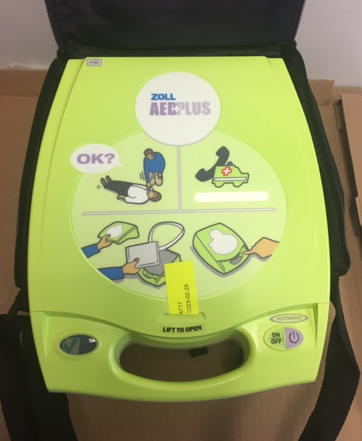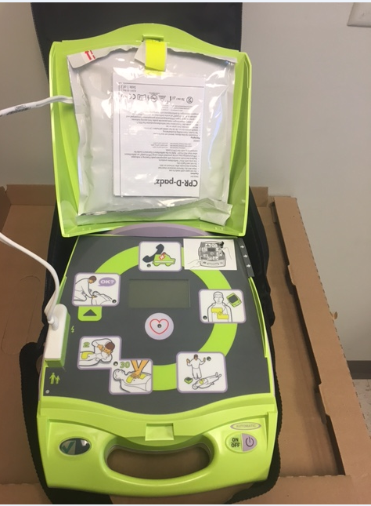  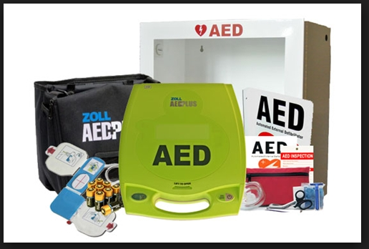  - Clinical Engineering is in the process of switching the AEDS and facilities will be assisting with switching the wall cabinets.
R | Recommendation:  - Please be aware of this change and communicate it broadly.  - Please watch video link: https://youtu.be/yo5jKJBKo0w

