52yo Female

T/F FROM BENDIGO WITH ? NEW AML.

History of Presenting Complaint told leukaemia and to present to ED  
-1/52 LL bruising  
-no other bleeding  
-increasing lethargy - but still able to go to work this week  
-no dyspnoea  
-no headache, no neurological symptoms  
-felt hot sunday night, no other infective symptoms  
-saw GP -> told leukaemia and to present to ED

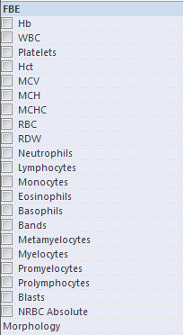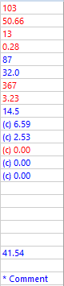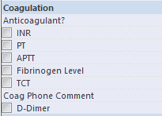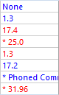

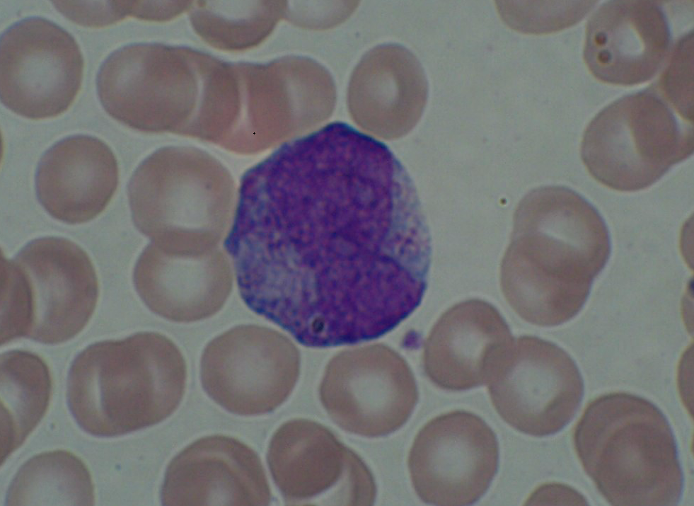

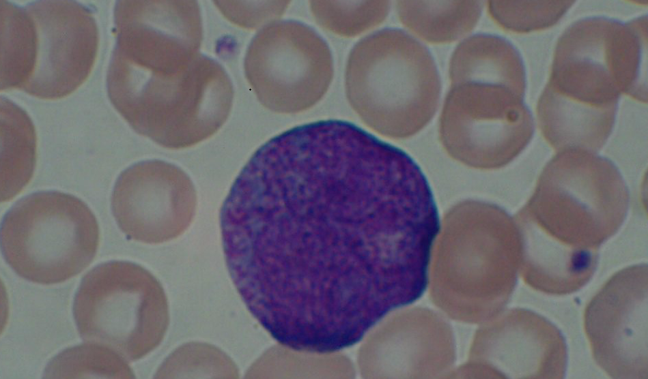

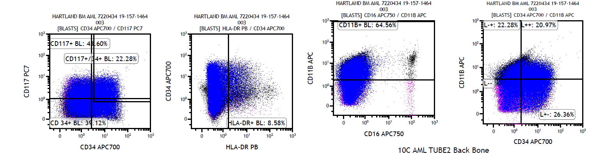

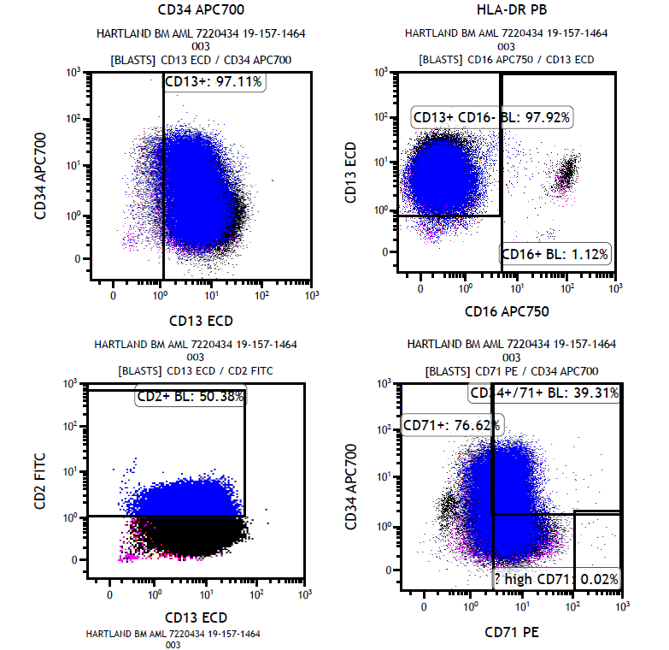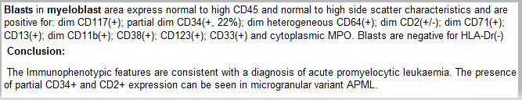

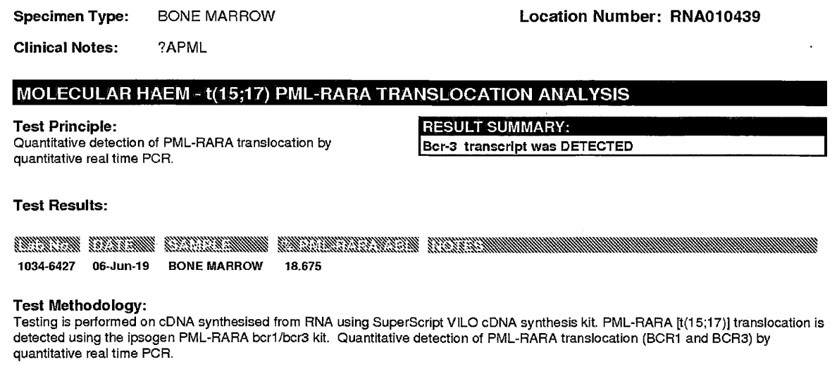

**Acute promyelocytic leukemia** (APL)

Biologically and clinically distinct variant of AML.

* AML-M3 in the older French-American-British (FAB) classification
* World Health Organization classification system currently classified as APL with PML-RARA

APL represents a medical emergency with a high rate of early mortality, often due to hemorrhage from a characteristic coagulopathy (disseminated intravascular coagulation (DIC) and/or primary fibrinolysis).

It is critical to start treatment with ATRA without delay as soon as the diagnosis is **suspected** and before definitive confirmation of the diagnosis has been made by genetic, cytogenetic, or immunostaining methods - if the diagnosis is not confirmed, ATRA can be discontinued and treatment changed to that used for other types of acute myeloid leukemia (AML).

The most important prognostic factor in APL is the WBC at diagnosis, which allows distinction of patients with higher or lower risk disease (WBC >10 or WBC <10). Induction involves treatment with combination therapies of ATRA and Arsenic trioxide (ATO) in low to intermediate risk patients.

Induction therapy **tretinoin** ([all-trans retinoic acid](https://www.uptodate.com/contents/all-trans-retinoic-acid-systemic-tretinoin-drug-information?search=apl&topicRef=4498&source=see_link)) (ATRA), promotes the terminal differentiation of malignant promyelocytes to mature neutrophils with a peak WCC at usually around day 15.

Arsenic trioxide acts through specific binding of the promyelocytic leukemia protein (PML) moiety of the disease-specific PML–retinoic acid receptor alpha (RARA) oncoprotein, leading to its degradation and resulting in partial differentiation and induction of apoptosis of leukemic promyelocytes

Fusion gene PML-RARA results from reciprocal translocation between the long arms of chromosomes 15 and 17. This fusion links the retinoic acid receptor alpha (RARA) gene on chromosome 17 with the promyelocytic leukemia (PML) gene on chromosome 15.

The resulting PML/RARA fusion protein inhibits the transcription of genes necessary for differentiation.

Over 95% of APL cases have the translocation containing t(15;17)(q24.1;q21.1), variant translocations include t(11;17) and t(5;17) .

**APL with PML-RARA typical presentation:**

* Low WCC +/- pancytopenia
* Promyelocytes are large – kidney or bilobed (butterfly) nucleus, abundant basophilic cytoplasm with large densely packed granules +/- auer rods
* Flow: High side scatter, wCD117+, b CD33+, MPO+, CD34 -, HLA-DR -, CD13+/-, CD64+. Aberrant CD56 associated with poorer prognosis
* **Microgranular form:**
* Usually presents with higher WCC.
* Promyelocytes predominantly bilobed and granules not visible or rare (the apparent lack of granules relates to the submicroscopic size of the granules present, which are not visible by light microscopy.)
* CD34 and HLA-DR may be dimly positive, Aberrant CD2+
* **t(11;17) variant**
* Morphologically distinct to t(15;17) – promyelocytes resemble normal promyelocytes with regular shaped, round nuclei
* poor response to ATRA at induction therapy
* high incidence at diagnosis of disseminated intravascular coagulation