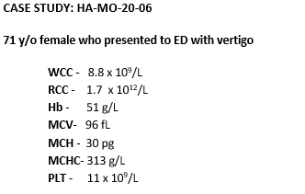

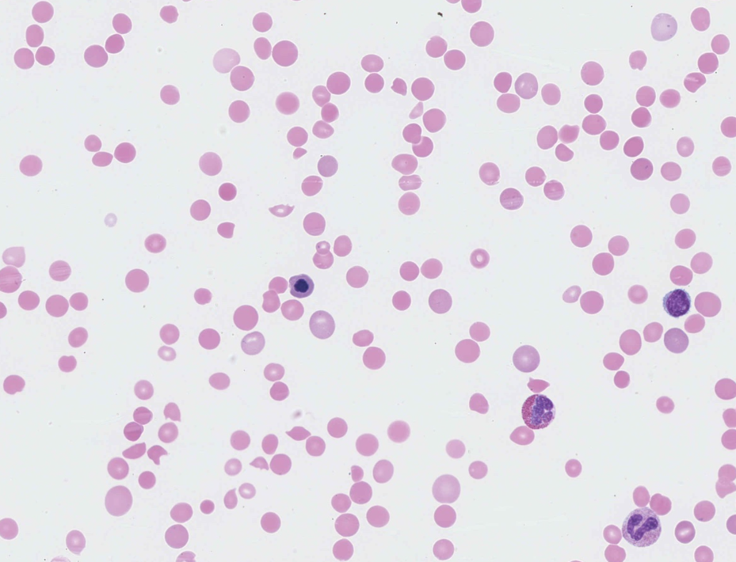

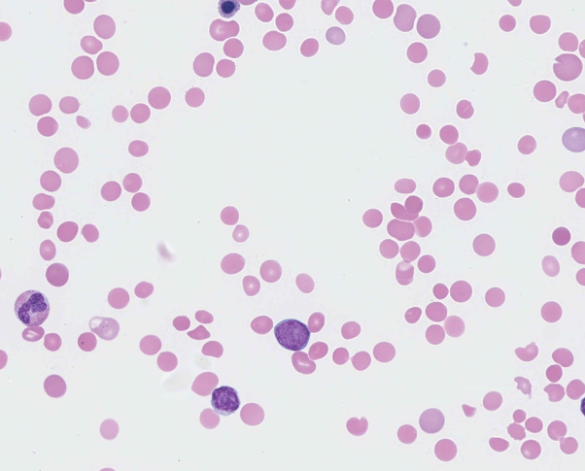

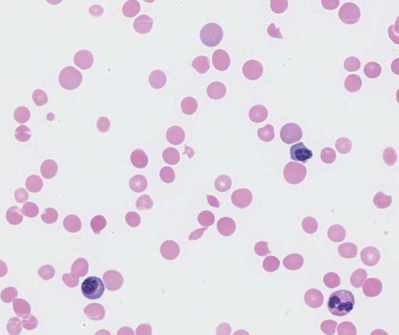

**RBC**

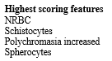

**WBC**



**Plts**



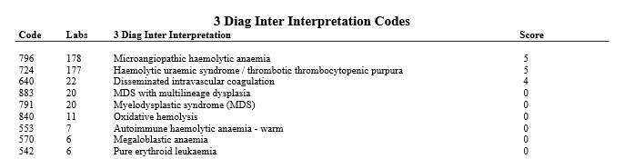



The blood film of this patient showed striking red cell changes, including schistocytes, spherocytes, nucleated RBC and increased polychromasia.

The white cells showed left shift with an occasional blast cell while the platelets appeared to have normal morphology.

Considering the morphological features described, the clinical notes and the reduced platelet count, the most likely diagnosis was microangiopathic haemolytic anaemia (MAHA).

Schistocytes were considered the essential diagnostic feature and scored 10. The other red cell changes mentioned were major features and awarded scores of 5. Although bite cells were present, they are in this case of lesser significance in the presence of the marked thrombocytopenia with schistocytes, which are strongly suggestive of MAHA.

Basophilic stippling and microspherocytes were of minor relevance to the diagnosis and scored accordingly.

Being a leucoerythroblastic film, the left shift was also considered a major feature and scored 5.

MAHA, the most likely diagnosis, was scored 5.

Haemolytic uraemic syndrome / thrombotic thrombocytopenic purpura(HUS/TTP) were more specific diagnoses with the described features present and were also considered acceptable. Disseminated intravascular coagulation (DIC) was considered less likely in the presence of the severe thrombocytopenia and no significant features of response to sepsis, however, due to its morphological similarities to MAHA, this diagnosis was considered acceptable and scored 4.

MAHAs are a group of potentially life-threatening disorders characterised by RBC fragmentation and thrombocytopenia. The presence of schistocytes on the blood film is a typical feature of this condition, and occasionally, microspherocytes. Increased polychromasia and nucleated RBC may also be present, depending on the severity of the anaemia.

Characteristic laboratory data are a negative direct antiglobulin test, an increased lactate dehydrogenase (LDH) level, increased indirect bilirubin, and low haptoglobin with an increased reticulocyte count.

Various systemic disorders can present with MAHA-type features, including TTP, HUS, DIC, systemic infections, and autoimmune disorders. Its occurrence in cases of widespread metastasis of malignant tumours - cancer-related MAHA (CR-MAHA) - has also been reported.2 CA-MAHA with thrombocytopenia can occasionally be a presenting feature that leads to the diagnosis of the underlying cancer, particularly in adenocarcinomas of the stomach and gastrointestinal tract. This is less likely with gynaecological adenocarcinomas which usually have clinical symptoms. The pathophysiology of CR-MAHA has not been fully elucidated; the mechanism by which haemolysis progresses due to the mechanical fragmentation of red blood cells as blood flows through the vascular lumen narrowed by such tumour thrombi has been proposed. Accordingly, the use of antineoplastic agents as an effort to reduce tumour burden, in addition to supportive measures, are considered the most important in improving MAHA in this scenario.

Characteristic features of CR-MAHA, other than those previously described for MAHA, have been listed below3: Please note that these points are general and in practice, these features may overlap with those of TTP so they should be used as a guide only.

1. Patients with CR-MAHA present at an older ager (mean age: 56 years) versus those with TTP associated with severe ADAMTS13 deficiency (mean age: 40 years).

2. There is usually evidence of an active malignancy or a recurrence, for example, in the bone marrow 3. Progressive weakness, weight loss, and pain, with a longer duration of symptoms (median 21 days) versus those with TTP-associated with ADAMTS13 deficiency (median duration: 8 days)

4. Pulmonary involvement characterised by dyspnoea, cough, and abnormal chest X-ray

5. Leucoerythroblastic film and markedly elevated LDH

6. The median value of ADAMTS13 activity is 50% in those with CR-MAHA.7.

MAHA associated with systemic malignancies fails to respond to plasma exchange. On the other hand, patients with TTP due to ADAMTS13 deficiency respond promptly with rapid reversal of neurologic symptoms, reduction of LDH levels over 1 to 2 days and rise in platelet counts over 3 to 4 days.

This patient presented to the emergency department with vertigo. She had a known history of breast cancer. Her bone marrow trephine showed a near total replacement of haemopoietic tissue by metastatic carcinoma, with over 90% of the cells showing strong nuclear staining for the oestrogen receptor. The features were consistent with metastatic breast carcinoma, favouring metastatic lobular carcinoma.

Her LDH was markedly elevated (1947 U/L), haptoglobin reduced (<0.20 g/L), direct antiglobulin test negative, C-reactive protein elevated (185.3 mg/L) and bilirubin increased (48 μm/L