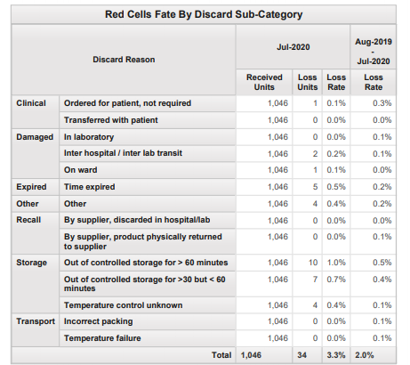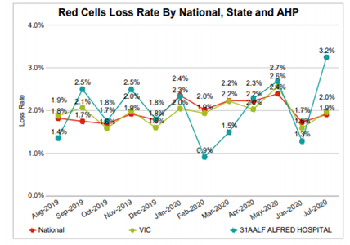

**The Alfred Hospital percentage of RBC fated has increased from last month.**

* What could be the possible reasons?
* Is there something blood bank can do to lower the percentage of red cell loss?

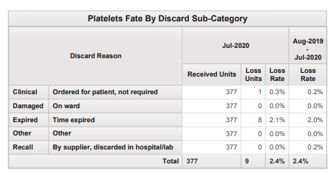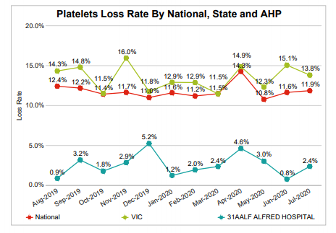

**Alfred Hospital’s percentage of platelets loss is below the national and state average. However we still waste platelets due to time expiring.**

* Do you think the changes in managing the platelet inventory will help assist in lowering the number of platelets fated due to expiry?

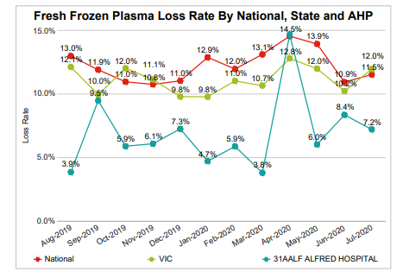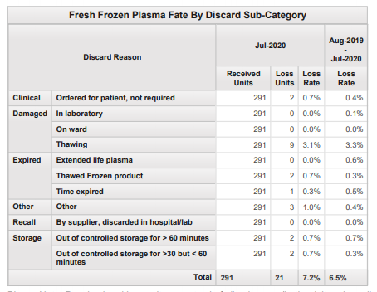

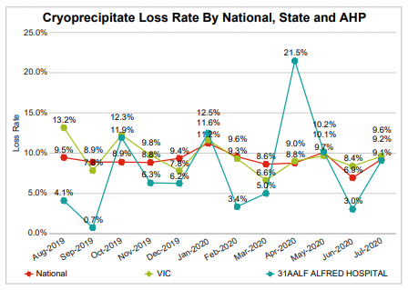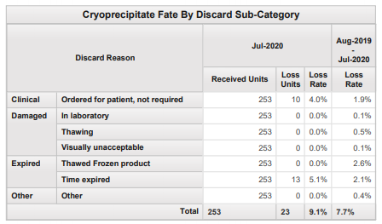

The Alfred Hospital cryoprecipitate wastage percentage varies each month. A major factor is the number of MTP’s that require cryoprecipitate but do not end up using it.