Malarial Parasite Program

**Malarial Parasite Case: HA-MA-20-04**

|  |  |  |  |  |  |  |  |  |  |  |  |  |  |  |
| --- | --- | --- | --- | --- | --- | --- | --- | --- | --- | --- | --- | --- | --- | --- |
|  | **HA-MA-20-04** | | | | | | | | | **RCPA Scoring** | | |  | |
| RBC Features | Parasitised rbc largen than uninfected cells | Parasites - malaria | Parasites - malaria | Parasitised rbc largen than uninfected cells | Parasites - malaria | Parasitised rbc largen than uninfected cells | Parasites - malaria | Parasitised rbc largen than uninfected cells | Parasites - malaria | Parasitised red cells larger than un-infected cells | Schizont |  | |
| Trophozoites with amoeboid-like morphology | Trophozoites with amoeboid-like morphology | Trophozoites with amoeboid-like morphology | Schuffner’s dots | Parasitised rbc largen than uninfected cells | Trophozoites with amoeboid-like morphology | Schuffner’s dots | Schuffner’s dots | Parasitised rbc largen than uninfected cells | Schuffner's dots | Gametocytes |  | |
| Schizonts | Schuffner’s dots | Parasitised rbc largen than uninfected cells | Schizonts | Gametocytes | Mature trophozoites | Trophozoites with amoeboid-like morphology | Gametocytes | Trophozoites with amoeboid-like morphology | Trophozoites with ameboid-like morphology | Mature trophozoites |  | |
| Early trophozoites | Schizonts | Schuffner’s dots | 0 | Schuffner’s dots | Schizonts | Schizonts | Trophozoites with amoeboid-like morphology | Gametocytes |  | Early trophozoites |  | |
| Schuffner’s dots | Parasitised rbc largen than uninfected cells | Mature trophozoites | 0 | Schizonts | Gametocytes | Gametocytes | Schizonts | Schuffner’s dots |  | Fine malaria pigment |  | |
| 0 | 0 | Gametocytes | 0 | Trophozoites with amoeboid-like morphology | Schuffner’s dots | 0 | 0 | 0 |  |  |  | |
| Primary Diagnosis | Malaria - Plasmodium vivaxA | Malaria - Plasmodium vivaxA | Malaria - Plasmodium vivaxA | Malaria - Plasmodium vivaxA | Malaria - Plasmodium vivaxA | Malaria - Plasmodium vivaxA | Malaria - Plasmodium vivaxA | Malaria - Plasmodium vivaxA | Malaria - Plasmodium vivaxA | Plasmodium vivax | Plasmodium ovale | Plasmodium malariae + Plasmodium vivax or Plasmodium falciparum + Plasmodium vivax | |

|  |  |
| --- | --- |
| High scoring response | Moderate scoring response |

**Plasmodium vivax**

* Both the thick and thin films had typical features of P. vivax.
* Schuffner's stippling could be seen on mature trophozoites in both thick and thin films. On the thick film, the stippling appears as faint mauve staining of the "ghost" RBC around the more advanced parasite stages.
* The typical amoeboid appearance of the malaria parasite inside the enlarged RBC could be seen.
* Early trophozoites were also prominent.
* Early schizonts can be seen where the merozoites have not separated into individual parasites are frequently seen.
* Infected RBCs are seen "dented" by uninfected RBCs next to them.

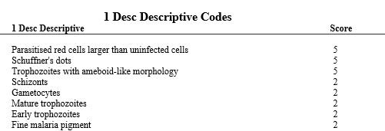

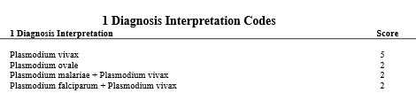

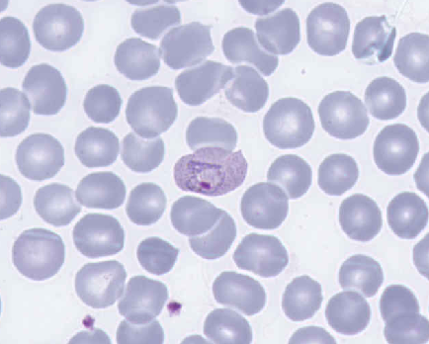 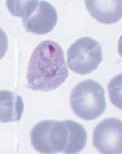

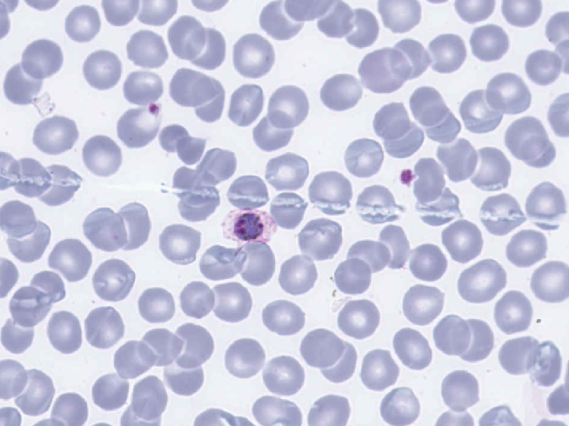

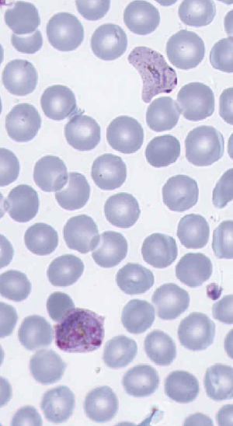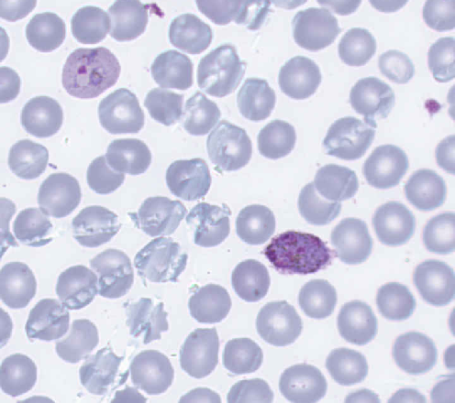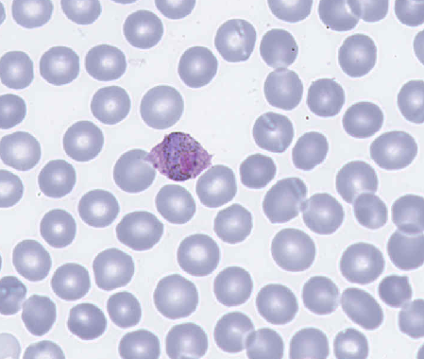

**Malarial Parasite Case: HA-MA-20-05**

|  |  |  |  |  |  |  |  |  |  |  |  |  |
| --- | --- | --- | --- | --- | --- | --- | --- | --- | --- | --- | --- | --- |
|  | **HA-MA-20-05** | | | | | | | | | **RCPA Scoring** | |  |
| RBC Features | Parasitised rbc largen than uninfected cells | Parasites - malaria | Parasites - malaria | Parasitised rbc largen than uninfected cells | Parasites - malaria | Parasitised rbc largen than uninfected cells | Parasites - malaria | Parasitised rbc largen than uninfected cells | Parasites - malaria | Schuffner's dots | Gametocytes |  |
| Parasitised fimbriated red cells | Parasitised rbc largen than uninfected cells | Parasitised rbc largen than uninfected cells | Parasitised fimbriated red cells | Schuffner’s dots | Parasitised fimbriated red cells | Parasitised fimbriated red cells | Parasitised fimbriated red cells | Parasitised rbc largen than uninfected cells | Parasitised fimbriated red cells Fine malaria pigment | Mature trophozoites |  |
| Mature trophozoites | Schuffner’s dots | Schuffner’s dots | Gametocytes | Parasitised rbc largen than uninfected cells | Schuffner’s dots | Schuffner’s dots | Schuffner’s dots | Parasitised fimbriated red cells | Parasitised red cells larger than un-infected cells | Schizont |  |
| Gametocytes | Trophozoites with amoeboid-like morphology | Gametocytes | 0 | Mature trophozoites | Mature trophozoites | Trophozoites with amoeboid-like morphology | Gametocytes | Schuffner’s dots |  | Early trophozoites |  |
| Schizonts | 0 | Parasitised fimbriated red cells | 0 | Early trophozoites | Gametocytes | Gametocytes | Mature trophozoites | Gametocytes |  | Fine malaria pigment |  |
| Primary Diagnosis | Malaria - Plasmodium ovaleA | Malaria - Plasmodium ovaleA | Malaria - Plasmodium ovaleA | Malaria - Plasmodium ovaleA | Malaria - Plasmodium ovaleA | Malaria - Plasmodium ovaleA | Malaria - Plasmodium ovaleA | Malaria - Plasmodium ovaleA | Malaria - Plasmodium ovaleA | Plasmodium ovale | Plasmodium vivax | Plasmodium malariae + Plasmodium ovale |

|  |  |
| --- | --- |
| High scoring response | Moderate scoring response |

**Plasmodium ovale**

* Thick films show presences of compact parasites inside RBCs which have coarse Schuffner's stippling.
* Infected RBCs are larger than uninfected RBCs.
* Pigment is more obvious in the mature stages.
* Some infected RBCs have the typical comet shape and fimbriae.
* Gametocytes only occupy ¾ of the infected RBC.

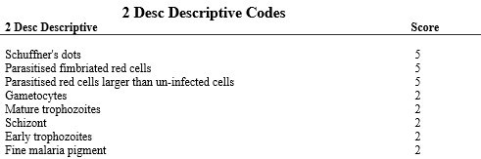

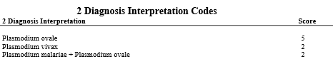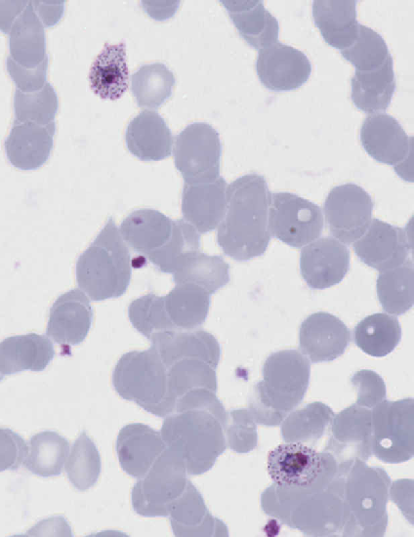

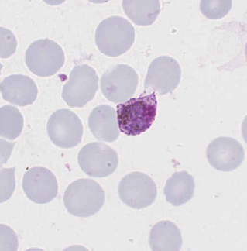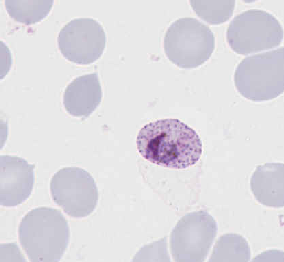

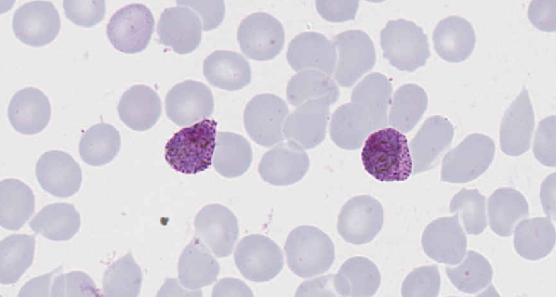

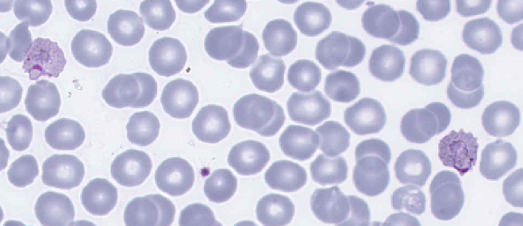

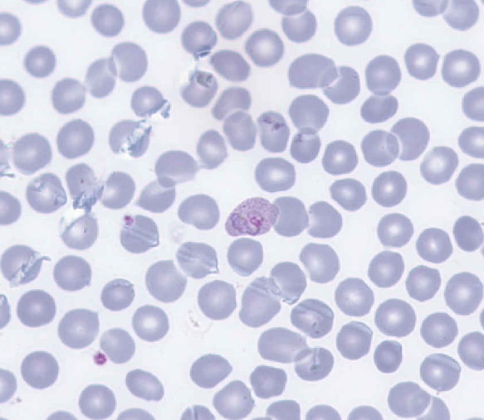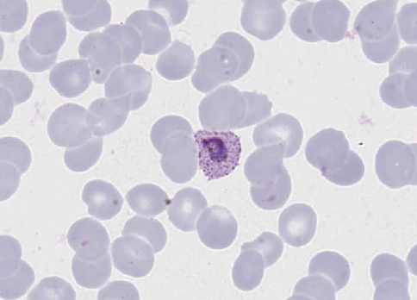

MALARIAL PARASITE DENSITY COUNT

|  |  |  |  |  |  |  |  |  |  |  |  |
| --- | --- | --- | --- | --- | --- | --- | --- | --- | --- | --- | --- |
| Parasite Density Count | **HA-MA-20-06** | | | | | | | | | **RCPA Scoring** | |
| 0 | 62 | 78,867 parasites/uL | 67 | 72 per 1100 cells. | 21325 | 0 | 102 | 65 | RCPA Median 1.03 |  |
| 0 | 0.63 | 2.16% infected RBCs | 0.68 | 0.0072 | 0.59 | 0 | 1.03 | 0.66 | . | |

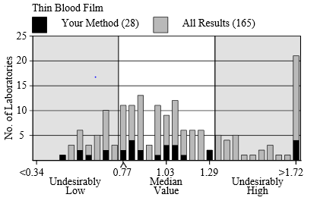

Participants are reminded to take care when performing malarial parasite counts on thin and thick blood films. The large variation of results may be attributed to the under and over estimation of malarial parasites seen on both films.

Participants that recorded results in the undesirably low or high regions should be aware that the number of red cells counted could influence the final determination with some authors suggesting a minimum of 10,000 red cells should be used to determine the parasite density.Participants should also distinguish the cellular debris from the parasites when counting, ensure consecutive fields are counted, and count at least 100 white cells (preferably 200 white cells) when performing the malarial parasite density counts.

Analytical performance specifications (APS) are currently set at; Thin and Thick film % parasites/infected RBC's +/- 0.25 up to 1% parasites/infected RBC's and +/- 25% above 1% parasites/infected RBC's respectively.