**CASE STUDY: HA-MO-21-01**

**T-cell/NK cell Large Granular Lymphocytic Leukemia**

|  |
| --- |
| 70yo male with skin rash  WCC: 7.4 x 109/L  RCC: 5.05 x 1012/L  Hb: 165 g/L  MCV: 92.1 fL  MCH: 32.7 pg  MCHC: 355 g/L  Plt: 194 x 109/L |

The main feature of this blood film was the presence of abnormal lymphocytes, a large proportion of which had moderate to abundant pale cytoplasm and fine to coarse azurophilic granules. These abnormal lymphocytes are described as "large granular lymphocytes" (LGL). A lymphocytosis was present.

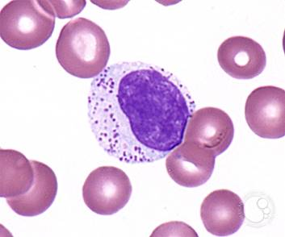

LGL are larger cells with abundant cytoplasm and prominent granules; they can be seen in healthy individuals as high as 10-15% of lymphocytes but they are usually less frequent.

The red cells were generally unremarkable, and a few giant platelets were noted.

Considering the clinical information provided and the morphological features described, the most likely diagnosis was T-cell/NK cell large granular lymphocytic leukemia (T-LGLL).

This case had been presented as a Blood Film Differential exercise in January 2020 (HA-BF-20-01). This case was presented again for the February Blood Film Differential and Morphology surveys in order to reinforce its educational value.

The distinction between abnormal and reactive lymphocytes relates to their likely origin and suspicion of clonality based initially on their morphological features. Reactive lymphocytes indicate a benign origin compared to the malignant or clonal aetiology of abnormal lymphocytes. Although the distinction can be difficult, when an overwhelmingly atypical lymphoid population is present, such as in the current case, the features raise the suspicion of clonality and should prompt further clinical and laboratory assessment.

T-cell large granular lymphocytic leukaemia is a heterogeneous disorder characterised by a persistent (>6 months) increase in the number of peripheral blood large granular lymphocytes (LGLs). Severe neutropenia is frequent,1 although neutropenia was not evident in this case. There is some disagreement about the level of lymphocytosis required for the diagnosis of T-LGLL.

A T-LGL count of >2 x 109/L is frequently associated with a large clonal proliferation. However, the diagnosis of T-LGLL can be made in patients with LGL counts of <2 x 109/L when other criteria are met. The lymphoproliferation is typically indolent and non-progressive, and some investigators feel that this condition is better regarded as a clonal disorder of uncertain significance than as a leukaemia.

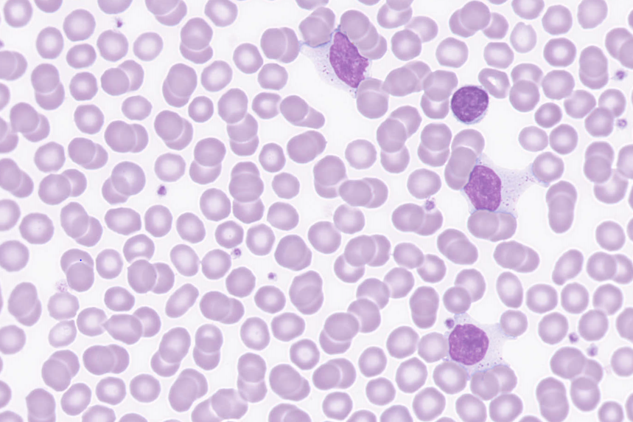

The peripheral blood flow cytometry analysis of this patient showed a majority of T cells (~92%) with a normal CD4:CD8 T cell ratio. An abnormal T cell population was present which was CD2+, CD5+, CD7+, CD4+(low)/CD8+ (double positive) CD56+ and CD57+ · These results are consistent with a suspected T-cell lymphoproliferative disorder.

1. WHO Classification of Tumours of Haematopoietic and Lymphoid Tissues, Swerdlow, S et al, revised 4th edition, 2017

|  |  |  |  |  |  |  |  |  |  |  |
| --- | --- | --- | --- | --- | --- | --- | --- | --- | --- | --- |
| RBC Features | No significant morphological red blood cell abnormality | Rouleaux | No significant morphological red blood cell abnormality | Rouleaux | No significant morphological red blood cell abnormality | No significant morphological red blood cell abnormality |  | Rouleaux | Spherocytes | No significant morphological red blood cell abnormality |
|  |  |  |  |  |  | No significant morphological red blood cell abnormality | Elliptocytes / ovalocytes |  |  |
|  | NONE |  |  |  |  |  |  |  |  |
| WBC Features | Large granular lymphocytosis | Large granular lymphocytosis | Large granular lymphocytosis | Large granular lymphocytosis | Large granular lymphocytosis | Lymphocytosis |  | Lymphocytes – abnormal | Large granular lymphocytosis | Large granular lymphocytosis |
|  |  | Lymphocytes - cytoplasmic inclusions |  |  | Large granular lymphocytosis | Large granular lymphocytosis |  |  | Lymphocytosis |
|  |  |  |  |  |  |  |  |  |  |
|  |  |  |  |  |  |  |  |  |  |
| Platelet Features | No significant morphological platelet abnormality | No significant morphological platelet abnormality | No significant morphological platelet abnormality | No significant morphological platelet abnormality | No significant morphological platelet abnormality | No significant morphological platelet abnormality |  |  | No significant morphological platelet abnormality | No significant morphological platelet abnormality |
|  |  |  |  |  |  | No significant morphological platelet abnormality |  |  |  |
| Primary Diagnosis | T-LGL leukaemia/T-LGL LPD/Chronic lymphoproliferative disorder of NK cells (CLPD-NKs) | T-LGL leukaemia/ Chronic lymphoproliferative disorder of NK cells (CLPD-NKs) | T-LGL leukaemia/T-LGL LPD/Chronic lymphoproliferative disorder of NK cells (CLPD-NKs) | T-LGL leukaemia/T-LGL LPD/Chronic lymphoproliferative disorder of NK cells (CLPD-NKs) | T-LGL leukaemia/T-LGL LPD/Chronic lymphoproliferative disorder of NK cells (CLPD-NKs) | T-LGL leukaemia/ Chronic lymphoproliferative disorder of NK cells (CLPD-NKs) | T-LGL leukaemia/T-LGL LPD/Chronic lymphoproliferative disorder of NK cells (CLPD-NKs) | T-LGL leukaemia/T-LGL LPD/Chronic lymphoproliferative disorder of NK cells (CLPD-NKs) | T-LGL leukaemia/T-LGL LPD/Chronic lymphoproliferative disorder of NK cells (CLPD-NKs) | T-LGL leukaemia/T-LGL LPD/Chronic lymphoproliferative disorder of NK cells (CLPD-NKs) |
|  |  |  |  |  |  |  |  |  |  |

|  |  |  |  |
| --- | --- | --- | --- |
| High scoring response | Moderate scoring response | Low scoring response | Response given no score |

|  |  |  |  |  |  |  |  |  |  |  |
| --- | --- | --- | --- | --- | --- | --- | --- | --- | --- | --- |
| RBC Features | No significant morphological red blood cell abnormality | No significant morphological red blood cell abnormality | Spherocytes | No significant morphological red blood cell abnormality | Rouleaux | Rouleaux | No significant morphological red blood cell abnormality | Rouleaux | Rouleaux | No significant morphological red blood cell abnormality |
|  |  |  |  |  |  |  |  |  |  |
|  |  |  |  |  | Cryoglobulins |  |  |  |  |
| WBC Features | Large granular lymphocytosis | Lymphocytes - reactive | Lymphocytes – abnormal | Large granular lymphocytosis | Large granular lymphocytosis | Large granular lymphocytosis | Large granular lymphocytosis | Lymphocytes – abnormal | Large granular lymphocytosis | Lymphocytosis |
|  | Lymphocytes – abnormal |  | Lymphocytes – abnormal | Lymphocytosis |  |  | Large granular lymphocytosis |  | Large granular lymphocytosis |
|  | Lymphocytosis |  |  | Lymphocytes – abnormal |  |  | Smear / smudge cells |  |  |
|  |  |  |  |  |  |  | Lymphocytes - reactive |  |  |
| Platelet Features | No significant morphological platelet abnormality | No significant morphological platelet abnormality | Giant platelets / significant numbers of large platelets. *ICSH definition | No significant morphological platelet abnormality | No significant morphological platelet abnormality | No significant morphological platelet abnormality | No significant morphological platelet abnormality | No significant morphological platelet abnormality | No significant morphological platelet abnormality | No significant morphological platelet abnormality |
|  |  |  |  |  |  |  |  |  |  |
| Primary Diagnosis | T-LGL leukaemia/T-LGL LPD/Chronic lymphoproliferative disorder of NK cells (CLPD-NKs) | T-LGL leukaemia/T-LGL LPD/Chronic lymphoproliferative disorder of NK cells (CLPD-NKs) |  | T-LGL leukaemia/ Chronic lymphoproliferative disorder of NK cells (CLPD-NKs) | Chronic lymphocytic leukaemia - large cell transformation | T-LGL leukaemia/T-LGL LPD/Chronic lymphoproliferative disorder of NK cells (CLPD-NKs) | T-LGL leukaemia/T-LGL LPD/Chronic lymphoproliferative disorder of NK cells (CLPD-NKs) | T-LGL leukaemia/T-LGL LPD/Chronic lymphoproliferative disorder of NK cells (CLPD-NKs) | T-LGL leukaemia/T-LGL LPD/Chronic lymphoproliferative disorder of NK cells (CLPD-NKs) | T-LGL leukaemia/T-LGL LPD/Chronic lymphoproliferative disorder of NK cells (CLPD-NKs) |
|  |  | Mononucleosis syndrome / infectious mononucleosis |  |  |  |  |  |  |  |

|  |  |  |  |
| --- | --- | --- | --- |
| High scoring response | Moderate scoring response | Low scoring response | Response given no score |

|  |  |  |
| --- | --- | --- |
| **CLOSED 06/04/2021** | **Submissions** | **Total** |
| **All Staff** | **21** | **48** |
|  |  |  |
|  |  |  |
|  |  |  |
| **Morph Trained** | 13 | 22 |
| **Incomplete** | 1 |  |
| **Routine** | 3 | 12 |
| **SANDY** | **2** | **3** |
| **CORE** | **2** | **8** |
| **Flow** | **0** | **6** |

