**CASE STUDY: HA-MO-21-02**

**Megaloblastic Anaemia**

|  |
| --- |
| 89yo m with palpitations, shortness of breath.  WCC: 6.3 x 109/L  RCC: 1.34 x 1012/L  Hb: 51 g/L  MCV: 116 fL  MCH: 38.1 pg  MCHC: 329 g/L  Plt: 118 x 109/L |

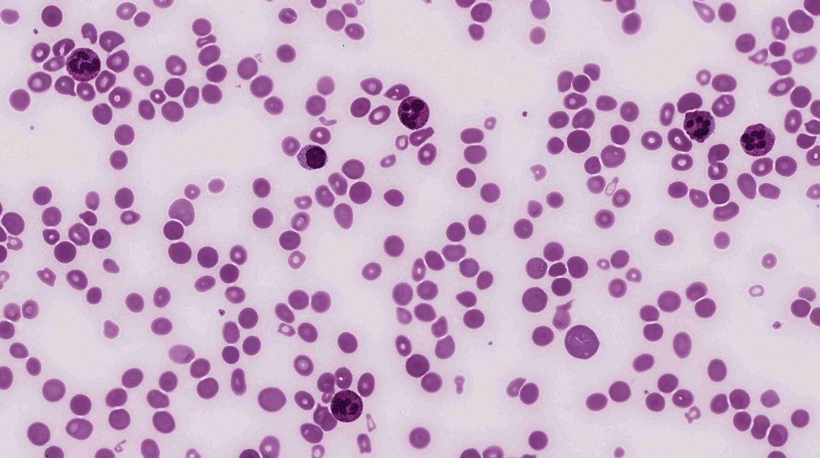

The blood film of this patient showed a variety of red cell changes, the most significant being oval macrocytes and tear-drop cells. Other evident features included nucleated RBC, basophilic stippling, schistocytes and increased polychromasia.

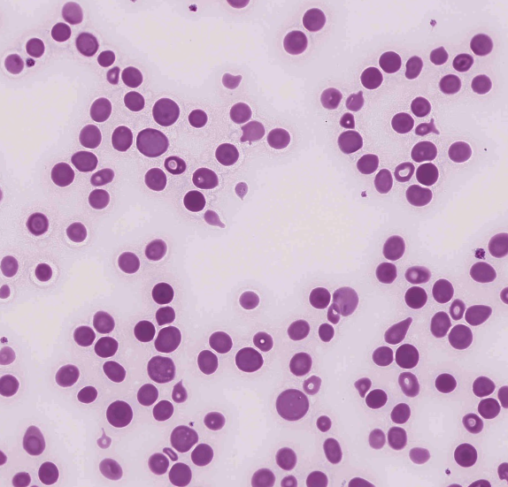

The white cells showed moderate numbers of hypersegmented neutrophils, with some neutrophils showing mild hypergranulation.

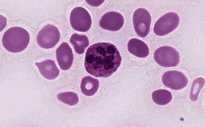

The platelet morphology was unremarkable. The platelets were essentially normal, and presence of a small number of large platelets was noted. The presence of the smaller red cells (schistocytes and microcytes) possibly resulting in an inaccurate platelet count was also considered with the scoring

Considering the morphological features described, the clinical notes and full blood count indices, the most likely diagnosis was megaloblastic anaemia.

Hypochromic microcytes are a well recognised finding in megaloblastic anaemia and generally should not be considered a sign of iron deficiency, however, a response of a combined iron and B12/folate deficiency was considered acceptable on a morphological basis.

Megaloblastic anaemia (MA) encompasses a heterogeneous group of anaemias characterised by the presence of megaloblasts in the bone marrow. This condition is due to impaired DNA synthesis, which inhibits nuclear division. Cytoplasmic maturation, mainly dependent on RNA and protein synthesis, is less impaired, causing asynchronous maturation between the nucleus and cytoplasm of the erythroblasts and leading to the large size of the megaloblasts. Both vitamin B12 and folate deficiencies may cause defective DNA synthesis 1,2.

The characteristic morphological findings of MA in the peripheral blood include oval macrocytes and hypersegmented neutrophils (> 1% of neutrophils with 6 or more lobes), the latter being essentially pathognomonic of MA. Impaired RBC production results in a low absolute reticulocyte count especially in the light of severe anaemia. Other changes may include the presence of teardrop cells, schistocytes and microspherocytes. These erythrocyte changes reflect the severity of the dyserythropoiesis and should not be taken as evidence of microangiopathic haemolytic anaemia (MAHA)2,3. Lack of Vitamin B12 can present with features of haemolysis due to ineffective erythropoiesis and unconjugated hyperbilirubinaemia, where MAHA or fragmentation haemolysis is the result of intravascular haemolysis of RBC from mechanical trauma or sheer stress3. Nucleated RBCs, Howell-Jolly Bodies, basophilic stippling and Cabot rings may also be observed.

Vitamin B12 deficiency may result in various complications including neurological problems such as memory impairment, paraethesias, compromised vision ataxia and peripheral neuropathy. Other conditions include infertility, gastric cancer and neural tube defects in the developing foetus, leading to spina bifida or anencephaly1.

The prevalence of vitamin B12 deficiency varies from 1 to 2 percent in general populations and up to approximately 10-15 percent in older adults and hospitalised patients. Folate deficiency in healthy people with a normal diet has declined progressively due to countries implementing routine supplementation of foods with folic acid.

Vitamin B12 deficiency typically develops over the course of years as total body stores are large (approximately 3-5mg) which is sufficient to provide adequate levels of vitamin B12 for 5 to 10 years. However, in infants born to vitamin B12 deficient mothers, there may not be any stores established, and the infant may be born deficient. Exposure to nitrous oxide can also cause rapid depletion of vitamin B12. Folate deficiency can develop rapidly as body stores are limited (approximately 5-10mg) and become rapidly depleted during cell division. Patients present with the usual symptoms of anaemia but in addition there may be glossitis, mild splenomegaly and jaundice.

Laboratory evaluation includes a CBC, vitamin B12 and folate levels. Further testing with methylmalonic acid (MMA), homocysteine, and/or autoantibodies to intrinstic factor (IF) or gastric parietal cell antigens may be appropriate. The diagnosis is then confirmed if the individual has a low serum level of vitamin B12 or folate; MMA and homocysteine testing consistent with deficiency and/or response to vitamin B12 and/or folate repletion.

This patient's vitamin B12 level was markedly reduced, and the red cell folate was normal. His serum iron, ferritin and transferrin were normal, and the transferrin saturation decreased.

1. Megaloblastic Anaemia, Hariz, A et al, NCBI Bookshelf, updated 23rd October 2020.

2. Rodak's Haematology: Clinical Principles and Applications, 5th edition, Keohane et al, 2016, Elsevier Inc.

3. When the picture is fragmented: Vitamin B12 deficiency masquerading as thrombotic thrombocytopenic purpura, Tanmay, S et al, Int. J. Crit. Inj Sci, 2016 Apr-Jun; 6(2): 89-92

|  |  |  |  |  |  |  |  |  |  |  |
| --- | --- | --- | --- | --- | --- | --- | --- | --- | --- | --- |
| RBC Features | Dimorphism / Dimorphic red blood cells | Macrocytes round | Macrocytes oval | Tear drop cells | Macrocytes oval | Macrocytes oval | Microcytes | Macrocytes oval | Macrocytes oval | Macrocytes round |
| Tear drop cells | Dimorphism / Dimorphic red blood cells | Tear drop cells | Schistocytes | Schistocytes | Tear drop cells | Spherocytes | Tear drop cells | Schistocytes | Schistocytes |
| Macrocytes oval | Tear drop cells | Microcytes | Microcytes | Microcytes | Schistocytes | Schistocytes | Microcytes | Tear drop cells | Nucleated red blood cells |
|  | Polychromasia increased | Dimorphism / Dimorphic red blood cells | Macrocytes oval | Tear drop cells | Polychromasia increased | Tear drop cells | Schistocytes | Spherocytes | Tear drop cells |
| WBC Features | Neutrophils – hypersegmented | Neutrophils - hyposegmented | Neutrophils – hypersegmented | Neutrophils – hypersegmented | Neutrophils – hypersegmented | Neutrophils – hypersegmented | Neutrophils - hypergranulation | Neutrophils – hypersegmented | Neutrophils – hypersegmented | Neutrophils - hyposegmented |
|  |  |  |  |  | Neutrophil – Hypogranulation. |  |  |  |  |
| Platelet Features | No significant morphological platelet abnormality | No significant morphological platelet abnormality | Inaccurate platelet count | No significant morphological platelet abnormality | No significant morphological platelet abnormality | No significant morphological platelet abnormality | No significant morphological platelet abnormality | Inaccurate platelet count |  | No significant morphological platelet abnormality |
| Primary Diagnosis | Megaloblastic anaemia | Megaloblastic anaemia | Megaloblastic anaemia | Megaloblastic anaemia | Megaloblastic anaemia | Megaloblastic anaemia | Autoimmune haemolytic anaemia - warm | Megaloblastic anaemia | Megaloblastic anaemia | Megaloblastic anaemia |

|  |  |  |  |
| --- | --- | --- | --- |
| High scoring response | Moderate scoring response | Low scoring response | Response given no score |

|  |  |  |  |  |  |  |  |  |  |
| --- | --- | --- | --- | --- | --- | --- | --- | --- | --- |
| RBC Features | Nucleated red blood cells | Schistocytes | Tear drop cells | Tear drop cells | Microcytes | Dimorphism / Dimorphic red blood cells | Macrocytes oval | Irregularly contracted cells | Nucleated red blood cells |
| Macrocytes round | Tear drop cells | Schistocytes | Macrocytes oval | Macrocytes round | Tear drop cells | Tear drop cells | Tear drop cells | Tear drop cells |
| Schistocytes | Microspherocytes | Spherocytes | Schistocytes | Basophilic stippling | Macrocytes oval | Microcytes | Macrocytes oval | Basophilic stippling |
| Spherocytes | Macrocytes round | Macrocytes oval | Microcytes | Tear drop cells |  | Hypochromia | Polychromasia increased | Dimorphism / Dimorphic red blood cells |
| WBC Features | Neutrophils – hypersegmented | Neutrophils – other abnormal granulation |  | Neutrophils – hypersegmented | Neutrophils – hypersegmented | Neutrophils – hypersegmented | Neutrophils – hypersegmented | Neutrophils – hypersegmented | Neutrophils - hypergranulation |
|  |  |  |  | Neutrophils - hypergranulation |  | Neutrophils - hypergranulation |  | Blast cells |
| Platelet Features | No significant morphological platelet abnormality | No significant morphological platelet abnormality | No significant morphological platelet abnormality | No significant morphological platelet abnormality | Inaccurate platelet count | No significant morphological platelet abnormality | Inaccurate platelet count | No significant morphological platelet abnormality | Inaccurate platelet count |
| Primary Diagnosis | Megaloblastic anaemia | Fragmentation haemolysis |  | Combined Fe + B12/folate deficiency | Combined Fe + B12/folate deficiency | Megaloblastic anaemia | Megaloblastic anaemia | Megaloblastic anaemia | Combined Fe + B12/folate deficiency |

|  |  |  |  |
| --- | --- | --- | --- |
| High scoring response | Moderate scoring response | Low scoring response | Response given no score |

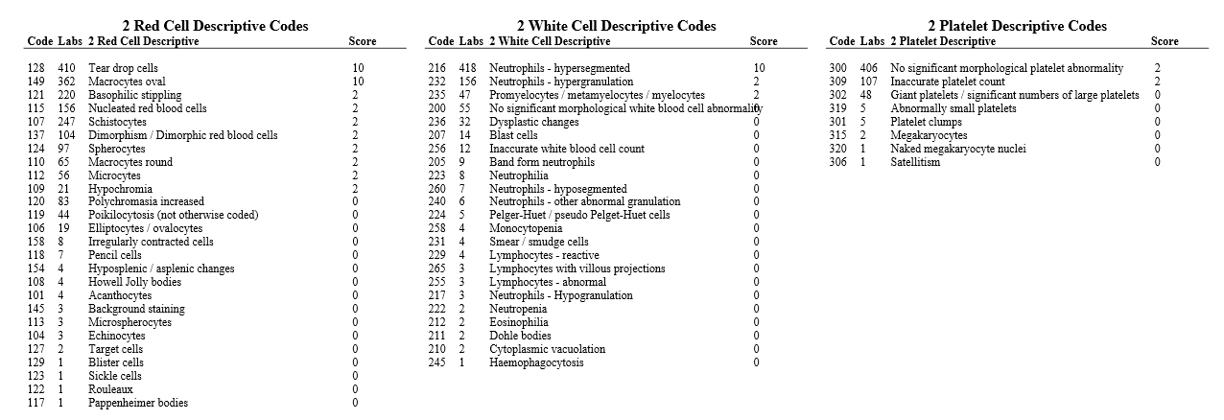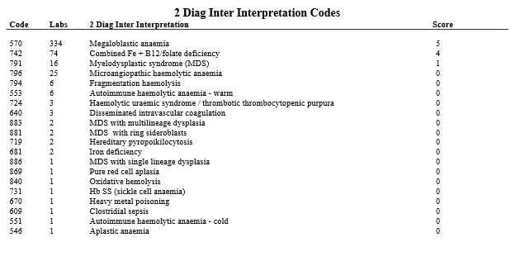

|  |  |  |
| --- | --- | --- |
| **CLOSED 06/04/2021** | **Submissions** | **Total** |
| **All Staff** | **19** | **56** |
|  |  |  |
|  |  |  |
|  |  |  |
| **Morph Trained** | 13 | 22 |
| **Incomplete** | 2 |  |
| **Routine** | 3 | 12 |
| **SANDY** | **2** | **3** |
| **CORE** | **2** | **8** |
| **Flow** | **0** | **6** |