Flow Method updates – sign Flow Cytometry Methodology Updates form kept in flow room

- NEW SOP VERSION of a Controlled Document has been issued, please note & sign updates log for:
  - CD-HA_0308 – Manual sample preparation – please see recommendations for low viability tissue with high counts of non-viable cells – use 7AAD panel as large number of non-viable cells will be hard to interpret on routine 10c NHL panel.
  - CD_HA_0253 – added section about long term QC as per internal audit recommendation
- NEW SOP - none

New projects

- New instrument NAVIOS EX , SN BE05526 (delivered & installed by BEC on 20th MAY 21)- Number 3 out of 3 Flow cytometers present in Lab: Number 1-Navios; Number2- NaviosEx BC40631 & now number 3- new NaviosEx instrument BE05526
  - Installation final report received & reviewed on 27th May 2021 by Gosia
  - Started with validation of Single platform Stem Kit CD34 test – protocols settings / panels set up on 23.06.21 by Gosia – S. Romanin/ D. Theologos supervising this validation project with Gosia’s guidelines
  - New project CD3CTU enumeration and viability testing as per CTU / NATA requirements, project started on 16th June 2021 ( 28th Jan-planning started with Dr S. Morgan & S. Schischka):
    - Two staff nominated to be involved: S. Romanin & D. Theologos – both agreed, they are the ‘persons’ to go to.
    - Due to delay in analyser delivery project started in June 2021
    - Plan/actions of new test: vCD3 CTU validation – minimum 20 of each samples’ type to be tested on PB, fresh Bag sample & CryoQC – total of 60 samples.
      - CD3 antibody ordered on 23.06.21 in PB as the best detector position with minimal interference with CD34 channels used in routine CD34 protocol
        - AB Titration to be done by S. Romanin - to confirm AB volume to be used.
      - Routine protocol for CD34 stem kit will be modified on both NaviosEX analysers & used only for CD3 CTU test with an added laser/channel (hopefully no comp will be required for channels used in routine CD34 test: FL1/FL2/FL4)
      - New Test order -IT job to be raised – name of test?? – Any suggestions so it is not confused with CD2/3 test..??
      - Proposed test validation will need to include, S. Romanin is doing a detailed plan but in overview projects involves as follow:
        - PB samples setting up two tests: routine BMTC & new vCD3CTU test & correlating: %CD3 results obtained from routine (BMTC) & vCD3CTU _? run LSUB as well
          - % CD3 / CD3Enumeration correlated & Viability will be assessed / noted with new test
        - Fresh bag samples setting up two tests: routine BMTC & new vCD3CTU test & correlating: %CD3 results obtained from routine (BMTC) & vCD3CTU _ ? run LSUB as well
          - % CD3 / CD3Enumeration correlated & Viability will be assessed / noted with new test
        - CryoQC samples for bag samples used in (b) will be tested by new test on both NaviosEX(2&3) and results correlated for:
          - Gating strategy to be build - ? use NaviosEX vs Kaluza
          - vCD3CTU enumeration (single platform)
          - CD3 viability
          - totalCD3 T-cell Recovery monitored with aim at 100+/-10% recovery
        - vCD3CTU test to be set up & run on both NaviosEx(2) & new NaviosEx(3) for correlation
      - 2 Controls to be set up: ONE- FSpro CD3CTU protocol, CD34 setting + PB settings monitoring & TWO- CDChex control, set up as SP will be run & monitored for CD3% and absolute numbers
        - Run during the project when test is set up and both are intended to be included in our weekly 5c cnt post validation

- NAVIOS EX(2) BC40631 Flow analyser -validation notes (continuation):
  - Note: All finished reports & tabulated printed results – NAVEX printouts & Navios validated reports are stored in card box under the sink. Please keep it there – for long term storage it will be kept in lab
  - More written specific test validations reports are still required
    - There are few final reports to be written- work in progress (see validation task link below):
H:\AAA_Quality\UNIT_HAem_q\Validation Data\Flow\NAVEX BC40631 validation\Record of NAVEX2 BC40631_ Validation tasks.doc

- CTU CryoQC vCD3 viability testing, NATA requirement – test validation started in June 2021 – plan/schedule – see point 1 c above in this section.

- NATA assessment starting on 23rd August 2021 – preparations started in week 14th MAY, getting ready – see XL in \\TH-FS01\Shared\PATHOLOGY\shared\IMMUNO\GOSIA PRDS\NATA flow _2021

..\..\..\IMMUNO\GOSIA PRDS\NATA flow _2021\NATA Audit Prep Checklist_FLOW 2021.xlsx
  - Updating SOP – Amber is updating CD_HA_0480.docx that will include day booking of our RCPA/QAP samples
  - Clean lab – no loose notes, please remove any if you note
  - Internal Audit was done and few oil slicks raised:
    - Please go through your training logs and make sure all sections have signatures of trainee and trainer as required
    - Please sign all logs as you perform tasks & check & complete
- Records of daily QC review
- Temperature Charts (max/min recorded, out of range actions recorded)
- Analyser Maintenance Logs
- Reagent Logs complete
    - If you note any SOP that are old, issued in 2018 please make me aware
    - Check critical pipettes that you use are correctly labelled, date and signature

- Issues continue with Kaluzav2.1 on problematic computer APATHD8AC066219 - ITS job was escalated by Dr Sue Morgan – ITS changed graphic card
  - Issues addressed, continuation:
    - Computer with Kaluza Software V2.1 (from 2018) – operating fine till Friday 26th June 2021 post ITS graphic card change.
- IT person looking after this is: Aliu, Merzan <M.Aliu@alfred.org.au>
    - Our ITS created a dump file as per BEC request and with their tools diagnosed possible error with a QUADRO card.
Note: The works carried out by ITS Service Delivery :
1. Powered system off
2. ATI FirePro V5800 graphics card connected in place of NVIDIA Tesla P4
3. Powered computer back on and logged in with gahaematol2 account
4. Display driver for ATI FirePro V5800 was successfully installed
5. Rebooted system
6. Logged in with gahaematol at logon
7. System instantly crashing when Kaluza was launched
8. Powered off system
9. NVIDIA Tesla P4 reconnected to motherboard
10. Powered computer back on and logged in with gahaematol2 account
11. ATI FirePro V5800 graphics card connected in place of NVIDIA Quadro P400
    - BEC is still analysing dump file (sent on 9th June2021), no progress as yet.

  - Computer in flow room with Kaluza V1.5 – As per Maree wait with an upgrade it to new version

- InstruNor – to remove, please note below – no update
  - Fully decontaminated (20th May 2021), metal racks left inside.
  - Left ‘power off’, analyser is in shipment mode (but the mechanism not secured as yet) – need to open and put a shield, to open the analyser you need to switch analyser on again.

Staff training / proficiencies
- New 5 members ‘ICCS Log ON’ in 2021– Please see below link and new logon credential for ICCS site we can use as part as our continual education as well as trigger to flow innovation – you can read eNewsletters that are quite informative of what is in frontiers in flow cytometry.
ICCS eNewsletter (cytometry.org

International Clinical Cytometry Society
Use login tap : 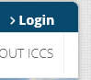
Log on: Gosia
Password: alfredflow

To access: 

- Dan Luo training in flow going well- thanks everyone for taking an extra effort in training DAN.
  - Still some gaps in tests’ preparation:
    - CD34cord (rare test)
  - Kaluza analysis training – NHL – proficient, AML training started (Dan keeps record of done/ analysed cases, please update as you go)
- Amber- MMMRD Infinicyt training – started again as per roster, rostered with Emma for last couple of weeks.
- Jennifer Ma – had introduction to MM_MRD Infinicyt training started but needs more time
- Proficiencies done – thank you, 7 staff out of 8 assigned finished with 100 score!!

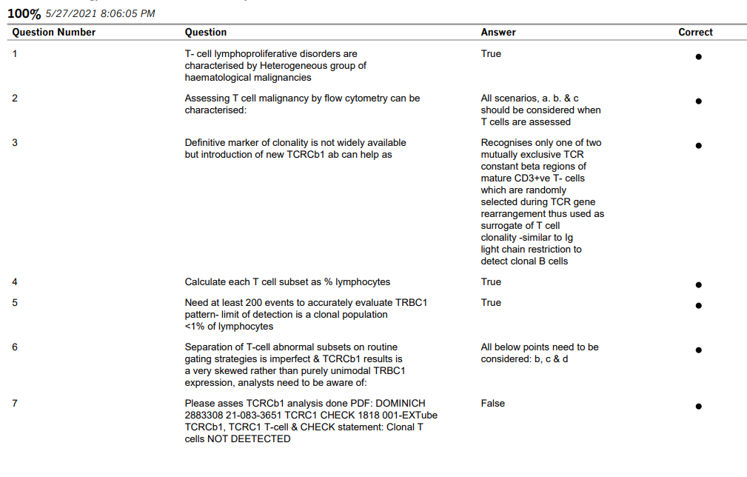

Other issues:
- PATH73164_ AML MRD requests, set up and run on MRD protocol – analysis for LAPs will be confirmed by Haematologist

Flow was picked up last minute by the coordinator as an optional requirement prior to the trial’s commencement so anticipated numbers are not exactly known, however Bone Marrow trial requests were estimated as 4 occasions for 6 participants.

To date, there are two participants:

Name | MRN | Client Code | DOB | Gender
HURST, MICHAEL JOHN | 7396742 | 73164 | 03-09-47 | Male
OSBORNE, NEAL | 7389392 | 73164 | 07-04-55 | Male
As per Dr S. Morgan: ‘the trial will require MRD assessment; it might be easiest if a LAIP is done for all patients in this study at enrolment, then either just do MRD at follow-up or check with the morphology first and do MRD only if no morphological disease’

- CD34 test – change in Cell Count (CC) for storage by Cellular Therapy Unit (CTU): NO Update of start time!
  - CTU storage validation still pending ( no ETA given by CTU yet): (No change) comparing the CryoQc results of our current procedure with the modified procedure with 4 cell concentrations titrating up to a maximum of 550 x 10^6/ml as follows: a) 250 x 10^6/ml b) 350 x 10^6/ml c) 450 x 10^6/ml and d) 550 x 10^6/ml and ensuring the modified CC storage procedure is at least as good as the current procedure. It would be necessary to modify flow’s SOP, Cryo QC Thaw procedure to accommodate the higher cell concentration.
    - Planning on initially testing 5 patients with the 4 cell concentrations, so there will be 20 Cryo QC tests.
    - I created a table how to adjust the dilutions as our SOP will not work for CRYOQC dilutions in above concentrations– first dilution for ‘waking up cells’ is the same – second dilution as per table in flow room.
    - TRIAL number created for day booking as per Sarah Green.

- Shut down of computers - once a week is required– proposed time: change to Tuesday / Wednesday/ Thursday
  - Do one computer at a time –
    - I think I need to make one person responsible – Dan volunteered
  - Please note when performed this in the NAVIOS & NAVIOS EX logs

- Flow cytometry Results Summary printed paper sheets – please update in folder when printing analysed BM PDFs, this will save time, streamline reporting – Please state ‘updated’ on a printed paper copy that is attached to the request slip.

- Vacuboy – new company is looking servicing our vacuum system - BioTools – Adam from BioTools came in to check our noisy system and cleaned / changed two filters in the bench unit.
BioTools contacts:
Phone: +61 412 700 870
Fax: +61 7 3112 5000
Email: adam@biotools.com.au

Web: www.biotools.com.au
Phone: +61 409 487 788
w: www.biotools.com.au
  - He also looked into our broken unit and managed to fix it so now we have a backup.

- B-ALL settings for new lot 17DRY451-4 finalized – but we need to collect more of normal BM cases – please set up any normal BM that were send for screening for lymphoma – we need ~ 5 BM to be setup/run as diagnostic B-ALL runs only – Amber/ Jennifer could you monitor this please.

  - New compensation values (‘comp’) was entered into Navex settings on 25th June so anything running after that date have the ‘comp’ adjusted. If you need to reanalyse anything that was run after 04.06.21 use Kaluza ‘comp’ protocols stored in:
\\172.22.57.171\PatientReview2\AAA A KALUZA TEMPLATES 2016\AA Analysis panels KaluzaV1.5\10c B-ALL\Comps
\\172.22.57.171\PatientReview2\AAA A KALUZA TEMPLATES 2016\AA A KALUZAV2.1.1\10c B ALL\comps

  - Also note our first normal BM that we run - merged 2 LMD files (BALL NBM 2021.analysis) are to be used if checking phenotypic shifts or designing LAPs is stored in:
\\172.22.57.171\PatientReview2\AAA A KALUZA TEMPLATES 2016\AA Analysis panels KaluzaV1.5\10c B-ALL\normal BM controls

- Flow reports are getting mixed up between designated trays – please take care and spread the knowledge if you see someone confused with our filing system

Staff Suggestions / Concerns

- Roster Issues:
  - Note Gosia is on AL during NATA, Amber will do cover, backup by Jorge C.
    - Good luck – hope all goes well!
  - Rostered ADO are scheduled by management – check your roster!

QAP/EQAP

- 2021 RCPA/QAP – latest runs – thank you for participation!
  - RCPA Oncology Immunophenotyping – HA-IP-21-01: Acceptable diagnosis with one marker CD38 for review – gated as dim positive with target being negative, but? Overestimated due to high background – caution on preserved cells with high background.
RCPA interpretation of this case: Immunophenotyping of Case HA-IP-21-01The peripheral blood smear showed abnormal lymphocytes with prominent villi. The cells were of small to medium size with oval or indented nucleus, homogenous ground glass chromatin, and inconspicuous nucleoli. The cytoplasm is abundant and pale blue, with circumference hairy projections. The abnormal B-cell population expressed bright co-expression of CD20, CD22 and CD11c, medium CD103, dim CD25, medium CD123, dim CD200, medium CD19, medium CD79b, bright Lambda and medium FMC7. These cells did not express CD3, CD4, CD5, CD8, CD10, CD23, CD38, CD56 or Kappa. Interpretation of results The immunophenotype of this case is highly suggestive of Hairy Cell Leukaemia (HCL).There was weaker expression of CD25 and CD200 which may explain the proportion of participants reporting negative interpretations for these markers. This weak expression in conjunction with the low viable cell count may have persuaded some participants to indicate a diagnosis of HCL-v rather than HC

  - RCPA/QAP – all within expected ranges.
    - FMH on both analysers (NAVIOS 1+2)
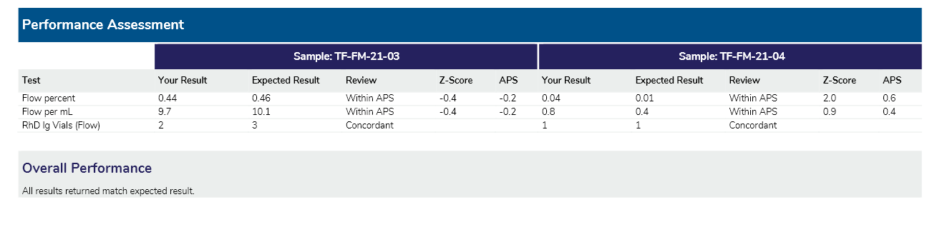
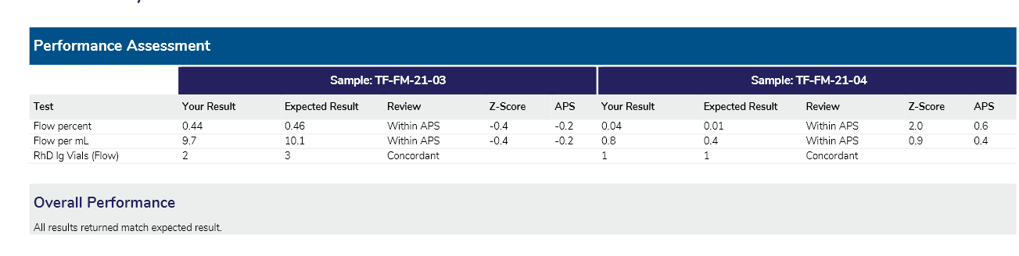
    - Memory B cells (NAVIOS2)– delayed sample delivery, but acceptable.
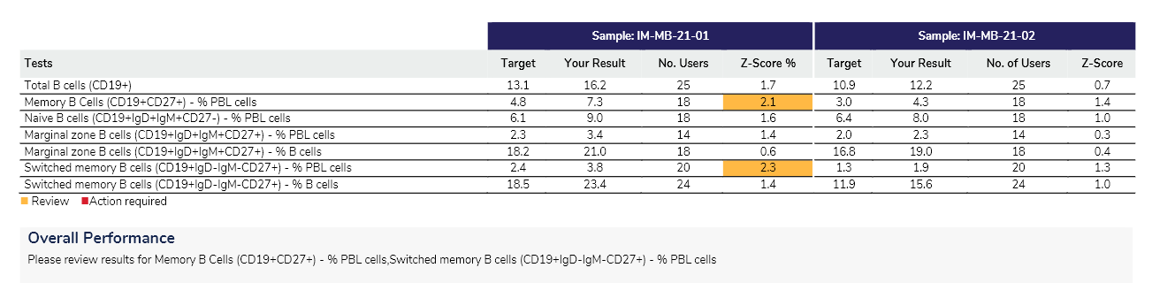
Note – looks like delayed setup affect T-cells most as (lost preferentially) only % of Lymphocytes were out & % of B cells were within Z score of <2. Accepted by Dr. J. Bosco & Dr S. Morgan

    - CD34 test on both NAVIOS (1+2)analysers:
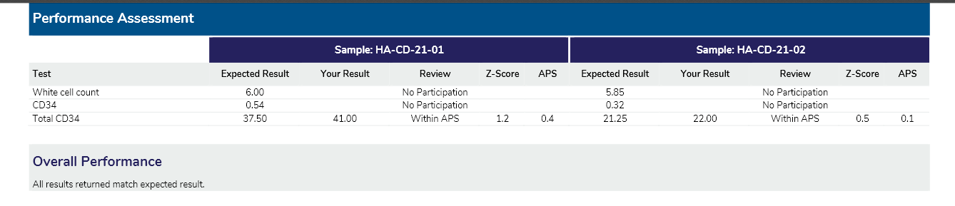
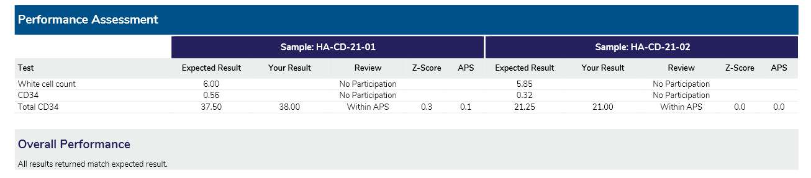

Please note: we are due for next dispatch on 5th July – run test also on our new analyser 3 (NAVIOSEX) – we have CD34 test just starting to validate and would be great to run on new analyser as well.

    - LSUB on Aquios
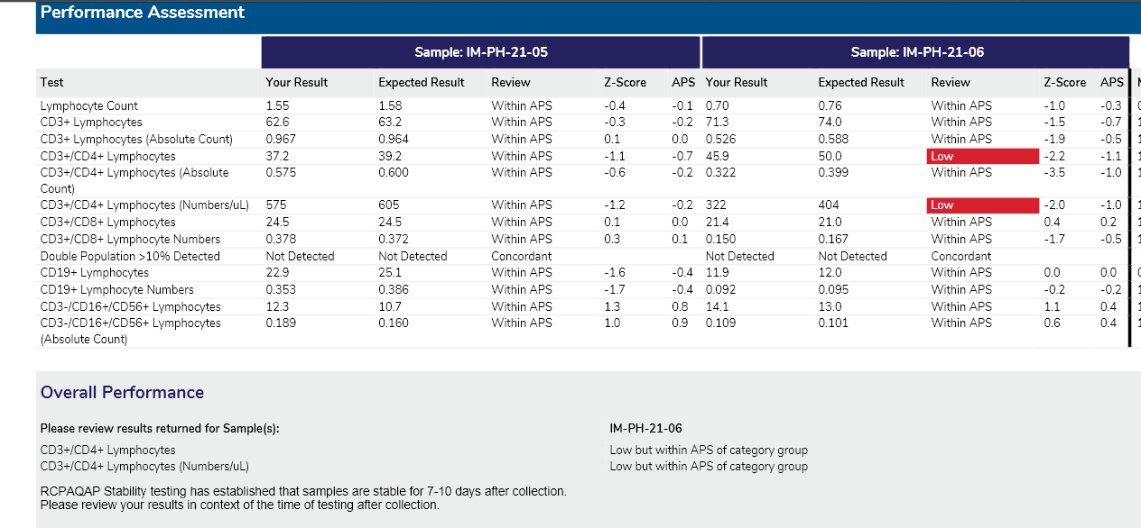

CD3+/CD4+ :
- %:
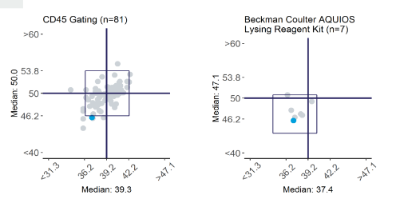

- Absolute:
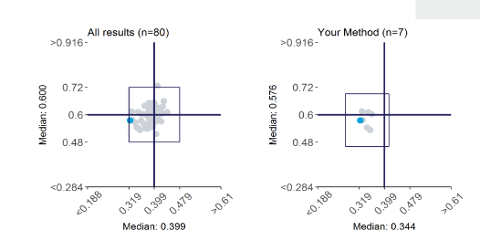 Gating reviewed & looks like Aquios is better in excluding contaminating Monocytes

  - Continue to daybook IM/PH RCPA samples for Aquios LSUB & FMH RCPA - they need to be day booked in Cerner for whole process monitoring that includes calculations & DIM – instructions will be added to SOP – still in progress (Amber is adding it to our External QC SOP: CD_HA_0480)

IT issues / Network Alerts / Trials

- See above comments for PATH73164_ AML MRD
- MMMRD CARTITUDE-4 PATH3068: Flow is NOT required as per trial co-ordinator
  - The initial trial set up was wrong - request for Flow will be removed from the PATH73068/Cartitude-4 screening/and @ PD slip
- PATH73173 / MM23 (452/20) – NUMBERS ARE PICKING UP – please note if any collection issues persist
New Staff / Social Events / Congratulations / Conference applications

- NaviosEX KOT: 3 spaces pending

Please indicate you have received this information if not already ticked – see minutes folder.
\\th-fs01\shared\PATHOLOGY\shared\Haematology\Meetings\Flow Cytometry 2017

Name | Signature / Tick | Name | Signature / Tick
MADDEN, AMBER |  | GORNIAK, MALGORZATA (GOSIA)  Senior scientist
ROMANIN, SUSAN |  | Dan Luo
THEOLOGOS, DANIELLE |  | JENNIFER MA
CHICAS, JORGE
HALLETT EMMA

