**PURPOSE:**

This procedure outlines the steps that are required to ensure Blood Bank has full supply of blood products in stock and available for use. It demonstrates how to identify blood products in Pathnet to ensure there is traceability of the products that we externally receive.

**KEYWORDS:**

FFP: Fresh Frozen Plasma

ARCBS: Australian Red Cross Blood service

PTX: Prothrombin X

IVIG: Intravenous Immunoglobulin

DIN: Donation Identification Number

**PROCEDURE:**

The Blood Bank reserve is counted daily Monday-Friday either by the overnight Core Scientist, overnight staff or the 7am Blood Bank Scientist. The reserve consists of packed Red Cells, FFP, cryoprecipitate, platelets, IVIG, Albumin and Factor concentrates PTX and Biostate. The reserve is count is recorded on the log sheet which can be found in the procedure [CD_HA_0506](http://AHSHAREDAPP02/Fasttrack/Portal/CD_HA_0506.docx). Once counted the order must be placed in BloodNet for delivery at 2:30pm to Blood Bank.

Once delivered the blood products need to be received into the lab and traceable by Pathnet:

1. Unpack shippers one at a time to minimize the time out of ARCBS shipper before the product is placed into the reserve.
2. Sort the units into blood group order within their product groups.
3. Sort these units/derivatives by their expiry dates and/or antigens present.
4. Open **Receive Products** application 
5. Select your location from the pop-up location menu.
6. Select the product being entered inventory:
   * + 1. **Blood Products: For red cells, FFP, Platelets, cryoprecipitate.**
       2. **Derivatives: For all lot numbered product e.g. IVIG.**
7. **Blood Product**
   1. From the visual inspection select OK from the drop-down menu (any other selection will quarantine the product).
   2. Select supplier from the Drop-down menu: Australian Red Cross Blood Service VIC/TAS.
   3. Scan first between the two barcodes shown in the image below to pick up the donation number and ABO/Rh:

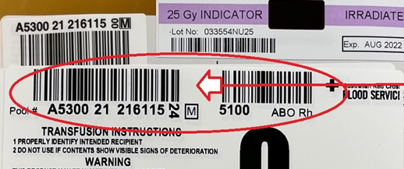

* 1. Next scan between the two barcodes shown in the image below to pick up the component code and expiry date:

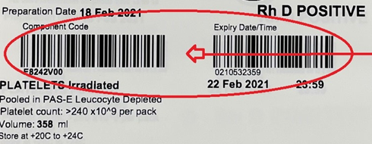

* 1. Left click on the “Add” tab. Repeat this process for all products being entered. When finished click on the save icon. All **non-red cell** blood products are now available in Pathnet.
  2. For red cells to be updated to available in Pathnet a tile blood group must be performed and reported using the following anti-sera:

|  |  |
| --- | --- |
| **Unit group** | **Anti-Sera** |
| Group O Pos | Anti-A, B |
| Group A Pos | Anti-B |
| Group B Pos | Anti-A |
| Group AB Pos | Anti A, Anti-B  Group AB units are ONLY for issue to group AB patients. The group confirmation is just confirming group of A, B to identify any typing error so it can be referred to the Red Cross. |
| If units are **Rh (D) Negative** in addition to confirming the ABO group as above, they are also typed with **Anti-D** to ensure no mistyping by Red Cross would potentially immunize a Rh (D) Negative recipient unexpectedly. | |

* 1. **To** report the red cell confirmation group open “result entry” application .
  2. Select “Product number” option.
  3. From “test Group” drop down menu select unit check and OK.
  4. Scan in the unit donation numbers into the Number field.
  5. Report confirmatory reactions and left click the blood group interpretation.
  6. When complete click on verify to save results. The blood group has now been reported and confirmed for the red cell units. These are now available for use.

**Note**:

* All modifications completed on red blood cells from Red Cross, example Irradiated packed cells, are scanned as part of the component barcode in receiving products and no not need to be manually modified in Pathnet.
* The blood components at the Alfred and Sandringham Blood Bank are identified using the ISBT 128 unique identifier.



* When recording the unit number, also known as the ISBT 128 DIN, record the 13 alphanumeric character DIN, which includes the facility identification number, the year, and 6-digit sequencer, **as well as the manual check character**. The manual entry check character **must** be recorded as part of the unique identification of the product for traceability purposes. Flag characters, shown in the image above in purple, are not a part of the Donation Identification Number itself and are used only for process control by the blood service.

1. **Derivatives**
   1. From the visual inspection select OK from the drop-down menu (any other selection will quarantine the product).
   2. Select supplier from the Drop-down menu: Australian Red Cross Blood Service VIC/TAS.
   3. Scan the two-dimensional (2D) barcodes (2D Data Matrix) shown in the image below to automatically populate the derivative details of lot number, product type, manufacture and expiry date and time:

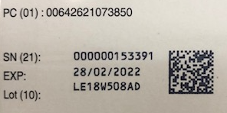

* 1. Enter the Quantity of the product received.
  2. Left click on the “Add” tab.
  3. When finished click on the save icon. 
  4. If the product has already been entered a message pops up to notify you. If correct Click to accept the entry.

**Note**: Derivatives that are received that are not part of the reserve, such as factor concentrates ordered by hemophilia are to be entered through receive products using the derivatives function.

1. **Correcting product entry errors**
2. Open the correct inventory application.
3. Click on the “Demographics” tab and scan in the blood product or derivative number.
4. In the demographic that needs to be corrected open the drop-down menu and select the correct information.
5. Once corrected click on “save”.
6. A pop up “correct inventory” message appears. Click “Ok”.
7. In the “Save” box that is present select the reason for the change from the drop-down menu. If any additional information is needed this is then typed into the “comments” field. Once correct click “Ok” to update product information.

# Related Documents

* [BBK_CER_001](http://AHSHAREDAPP02/Fasttrack/Portal/BBK_CER_001.docx)
* [CD_HA_0506](http://AHSHAREDAPP02/Fasttrack/Portal/CD_HA_0506.docx)

# References

Australian Red Cross Blood Service, ISBT 128-Frequently Asked Questions, Laboratories November 2018.