Malarial Parasite Program

**Malarial Parasite Case: HA-MA-21-01**

47 y/o male, arrived last week from Ghana where he was holidaying for 1.5 months. Developed malaria while he was there.

Says he was fully treated there and discharged.

WCC: 5.2 x 109/L

RCC: 3.4 x 1012/L

Hb: 99 g/L

MCV: 95 fL

Plt: 282 x 109/L

|  |  |  |  |  |  |  |  |  |  |  |  |  |  |  |  |  |  |  |  |  |  |  |  |  |  |
| --- | --- | --- | --- | --- | --- | --- | --- | --- | --- | --- | --- | --- | --- | --- | --- | --- | --- | --- | --- | --- | --- | --- | --- | --- | --- |
| **RBC (Malaria)** | No parasites seen | No parasites seen | No parasites seen | No parasites seen | No parasites seen | No parasites seen | No parasites seen | No parasites seen | No parasites seen | No parasites seen | No parasites seen | No parasites seen | No parasites seen | No parasites seen | NONE | No parasites seen | No parasites seen | No parasites seen | NONE | No parasites seen | No parasites seen | No parasites seen | No parasites seen | No parasites seen | No parasites seen |
| **Primary Diagnosis** | No malarial parasites | No malarial parasites |  | No malarial parasites | No malarial parasites | No malarial parasites | No malarial parasites | No malarial parasites | No malarial parasites | No malarial parasites |  | No malarial parasites | No malarial parasites | No malarial parasites |  | No malarial parasites | No malarial parasites | No malarial parasites | No malarial parasites | No malarial parasites | No malarial parasites | No malarial parasites | No malarial parasites | No malarial parasites | No malarial parasites |

|  |  |  |  |
| --- | --- | --- | --- |
| **Key** |  |  |  |
| High scoring response | Moderate scoring response | Low scoring response | not submitted |

**No parasites seen.**

The prominent feature of this blood film is the presence of numerous Howell-Jolly bodies (basophilic nuclear remnants of DNA clusters in erythrocytes) consistent with hyposplenic changes. Some (RCPA)participants misdiagnosed these inclusions as early trophozoites of P. falciparum. Whilst there were numerous intracellular inclusions present on the thick and thin films, they lacked the typical bluish cytoplasm, the red magenta like chromatin dot and vacuole that is typical of malarial trophozoites, this absence was most prominent on the thick film.

Plasmodium falciparum early trophozoites are often thin and delicate measuring on average 1/5 the diameter of the red blood cell however, there were no parasites present on this film. While blood film review remains the gold standard for detecting malarial parasite infection, the thick film is more sensitive for detecting Plasmodium species in low densities. There were no parasites in the thick film for this case as well.

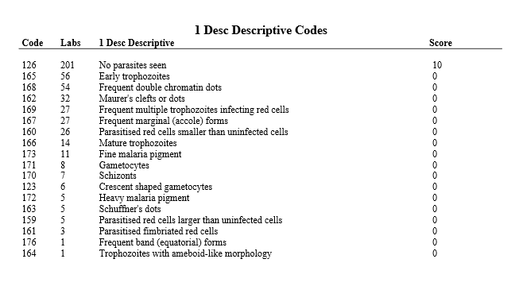

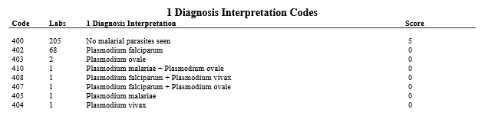

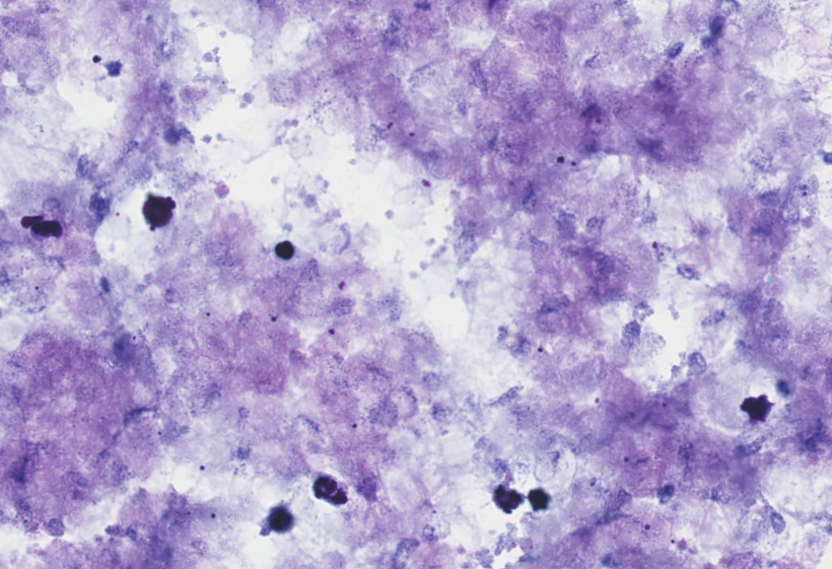

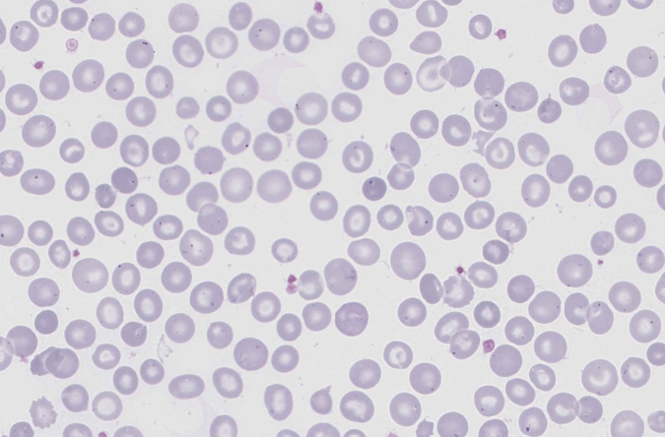

**Malarial Parasite Case: HA-MA-21-02**

59 y/o female, febrile illness, recently diagnosed with malaria & completed treatment.

WCC: 6.7 x 109/L

Hb: 118 g/L

Plt: 83 x 109/L

|  |  |  |  |  |  |  |  |  |  |  |  |  |  |  |  |  |  |  |  |
| --- | --- | --- | --- | --- | --- | --- | --- | --- | --- | --- | --- | --- | --- | --- | --- | --- | --- | --- | --- |
| **RBC (Malaria)** | | Parasitised rbc larger than uninfected cells | | Parasites - malaria | | Parasitised rbc larger than uninfected cells | | Parasites - malaria | | Parasitised rbc larger than uninfected cells | Early trophozoites | Mature trophozoites | Parasites - malaria | Parasitised rbc larger than uninfected cells | Parasitised rbc larger than uninfected cells | Parasites - malaria | Parasites - malaria | Parasitised rbc larger than uninfected cells | Schuffner’s dots |
| Schuffner’s dots | | Trophozoites with amoeboid-like morphology | | Trophozoites with amoeboid-like morphology | | Schuffner’s dots | | Trophozoites with amoeboid-like morphology | Parasitised rbc larger than uninfected cells | Parasitised rbc larger than uninfected cells | Parasitised rbc larger than uninfected cells | Schuffner’s dots | Early trophozoites | Parasitised rbc larger than uninfected cells | Parasitised rbc larger than uninfected cells | Schuffner’s dots | Parasitised rbc larger than uninfected cells |
| Trophozoites with amoeboid-like morphology | | Early trophozoites | | Parasites - malaria | | Trophozoites with amoeboid-like morphology | | Schuffner’s dots | Trophozoites with amoeboid-like morphology | Parasites - malaria | Schuffner’s dots | Trophozoites with amoeboid-like morphology | Schuffner’s dots | Schuffner’s dots | Schuffner’s dots | Trophozoites with amoeboid-like morphology | Trophozoites with amoeboid-like morphology |
|  | | Parasitised rbc larger than uninfected cells | |  | | Schizonts | |  |  | Schuffner’s dots | Trophozoites with amoeboid-like morphology | Fine malaria pigment | Trophozoites with amoeboid-like morphology | Trophozoites with amoeboid-like morphology | Trophozoites with amoeboid-like morphology |  | Early trophozoites |
|  | | Schuffner’s dots | |  | | Parasitised rbc larger than uninfected cells | |  |  | Trophozoites with amoeboid-like morphology |  |  |  | Mature trophozoites | Schizonts |  |  |
|  | |  | |  | | Early trophozoites | |  |  |  | Schuffner’s dots |  |  |  |  |  |  |
| **Primary Diagnosis** | | Malaria - Plasmodium vivax | | Malaria - Plasmodium vivax | | Malaria - Plasmodium vivax | | Malaria - Plasmodium vivax | | Malaria - Plasmodium vivax | Malaria - Plasmodium vivax | Malaria - Plasmodium vivax | Malaria - Plasmodium vivax | Malaria - Plasmodium vivax | Malaria - Plasmodium vivax | Malaria - Plasmodium vivax | Malaria - Plasmodium vivax | Malaria - Plasmodium vivax | Malaria - Plasmodium vivax |
| **Key** | |  | |  | |  | |
| High scoring response | | Moderate scoring response | | Low scoring response | | not submitted | |

|  |  |  |  |  |  |  |  |  |  |  |  |  |  |  |  |  |  |  |
| --- | --- | --- | --- | --- | --- | --- | --- | --- | --- | --- | --- | --- | --- | --- | --- | --- | --- | --- |
| **RBC (Malaria)** | | Heavy malaria pigment | | Parasitised rbc larger than uninfected cells | | Parasitised rbc larger than uninfected cells | | Parasitised rbc larger than uninfected cells | | Parasitised rbc larger than uninfected cells | Parasites - malaria | Parasitised rbc larger than uninfected cells | Parasitised rbc larger than uninfected cells | Parasites - malaria | Gametocytes | Parasites - malaria | Parasites - malaria | Parasitised rbc larger than uninfected cells |
| Parasitised rbc larger than uninfected cells | | Schuffner’s dots | | Schuffner’s dots | | Trophozoites with amoeboid-like morphology | | Early trophozoites | Parasitised fimbriated red cells | Schuffner’s dots | Schuffner’s dots | Mature trophozoites | Schuffner’s dots | Parasitised fimbriated red cells | Parasitised rbc larger than uninfected cells | Schuffner’s dots |
| Trophozoites with amoeboid-like morphology | | Trophozoites with amoeboid-like morphology | | Mature trophozoites | | Schuffner’s dots | | Mature trophozoites | Trophozoites with amoeboid-like morphology | Trophozoites with amoeboid-like morphology | Trophozoites with amoeboid-like morphology | Parasitised rbc larger than uninfected cells | Parasitised rbc larger than uninfected cells | Parasitised rbc larger than uninfected cells | Schuffner’s dots | Mature trophozoites |
|  | | Early trophozoites | | Trophozoites with amoeboid-like morphology | | Early trophozoites | | Parasites - malaria | Parasitised rbc larger than uninfected cells | Early trophozoites | Early trophozoites | Trophozoites with amoeboid-like morphology | Trophozoites with amoeboid-like morphology | Trophozoites with amoeboid-like morphology | Mature trophozoites | Trophozoites with amoeboid-like morphology |
|  | | Mature trophozoites | |  | |  | | Trophozoites with amoeboid-like morphology | Heavy malaria pigment |  | Mature trophozoites |  |  |  |  | Schizonts |
|  | | Parasites - malaria | |  | |  | | Schizonts |  |  | Parasites - malaria |  |  |  |  | Parasites - malaria |
| **Primary Diagnosis** | | Malaria - Plasmodium vivax | | Malaria - Plasmodium vivax | | Malaria - Plasmodium vivax | | Malaria - Plasmodium vivax | | Malaria - Plasmodium vivax | Malaria - Plasmodium vivax | Malaria - Plasmodium vivax | Malaria - Plasmodium vivax | Malaria - Plasmodium vivax | Malaria - Plasmodium vivax | Malaria - Plasmodium vivax | Malaria - Plasmodium vivax | Malaria - Plasmodium vivax |
| **Key** | |  | |  | |  | |
| High scoring response | | Moderate scoring response | | Low scoring response | | not submitted | |

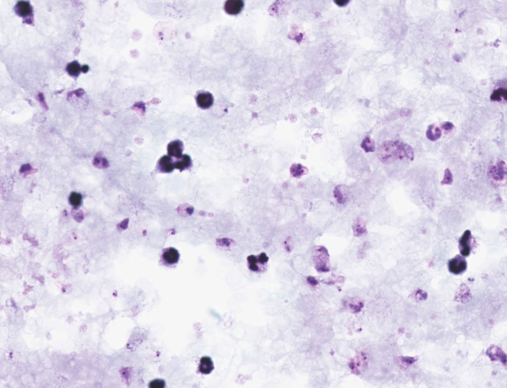

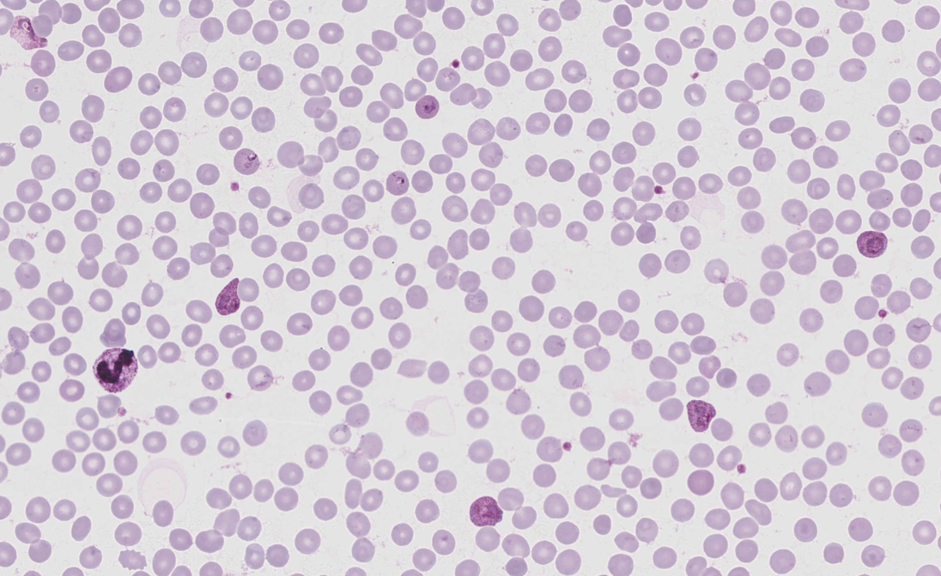

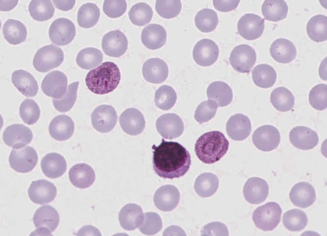

**Plasmodium vivax**

* The majority of parasitised red blood cells are larger than the uninfected red blood cells which increase as the parasite grows. The infected red blood cell itself is predominantly inconstant in shape (variable and irregular), in all stages except in early trophozoites (ring form stages).
* The early trophozoites exhibit a vacuole whilst the mature/late trophozoites have an amoeboid appearance with or without a vacuole.
* All stages of maturation are present ranging from early trophozoites to mature/late amoeboid trophozoites, schizonts and gametocytes.
* Schuffner's dots were present at all stages but faintly seen in the very early trophozoites. The Schuffner's dots in P.ovale are more prominent along the cell margin when compared to P.vivax.
* Although a number of infected red blood cells showed what may appear to be fimbriation around the entire circumference, it was not restricted to one or both sides and are most likely crenated red blood cells in an already infected red blood cell environment.
* The amount of cytoplasm and dark brown pigment increases as the parasites matures.
* The thick film shows a number of early trophozoites with a chromatin dot and fleshy cytoplasm. Numerous amoeboid trophozoites, some schizonts and rounded gametocytes with the cytoplasm filling most of the host cell and Schuffner's dots were also present.

A number of (RCPA) participants submitted P.ovale as the species.

•The gametocytes of P.vivax are more rounded than those of P.ovale (which are often oval) with its cytoplasm filling most of the host cell. The pigment is also more coarse in P.ovale.

•The late/mature trophozoites exhibited an amoeboid appearance whereas P.ovale exhibit a more compact stage and lack amoeboidicity.

•True fimbriation is lacking in P.vivax. Fimbriation must not be confused with crenation - fimbriation is one or two "ends" of the red blood cell and not around the entire circumference.

•Generally 20% or more of infected red blood cells are oval or fimbriated in P.ovale but considerably less in P.vivax (with no fimbriation).

•Elongated/oval shaped host cells are commonly seen in P.ovale and to a lesser extent in P.vivax. There may also be the occasional typical "comet" or "rocket" shaped host cell present in P.ovale.

•Schuffner's dots are more apparent in early trophozoites of P.ovale and concentrated predominantly at the periphery of the host cell. Schuffner's dots are more coarse in P.ovale in comparison to P.vivax.

•Trophozoites of P.ovale are very compact with somewhat solid mass of cytoplasm surrounding the chromatin mass (birds eye appearance).There will always be a few parasites that exhibit P.ovale like features in a P.vivax infection and vice versa but speciation must be made on the morphological appearance of the majority of parasites.

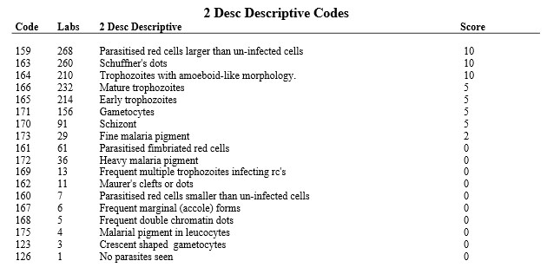

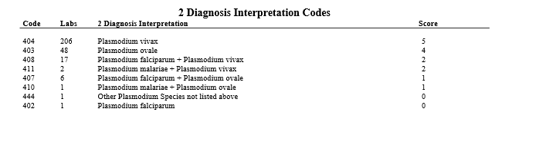

**Malarial Parasite Case: HA-MA-21-02**

42 y/o male, travelled to Canada, USA, South Africa, and Malawi. Became sick 3 weeks before returning to Australia and was taken to hospital by ambulance.

WCC: 5.6 x 109/L

RCC: 4.0 x 1012/L

Hb: 108 g/L

MCV: 77 fL

Plt: 80 x 109/L

|  |  |  |  |  |  |  |  |  |  |  |  |  |  |  |  |  |  |  |  |  |  |  |  |  |  |  |  |  |
| --- | --- | --- | --- | --- | --- | --- | --- | --- | --- | --- | --- | --- | --- | --- | --- | --- | --- | --- | --- | --- | --- | --- | --- | --- | --- | --- | --- | --- |
| **PARASITE COUNT (#)** | 141 | 102 per 1100 red cells | 105 | 98 |  | 88 | 158 | 36363 parasites/uL |  | 99 | 95 | 127 | 98 | 141 | 92 | 97 |  | 108 |  | 98 | 98 | 117 |  | 104 | 121 | 101 |  | 103 |
| **PARASITE DENSITY (%)** | 0.0141 | 1.02 | 1.06 | 0.98 |  | 0.88 | 1.6 | 0.9 | 1.46 | 0.99 | 0.95 | 1.27 | 1.05 | 0.0141 | 0.0093 | 0.97 |  | 1.08 |  | 0.99 | 0.98 | 0.0117 |  | 1.05 | 1.21 | 1.01 |  | 1.04 |

**Key**

|  |  |  |
| --- | --- | --- |
| not submitted | Within Analytical performance specifications | Outside Analytical performance specifications |

Analytical performance specifications (APS) are currently set as: - Thin and Thick film parasites/ul: +/- 125 up to 500 parasites/ul, and +/- 25% above 500 parasites/ul - Thin and Thick film % parasites/infected RBC's +/- 0.25 up to 1% parasites/infected RBC's and +/- 25% above 1% parasites/infected RBC's respectively.

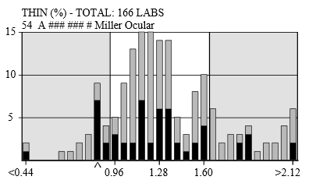

Participants are reminded to take care when performing malarial parasite counts on thin and thick blood films. The large variation of results may be attributed to the under and over estimation of malarial parasites seen on both films. We encourage that calculations are checked prior to submission. Participants that recorded results in the undesirably low or high regions should be aware that the number of red cells counted could influence the final determination with some authors suggesting a minimum of 10,000 red cells should be used to determine the parasite density. Participants should also distinguish the cellular debris from the parasites when counting, ensure consecutive fields are counted, and count at least 100 white cells (preferably 200 white cells) when performing the malarial parasite density counts.