CASE STUDY: HA-PM-21-01

Chronic myeloid leukemia

9 year old male, referred to ED urgently by GP

WBC: 624.7 x109/L (Reference range: 4.9-12.8 x109)

RBC: Not available (Reference range: 3.86-5.01 x1012)

Hb: 67 g/L (Reference range: 107-136 g/L)

MCV: Not available (Reference range: 73-85 fL)

MCH: Not available (Reference range: 24.8-29.9pg)

MCHC: Not available (Reference range: 329-359 g/L)

PLT: 283 x109/L (Reference range: 214-483 x109)

The most significant feature of the film was the extreme leucocytosis in various stages of maturation. Basophilia and eosinophilia were present. The blast count was <5% of the white cell count.

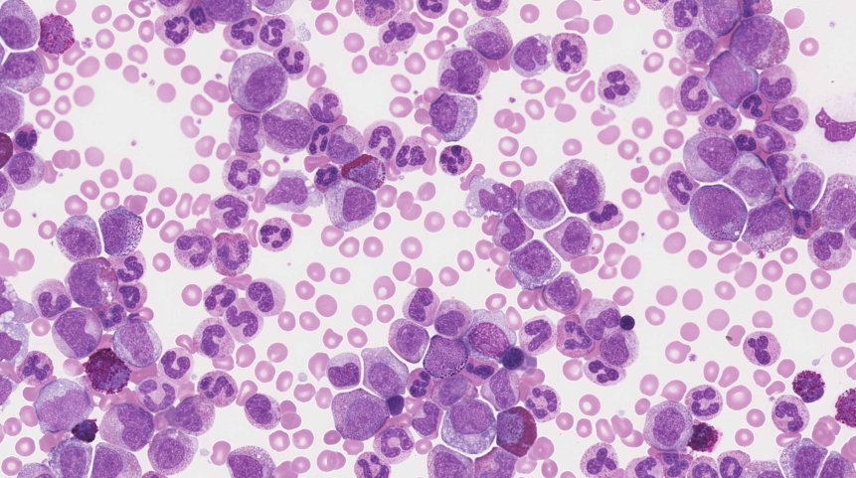

The red cells showed significant numbers of nucleated RBCs and increased polychromasia. The platelets were morphologically unremarkable.

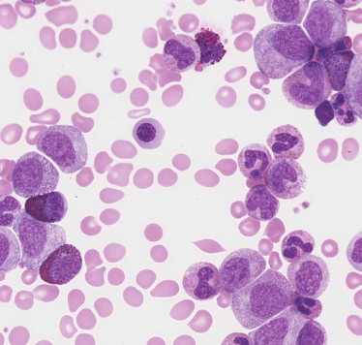

The features described were consistent with a myeloproliferative neoplasm, specifically chronic myeloid leukaemia - chronic phase (CML-CP). The majority of participants identified the blasts and immature granulocytes, which were considered essential diagnostic features and attracted score of 10. Eosinophilia, the presence of abnormal eosinophilic granules, neutrophilia and basophilia were major features and given scores of 5. The nucleated RBCs and increased polychromasia were also scored 5, being considered major red cell features. No morphological abnormality was evident in the platelets, and the giant/large platelets were not present in sufficient numbers to attract a score.

CML is a myeloproliferative neoplasm in which granulocytes are the major proliferative component. It arises in the haemopoietic stem cell and is characterised by the chromosomal translocation t(9;22)(q34.1; q11.2), which results in the formation of the Philadelphia(Ph) chromosome, containing the BCR-ABL1 fusion gene. The natural history of untreated CML is biphasic or triphasic: an initial indolent chronic phase is followed by an accelerated phase, a blast phase, or both. The diagnosis requires detection of the Ph chromosome and/or BCR ABL in the appropriate clinical and laboratory setting1.In CML-CP, the peripheral blood typically shows marked leucocytosis due to neutrophils in various stages of maturation, with peaks in the proportions of myelocytes and segmented neutrophils1. Blasts typically account for <2% of the WBCs. Absolute basophilia and eosinophilia are common, monocytes are usually <3%. Platelet counts may be normal or increased. Bone marrow specimens are markedly hypercellular, with a marked granulocytic proliferation and a maturation pattern similar to that of the peripheral blood. Blasts account for <5% of marrow cells1. The majority of participants reported a diagnosis of CML-CP, the most likely diagnosis based on the morphological features described previously, including a blast count of <5%.

Acute myeloid leukaemia with inv(16) often shows eosinophilia with abnormal eosinophils and can be diagnosed with a blast count of <20%, so this was also considered acceptable due to some similarities in the morphological features. A diagnosis of CML-accelerated phase did not meet the WHO diagnostic criteria and was scored 2. Responses of AML and Acute Leukaemia were considered diagnoses with minimal consistent features and were scored accordingly.

This patient was referred to the emergency department urgently by his GP. His reported blast count was 6.2 x109/L (1%) and the eosinophil and basophil counts were both 14.5 x109/L (2.3%). The differential count clearly showed peaks in the proportions of myelocytes and segmented neutrophils. He was treated with a tyrosine kinase inhibitor - Imatinib-for 4 years but the CML transformed to acute lymphoblastic leukaemia. He was subsequently successfully treated with a bone marrow transplant.

1.WHO Classification of Tumours of Haematopoietic and Lymphoid Tissues, Swerdlow, S et al, revised 4th edition, 20

|  |  |  |  |  |  |  |  |  |  |  |  |  |  |
| --- | --- | --- | --- | --- | --- | --- | --- | --- | --- | --- | --- | --- | --- |
|  | **HA-PM-21-01** | | | | | |  |  | **RCPA response** | | | |  |
| RBC Features | Polychromasia increased | Nucleated red blood cells | Nucleated red blood cells | Nucleated red blood cells | Nucleated red blood cells | Nucleated red blood cells | Nucleated red blood cells |  | Nucleated red blood cells |  |  |  | |
| Nucleated red blood cells |  | Polychromasia increased | Polychromasia increased | Spherocytes | Polychromasia increased | Polychromasia increased |  | Polychromasia increased |  |  |  | |
|  |  |  |  | Polychromasia increased | Spherocytes |  |  |  |  |  |  | |
|  |  |  |  | Echinocytes |  |  |  |  |  |  |  | |
| WBC Features | Blast cells | Eosinophilia | Neutrophilia | Blast cells | Blast cells | Promyelocytes / metamyelocytes / myelocytes | Promyelocytes - abnormal |  | Promyelocytes / metamyelocytes / myelocytes | Eosinophilia |  |  | |
| Promyelocytes / metamyelocytes / myelocytes | Basophilia | Eosinophilia | Promyelocytes / metamyelocytes / myelocytes | Promyelocytes / metamyelocytes / myelocytes | Basophilia | Basophilia |  | Blast cells | Basophilia |  |  | |
| Eosinophilia | Promyelocytes / metamyelocytes / myelocytes | Basophilia | Band form neutrophils | Neutrophilia | Neutrophilia | Eosinophilia |  |  | Neutrophilia |  |  | |
| Neutrophilia | Band form neutrophils | Promyelocytes / metamyelocytes / myelocytes | Neutrophilia | Smear / smudge cells |  | Blast cells |  |  | Eosinophils – abnormal granulation |  |  | |
| Platelet Features | No significant morphological platelet abnormality | No significant morphological platelet abnormality | No significant morphological platelet abnormality | Giant platelets / significant numbers of large platelets. *ICSH definition | No significant morphological platelet abnormality | No significant morphological platelet abnormality |  |  | No significant morphological platelet abnormality |  |  |  | |
| Primary Diagnosis | Chronic myeloid leukaemia – accelerated phase | Chronic myeloid leukaemia – chronic phase | Chronic myeloid leukaemia – chronic phase | Chronic myeloid leukaemia – blast phase | Chronic myeloid leukaemia – chronic phase | Chronic myeloid leukaemia – chronic phase | Chronic myeloid leukaemia – accelerated phase |  | Chronic myeloid leukaemia – chronic phase | Acute myeloid leukaemia with abnormal eosinophils/eosinophilia | Chronic myeloid leukaemia – accelerated phase | Acute leukaemia | |
|  |  |  |  |  |  | Juvenile myelomonocytic leukaemia |  |  |  | Acute myeloid leukaemia |  | |

|  |  |  |  |
| --- | --- | --- | --- |
| High scoring response | Moderate scoring response | Low scoring response | Response given no score |

|  |  |  |  |  |  |  |  |  |  |  |  |
| --- | --- | --- | --- | --- | --- | --- | --- | --- | --- | --- | --- |
|  |  | | | | | |  | **RCPA response** | | | |
| RBC Features | Nucleated red blood cells | No significant morphological red blood cell abnormality | No significant morphological red blood cell abnormality | Polychromasia increased | Nucleated red blood cells | Nucleated red blood cells |  | Nucleated red blood cells |  |  |  |
|  |  |  | Nucleated red blood cells | Polychromasia increased | Dimorphism / Dimorphic red blood cells |  | Polychromasia increased |  |  |  |
|  |  |  |  |  | Polychromasia increased |  |  |  |  |  |
| WBC Features | Neutrophilia | Blast cells | Eosinophilia | Blast cells | Blast cells | Blast cells |  | Promyelocytes / metamyelocytes / myelocytes | Eosinophilia |  |  |
| Eosinophilia | Promyelocytes / metamyelocytes / myelocytes | Promyelocytes / metamyelocytes / myelocytes | Promyelocytes / metamyelocytes / myelocytes | Promyelocytes / metamyelocytes / myelocytes | Promyelocytes / metamyelocytes / myelocytes |  | Blast cells | Basophilia |  |  |
| Promyelocytes / metamyelocytes / myelocytes |  | Basophilia | Eosinophilia | Basophilia | Eosinophilia |  |  | Neutrophilia |  |  |
| Basophilia |  | Blast cells | Neutrophilia | Eosinophilia | Neutrophils - hyposegmented |  |  | Eosinophils – abnormal granulation |  |  |
| Platelet Features | No significant morphological platelet abnormality | No significant morphological platelet abnormality | No significant morphological platelet abnormality | No significant morphological platelet abnormality | No significant morphological platelet abnormality | Giant platelets / significant numbers of large platelets. *ICSH definition |  | No significant morphological platelet abnormality |  |  |  |
| Primary Diagnosis | Chronic myeloid leukaemia – chronic phase | Chronic myeloid leukaemia – blast phase | Chronic myeloid leukaemia – chronic phase | Chronic myeloid leukaemia – accelerated phase | Chronic myeloid leukaemia – chronic phase |  |  | Chronic myeloid leukaemia – chronic phase | Acute myeloid leukaemia with abnormal eosinophils/eosinophilia | Chronic myeloid leukaemia – accelerated phase | Acute leukaemia |
|  |  |  |  |  | Juvenile myelomonocytic leukaemia |  |  |  | Acute myeloid leukaemia |  |

|  |  |  |  |
| --- | --- | --- | --- |
| High scoring response | Moderate scoring response | Low scoring response | Response given no score |

