CASE STUDY: HA-PM-21-02

Oxidative haemolysis

2 week old female

WCC: 12.9 x 109/L (Reference range: 5.0-19.0 x109)

RBC: Not available(Reference range: Not provided)

Hb: 102 g/L (Reference range: 105-205 g/L)

MCV: Not available (Reference range: 85-110 fL)

MCH: Not available (Reference range: 28.0-40.0 pg)

MCHC: Not available(Reference range: 320-360 g/L)

PLT: 175 x 109/L (Reference range: 150-600 x109)

The blood film of this patient showed a variety of red cell changes, including bite cells, blister cells and increased polychromasia. Some spherocytic-appearing red cells, occasional nucleated RBC and Howell-Jolly bodies were present. The white cell and platelet morphology were essentially normal.

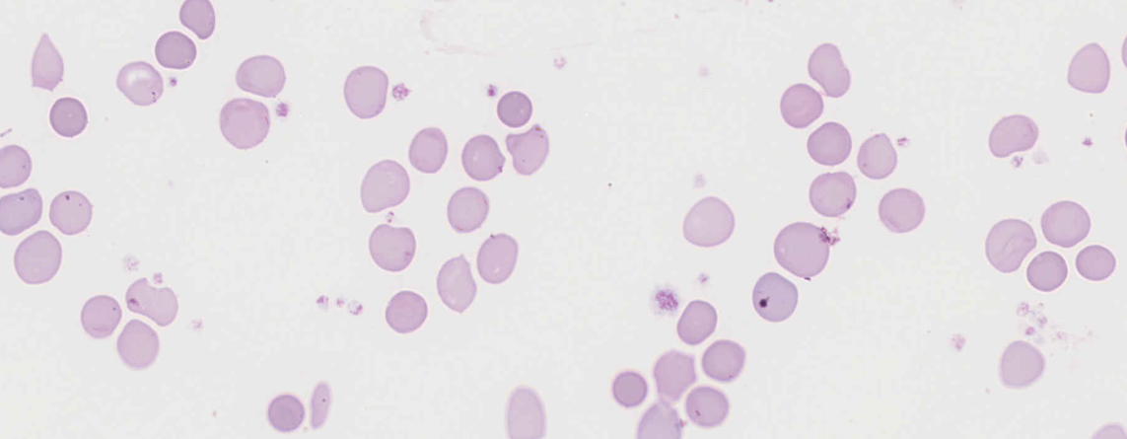

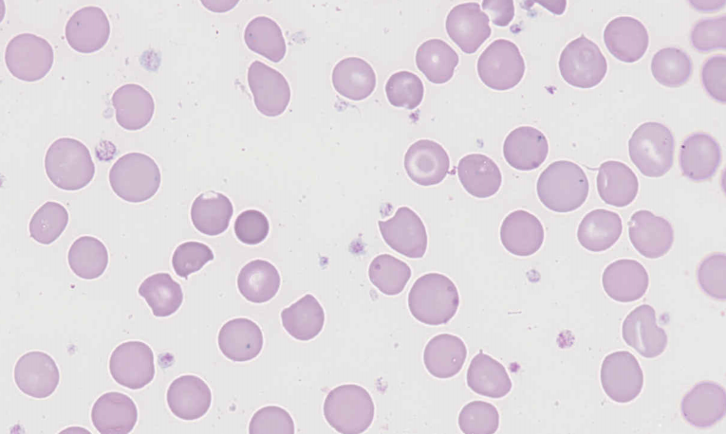

These morphological features are highly suggestive of oxidative haemolysis, with the bite and blister cells being commonly associated with, but not diagnostic of, Glucose-6-Phospate Dehydrogenase (G6PD) deficiency.1

The majority of participants submitted the salient features, of which bite cells and blister cells were considered diagnostic and scored 10. The presence of irregularly shaped red cells, classified as schistocytes by a number of participants, was also acknowledged with the scoring. Note that although 110 participants reported schistocytes, only 8 submitted a diagnosis of microangiopathic haemolytic anaemia or fragmentation haemolysis, so the vast majority of participants did not misinterpret the schistocytes as the primary pathophysiological mechanism, and recognised the overall picture as oxidative haemolysis. Nucleated RBCs, increased polychromasia, spherocytes and hyposplenic/asplenic changes were considered major features and scored 5. Other less significant features were acknowledged with the scoring. An inaccurate platelet count was noted, as the platelet count appeared higher in the film than the numerical result given.The vast majority of participants submitted the most likely diagnosis of oxidative haemolysis. As previously stated, G6PD deficiency is a prime consideration when bite and blister cells are observed, however, these cells can also be generated (less commonly) when other enzymes of the same pathway are deficient, resulting in a haemolytic crisis.3 In addition, G6PD deficiency is X-linked, and although females should not be excluded from consideration, it makes this diagnoses less likely. G6PD deficiency was therefore scored 4, in keeping with the majority of the expected morphological features present. Infantile pyknosis was scored 2 due to the presence of some densely stained, irregularly shaped red cells, however this diagnosis is less well defined and does not acknowledge the presence of the bite cells and blister cells. Similarly, pyruvate kinase deficiency was scored as a diagnosis with minimal consistent features present.

Oxidative haemolysis occurs when when normal process are unable to reduce ferric iron (methaemoglobin) to ferous iron, which carries oxygen. This results in methaemoglobinaemia i.e. the denaturing of ferric haemoglobin into multimers called Heinz bodies. These Heinz bodies can be removed by splenic macrophages through a "pitting" mechanism, which results in premature red cell destruction manifested by the formation of bite and blister cells. G6PD is integral to the systems which protect against oxidative stress, and when it is deficient, oxidative insults may cause haemolysis.Classically, fava beans, sulfa drugs, and primaquine were the primary triggers of oxidative

haemolysis, but the list of medications to avoid in persons with G6PD deficiency is extensive. Amyl and butyl nitrate, topical benzocaine, phenazopyridine, dapsone, ribavirin, and paraquat ingestion can also cause oxidative haemolysis, even with normal G6PD levels 1,2There was no clinical history or results of confirmatory testing available for this patient.

1.Lake M, Bessmer D. Hemolytic anemia: enzyme deficiencies. In: Clinical laboratory hematology. 3rd ed. New Jersey: Pearson; 2015.

2.Phillips, J et al, Hemolytic anaemia; evaluation and differential diagnosis, Am. Fam. Physician, 2018;98(6):354-3613.Christensen, R et al, Neonatal Hemolytic Jaundice: Morphologic Features of Erythrocytes That will Help You Diagnose the Underlying Condition, Neonatology, 2014, 105: 243-249

|  |  |  |  |  |  |  |  |  |  |  |  |  |
| --- | --- | --- | --- | --- | --- | --- | --- | --- | --- | --- | --- | --- |
|  | **HA-PM-21-2** | | | | | | |  | **RCPA response** | | | |
| RBC Features | Blister cells | Bite cells | Bite cells | Blister cells | Spherocytes | Spherocytes | Bite cells |  | Bite cells | Polychromasia increased | Target cells |  |
| Schistocytes | Spherocytes | Blister cells | Hyposplenic / asplenic changes | Polychromasia increased | Blister cells | Blister cells |  | Blister cells | Spherocytes | Schistocytes |  |
| Polychromasia increased | Polychromasia increased | Irregularly contracted cells | Target cells | Blister cells | Bite cells | Nucleated red blood cells |  |  | Nucleated red blood cells | Irregularly contracted cells |  |
| Target cells | Schistocytes | Target cells | Polychromasia increased | Schistocytes | Target cells |  |  |  | Hyposplenic / asplenic changes | Howell Jolly bodies |  |
| WBC Features | No significant morphological white blood cell abnormality | No significant morphological white blood cell abnormality | No significant morphological white blood cell abnormality | No significant morphological white blood cell abnormality | Cytoplasmic vacuolation | No significant morphological white blood cell abnormality | Lymphocytosis |  | No significant morphological white blood cell abnormality |  |  |  |
|  |  |  |  | Döhle bodies |  |  |  |  |  |  |  |
| Platelet Features | Inaccurate platelet count | Inaccurate platelet count | No significant morphological platelet abnormality | No significant morphological platelet abnormality | No significant morphological platelet abnormality | No significant morphological platelet abnormality | Giant platelets / significant numbers of large platelets. *ICSH definition |  | No significant morphological platelet abnormality | Inaccurate platelet count |  |  |
| Primary Diagnosis | Oxidative haemolysis | Oxidative haemolysis | Oxidative haemolysis | G6PD deficiency | Oxidative haemolysis | Oxidative haemolysis | Oxidative haemolysis |  | Oxidative haemolysis | G6PD deficiency | Infantile pyknocytosis | Pyruvate kinase deficiency |

|  |  |  |  |
| --- | --- | --- | --- |
| High scoring response | Moderate scoring response | Low scoring response | Response given no score |

|  |  |  |  |  |  |  |  |  |  |  |  |
| --- | --- | --- | --- | --- | --- | --- | --- | --- | --- | --- | --- |
|  | **HA-PM-21-2** | | | | | |  | **RCPA response** | | | |
| RBC Features | Bite cells | Bite cells | Blister cells | Blister cells | Bite cells | Bite cells |  | Bite cells | Polychromasia increased | Target cells |  |
| Blister cells | Schistocytes | Bite cells | Schistocytes | Spherocytes | Dimorphism / Dimorphic red blood cells |  | Blister cells | Spherocytes | Schistocytes |  |
| Polychromasia increased | Acanthocytes | Polychromasia increased | Polychromasia increased | Polychromasia increased | Poikilocytosis (not otherwise coded) |  |  | Nucleated red blood cells | Irregularly contracted cells |  |
| Irregularly contracted cells |  | Schistocytes | Target cells | Schistocytes | Target cells |  |  | Hyposplenic / asplenic changes | Howell Jolly bodies |  |
| WBC Features | No significant morphological white blood cell abnormality | No significant morphological white blood cell abnormality | Cytoplasmic vacuolation | No significant morphological white blood cell abnormality | No significant morphological white blood cell abnormality | Neutrophils – hypersegmented |  | No significant morphological white blood cell abnormality |  |  |  |
|  |  | Neutrophils - hypergranulation |  |  |  |  |  |  |  |  |
| Platelet Features | No significant morphological platelet abnormality | No significant morphological platelet abnormality | Inaccurate platelet count | Inaccurate platelet count | No significant morphological platelet abnormality | Inaccurate platelet count |  | No significant morphological platelet abnormality | Inaccurate platelet count |  |  |
| Primary Diagnosis | Oxidative haemolysis | Oxidative haemolysis | Oxidative haemolysis | Oxidative haemolysis | Oxidative haemolysis | Oxidative haemolysis |  | Oxidative haemolysis | G6PD deficiency | Infantile pyknocytosis | Pyruvate kinase deficiency |

|  |  |  |  |
| --- | --- | --- | --- |
| High scoring response | Moderate scoring response | Low scoring response | Response given no score |

