Case Study HA-MO-21-03:

Haemoglobin SC

|  |
| --- |
| 31yo female for follow-up testing.  WCC: 9.5 x 109/L  RCC: 3.9 x 1012/L  Hb: 125 g/L  MCV: 83 fL  MCH: 32.2 pg  MCHC: Not available  Plt: 423 x 109/L |

The predominant changes in this film were seen in the red cells, including target cells, spherocytes and intraerythrocytic crystalline structures.

Occasional sickle cells, nucleated RBC and Howell-Jolly bodies were also seen.

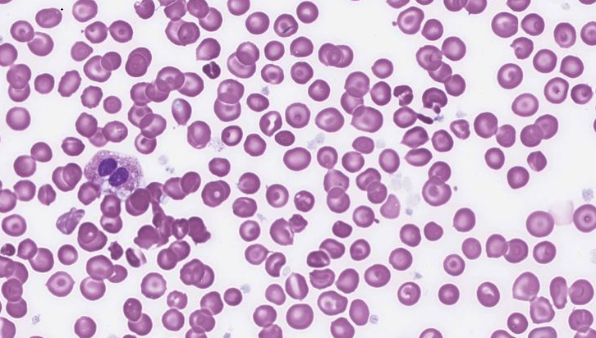

The white cells showed mild hypergranulation and vacuolation, and some giant platelets and fibrin clots were evident. Considering the morphological features described, the most likely diagnosis was considered to be Haemoglobin SC.

Fewer sickle or boat cells were present, which is typical of Hb SC.

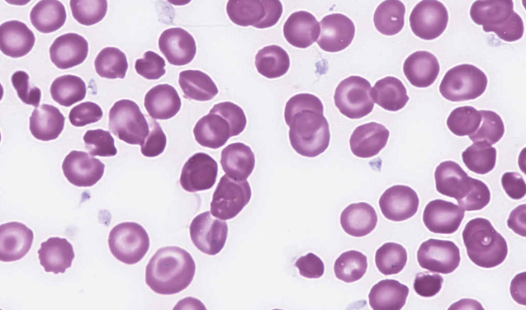

There were frequent Hb SC poiklocytes evident on the film which may be described as irregularly contracted cells.. The presence of giant platelets and a few platelet clumps were also acknowledged with the scoring.

Hb SC and Hb CC were considered the most likely diagnoses on a morphological basis. The less specific response of "Haemoglobinopathy" was also considered acceptable.

This patient was known to have Hb SC. An HPLC analysis revealed a Hb S level of 48.9% and a Hb C of 44.8%. Her iron studies were normal. Although toxic changes were evident in this film, there was no further information relating to a concurrent infection.

Hb SC is one of the most common compound heterozygous syndromes that results in a structural defect in the haemoglobin molecule in which different amino acid substitutions are found on each of the two β-globin chains. At position 6, glutamic acid is replaced by valine (Hb S) on one β-globin chain and by lysine (Hb C) on the other β-globin chain. Hb SC disease usually results in a milder form of sickle cell disease, but it can be severe in some cases. Growth and development are delayed compared with normal children. Unlike Hb SS, Hb SC usually does not produce significant symptoms until the teenage years. Hb SC disease may cause all the vaso-occlusive complications of sickle cell anaemia, but episodes are less frequent and damage is less disabling. Haemolytic anaemia is moderate, and many patients exhibit moderate splenomegaly. Proliferative retinopathy is more common and more severe than in sickle cell anaemia. Respiratory tract infections with S. pneumoniae are common. Patients with Hb SC disease live longer than patients with Hb SS and have fewer painful episodes, but Hb SC is also associated with considerable morbidity and mortality, especially after age 30.

The peripheral blood typically shows a few sickle cells, target cells and intraerythrocytic crystalline structures. These Hb SC crystals form in some cells, where they protrude from the membrane and often appear as a hybrid of Hb S and Hb C crystals. They are typically longer than Hb C crystals but shorter and thicker than Hb S polymers and are often branched.

1. Rodak's Haematology: Clinical Principles and Applications, 5th edition, Keohane et al, 2016, Elsevier Inc.

|  |  |  |  |  |  |  |  |  |  |
| --- | --- | --- | --- | --- | --- | --- | --- | --- | --- |
| RBC Features | Target cells | Target cells | Target cells | Target cells | Target cells | Target cells | Target cells | Target cells | Crystallised haemoglobin |
| Microspherocytes | Irregularly contracted cells | Irregularly contracted cells | Irregularly contracted cells | Sickle cells | Irregularly contracted cells | Irregularly contracted cells | Irregularly contracted cells | Sickle cells |
| Polychromasia increased | Spherocytes | Hyposplenic / asplenic changes | Nucleated red blood cells | Irregularly contracted cells |  | Crystallised haemoglobin | Hyposplenic / asplenic changes | Target cells |
| Nucleated red blood cells | Polychromasia increased | Crystallised haemoglobin | Sickle cells | Nucleated red blood cells |  | Nucleated red blood cells | Nucleated red blood cells |  |
| WBC Features | Dysplastic changes | No significant morphological white blood cell abnormality | Band form neutrophils | Haemophagocytosis | Cytoplasmic vacuolation |  | No significant morphological white blood cell abnormality | Band form neutrophils | Neutrophils - hypergranulation |
| Pelger-Huet / pseudo Pelger-Huet cells |  | Neutrophils – other abnormal granulation | Neutrophils - hypergranulation | Neutrophils - hypergranulation |  |  | Cytoplasmic vacuolation | Cytoplasmic vacuolation |
| Neutrophils - hyposegmented |  |  |  |  |  |  |  |  |
|  |  |  |  |  |  |  |  |  |
| Platelet Features | Giant platelets / significant numbers of large platelets. *ICSH definition | Giant platelets / significant numbers of large platelets. *ICSH definition | Giant platelets / significant numbers of large platelets. *ICSH definition | Giant platelets / significant numbers of large platelets. *ICSH definition | Inaccurate platelet count |  | Giant platelets / significant numbers of large platelets. *ICSH definition | Giant platelets / significant numbers of large platelets. *ICSH definition |  |
|  |  | Inaccurate platelet count | Inaccurate platelet count |  |  |  | Inaccurate platelet count |  |
|  |  |  |  |  |  |  |  |  |
| Primary Diagnosis | Hb CC | Hb SC | Hb SC | Hb SC | Hb SC | Hb SC | Hb SC | Hb SC | Hb SC |
|  |  |  |  |  |  |  |  |  |

|  |  |  |  |
| --- | --- | --- | --- |
| High scoring response | Moderate scoring response | Low scoring response | Response given no score |

|  |  |  |  |  |  |  |  |  |  |  |  |  |  |  |
| --- | --- | --- | --- | --- | --- | --- | --- | --- | --- | --- | --- | --- | --- | --- |
| RBC Features | | Crystallised haemoglobin | | Crystallised haemoglobin | | Target cells | | Target cells | | Microcytes | Target cells | Target cells | Target cells | Target cells |
| Target cells | | Hyposplenic / asplenic changes | | Polychromasia increased | |  | | Irregularly contracted cells | Microspherocytes | Crystallised haemoglobin | Tear drop cells | Spherocytes |
| Hyposplenic / asplenic changes | | Microspherocytes | | Sickle cells | |  | | Target cells | Polychromasia increased | Irregularly contracted cells | Sickle cells | Bite cells |
|  | |  | | Nucleated red blood cells | |  | | Hyposplenic / asplenic changes | Nucleated red blood cells | Spherocytes | Irregularly contracted cells |  |
| WBC Features | | Neutrophils - hypergranulation | |  | | Cytoplasmic vacuolation | |  | | Band form neutrophils | Dysplastic changes | Neutrophils - hypergranulation | Neutrophil – Hypogranulation. | Cytoplasmic vacuolation |
|  | |  | | Neutrophils – other abnormal granulation | |  | | Neutrophils - hypergranulation | Pelger-Huet / pseudo Pelger-Huet cells | Cytoplasmic vacuolation |  | Neutrophils - hypergranulation |
|  | |  | |  | |  | |  | Neutrophils - hyposegmented |  |  | Promyelocytes / metamyelocytes / myelocytes |
|  | |  | |  | |  | |  |  |  |  | Other inclusions |
| Platelet Features | | Giant platelets / significant numbers of large platelets. *ICSH definition | |  | | Giant platelets / significant numbers of large platelets. *ICSH definition | | Giant platelets / significant numbers of large platelets. *ICSH definition | | Giant platelets / significant numbers of large platelets. *ICSH definition | Giant platelets / significant numbers of large platelets. *ICSH definition | Platelet clumps | No significant morphological platelet abnormality | Giant platelets / significant numbers of large platelets. *ICSH definition |
|  | |  | | Inaccurate platelet count | |  | |  |  | Inaccurate platelet count |  | Inaccurate platelet count |
|  | |  | |  | |  | |  |  | Giant platelets / significant numbers of large platelets. *ICSH definition |  |  |
| Primary Diagnosis | | Hb variant/thalassaemia (double heterozygous | |  | | Hb SC | |  | | Hb SC | Hb CC | Hb SC | Hb SC |  |
|  | |  | |  | |  | |  |  |  |  | Artefact / aged specimen |
| High scoring response | | Moderate scoring response | | Low scoring response | | Response given no score | |

