Flow Method updates – sign Flow Cytometry Methodology Updates form kept in flow room

- UPDATED FLOW LAB SOP _new VERSION of a Controlled Document has been issued, please note & sign the ‘methodology updates log’ for:
  - CD_HA-0308 – updated extra tubes (new instrument added).
  - CD_HA_0220 – LISTMODE DATA STORAGE, updated with current storage discs.
  - CD_HA_0480- EXTERNAL QUALITY ASSURANCE SPECIMENS
  - CD_HA_0251 FLOW CYTOMETRY ONCOLOGY REPORTS – filling detailed instruction added + archiving BOX registry / record instructions added in.
  - CD_HA_0477 - FLOW CYTOMETER AUTO-COMPENSATION PROCEDURES – removed unused analysers/procedures

- NEW SOP – none
- UDATED general APS documents to note:
  - CD-MA –0138 Handling Incidents, Non-Conformance and Complaints Manual sample preparation – please see SOP for how to raise incidents in AH Management System ‘RiskMan’ if required –

New projects

- New instrument NAVIOS EX(3) , SN BE05526 (delivered & installed by BEC on 20th MAY 21)- Number 3 out of 3 Flow cytometers present in Lab: Number 1-Navios; Number2- NaviosEx BC40631 & now number 3- new NaviosEx instrument BE05526
  - Installation final report received & reviewed on 27th May 2021 by Gosia
  - Routine tests validations - Started with validation of Single platform Stem Kit CD34 test
    - CD34 correlation: work in progress, as per S. Romanin/Danni Theologos update we are very close to achieving our target of 30. The breakdown of numbers for each sample type to be revised – need to review and collect minimum 10 of each sample type category.
    - Run to RUN - set up & run SFP low and SFP high over a minimum of 5 days – L_J monitored & ok
    - Within RUN – done on both SFP low and SFP High and both have <10% CV
    - Please run controls and CryoQC samples only if within our time limit specifications for the test: ≤ 1 hr post lyse.

- NAVIOS EX(2) BC40631 Flow analyser (routine use) – validation, final reports updates (continuation):
  - Note: All finished reports & tabulated printed results – NAVEX printouts & Navios validated reports are stored in card box under the sink. Please keep it there – for long term storage it will be kept in lab
  - 5cQ-prep ‘final’ validation for CD2/3 & BCQ tests finished by Gosia:
    - Paperwork with Seniors for checking
    - To be presented on the next ‘Haem Tech Com’ by Amber
    - To be signed by Dr S. Morgan post presentation
  - More written specific test validations reports are still required
    - There are few final reports to be written- work in progress (see validation task link below):
H:\AAA_Quality\UNIT_HAem_q\Validation Data\Flow\NAVEX BC40631 validation\Record of NAVEX2 BC40631_ Validation tasks.doc

- vCD3CTU - New test on NAVIOS EX(3) , SN BE05526 – project updates.

  - The vCD3CTU enumeration project started on 16th June 2021 (28th Jan-planning started with Dr S. Morgan & S. Schischka). Set up Complete! Collecting data in progress.
  - Sue & Danni are coordinating this project – main points to note:
      - New Test order -IT job to be raised by Sue R. – we proposed name of test to be: vCD3CTU, vCD3CTU = viable CD3 enumeration for Cell Therapy Unit
      - Antibody titration and protocols and panels all created and checked & working ok
      - Collection of correlation data for LSUB/BMTC/vCD3CTU started and so far we have data for: 6 samples ( 4 PB and 2 HPCA). BMTC % CD3 of Lymph to be correlated. For absolute BMTC CD3 cell / uL will have to use dual platform calculation & need to be calculated from Navios SP lymphocyte count (cells/uL) as two issues noted:
        - Haem analyser is not gating correctly lymphocytes and
        - BMTC test is wash & lyse with loss of Neutrophils thus % of Lymphocytes is overestimated
      - Data collected in folder: \\TH-FS01\Shared\PATHOLOGY\shared\IMMUNO\RESEARCH AND DEVELOPMENT (R&D) FLOW\NEW IN PROGRESS\NavExi_BE05526 THREE correlation May2021+\CD3 enumeration and viability validation
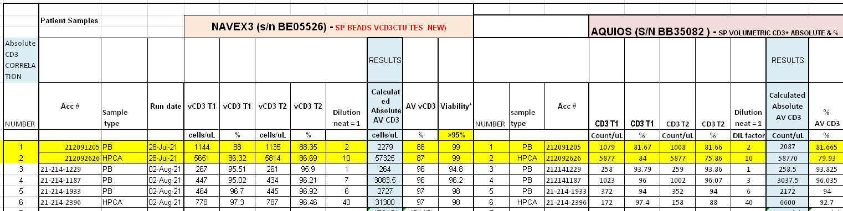
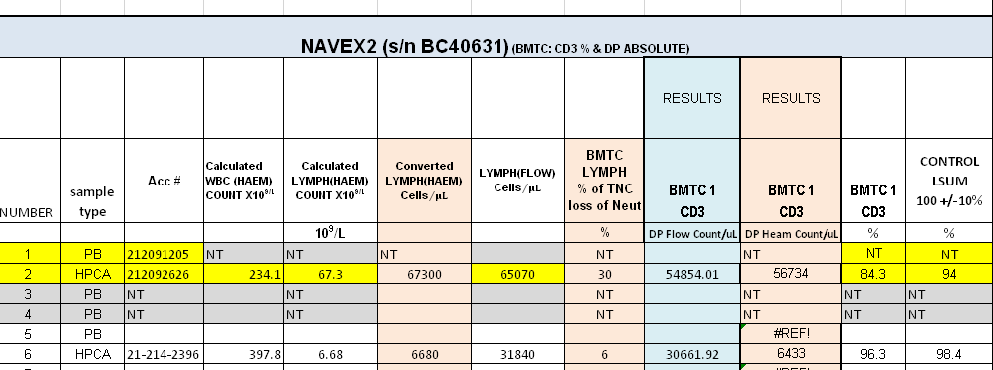

      - 2 Controls monitored and perform within expected ranges:
        - FSpro CD3CTU protocol, settings monitoring (MFI within 10%) – run daily
        - CDChex control,- monitored CD3% and absolute numbers within controls ranges – minimum run: on the day of running test, set up & run prior patient
        - Check stock of CDCHEX – if running low in volume do not use for vCD3CTU ( I ordered some extra reagents)

- NATA assessment, NATA onsite inspection week of 6th September – preparations started in week 14th MAY, getting ready –..\..\..\IMMUNO\GOSIA PRDS\NATA flow _2021\NATA Audit Prep Checklist_FLOW 2021.xlsx

  - Updating SOP – Amber has updated CD_HA_0480.docx that will include day booking of our RCPA/QAP samples
  - Check your training log & alert Amber if any fields are not signed! Please go through your training logs and make sure all sections have signatures of trainee and trainer as required
  - Clean lab – no loose notes, please remove any if you note
  - Please sign all logs as you perform tasks & check & complete
- Records of daily QC review
- Temperature Charts (max/min recorded, out of range actions recorded)
- Analyser Maintenance Logs
- Reagent Logs complete
  - If you note any SOP that are old, issued in 2018 please make me aware

- Issues continue with Kaluzav2.1 on problematic computer APATHD8AC066219 - ITS job was escalated by Dr Sue Morgan – Post ITS replacement with new graphic card
  - Issues addressed, continuation:
    - Computer with Kaluza Software V2.1 (from 2018) – Amber raised IT job again to address crashes post ITS graphic card change.
- IT person looking after this is: Aliu, Merzan <M.Aliu@alfred.org.au>
    - Our ITS created a dump file as per BEC request and with their tools diagnosed possible error with a QUADRO card.

  - Computer in flow room with Kaluza V1.5 – As per Maree wait with an upgrade it to new version – no change

- InstruNor – to remove, please note below – no update
  - Fully decontaminated (20th May 2021), metal racks left inside.
  - Left ‘power off’, analyser is in shipment mode (but the mechanism not secured as yet) – need to open and put a shield, to open the analyser you need to switch analyser on again.

Staff training / proficiencies
- New educational material are uploaded into MTS – have a read/listen to both.
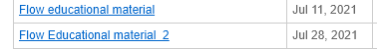
- Dan Luo training in flow going well- thanks everyone for taking an extra effort in training DAN.
  - Still some gaps in tests’ preparation:
    - CD34cord (rare test)
  - Kaluza analysis training – NHL – proficient, AML training started (Dan keeps record of done/ analysed cases, please update as you go)
- Amber- MMMRD Infinicyt training – started but slow progress as short staff.
- Jennifer Ma – had introduction to MM_MRD Infinicyt training started but slow as short staff

Other issues:
- NaviosEX(2) – computer is very slow, BEC (Maree B.) notified. I did a backup and some archiving on 03.08.2021 but no real change. Our options are:
  - Reimage of computer – Maree contacting engineers, Amber please follow up in next week.
  - Purchasing Window10 - Amber raise this as an issue in next com meeting
  - To be on safe side do a ‘Backup’ for NAVIOSEX(2) via Administration function to keep all L-J/ reports up to date – this will make restoration of data if required by BEC very easy.
    - At the end of each week
    - Last backup was done on 3rd August 2021

- CD34 test – change in Cell Count (CC) for storage by Cellular Therapy Unit (CTU): NO Update of start time!

- MM-MRD – two lots in use. Please note on slip which vial test was set up. New lot kit checked, new settings saved in Cytognos protocol.
  - Compensation values (‘comp’) will need to be uploaded by analyst in Infincyt software according to vial number, both are saved in Cytognos protocol:
ProfilePlasmaCell_MM-MRD_V2.0.1.b v6_ INFIN 2.0_NEW_2.inp
Kept in folder: \\172.22.57.171\PatientReview2\AAA A INFINICYTE\Profiles AH

- Problem persists: flow reports are getting mixed up between designated trays – please take care and spread the knowledge if you see someone confused with our filing system

Staff Suggestions / Concerns

- Roster Issues:
  - Note Gosia is on AL during NATA, Amber will do cover as acting Grade3, backup by Jorge C.
    - Good luck – hope all goes well! Happy flowing!
  - Rostered ADO are scheduled by management – check your roster!

QAP/EQAP

- 2021 RCPA/QAP – latest runs – thank you for participation!

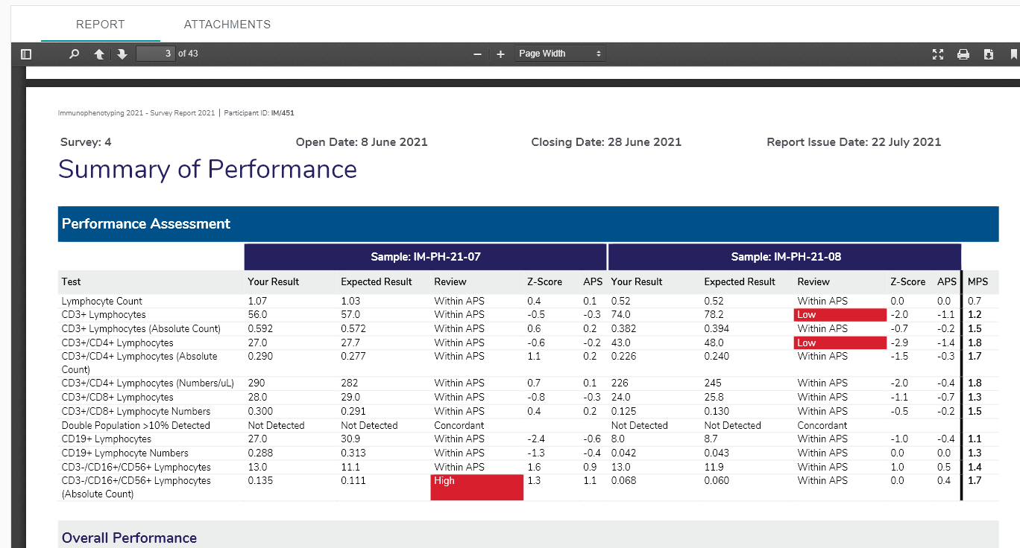
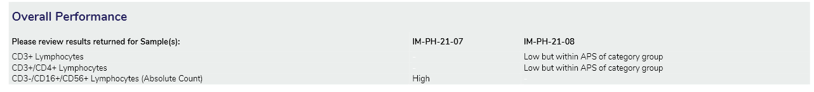
    - LSUB on Aquios PH21-07 – High APS for absolute CD16+/56+CD3-ve NK
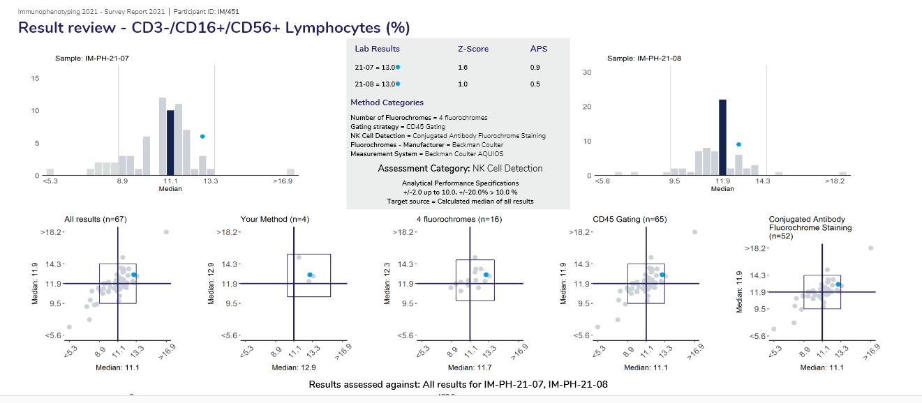
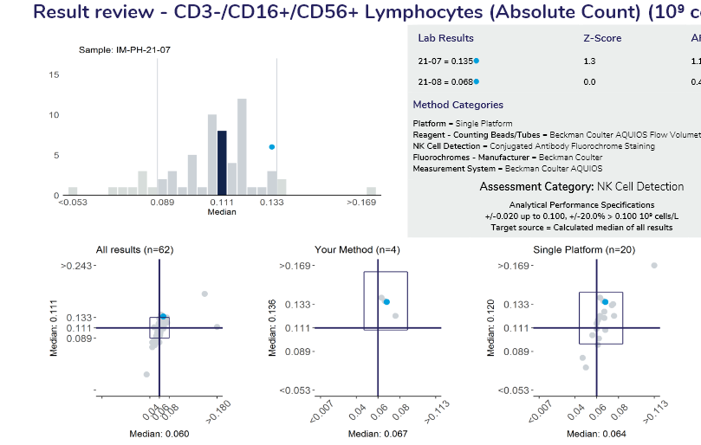

    - LSUB on Aquios PH21-08 – High APS for % results: CD3% & CD3/4%

% results for two subsets out: CD3+ and CD3+/CD4+ :
- %:
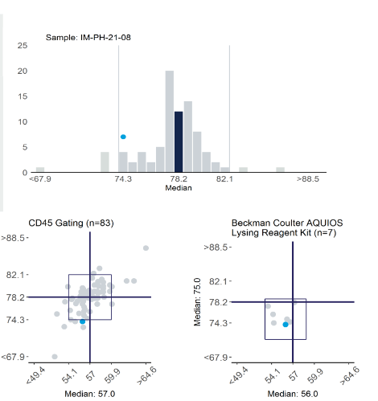 CD3 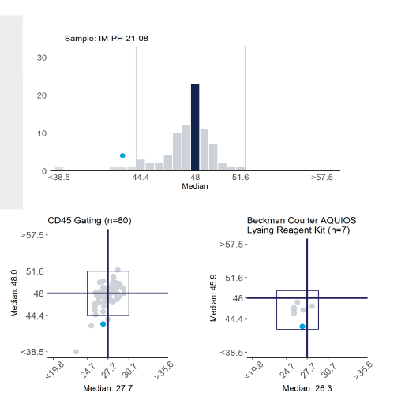CD3/4

- Absolute:
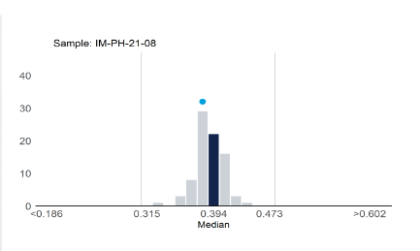 CD3 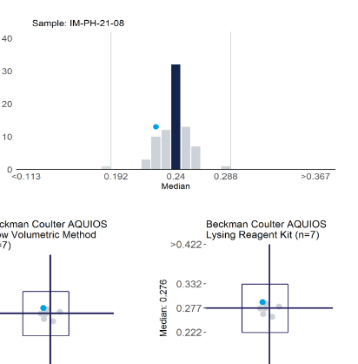CD3/4
Gating reviewed & looks like Aquios is better in excluding contaminating Monocytes (same noticed in previous cycles !)

  - Continue to daybook IM/PH RCPA samples for Aquios LSUB & FMH RCPA - they need to be day booked in Cerner for whole process monitoring that includes calculations & DIM – added to SOP CD_HA_0480 – thank you Amber!

IT issues / Network Alerts / Trials

- New trials listed by Sarah Green:
  - PATH73173 / MM23 (452/20) – NUMBERS ARE PICKING UP – please note if any collection issues persist
    - TAT on two time point are 2 weeks
  - PATH73257 2 occasions x 6 patients
  - PATH73259 4 occasions x 6 patients
    - They have not confirmed how long the trials are expected to run, but most likely “years”

- New trials are added to a table as per Dr S. Morgan, our MMMRD method to be updated.
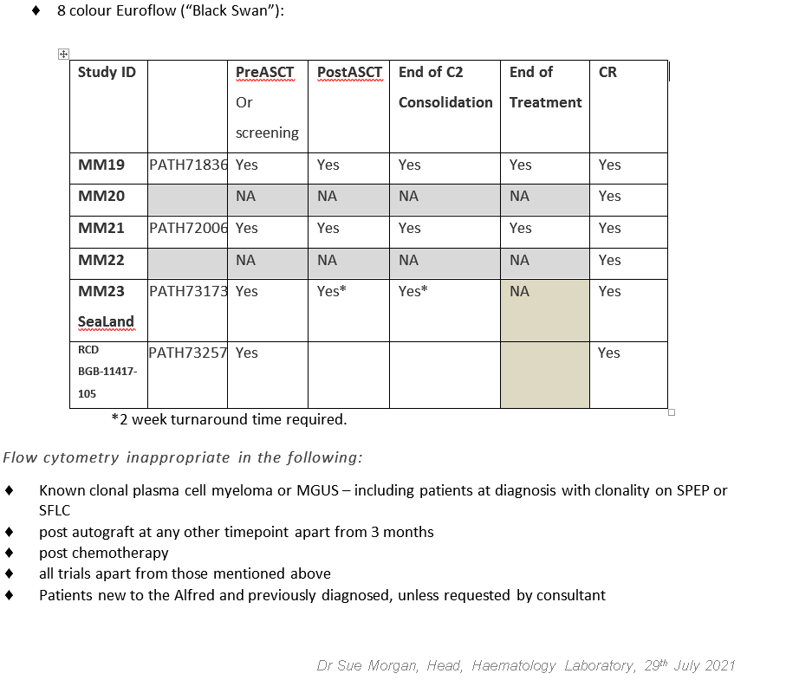

New Staff / Social Events / Congratulations / Conference applications

- Congratulation to Amber for acting Gr3 role -thank you for accepting
- NaviosEX KOT: 3 spaces pending

Please indicate in MTS that you have received this information. Persons present at meeting are ticked – see also minute’s folder.
\\th-fs01\shared\PATHOLOGY\shared\Haematology\Meetings\Flow Cytometry 2017

Name | Signature / Tick | Name | Signature / Tick
MADDEN, AMBER |  | GORNIAK, MALGORZATA (GOSIA)  Senior scientist
ROMANIN, SUSAN |  | Dan Luo
THEOLOGOS, DANIELLE |  | JENNIFER MA
CHICAS, JORGE
HALLETT EMMA

