CASE STUDY: HA-MO-21-04

Acute Myelomonocytic Leukaemia

45 year old female with fatigue, fever and

WCC: 69.1 x109/L

RCC: 3.00 x1012/L

HB: 94 g/L

MCV: 91.7 fL

MCH: 31.2 pg

MCHC: 341 g/L

PLT: 89 x109/L

The most significant feature of the film was the marked leucocytosis with a proliferation of neutrophil and monocyte precursors. The monoblasts were large with abundant basophilic cytoplasm, with some showing scattered fine azurophilic granules, vacuoles and occasional cells with Auer rods. The nuclei were round with open chromatin and one or more large prominent nucleoli. The promonocytes had a more irregular and convoluted nuclear configuration, with less basophilic cytoplasm and sometimes more granulation and vacuolation. An increased number of monocytic cells were present in this case. The red cells showed increased polychromasia, tear drop cells and occasional nucleated RBCs, and the platelets were essentially normal. These features were highly suggestive of acute myelomonocytic leukemia (AMML).

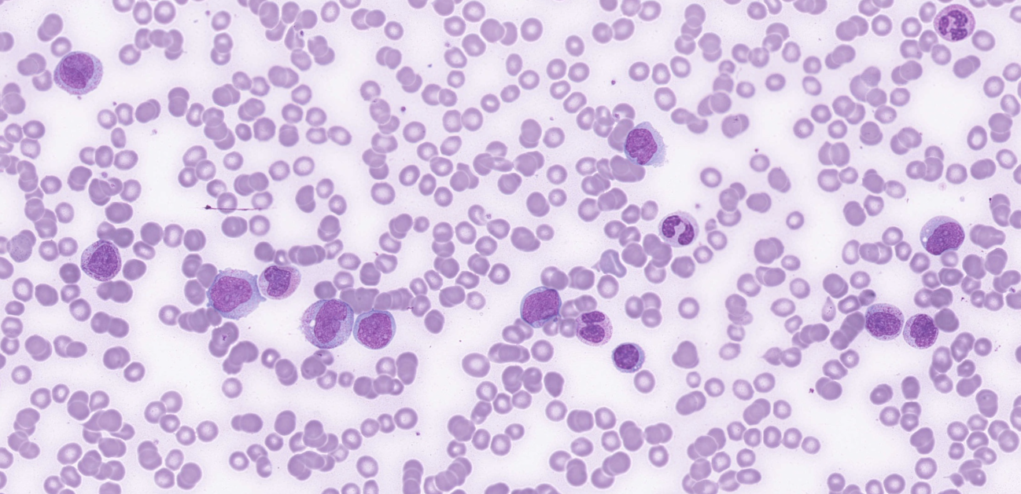

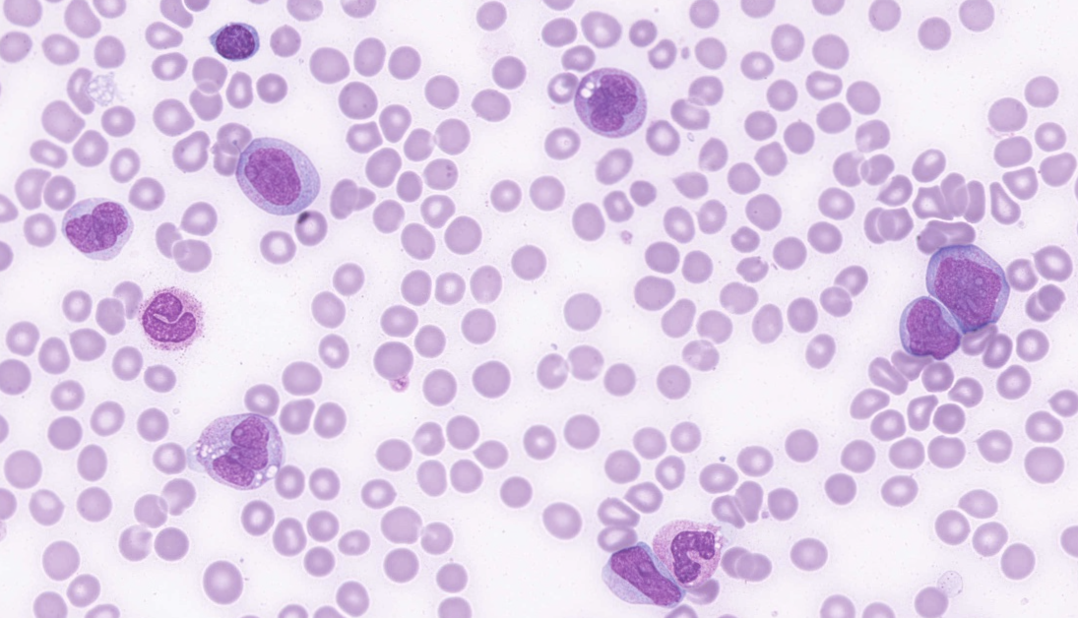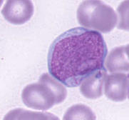

The majority of participants reported the blasts, monocytosis and left shift, which were considered essential diagnostic features of the film and scored 10. The Auer rods were considered a major feature and scored 5. Features indicating the presence of mild dysplasia were scored accordingly and the minor red cell changes previously described were scored similarly. The overall normal platelet morphology was acknowledged in the scoring.

AMML is an acute leukaemia characterised by a proliferation of neutrophil and monocyte precursors. The peripheral blood or bone marrow has ≥20% blasts (including promonocytes)1. This case was also used for the corresponding Blood Film differential survey (HA-BF- 21-03) where the median count of the combined blasts and promonocytes was 32%. Neutrophils and their precursors and monocytes and their precursors each constitute ≥20% of bone marrow cells. This conventional minimal limit of 20% monocytes and their precursors distinguishes AMML from cases of acute myeloid leukaemia (AML) with or without maturation, in which some monocytes may be present. AMML accounts for 5-10% of AML cases. It occurs in all age groups but is more common in older individuals. Patients typically present with anaemia and thrombocytopenia, fever and fatigue. The WBC count may be high, with numerous blasts and promonocytes. Considering the morphological features described, and the median count of the combined blasts and promonocytes as shown by the corresponding Blood Film differential survey, the most likely diagnosis was considered to be AMML and allocated a score of 5. 'AML' and 'acute monoblastic/monocytic leukaemia' were considered diagnoses 'with the majority of the expected features' and were scored 4. Other submitted diagnoses which indicated minor myeloid and /or monocytic features were scored accordingly.

This patient's immunophenotype showed a heterogeneous myeloid/monocytic blast population which was CD11b+ (partial), CD13+, CD33+, CD34+, CD64+, CD38+, CD117+(partial) HLADR+ and MPO+. FLT3-ITD was detected in the bone marrow aspirate. These results are consistent with the presence of an AML with both immature monocytic and myeloid components.

1.WHO Classification of Tumours of Haematopoietic and Lymphoid Tissues, Swerdlow, S et al, revised 4th edition, 2017

|  |  |  |  |  |  |  |  |  |  |  |  |  |  |  |  |  |  |
| --- | --- | --- | --- | --- | --- | --- | --- | --- | --- | --- | --- | --- | --- | --- | --- | --- | --- |
| RBC Features | | Polychromasia increased | | Tear drop cells | | Tear drop cells | | Nucleated red blood cells | | Nucleated red blood cells | Polychromasia increased | | Irregularly contracted cells | No significant morphological red blood cell abnormality | Polychromasia increased | Nucleated red blood cells | Nucleated red blood cells |
| Dimorphism / Dimorphic red blood cells | | Nucleated red blood cells | |  | | Rouleaux | | Tear drop cells | Nucleated red blood cells | | Spherocytes |  | Hypochromia | Spherocytes | Polychromasia increased |
| Spherocytes | | Schistocytes | |  | |  | |  | Rouleaux | |  |  |  | Polychromasia increased |  |
|  | |  | |  | |  | |  | Tear drop cells | |  |  |  | Tear drop cells |  |
| WBC Features | | Promyelocytes / metamyelocytes / myelocytes | | Blast cells | | Monocytosis | | Blast cells | | Blast cells | Blast cells | | Dysplastic changes | Blast cells | Blast cells | Blast cells | Blast cells |
| Blast cells | | Monocytosis | | Blast cells | | Monocytosis | | Dysplastic changes | Auer rods | | Monocytosis | Monocytosis | Auer rods | Auer rods | Promyelocytes / metamyelocytes / myelocytes |
| Monocytosis | | Auer rods | | Promyelocytes / metamyelocytes / myelocytes | |  | | Promyelocytes / metamyelocytes / myelocytes | Dysplastic changes | | Blast cells |  | Monocytosis | Monocytosis | Monocytosis |
|  | | Monocytosis | |  | |  | |  | Monocytosis | |  |  |  | Promyelocytes / metamyelocytes / myelocytes |  |
| Platelet Features | | No significant morphological platelet abnormality | | No significant morphological platelet abnormality | |  | | No significant morphological platelet abnormality | | No significant morphological platelet abnormality | No significant morphological platelet abnormality | | No significant morphological platelet abnormality | No significant morphological platelet abnormality |  | Platelet clumps | No significant morphological platelet abnormality |
| Primary Diagnosis | | Acute myelomonocytic leukaemia | | Acute myelomonocytic leukaemia | | Acute myelomonocytic leukaemia | | Acute monoblastic / monocytic leukaemia | | Acute leukaemia | Acute myelomonocytic leukaemia | | Acute myelomonocytic leukaemia | Acute monoblastic / monocytic leukaemia | Acute myelomonocytic leukaemia | Acute myelomonocytic leukaemia | Acute monoblastic / monocytic leukaemia |
|  | |  | |  | |  | |  |  | |  |  |  |  |  |
| High scoring response | | Moderate scoring response | | Low scoring response | | Lowest scoring response | | Response given no score | | |

|  |  |  |  |  |  |  |  |  |  |  |  |  |  |  |  |  |
| --- | --- | --- | --- | --- | --- | --- | --- | --- | --- | --- | --- | --- | --- | --- | --- | --- |
| RBC Features | | Nucleated red blood cells | | Schistocytes |  | | Nucleated red blood cells | | Nucleated red blood cells | | Nucleated red blood cells | | Nucleated red blood cells | Nucleated red blood cells | Polychromasia increased | Rouleaux |
|  | | No significant morphological red blood cell abnormality |  | | Rouleaux | | Polychromasia increased | | Polychromasia increased | | Polychromasia increased |  |  | Microcytes |
|  | |  |  | |  | | Rouleaux | |  | | Tear drop cells |  |  | Polychromasia increased |
|  | |  |  | |  | |  | |  | | Spherocytes |  |  | Tear drop cells |
| WBC Features | | Blast cells | | Monocytosis | Auer rods | | Blast cells | | Auer rods | | Blast cells | | Auer rods | Blast cells | Promyelocytes / metamyelocytes / myelocytes | Promyelocytes / metamyelocytes / myelocytes |
| Promyelocytes / metamyelocytes / myelocytes | | Promyelocytes / metamyelocytes / myelocytes | Blast cells | | Promyelocytes / metamyelocytes / myelocytes | | Blast cells | | Promyelocytes / metamyelocytes / myelocytes | | Blast cells | Monocytosis | Blast cells | Auer rods |
| Monocytosis | | Blast cells |  | | Monocytosis | | Promyelocytes / metamyelocytes / myelocytes | | Monocytosis | | Promyelocytes / metamyelocytes / myelocytes | Promyelocytes / metamyelocytes / myelocytes | Band form neutrophils | Blast cells |
| Eosinophilia | |  |  | | Auer rods | | Monocytosis | | Auer rods | | Monocytosis |  | Neutrophils - hypergranulation | Monocytosis |
| Platelet Features | |  | | No significant morphological platelet abnormality |  | | No significant morphological platelet abnormality | | No significant morphological platelet abnormality | | No significant morphological platelet abnormality | | Giant platelets / significant numbers of large platelets. *ICSH definition | No significant morphological platelet abnormality | No significant morphological platelet abnormality | No significant morphological platelet abnormality |
| Primary Diagnosis | |  | | Acute myelomonocytic leukaemia |  | | Acute myelomonocytic leukaemia | | Acute myelomonocytic leukaemia | | Acute myelomonocytic leukaemia | | Acute monoblastic / monocytic leukaemia | Acute monoblastic / monocytic leukaemia | Acute myelomonocytic leukaemia | Acute myelomonocytic leukaemia |
| Chronic myelomonocytic leukaemia | |  | Chronic myelomonocytic leukaemia | |  | |  | |  | |  |  |  |  |
| High scoring response | | Moderate scoring response | | | Low scoring response | | Lowest scoring response | | Response given no score | |

|  |  |  |  |  |  |
| --- | --- | --- | --- | --- | --- |
|  | **RCPA result** | | | | |
|  |
|  | **HA-MO-21-04** | | | | |
| RBC Features | Nucleated red blood cells |  |  |  |  |
| Polychromasia increased |  |  |  |  |
| Tear drop cells |  |  |  |  |
|  |  |  |  |  |
| WBC Features | Blast cells | Auer rods | Dysplastic changes |  |  |
| Promyelocytes / metamyelocytes / myelocytes |  | Neutrophilia |  |  |
| Monocytosis |  | Neutrophils - hyposegmented |  |  |
|  |  | Pelger-Huet/pseudo Pelget-Huet cells |  |  |
| Platelet Features | No significant morphological platelet abnormality |  |  |  |  |
| Primary Diagnosis | Acute myelomonocytic leukaemia | Acute monoblastic / monocytic leukaemia | Acute promyelocytic leukaemia (hypergranular) | Chronic myelomonocytic leukaemia | Myelodysplastic / myeloproliferative neoplasm in acute leukemic transformation |
|  | Acute myeloid leukaemia | Acute promyelocytic leukaemia (hypogranular) variant | Acute leukaemia | Myelodysplastic / myeloproliferative neoplasm in accelerated phase |

|  |  |  |  |  |  |  |  |
| --- | --- | --- | --- | --- | --- | --- | --- |
| High scoring response | Moderate scoring response | | Low scoring response | | | Lowest scoring response | |
| **CLOSED 06/04/2021** | | **Submissions** | | **Total** | % | |
| **All Staff** | | **21** | | **46** | 45.7 | |
| **Morph Trained** | | 12 | | 22 | 54.5 | |
| **Incomplete** | | 2 | |  | 4.3 | |
| **Routine** | | 4 | | 12 | 33.3 | |
| **SANDY** | | **1** | | **3** | 33.3 | |
| **CORE** | | **3** | | **8** | 37.5 | |
| **Flow** | | **1** | | **6** | 16.7 | |

