CASE STUDY: HA-MO-21-06

**B-cell prolymphocytic leukaemia**

92 year old male with chronic obstructive pulmonary disease

WCC: 84.1 x 109/L

RCC: 4.2 x 1012/L

Hb: 103 g/L

MCV: 76.4 fL

MCH: 24.5 pg

MCHC: 321 g/L

PLT: 121 x 109/L

This film showed a lymphocytosis with a predominance of medium-sized abnormal lymphoid cells with round or slightly indented nuclei, moderately condensed chromatin, a prominent central nucleolus and faintly basophilic cytoplasm. The red cells were hypochromic and microcytic with increased polychromasia and small numbers of elliptocytes and the platelets showed normal morphology. The white cell features described are consistent with B-cell prolymphocytic leukaemia (B-PLL).

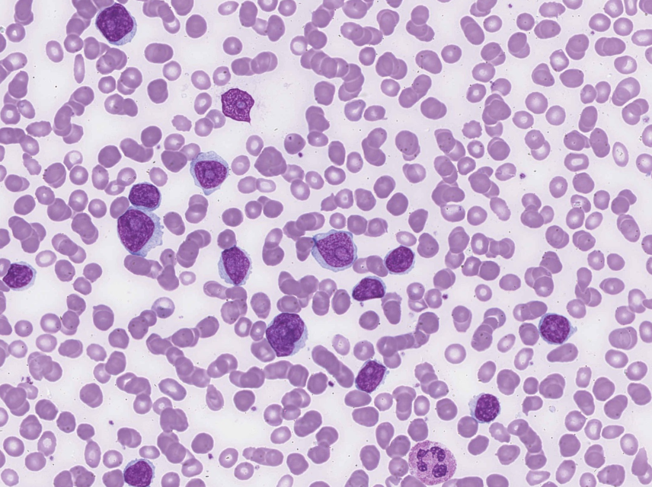

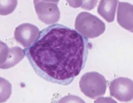

The majority of participants identified the lymphocytosis and recognised the abnormal lymphoid cells as prolymphocytes; both these features were considered essential diagnostic features and attracted scores of 10. The response of "Lymphocytes-abnormal" - was a significant comment and allocated a score of 5. The red cell features suggested a concurrent iron deficiency, however, these were of lesser significance for the diagnosis and scored accordingly, as was the normal platelet morphology.

B-PLL is a neoplasm of B-cell prolymphocytes affecting the peripheral blood, bone marrow and spleen, with the majority (>55% and usually >90%) of the circulating cells being prolymphocytes. The typical morphology of these cells is as described above. The bone marrow in this case showed an interstitial and nodular intertrabecular infiltration of lymphoid cells similar to those found in peripheral blood.

B-PLL is a rare condition, accounting for approximately 1% of lymphocytic leukaemias. Most patients are aged >60 years, and the frequencies in males and females is similar. Classically most patients present with B symptoms, massive splenomegaly with absent or minimal peripheral lymphadenopathy, and a rapidly increasing lymphocyte count. Anaemia and thrombocytopenia are seen in 50% of cases.1The vast majority of participants submitted a diagnosis of B-PLL, the most likely diagnosis based on the morphological features. Other diagnoses submitted were scored 2 in recognition of some of the features present.

The immunophenotype of this patient was in keeping with B-PLL, with the cells expressing sig CD19 (94%) kappa (94%) and the B lineage markers CD19 (96%), CD20 (96%), CD22 (96%), FMC7 (96%). CD10 and T lineage markers were not expressed.

B-PLL strongly express surface IgM plus B-cell antigens (CD19, CD20, CD22, CD79a and FMC7). Approximately 1/3 of cases will express CD5. CD23 is typically absent.

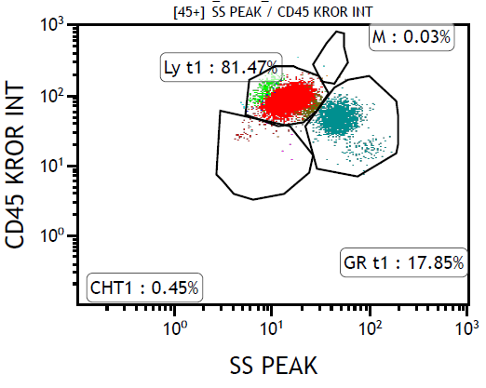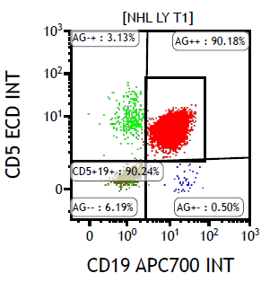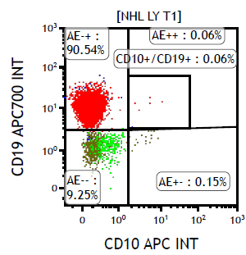

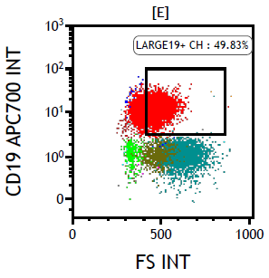

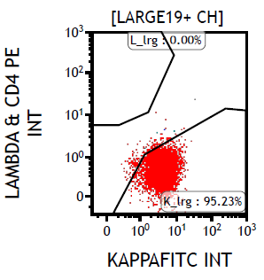

1.Rodak's Haematology: Clinical Principles and Applications, 5th edition, Keohane et al, 2016, Elsevier Inc.

|  |  |  |  |  |  |  |  |  |  |  |  |
| --- | --- | --- | --- | --- | --- | --- | --- | --- | --- | --- | --- |
|  | **HA-MO-21-06** | | | | | | | | | | |
| RBC Features | Rouleaux | Rouleaux | Elliptocytes / ovalocytes | Elliptocytes / ovalocytes | Tear drop cells | Microcytes |  | Microcytes | Schistocytes | Elliptocytes / ovalocytes | Elliptocytes / ovalocytes |
| Pencil cells | Elliptocytes / ovalocytes | Poikilocytosis (not otherwise coded) | Irregularly contracted cells | Pencil cells | Rouleaux |  | Hypochromia | Poikilocytosis (not otherwise coded) | Echinocytes | Polychromasia increased |
| Spherocytes | Microcytes | Echinocytes |  |  | Pencil cells |  | Pencil cells | Echinocytes | Microcytes | Microcytes |
|  |  |  |  |  |  |  | Rouleaux | Elliptocytes / ovalocytes | Hypochromia | Hypochromia |
| WBC Features | Prolymphocytes | Lymphocytosis | Smear / smudge cells | Lymphocytosis | Lymphocytes – abnormal | Lymphocytosis |  | Prolymphocytes | Prolymphocytes | Prolymphocytes | Prolymphocytes |
|  | Lymphocytes – abnormal |  | Prolymphocytes | Lymphocytosis | Prolymphocytes |  |  | Neutrophils – other abnormal granulation | Smear / smudge cells | Lymphocytes – abnormal |
|  | Prolymphocytes | Prolymphocytes |  |  |  |  |  | Blast cells | Blast cells | Lymphocytosis |
|  |  |  |  |  |  |  |  | Smear / smudge cells |  | Smear / smudge cells |
| Platelet Features | No significant morphological platelet abnormality | No significant morphological platelet abnormality | Platelet clumps | No significant morphological platelet abnormality | No significant morphological platelet abnormality | No significant morphological platelet abnormality |  | No significant morphological platelet abnormality | Platelet clumps | No significant morphological platelet abnormality | No significant morphological platelet abnormality |
|  |  |  |  |  |  |  |  |  |  |  |
| Primary Diagnosis | B-cell prolymphocytic leukaemia | B-cell prolymphocytic leukaemia | B-cell prolymphocytic leukaemia | B-cell prolymphocytic leukaemia | B-cell prolymphocytic leukaemia | B-cell prolymphocytic leukaemia |  | T-cell prolymphocytic leukaemia | B-cell prolymphocytic leukaemia | B-cell prolymphocytic leukaemia | B-cell prolymphocytic leukaemia |
|  |  |  |  |  |  |  |  |  |  |  |

|  |  |  |  |  |
| --- | --- | --- | --- | --- |
| High scoring response | Moderate scoring response | Low scoring response | Lowest scoring response | Response given no score |

|  |  |  |  |  |  |  |  |  |  |  |
| --- | --- | --- | --- | --- | --- | --- | --- | --- | --- | --- |
|  | **HA-MO-21-06** | | | | | | | | | |
| RBC Features | Pencil cells | Elliptocytes / ovalocytes |  | Microcytes | Elliptocytes / ovalocytes | Microcytes | Polychromasia increased | Irregularly contracted cells | Elliptocytes / ovalocytes | Pencil cells |
|  | Microcytes |  | Elliptocytes / ovalocytes | Rouleaux |  | Microcytes | Rouleaux | Polychromasia increased | Irregularly contracted cells |
|  |  |  | Hypochromia |  |  | Pencil cells | Pencil cells | Rouleaux | Rouleaux |
|  |  |  |  |  |  | Tear drop cells | Microcytes |  |  |
| WBC Features | Lymphocytes – abnormal | Prolymphocytes |  | Blast cells | Prolymphocytes | Prolymphocytes | Blast cells | Lymphocytes – abnormal | Blast cells | Prolymphocytes |
| Blast cells | Neutropenia |  | Prolymphocytes | Lymphocytosis | Lymphocytes – abnormal | Prolymphocytes | Lymphocytosis | Lymphocytosis | Blast cells |
| Eosinophilia |  |  | Neutropenia | Smear / smudge cells | Lymphocytosis | Lymphocytosis |  | Neutrophils - hypergranulation | Neutropenia |
| Neutrophils - hypergranulation |  |  | Smear / smudge cells |  |  | Smear / smudge cells |  | Lymphocytes – abnormal |  |
| Platelet Features | No significant morphological platelet abnormality | No significant morphological platelet abnormality |  | No significant morphological platelet abnormality | No significant morphological platelet abnormality | No significant morphological platelet abnormality | Platelet clumps | No significant morphological platelet abnormality | No significant morphological platelet abnormality | No significant morphological platelet abnormality |
|  |  |  |  |  |  | Inaccurate platelet count |  |  |  |
| Primary Diagnosis | Mantle cell lymphoma | B-cell prolymphocytic leukaemia |  | B-cell prolymphocytic leukaemia | B-cell prolymphocytic leukaemia | B-cell prolymphocytic leukaemia | B-cell prolymphocytic leukaemia | Mantle cell lymphoma | B-cell prolymphocytic leukaemia | B-cell prolymphocytic leukaemia |
|  |  |  |  |  |  |  |  |  |  |

|  |  |  |  |  |
| --- | --- | --- | --- | --- |
| High scoring response | Moderate scoring response | Low scoring response | Lowest scoring response | Response given no score |

|  |  |  |  |  |  |
| --- | --- | --- | --- | --- | --- |
|  | **RCPA results** | | | | |
| RBC Features | Elliptocytes / ovalocytes | Polychromasia increased |  |  |  |
| Microcytes |  |  |  |  |
| Hypochromia |  |  |  |  |
| Pencil cells |  |  |  |  |
| WBC Features | Prolymphocytes | Lymphocytes – abnormal | Smear / smudge cells |  |  |
| Lymphocytosis |  |  |  |  |
|  |  |  |  |  |
|  |  |  |  |  |
| Platelet Features | No significant morphological platelet abnormality |  |  |  |  |
|  |  |  |  |  |
| Primary Diagnosis | B-cell prolymphocytic leukaemia | T-cell prolymphocytic leukaemia | Chronic lymphocytic leukaemia - Large cell transformation | Mantle cell lymphoma |  |
|  | Hairy cell leukaemia variant / Splenic B cell lymphoma/leukaemia, unclassifiable | Chronic lymphocytic leukaemia / Small lymphocytic lymphoma |  |  |

|  |  |  |
| --- | --- | --- |
| High scoring response | Moderate scoring response | Low scoring response |

|  |  |  |  |
| --- | --- | --- | --- |
| **CLOSED 06/04/2021** | **Submissions** | **Total** | % |
| **All Staff** | **21** | **46** | 45.7 |
|  |  |  |  |
|  |  |  |  |
|  |  |  |  |
| **Morph Trained** | 12 | 22 | 54.5 |
| **Incomplete** | 2 |  | 4.3 |
| **Routine** | 4 | 12 | 33.3 |
| **SANDY** | **1** | **3** | 33.3 |
| **CORE** | **3** | **8** | 37.5 |
| **Flow** | **1** | **6** | 16.7 |

