CASE STUDY: HA-MO-21-08

Acute Myeloid Leukaemia with Myelodysplasia - Related Changes

22-year-old male, routine medical check.

WCC: 6.8 x 109/L

RCC: 5.0 x 1012/L

Hb: 148 g/L

MCV: 89 fL

MCH: 30 pg

MCHC: 335 g/L

Plt: 165 x 109/L

This film showed a population of blast cells, which were intermediate sized with a high nuclear/cytoplasmic ratio, immature prominent nucleoli and scant basophilic cytoplasm. Auer rods were infrequently seen.

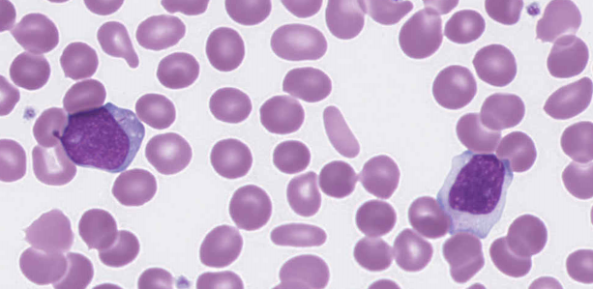

Dysplastic neutrophils with hypogranulation and hyposegmentation were present. The red cells showed nucleated RBC, elliptocytosis and tear drop cells. Giant platelets were present.

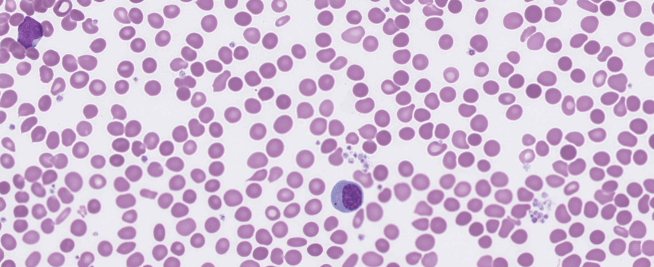

The blast cell features together with the dysplastic features are suggestive of acute myeloid leukaemia with myelodysplasia-related changes (AML-MRC).

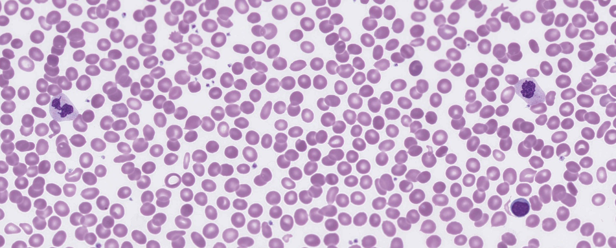The majority of participants reported the blasts, which were considered the essential diagnostic feature of the film and scored 10. The presence of Auer rods, dysplastic changes, neutrophil hypogranulation and hyposegmentation, as well as nucleated RBC were considered major features and awarded 5. Several minor white cell and red cell changes were also present and scored accordingly. The presence of giant platelets in significant numbers, and small platelet clumps were acknowledged in the scoring. With respect to the morphological features described, the most likely diagnoses were AML MRC as well as AML. Acute leukaemia and MDS with excess blasts were considered diagnoses with the majority of the expected features present and were scored 4. Other diagnoses with fewer consistent features were scored accordingly.

This patient's bone marrow aspirate was normocellular with trilineage dysplasia and blasts accounting for 23% of total nucleated cells, features which are consistent with acute myeloid leukaemia with myelodysplasia-related changes.

The flow cytometry showed 36% of total nucleated cells which expressed CD34, CD117, HLA-DR, CD33, CD15, CD64, cytoMPO, CD7 dim, CD13 dim, and CD14 neg, cytoCD3 neg. There was a bi-allelic CEBPA mutation detected, FLT3 ITD and NPM1 rearrangements were not detected and cytogenetics were normal. The presence of the bi-allelic CEBPA mutation may prompt further investigations for possible germline abnormalities.

**Reference: WHO Classification of Tumours of Haematopoietic and Lymphoid Tissues, Swerdlow, S et al, revised 4th edition, 2017**

|  |  |  |  |  |  |  |  |  |  |  |
| --- | --- | --- | --- | --- | --- | --- | --- | --- | --- | --- |
|  | **HA-MO-21-08** | | | | | | | | | |
| **RBC Features** | Pencil cells |  | Tear drop cells | Polychromasia increased | No significant morphological red blood cell abnormality | Target cells | Pencil cells | Elliptocytes / ovalocytes | Pencil cells | Elliptocytes / ovalocytes |
| Elliptocytes / ovalocytes | Tear drop cells | Elliptocytes / ovalocytes | Tear drop cells |  | Tear drop cells | Dimorphism / Dimorphic red blood cells | Sickle cells |  | Spherocytes |
| Spherocytes | Pencil cells |  | Spherocytes |  | Elliptocytes / ovalocytes |  | Tear drop cells |  | Nucleated red blood cells |
|  |  |  | Pencil cells |  | Nucleated red blood cells |  |  |  | Tear drop cells |
| **WBC Features** | Blast cells | Dysplastic changes | Blast cells | Dysplastic changes | Blast cells | Blast cells | Blast cells | Blast cells | Blast cells | Blast cells |
| Auer rods | Blast cells | Band form neutrophils | Auer rods |  | Eosinophilia |  | Auer rods | Neutrophils - hypergranulation | Auer rods |
| Monocytosis |  |  | Blast cells |  | Auer rods |  | Lymphocytes – abnormal | Lymphocytes - reactive | Eosinophilia |
|  |  |  | Lymphocytes - reactive |  |  |  | Eosinophilia | Auer rods | Dysplastic changes |
| **Platelet Features** | Platelet clumps | Platelet clumps | No significant morphological platelet abnormality | Platelet clumps | No significant morphological platelet abnormality | No significant morphological platelet abnormality | Platelet clumps | No significant morphological platelet abnormality | Platelet clumps | Platelet clumps |
|  | No significant morphological platelet abnormality |  | Inaccurate platelet count |  |  |  | Platelet clumps |  |  |
| **Primary Diagnosis** | Acute myelomonocytic leukaemia | Acute myeloid leukaemia | Acute myeloid leukaemia | Acute leukaemia | Acute leukaemia | Acute myeloid leukaemia | Acute myeloid leukaemia | Acute myeloid leukaemia with abnormal eosinophils / eosinophilia | Acute myeloid leukaemia | Acute myeloid leukaemia |
|  |  |  |  |  |  |  |  |  |  |

|  |  |  |  |  |
| --- | --- | --- | --- | --- |
| High scoring response | Moderate scoring response | Low scoring response | Lowest scoring response | Response given no score |

|  |  |  |  |  |  |  |  |  |  |
| --- | --- | --- | --- | --- | --- | --- | --- | --- | --- |
|  | **HA-MO-21-08** | | | | | | | | |
| **RBC Features** | Pencil cells |  | Elliptocytes / ovalocytes | Elliptocytes / ovalocytes | Pencil cells | Pencil cells | Tear drop cells | Pencil cells | Pencil cells |
| Acanthocytes |  | Tear drop cells | Tear drop cells | Elliptocytes / ovalocytes | Elliptocytes / ovalocytes | Irregularly contracted cells | Spherocytes | Spherocytes |
|  |  |  | Nucleated red blood cells | Nucleated red blood cells | Schistocytes | Pencil cells |  | Howell Jolly bodies |
|  |  |  |  | Tear drop cells | Spherocytes |  |  |  |
| **WBC Features** | Blast cells |  | Blast cells | Auer rods | Blast cells | Blast cells | Auer rods | Blast cells | Promyelocytes / metamyelocytes / myelocytes |
| Auer rods |  | Neutrophils - hypergranulation | Dysplastic changes | Auer rods | Auer rods | Blast cells | Auer rods | Auer rods |
|  |  | Auer rods | Blast cells | Dysplastic changes | Neutrophil – Hypogranulation. | Dysplastic changes | Dysplastic changes | Blast cells |
|  |  |  |  | Neutrophil – Hypogranulation. | Neutrophils - hyposegmented |  |  |  |
| **Platelet Features** | Platelet clumps |  | Platelet clumps | No significant morphological platelet abnormality | Platelet clumps | Platelet clumps | Platelet clumps | Platelet clumps | Platelet clumps |
|  |  |  |  |  | Inaccurate platelet count |  |  | Giant platelets / significant numbers of large platelets. *ICSH definition |
| **Primary Diagnosis** | Acute myelomonocytic leukaemia |  | Acute myeloid leukaemia with abnormal eosinophils / eosinophilia | Acute myeloid leukemia with myelodysplasia - related changes | Acute myeloid leukaemia | Acute myeloid leukemia with myelodysplasia - related changes | Acute myeloid leukaemia | Acute myeloid leukaemia | Acute myeloid leukemia with myelodysplasia - related changes |
|  |  |  |  |  |  |  |  |  |

|  |  |  |  |  |
| --- | --- | --- | --- | --- |
| High scoring response | Moderate scoring response | Low scoring response | Lowest scoring response | Response given no score |

|  |  |  |  |  |  |
| --- | --- | --- | --- | --- | --- |
| **RCPA results. Report 24Aug2021** | | | | | |
|
| **HA-MO-21-08** | | | | | |
| **RBC Features** | Nucleated red blood cells | Elliptocytes / ovalocytes |  |  |  |
|  | Tear drop cells |  |  |  |
|  | Pencil cells |  |  |  |
|  | Spherocytes |  |  |  |
| **WBC Features** | Blast cells | Neutrophil – Hypogranulation. | Eosinophilia |  |  |
|  | Auer rods | Promyelocytes / metamyelocytes / myelocytes |  |  |
|  | Dysplastic changes | Pelger-Huet / pseudo Pelget-Huet cells |  |  |
|  | Neutrophils - hyposegmented |  |  |  |
| **Platelet Features** | Platelet clumps | Inaccurate platelet count |  |  |  |
| No significant morphological platelet abnormality |  |  |  |  |
| **Primary Diagnosis** | Acute myeloid leukemia with myelodysplasia - related changes | MDS with excess blasts | Acute myeloid leukaemia with abnormal eosinophils / eosinophilia | Myelodysplastic / myeloproliferative neoplasm in acute leukemic transformation | Myelodysplastic / myeloproliferative neoplasm in accelerated phase |
| Acute myeloid leukaemia | Acute leukaemia | Myelodysplastic syndrome (MDS) | Lymphoblastic leukaemia/lymphoma, NOS (Acute lymphoblastic leukaemia | Myelodysplastic syndrome, unclassifiable |

|  |  |  |  |  |
| --- | --- | --- | --- | --- |
| High scoring response | Moderate scoring response | Low scoring response | Lowest scoring response | Response given no score |

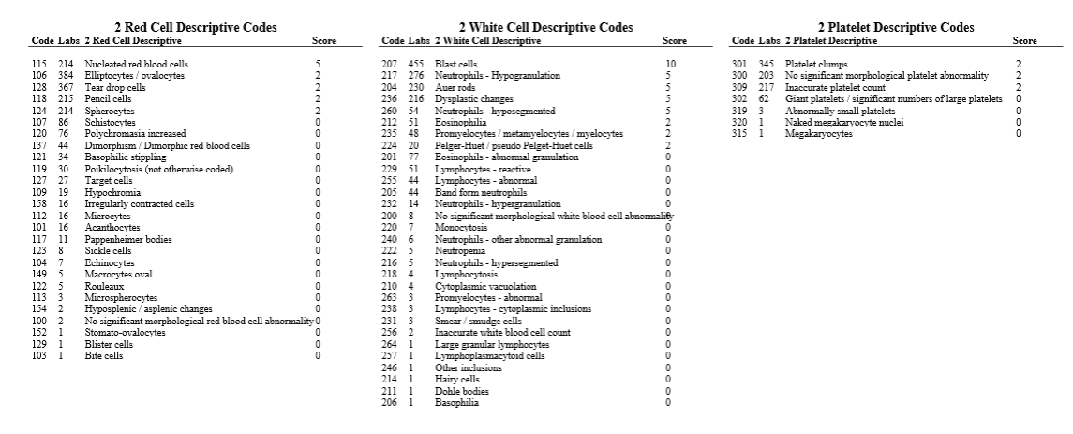

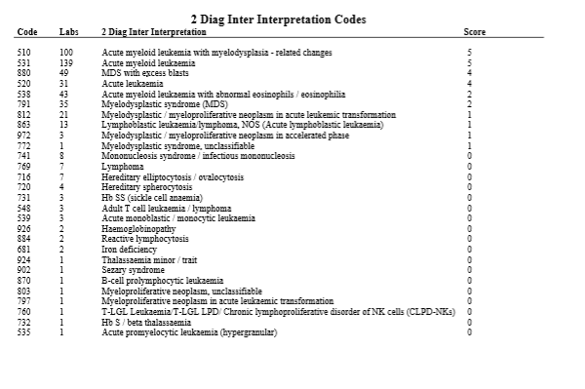

|  |  |  |  |
| --- | --- | --- | --- |
| **CLOSED 08/09/2021** | **Submissions** | **Total** | % |
| **All Staff** | **19** | **46** | 41.3 |
| **Morph Trained** | 12 | 22 | 54.5 |
| **Incomplete** | 2 |  | 4.3 |
| **Routine** | 3 | 12 | 25.0 |
| **SANDY** | **1** | **3** | 33.3 |
| **CORE** | **3** | **8** | 37.5 |
| **Flow** | **0** | **6** | 0.0 |